**INFO8240**

**Task 1:**

**Task 1A: LCS Class Diagram**

**Task 1B: Add a Catalog Item Communication Diagram**

**Task 2:**

**Task 2A: PAS Class Diagram**

**Task 2B: Add a Library Patron Communication Diagram**

**Task 3:**

**Task 3A: LBS Class Diagram**

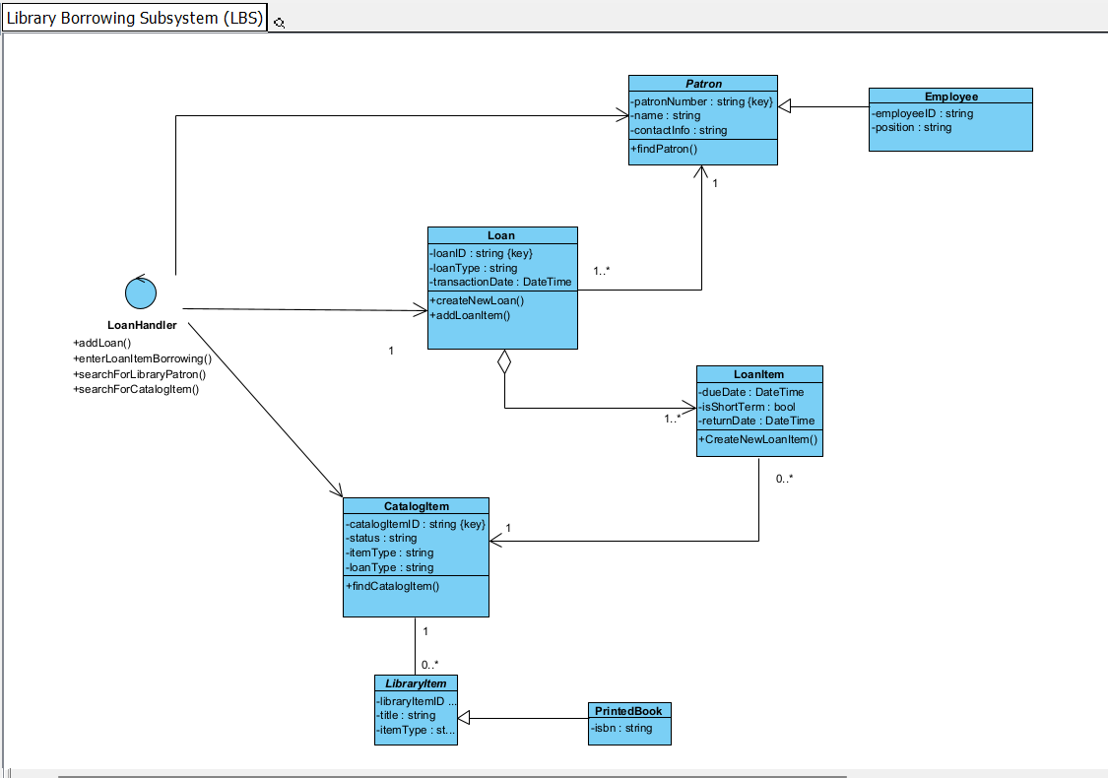

**Task 3B: Borrow Multiple Catalog Items Communication Diagram**

