**INFO8240**

**Task 1:** No diagrams required

**Task 2: CITL Use Case Diagram**

**Task 3: Multilayer Design Sequence Diagrams (DSD)**

**Task 3A:**

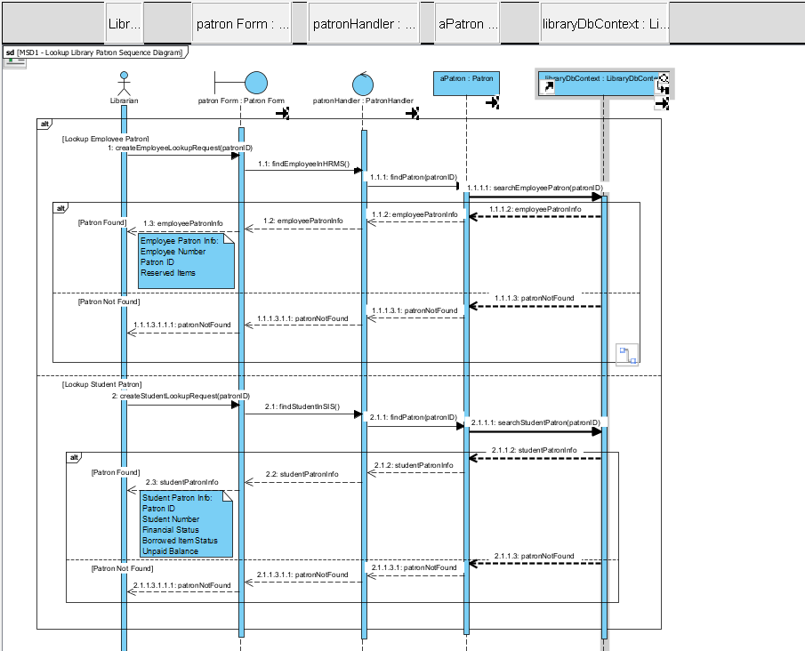

**Task 3B:**

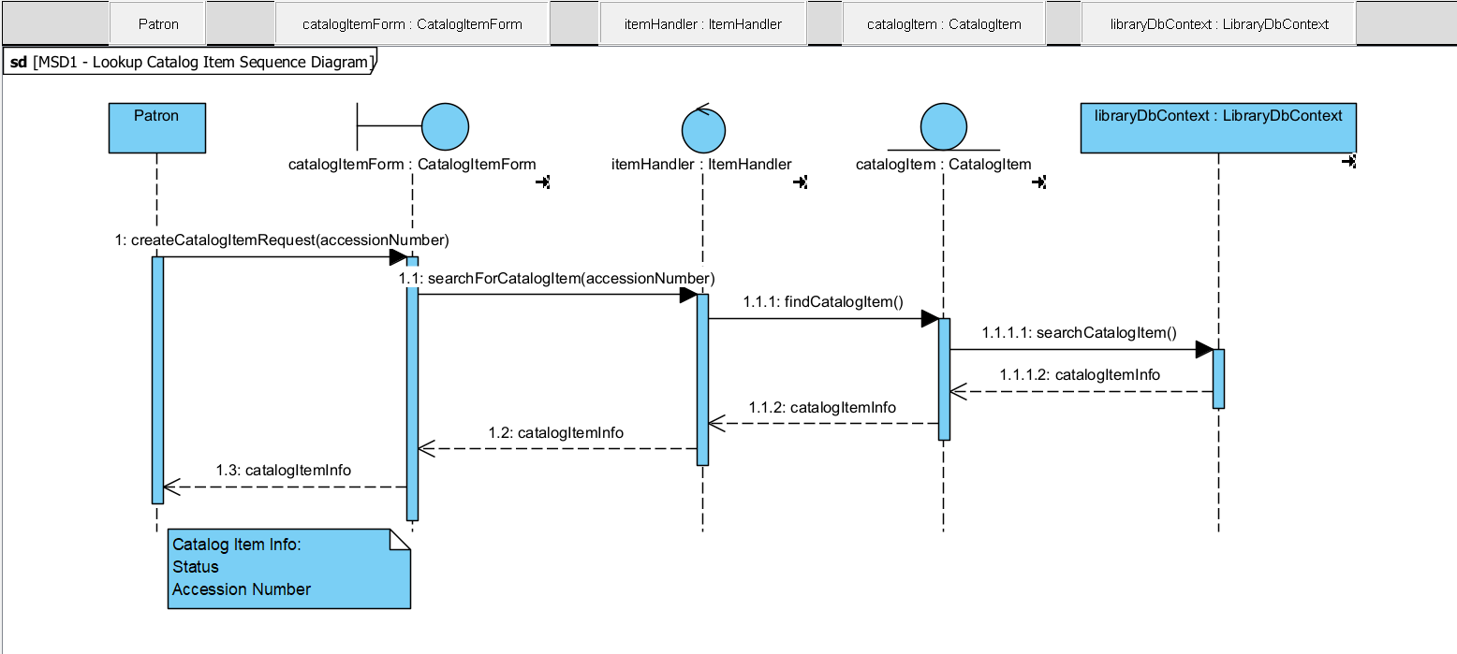

**Task 3C:**

**Task 4: Design Class Diagrams (DCD) for Domain Layer**

**Task 4A:**

**Task 4B:**

**Task 4C:**

**Task 4D:**

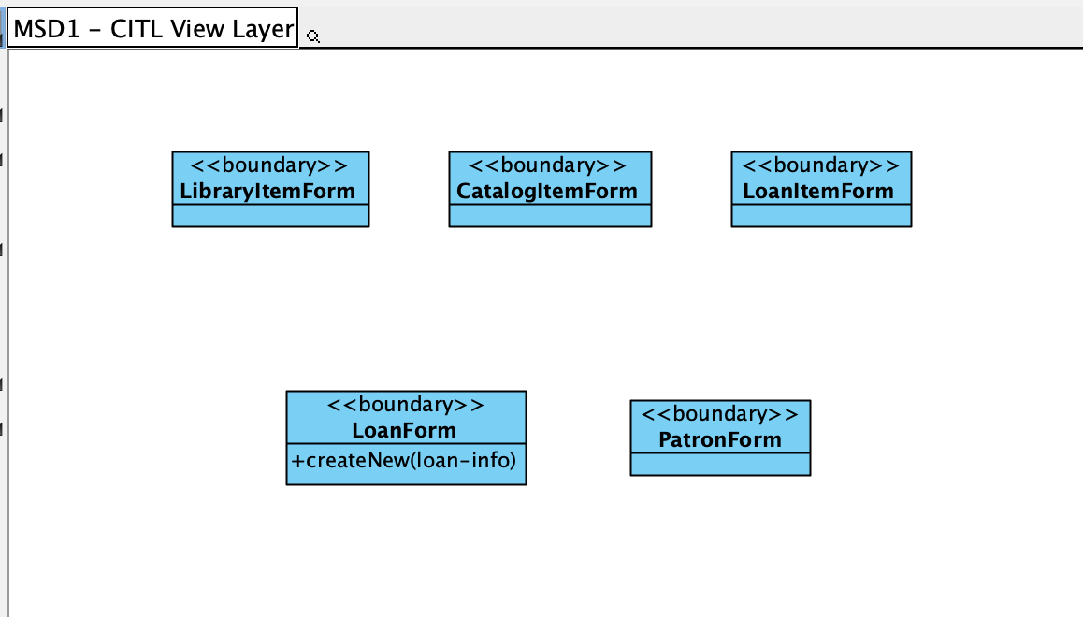

**Task 4E:**

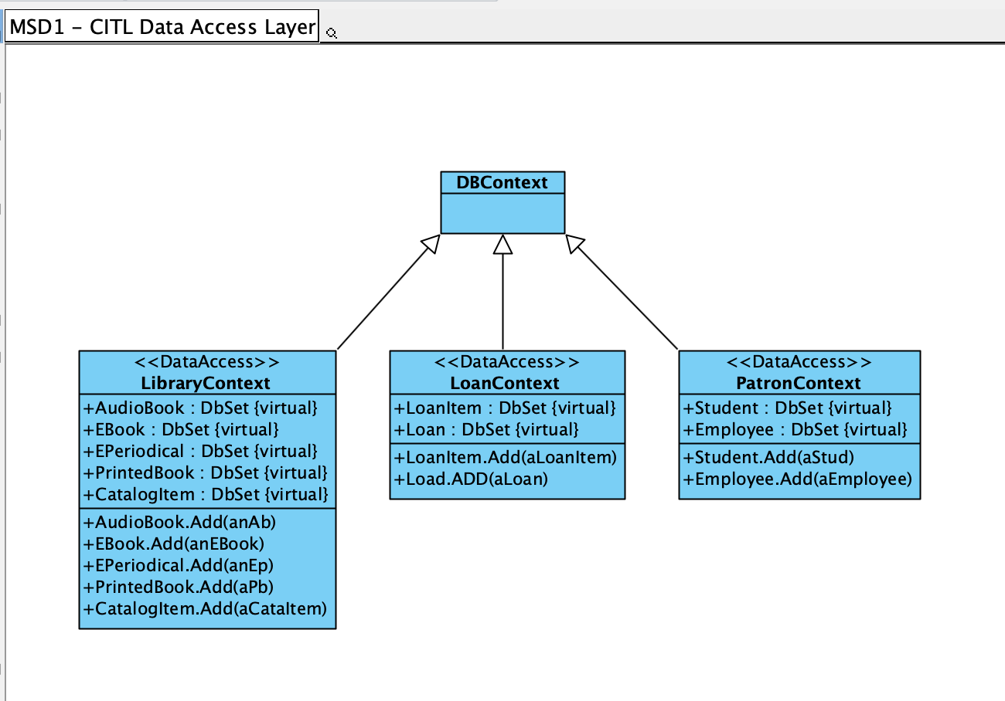

**Task 5: CITL UML Package Diagram (PD)**

