**INFO8240 Practical Assignment 2 (PA2)**

|  |
| --- |
| **1. UML First-Cut Design Class Diagram (FCDCD)**  **UML Diagram #1:** RMO Customer Account Subsystem |
| **2. UML Communication Diagrams 1 & 2 (CD #1 & CD #2)**  **UML Diagram #2a:** Add a Customer    **UML Diagram #2b Title:** Add an Account    **3. UML Design Class Diagram (DCD)**  **UML Diagram #3:** RMO Customer Account Subsystem |

**4. UML Multilayer Design Sequence Diagram 1 – Add a Customer (DSD #1)**

**UML Diagram #4:** Add a Customer

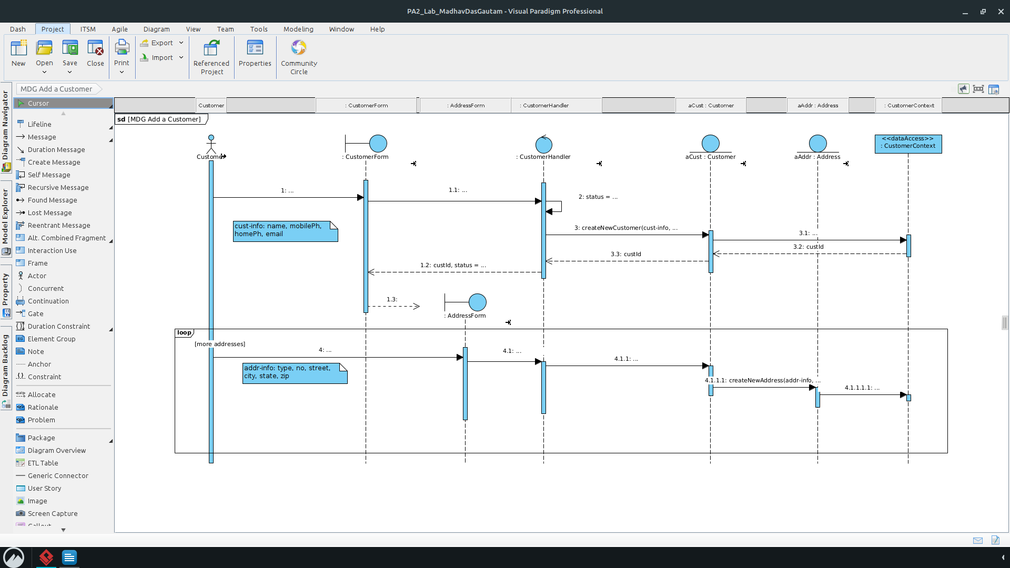

**5. UML Design Class Diagram: Domain Layer – Add a Customer (DSD #1)**

**UML Diagram #5:** RMO Domain Layer

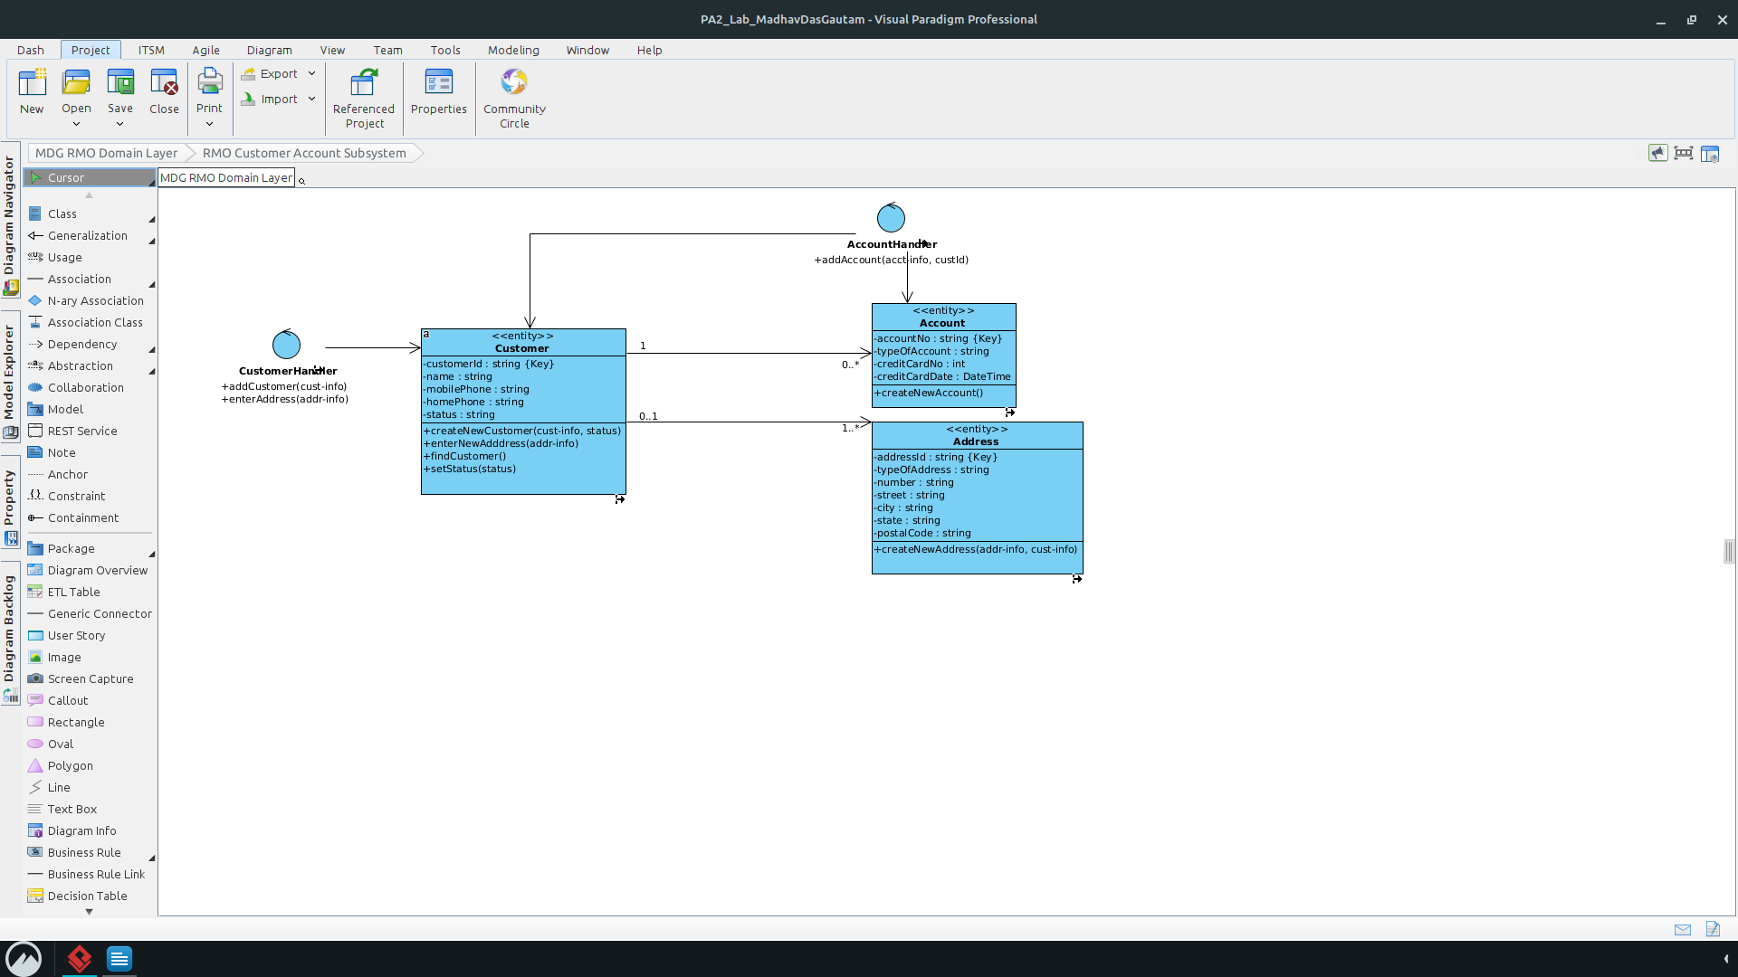

**6. UML Design Class Diagram: Data Access Layer – Add a Customer (DSD #1)**

**UML Diagram #6:** RMO Data Access Layer

