**Exercise 2: Normalization**

**EmployeeClients**

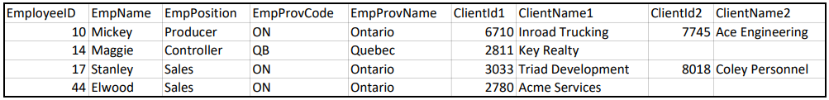

The table provided shows the list of clients for each employee.

**Steps to normalize**:

1. The un-normalized table above is not in **1NF** due to repeating columns. What are the repeating columns?

**Answer**:

Column 1: _______ClientId1 ________

Column 2: _______ClientName1________

Column 3: _______ClientId2 ________

Column 4: _______ClientName2________

1. [Describe the un-normalized table by filling out the blanks for **UNF** below.

**UNF**:

**EmployeeClients** (

EmployeeID,

EmpName, EmpPosition,

EmpProvCode, EmpProvName,

[ (_______ClientId1________ **,** _______ClientName1 ________) ,

(_______ClientId2 ________ **,** _______ClinetName2 ________ ) ]

)

1. Eliminate the repeating columns and fill out the blanks for **1NF** below.

**1NF:**

**EmployeeClients** (

_______EmployeeID ________ **,**

_______EmpName ________ **,** _______EmpPosition ________ **,**

_______EmpProvCode________ **,** _______EmpProvName ________ **,**

_______ClientId ________ **,** _______ClientName ________

)

1. The **EmployeeClients** table in **2NF** below should have a composite key. Make sure you underline them properly.

After identifying the composite key, there are several attributes, which does not completely depend on the entire composite key. This means that the **1NF** table is not in **2NF** (i.e., all non-key columns are dependent on the entire composite key).

To fix this issue, move the columns to new **Employee** and **Client** tables by filling out the blanks in **2NF** below. The keys for each of the newly added tables are pre-assigned.

**2NF:**

**Employee** (

EmployeeID,

_______EmpName ________ , _______EmpPosition ________ ,

_______EmpProvCode ________ , _______EmpProvName ________

)

**Client** (

ClientID, _______ClientName ________

)

**EmployeeClients** (

_______EmployeeID________ **,** _______ClientId ________

)

1. Observe that the **Employee** table from **2NF** is not in 3NF because there are non-key columns that depends on other non-key columns. Fix this issue by filling out the blanks for **3NF** below. The key for the Province table is pre-assigned.

**3NF:**

**Province** (

ProvCode, _______ProvName ________

)

**Employee** (

EmployeeID,

_______EmpName ________ , _______EmpPosition ________ ,

_______ProvCode ________

)

Note: No change to **Client** and **EmployeeClients** tables in **2NF**.

**Optional**: Manually check that the tables in **3NF** can store all the original data values (and no more!) by creating tables manually (e.g., on a scratch pad).