**Task 1: ITCPA Agile Project Charter**

1. **System Objectives**

* Conestoga College ACSIT requires a new information system to replace the current Learning Management System that is currently manual.
* The ITCPA project aims to automate end-to-end ITCPA process.
* The ITCPA application will be built using a full development cycle that includes local development environment using VS Code and MySQL, a staging environment, and a production environment on Azure cloud platform.
* The new system must continue to support the following major user roles: Client, ACSIT Program Coordinator, and ACSIT Student.
* The new system must provide an extensive set of reports and that can be viewed and printed.

1. **Project Roles/Responsibilities**

**Client Staff**

* **Lea Armstrong**, IT Program Coordinator: Project Sponsor, responsible for approving the project initially and then approving deliverables as the project proceeds;
* **Ted Tanner**, ACSIT Faculty Advisor: Project Contact / Domain Expert, responsible for working with the Technical Staff to manage the project on a day-to-day basis; also responsible for providing information and answering questions.

**Technical Staff**

* **Aman Wagle**, Senior Software Developer: Scrum Master, responsible for facilitating scrum meetings and activities; removes obstacles of the Development team members;
* **Francesco Marsico**, Business Analyst / QA: Product Owner, responsible for prioritizing the product backlog, business analysis and software testing
* **Madhav Das Gautam and Mudaliar Balamurugan,** Senior Software Developer: Development Team Member, responsible for developing the back-end services (API) of the system.
* **Nabil Al Raian**, Front-end Software Developer: Development Team Member, responsible for developing the UI of the system.

1. **Business Benefits**

* The new **External Client Proposal** will help facilitate the approval of student capstone projects proposed by clients reduce time loss between client and other student's groups after project assigned to a group.
* The new **Capstone Project Matching** Subsystem will track and quickly match the client IT capstone project proposals to student teams.
* The new **Student Team Management** Subsystem will allow students to apply to unassigned client project proposal.

1. **Requirements**

**4A. Preliminary Functional Requirements**

**User Story 1:** As a Student, I want to easily find the available project proposal so that I can select a client proposal and have clear understanding of its availability.

**Preliminary Acceptance Criteria:**

* List the available client project proposals.
* Search and filter projects based on availability.
* Able to choose from a project proposal.
* Able to submit the chosen project to Faculty Adviser for approval.

**User Story 2:** As a Faculty Coordinator, I want a software where I can review and approve the project proposals so that students can browse and choose the available project.

**Preliminary Acceptance Criteria:**

* Dashboard that displays all submitted project proposals.
* Ability to approve or reject proposals.
* Notify the client about the project proposal.
* Display project availability to student teams.

**4B. Non-functional Requirements**

|  |  |
| --- | --- |
| **Usability requirements** | * The system should have easy-to-use interface for faculty member, students as well as clients. * Design should be responsive in various screen sizes and devices. |
| **Reliability requirements** | * The system should have automated and regular data backup mechanisms. * The system should perform reliably without failure minimizing the downtime. |
| **Performance requirements** | * The system should provide quick response for any kind of tasks. * The system should be able to handle peak user loads without failure. |
| **Security requirements** | * The system should have role-based access control to set different permissions for various kind of users. * The system should use secure communication protocols like HTTPS. |

1. **Project Team Critical Success Factors**

* The ITCPA stakeholders are Clients from the industry, IT Program coordinator, IT students, Faculty advisors and the main stakeholder Ted Tanner (Faculty advisor).
* The Product Owner should: ensure the requirements are clear.
* The Scrum Master should: facilitate communication.
* Team members should: have skills to accomplish the tasks.
* All project team should: identify risks and mitigation actions to provide information to all the project team members assess and control threads.

1. **Preliminary Technical Architecture**

The proposed technical architecture is **Cloud-based technical architecture.**

* 1. **Development environment**
* Operating System: Windows, macOS, or Linux
* Integrated Development Environment (IDE): Visual Studio Code.
* Version Control System: Git
* Database: MySQL (can be implemented using Azure Database for MySQL
* Backend Server: Node.js
* Front-end Framework: Angular (or other approved modern frameworks)
  1. **Production Server Environment**
* Cloud Platform: Azure
* Web Server: Azure App Service
* Backend Server: Node.js (utilizing microservices architecture)
* Database: MySQL (Azure Database for MySQL) or optional MongoDB (NoSQL)
  1. **Production Client Environment**
* Web Browser: Any modern web browser (e.g., Chrome, Firefox)

**Task 2: Proposed To-be Workflow**

**Business Process Name:** ITCPA Client Capstone Project Matching Process

**Process Goal:** Develop a way to track and quickly match the client IT capstone project proposals to student teams.

**Process Result:** Remove inefficiencies and streamline the end-to-end capstone project approval process.

**Workflow Diagram:**

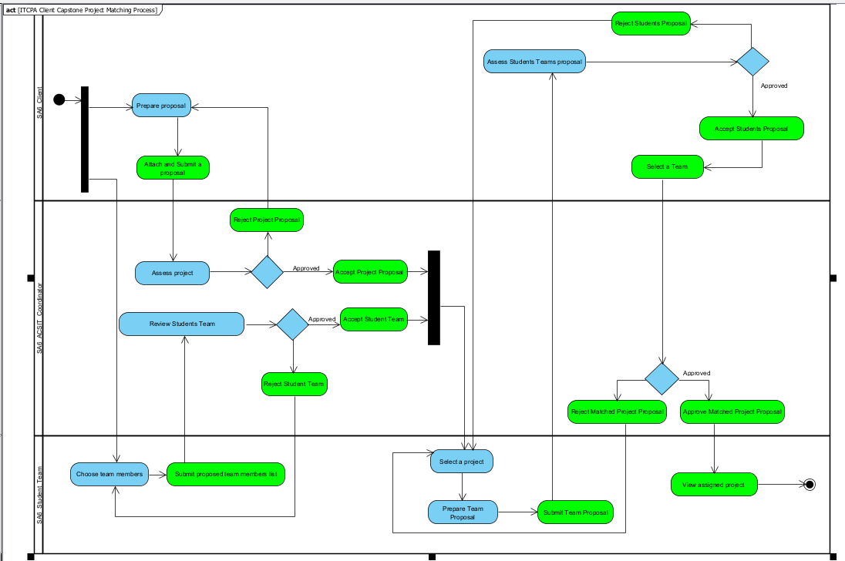

**Appendix A: Interview questions for the stakeholders**

**1. Stakeholder 1 Name / Position: ACSIT Program Coordinator**

**Questions:**

* **Close-ended question:**
  1. Would you like to make project submissions and progress more visible to clients, faculty advisors and students?
  2. Would you be interested in conducting a pilot testing of the new system before implementing it?
* **Open-ended question:**
  1. How do you address the situation when students keep contacting the clients who have already assigned the project to another team?
  2. What are the challenges you are facing with current manual procedures to match client proposal and assign student teams?

**2. Stakeholder 2 Name / Position: Student**

**Questions:**

* **Close-ended question:**

1. Would you like a system the provides real-time updates on the status and availability of client project proposals?
2. Do you think having a new system will improve the efficiency of choosing and approval process of capstone project?

* **Open-ended question:**

1. Would you please describe any issues when contacting clients or if a project has already been assigned to another team?
2. Would you please describe the experience with the manual submission process?