**Task 1: ITCPA CPMS Event Table using User Goal Technique**

**Subsystem Name**: Capstone Project Matching Subsystem (CPMS)

|  |  |  |  |  |  |  |
| --- | --- | --- | --- | --- | --- | --- |
| Event | Trigger | Source | Use Case ID | Use Case | Response | Destination |
| Program Coordinator to Review and approve a client project proposal  **(External)** | Client submits a proposal | Program coordinator | UC11 | Review and approve a client project proposal | Client proposals submitted | Client |
| Program coordinator to Review and approve a student team  **(External)** | Students submit a team | Program coordinator | UC12 | Review and approve a student team | Students teams submitted | Students |
| Program coordinator to Approve a matched project proposal  **(External)** | The client approved a student team. | Program coordinator | UC13 | Approve a matched project proposal | Projects matched | Client and Students |

**Table 1: Event Table for ITCPA CPMS**

**Task 2: ITCPA Event Table using Event Decomposition Technique**

**Subsystem Name**: External Client Proposal Subsystem (ECPS)

|  |  |  |  |  |  |  |
| --- | --- | --- | --- | --- | --- | --- |
| Event | Trigger | Source | Use Case ID | Use Case | Response | Destination |
| Client adds a project proposal  **(External)** | New Project Proposal | Client | UC21 | Submit new project proposal | Project proposal created confirmation | Program coordinator |
| Client will modify and resubmit proposal  **(External)** | The program coordinator rejects the proposal. | Client | UC22 | Modify a proposal | Proposal Submitted | Program coordinator |
| Client reviews and approve a team  **(External)** | Student team selected | Client | UC23 | Approve a student team project proposal | Student team project proposal approved | Student and Program Coordinator |
| Notify Students Teams that a team was chosen  **(State)** | Client chooses a student team |  | UC24 | Notify students teams | Notification sent | Students Teams |
| Automatic reminder for pending proposals  **(Temporal)** | Deadline |  | UC25 | Remind pending proposal | System will send an alert. | Program Coordinator |

**Table 2: Event Table using Event Decomposition Technique**

**Task 3: ITCPA Use Case Diagram (UCD)**

**Use Case Diagram Name**: IT Capstone Project Approval (ITCPA) System UCD

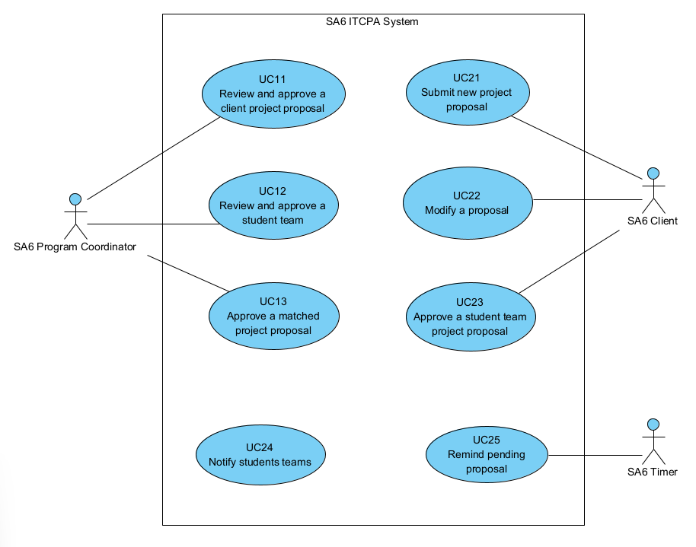

**Figure 1: ITCPA System Use Case Diagram**