**Task 1A:** ITCPA Student Team Management Subsystem **(STMS)**

|  |  |  |
| --- | --- | --- |
| **Class** | **Attribute** | **Synonym** (optional) |
| Student |  |  |
|  | studentID {Primary Key} |  |
|  | studentFirstName |  |
|  | studentLastName |  |
| ITProgram |  |  |
|  | programID {key} |  |
|  | programName |  |
|  | programCoordinator |  |
|  | programDuration |  |
|  | programDescription |  |
| StudentTeam |  |  |
|  | teamID{Primary Key} |  |
|  | teamName |  |
|  | teamMembers |  |
|  | projectTittle |  |
| StudentTeamApproval |  |  |
|  | approvalID {key} |  |
|  | teamMember |  |
|  | isApproved |  |
| ProgramCoordinator |  |  |
|  | coordinatorID {key} |  |
|  | coordinatorFirstName |  |
|  | coordinatorLastName |  |
|  | coordinatorEmail |  |
|  | coordinatorDepartment |  |
| FacultyAdvisor |  |  |
|  | facultyAdvisorID {key} |  |
|  | facultyAdvisorFirstName |  |
|  | facultyAdvisorLastName |  |
|  | facultyAdvisorEmail |  |
|  | facultyAdvisorDepartment |  |

**Task 1B:** ITCPA Capstone Project Matching Subsystem **(CPMS)**

|  |  |  |
| --- | --- | --- |
| **Class** | **Attribute** | **Synonym**  (optional) |
| Project |  |  |
|  | projectID |  |
|  | projectName |  |
|  | startDate |  |
|  | endDate |  |
|  | clientProposalID {key} |  |
| File |  |  |
|  | fileID {key} |  |
|  | fileName |  |
|  | fileSize |  |
|  | fileType |  |
|  | filePath |  |
| StudentTeamProjectApplication |  | ProjectApplication |
|  | applicationID {key} |  |
|  | projectTittle |  |
|  | applicationDate |  |
|  | applicationStatus |  |
| ExternalClient |  |  |
|  | clientID |  |
|  | clientName |  |
|  | clientEmail |  |
|  | clientPhone |  |
|  | organization |  |
| ClientApproval |  |  |
|  | approvalID{key} |  |
|  | client |  |
|  | approvalDate |  |
|  | approvalStatus |  |
|  | comments |  |
| ProgramCoordinatorApproval |  |  |
|  | approvalID {key} |  |
|  | coordinatorID |  |
|  | approvalStatus |  |
|  | approvalDate |  |
|  | comments |  |
| ProgramCoordinator |  |  |
|  | cordinatorID {key} |  |
|  | cordinatorFirstName |  |
|  | cordinatorLastName |  |
|  | cordinatorEmail |  |
|  | cordinatorResponsiblitie |  |

**Task 2: ITCPA Domain Class Diagram (DCD)**

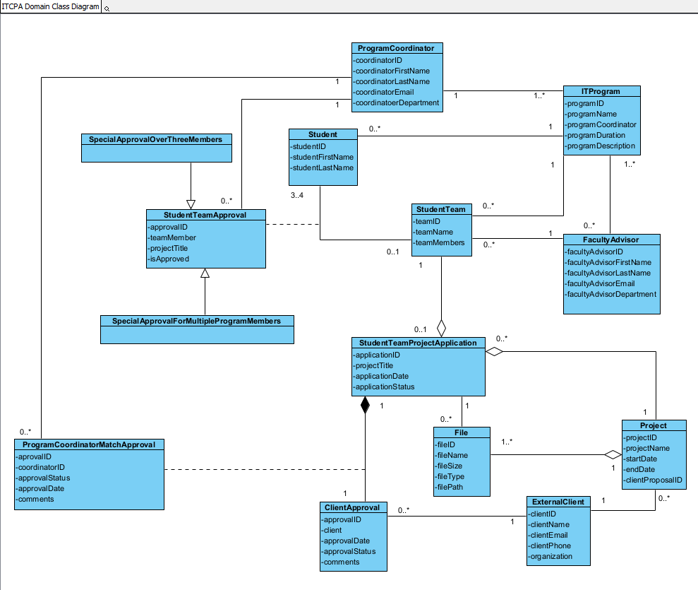

**Task 3A: ITCPA StudentTeamProjectApplication State Table**

|  |  |  |
| --- | --- | --- |
| **State ID** | **State Name** | **Transition Causing Exit** |
| S01 | Draft | Application is submitted, Application is reviewed |
| S02 | Cancelled | Application cancelled |
| S03 | Registered | Application submitted for approval |
| S04 | Matched | Application approved by client |
| S05 | Declined | Application declined by client |
| S06 | Expired | No client action after 14 days |
| S07 | Confirmed | Match approved by program coordinator, No review by program coordinator within 3 days |
| S08 | Rejected | Match rejected by program coordinator |

**Task 3B: ITCPA StudentTeamProjectApplication State Machine Diagram**

