**Task 1: Use Case Description with Wireframes, SSD and AD**

**1A.** **Fully developed Use Case Description**

|  |  |  |
| --- | --- | --- |
| Use Case # | UC21 | |
| Use Case Name | Client Looks Up the List of Student Teams. | |
| Scenario | The client wants to look up the list of student teams that have applied to their proposal in the CPMS (Client Proposal Management System). | |
| Triggering Event | The client wants to view the student teams who have applied to their proposal. | |
| Brief Description | This use case involves the client selecting their proposal information into the CPMS. The system then retrieves and displays the list of student teams who have applied to the specific proposal. | |
| Primary Actor | Client | |
| Included Use Cases (if any) | N/A | |
| Stakeholders | Client, Student Teams, IT Program Coordinator | |
| Pre-conditions | The Client must be logged into the CPMS.  The client’s proposal is approved by IT Program Coordinator.  At least one student team applied to the client a proposal. | |
| Post-conditions | The client can use this information for further evaluation or decision-making. | |
| Wireframe(s) |  | |
| Flow of Activities | **Actor** | **System** |
| 1. Client logs into the CPMS | 1.1 System authorizes access.  1.2 The system returns the list of proposals submitted by client. |
| 1. Client selects the desired proposal | 2.1 System returns the student teams lists that have applied to the specific proposal showing relevant information like team names and members' names. |
| 1. The client reviews the list of student teams and obtains the detailed information. |  |
| Exception  Conditions | 1.1 Login failure  1.2 There is no application of student teams for the chosen proposal | |

**1B.** **System Sequence Diagram (SSD)**

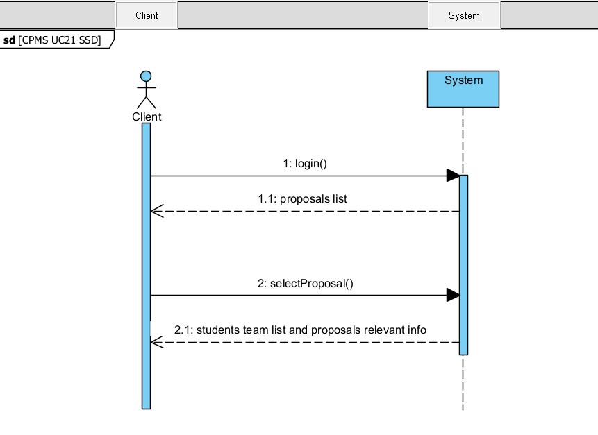

*CPMS UC21 SSD*

*Client Consults the list of Student Teams*

**1C.** **Activity Diagram (AD)**

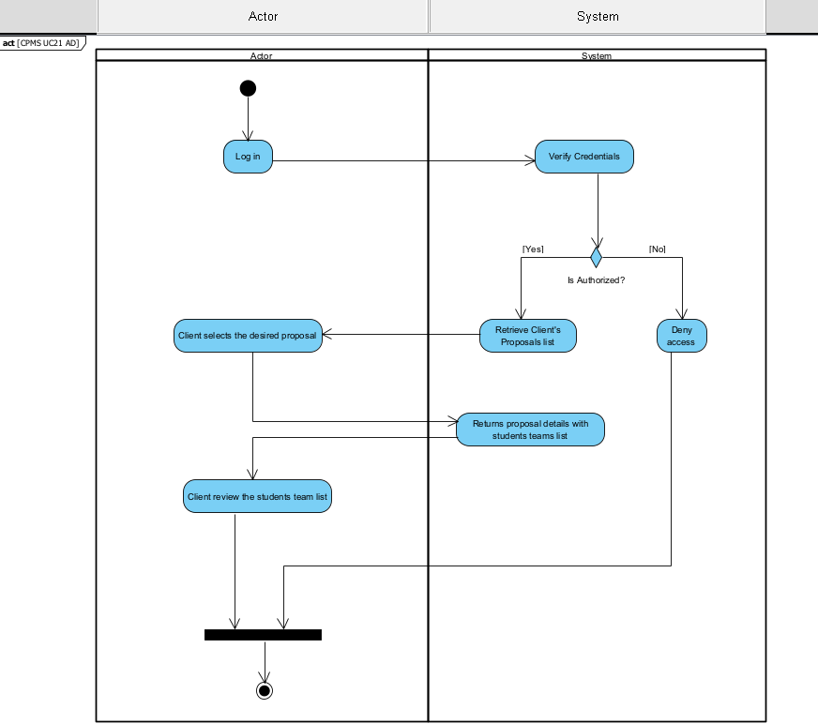

*CPMS UC21 AD*

*Process of Client Consulting the list of Student Teams*

**Task 2: Use Case Description with Wireframes and SSD**

**2A.** **Fully developed Use Case Description**

|  |  |  |
| --- | --- | --- |
| Use Case # | UC22 | |
| Use Case Name | Client Approves Student Teams | |
| Scenario | Client wants to approve zero or more student teams for a project submitted. | |
| Triggering Event | The client logs into the CPMS and navigates to the project application section to review and approve student team applications. | |
| Brief Description | This use case describes the process of a client approving zero or more student teams for a specific project in the CPMS. The client must review the student team applications and decide which teams to approve for the project. | |
| Primary Actor | Client | |
| Included Use Cases (if any) | N/A | |
| Stakeholders | Client, Students | |
| Pre-conditions | 1. The client must be logged into the CPMS. 2. There should be at least one student team application for the project. | |
| Post-conditions | 1. Zero or more student teams are approved for the project. 2. Approved student teams can proceed with the project tasks and assignments. | |
| Wireframe(s) |  | |
| Flow of Activities | **Actor** | **System** |
| 1. Client selects the project | 1.1 System returns project info and student teams applications. |
| 1. Client selects student team | 2.1 System returns info related student team selected. |
| 1. Client assesses student team application and approve or reject it. | 3.1 System add student team to approval or reject list and provides action feedback. |
| 1. After completing step 3, the client enters a loop where they can repeat steps 2 and 3 multiple times until they decide to stop the approval process. |  |
| Exception  Conditions | If the client rejects a team, the system should prompt them to provide a reason for the rejection. | |

**2B.** **System Sequence Diagram (SSD)**

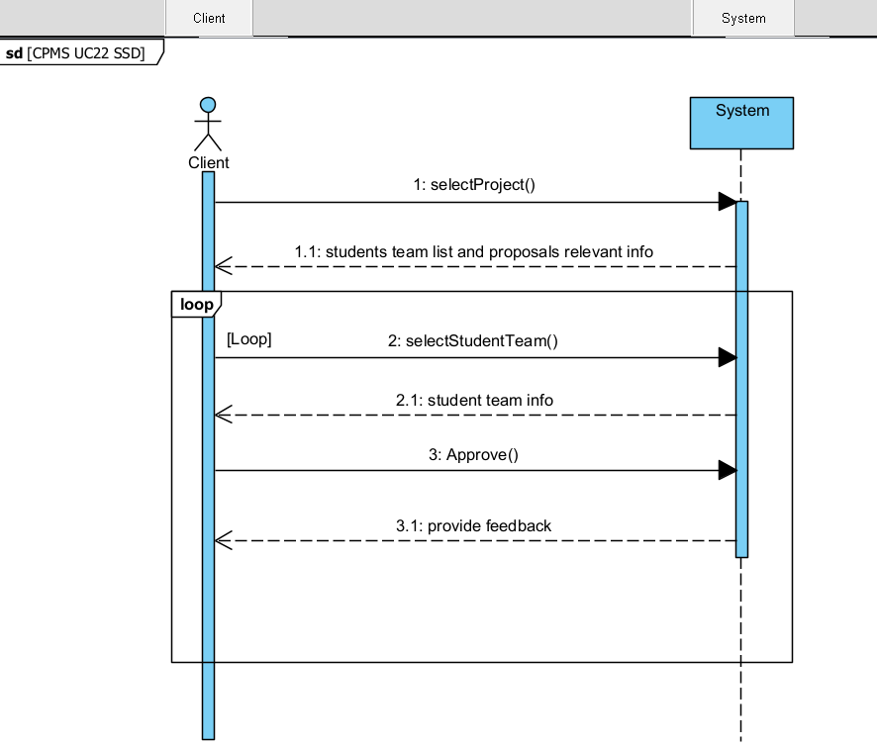

*CPMS UC22 SSD*

*Student Team Approval by the Client*

**Task 3: CRUD Matrix**

|  |  |  |  |  |
| --- | --- | --- | --- | --- |
|  | **Use Case** | | | |
| **Domain Class** | <UC #21 from **Task 1**>: < Client Looks Up the List of Student Teams > | <UC #22 from **Task 2**>: < Client Approves Student Teams > | <UC #14>: Cancel a student team | <UC #41>: Attach document to a client proposal |
| Student | R | R | R |  |
| StudentTeam | R | R | D | R |
| ITProgram |  | R | R | R |
| Project | R | R |  | R |
| StudentTeamProjectApplication | R | U | D | U |
| StudentTeamApproval | R |  | D |  |
| ProgramCoordinator | R |  |  |  |
| FacultyAdvisor | R | R | R |  |
| File | R | R | D | C |
| ExternalClient | R |  |  | R |
| ClientApproval | R | C | D | R |
| ProgramCoordinatorApproval | R |  | D |  |