**INFO8230 Practical Assignment 2 (PA2)**

|  |
| --- |
| **1. UML Class Diagram**  Point: 1 (33.3%):  **UML Diagram #1 Title:** Sales Class Diagram |
| **2. UML State Machine Diagram**  Point: 1 (33.3%):  **UML Diagram #2 Title:** SalesItem SMD |

**3. UML System Sequence Diagram**

Point: 1 (33.3%):

**UML Diagram #3 Title:** Ship Items SSD

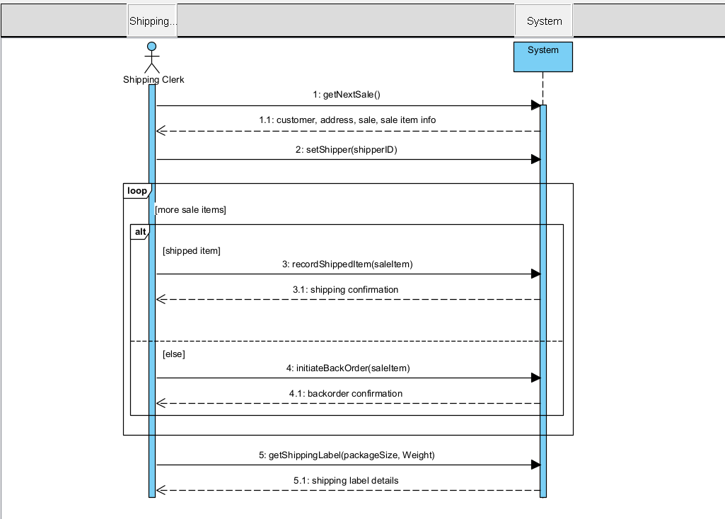

**4. UML System Sequence Diagram**

**UML Diagram #4 Title:** Theater System SSD

