List of limitation

-it cannot handle incorrect spelling

input

checkQuestiob():

to check the input and give response

Read response.txt file

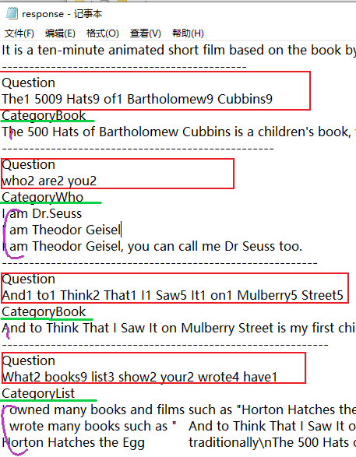

Got question word array from

“Question” number if ma

Word by word match between input and question word array add the number if matches

Get the category with highest value of matches

Get all possible response

Output a random response from possible response

end

-it is case sensitive, we did it on purpose

-it can only handle part of synonyms if the synonyms recorded in the database

-it cannot give response based on historical conversation

-it cannot create new response