These are intended to be practice questions and not to be passed in. You can solve these problems in separate PHP files or in 1 big PHP file if you want

**Question #1**

Change this code to use the ***ternary*** operator.

$var1= 10;

$var2= 10;

if ($var1 == $var2) {

echo "EQUAL<BR>";

}

else {

echo "not equal<BR>";

}

**Question #2**

Write a PHP script that will produce the following table:

HINT #1: each cell value is simply the product of the row index multiplied by the column index

HINT #2: you don’t need an array for this, just use a nested **for loop**

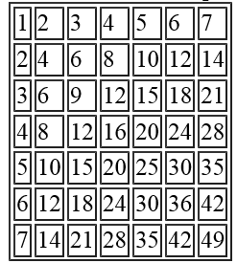

**QUESTION #3**

Write a PHP Script that will produce the following output:

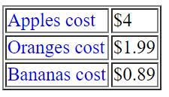

HINT: You don’t need to use a CSS file to make the text blue, just try doing it with inline styles