Automated Sorting System
Platform: Siemens S7 – 1200 (TIA Portal)
Environment: Factory I/O
Language: Ladder Logic (IEC 61131-3)
Project Summary
This project implements an automated pallet sorting system using PLC ladder logic. The pallets are detected, classified by height, tracked through the system and routed left or right conveyors using stored decisions rather than real time sensor dependency. The control logic is structured to be deterministic and fault tolerant.
1. System Architecture
The list of I/O sensors and actuators provided by Factory I/O simulation environment are provided in the figure 1 below.
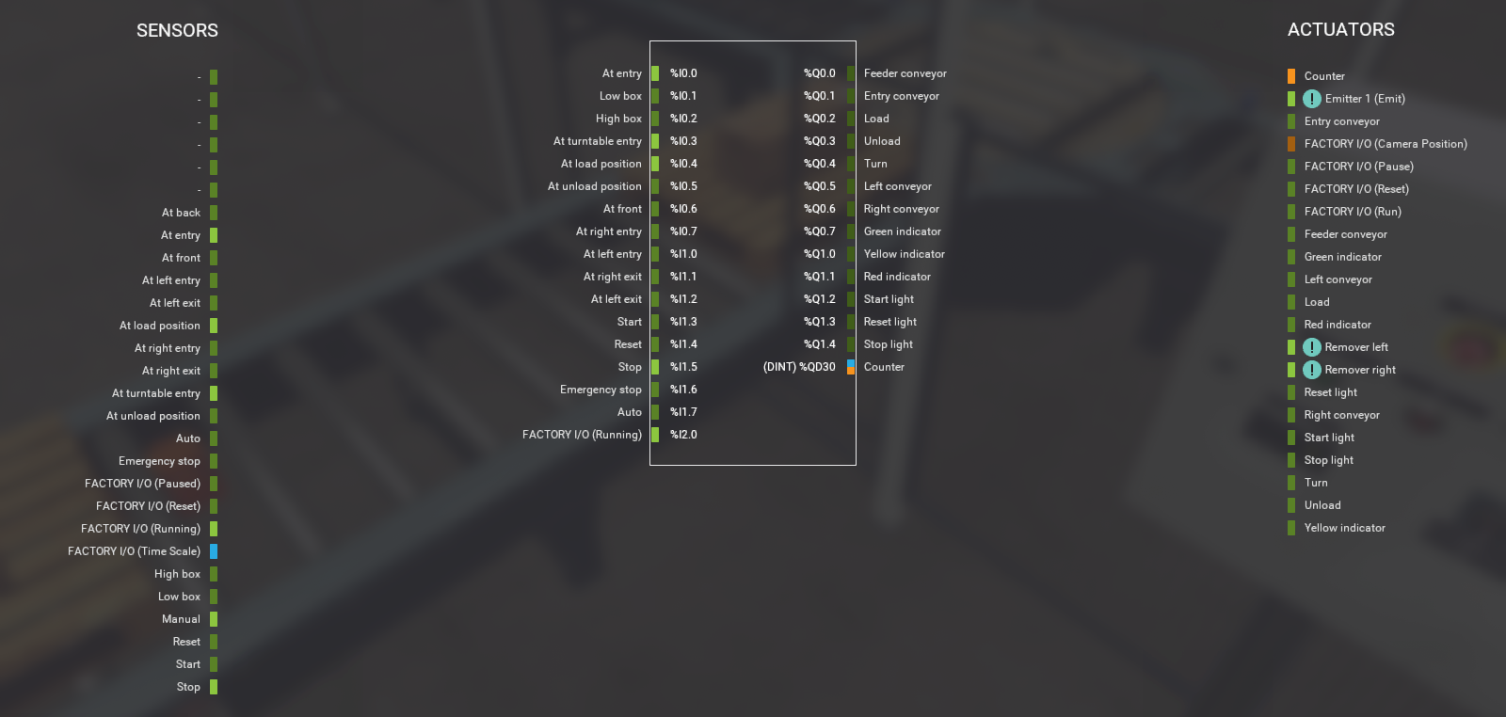
Figure 1: Factory IO list of sensors and actuators.
2. Logic Breakdown
The latched START/STOP memory bit in Network 2 controls all downstream logic. The Emergency STOP condition overrides all motion commands.
Purpose:
Ensure safe start-up, controlled operation and immediate shutdown during faults.
3. Pallet Detection & Entry Handling
Optical and proximity sensors detect pallet entry allowing the feeder and entry conveyors to feed the pallet to the turntable.
Purpose:
Prevent multiple triggers from sustained sensor signals.
4. Height Classification & Decision Storage
Low and high optical sensors classify each pallet. The classification result is stored in a decision memory using Set/Reset logic.
Purpose:
Preserve the sorting decision even after the pallet leaves the sensing zone, avoiding scan cycle dependency.
5. Pallet Tracking Using Shift Biting
A shift left instruction moves a bit through a storage byte each time a pallet advances.
Purpose:
Logically track pallet position through the system without relying solely on physical sensors.
6. Turntable Rotation Control
A timer controls the turn motor for a fixed duration. Upon completion, a TOTALLY ROTATED memory bit is set.
Purpose:
Guarantee consistent mechanical motion independent of sensor noise or delays.
7. Conveyor Routing
Based on the stored height decision and pallet position, the ladder logic activate either the left or right conveyor. Interlocks prevent simultaneous actuation.
Purpose:
Ensure exclusive and deterministic routing.
8. Production Counting & Validation
Counters track the number of processed pallets. Additional logic prevents double counting during edge cases.
Purpose:
Provided production feedback and validates correct system behaviour.
Key Engineering Decisions
- Memory bits are used to store decisions instead of relying on real time sensor states.
- Edge detection prevents repeated actions within a single pallet cycle.
- Logical tracking (bit shifting) improves robustness and scalability.
- Interlocks centralise and logic operation safety.

