Assignment 2 – Static Model

Courtney Olson, Marcus Domingo, Sam Kim

2. Software System Context Class Model

3. Static Model for Entity Classes

4. Purpose of Entity Classes

**Software System Context Class Model**

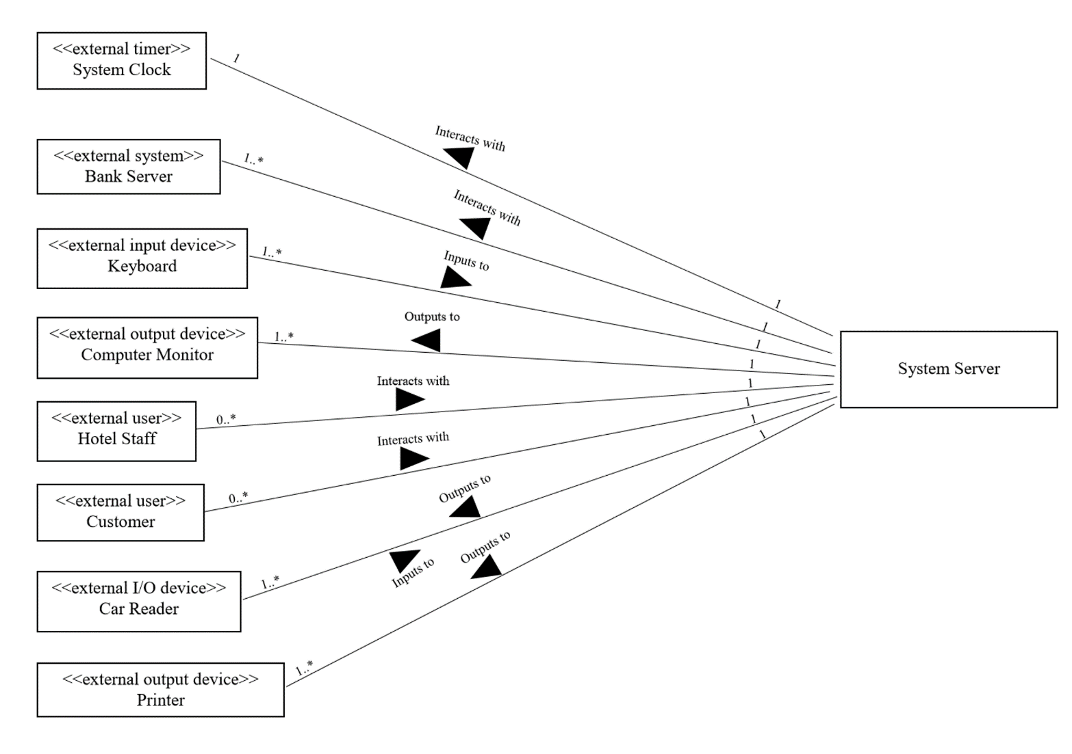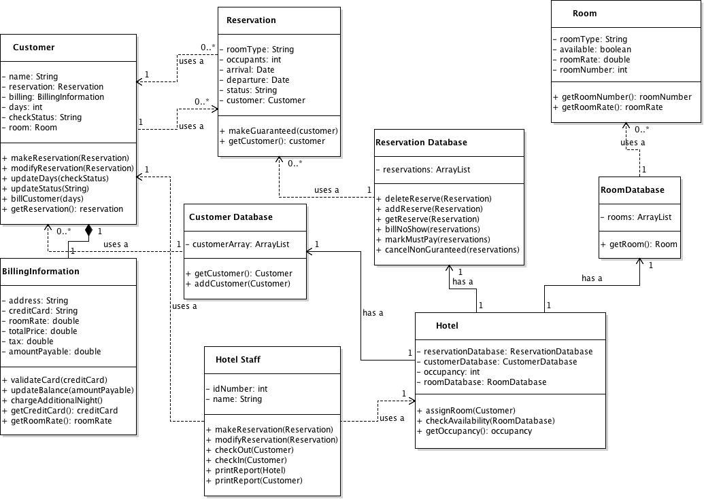**Static Model for Entity Classes**

**Purpose of Entity Classes**

**Customer:** The Customer Class will store all information required for a given Customer (including an instance of the BillingInformation object and a Reservation object) and provide methods for modification of an individual Reservation, the Customer’s fields, and billing the Customer through the use of BillingInformation.

**BillingInformation:** The BillingInformation Class will store all billing information required for a given Customer and provide methods for validating credit cards, updating balance, and adding additional charges to a Customer’s balance.

**CustomerDatabase:** The CustomerDatabase will store all instances of Customer for the Hotel class and provide methods to add and get a given Customer.

**Reservation:** The Reservation Class will store all information required for a given Reservation (including an instance of the Customer object) and provide methods for Reservation status change and retrieving the corresponding Customer.

**ReservationDatabase:** The ReservationDatabase will store all instances of Reservation for the Hotel class and provide methods to modify a given Reservation and process billing for no-show guaranteed Reservations.

**Room:** The Room Class will store all information required for a given Room and provide methods for Room information retrieval.

**RoomDatabase:** The RoomDatabase will store all instances of Room for the Hotel class and provide a method to get a given Room’s information.

**HotelStaff:** The HotelStaff Class will store all information required for a given HotelStaff and provide concrete methods for the HRS such as check-in, check-out, print report, and reservation modification.

**Hotel:** The Hotel Class will store all information about the HRS (such as Rooms, Reservations, and Customers) and provide methods to assign rooms, keep track of occupancy, and check availability.