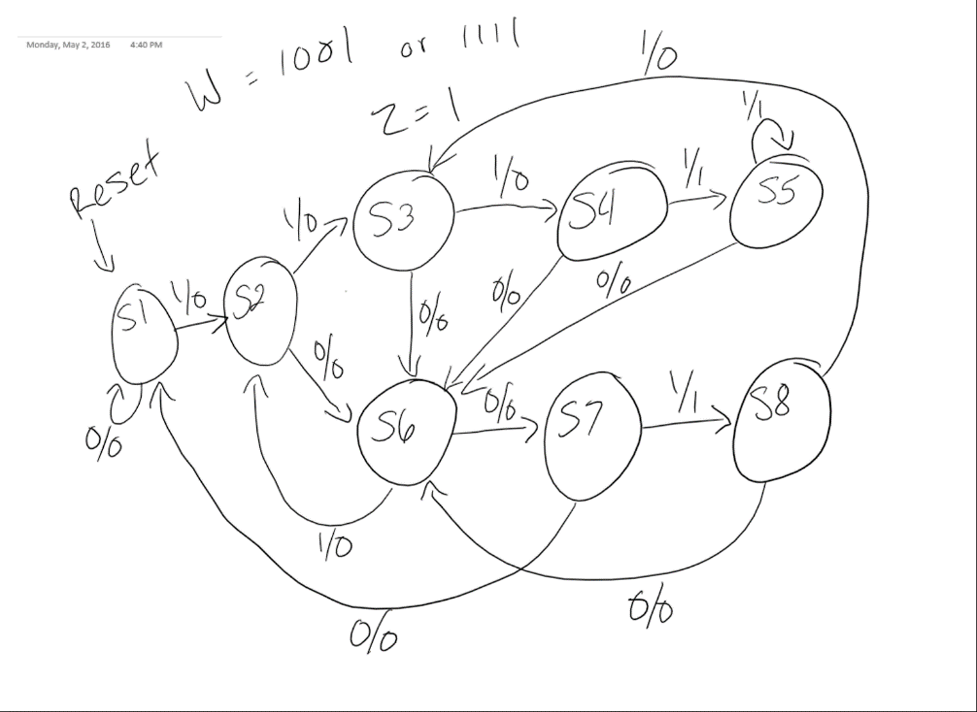**8.3:**

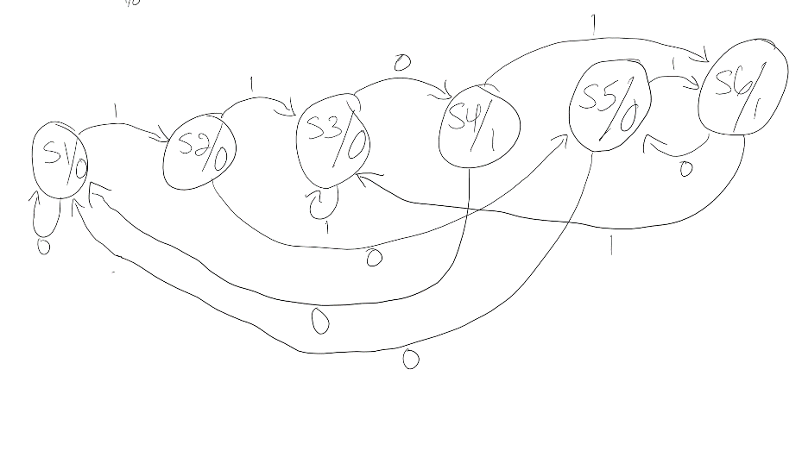**8.5:**

|  |  |  |  |
| --- | --- | --- | --- |
| **Present State** | **Next State** | | **Output**  **z** |
| **w = 0** | **w = 1** |
| S1 | S1 | S2 | 0 |
| S2 | S5 | S3 | 0 |
| S3 | S4 | S3 | 0 |
| S4 | S1 | S6 | 1 |
| S5 | S1 | S6 | 0 |
| S6 | S5 | S3 | 1 |

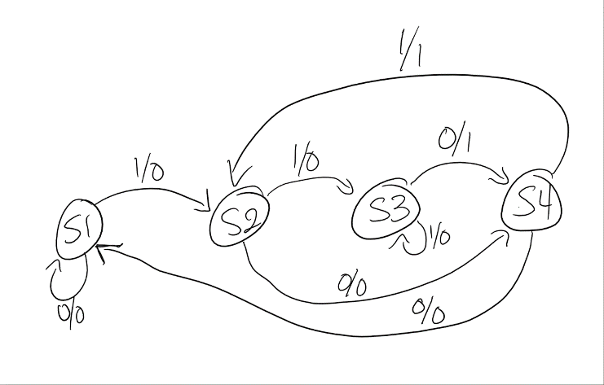**8.6:**

|  |  |  |  |  |
| --- | --- | --- | --- | --- |
| **Present State** | **Next State** | | **Output z** | |
| **w = 0** | **w = 1** | **w = 0** | **w = 1** |
| S1 | S1 | S2 | 0 | 0 |
| S2 | S4 | S3 | 0 | 0 |
| S3 | S4 | S3 | 1 | 0 |
| S4 | S1 | S2 | 0 | 1 |

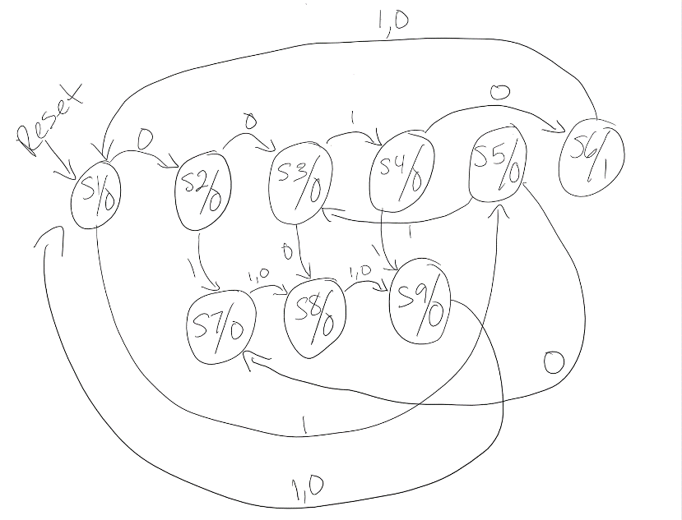**8.11:**

|  |  |  |  |
| --- | --- | --- | --- |
| **Present State** | **Next State** | | **Output**  **z** |
| **w = 0** | **w = 1** |
| S1 | S2 | S5 | 0 |
| S2 | S3 | S7 | 0 |
| S3 | S8 | S4 | 0 |
| S4 | S6 | S9 | 0 |
| S5 | S7 | S3 | 0 |
| S6 | S1(RESET) | S1(RESET) | 1 |
| S7 | S8 | S8 | 0 |
| S8 | S9 | S9 | 0 |
| S9 | S1(RESET) | S1(RESET) | 0 |

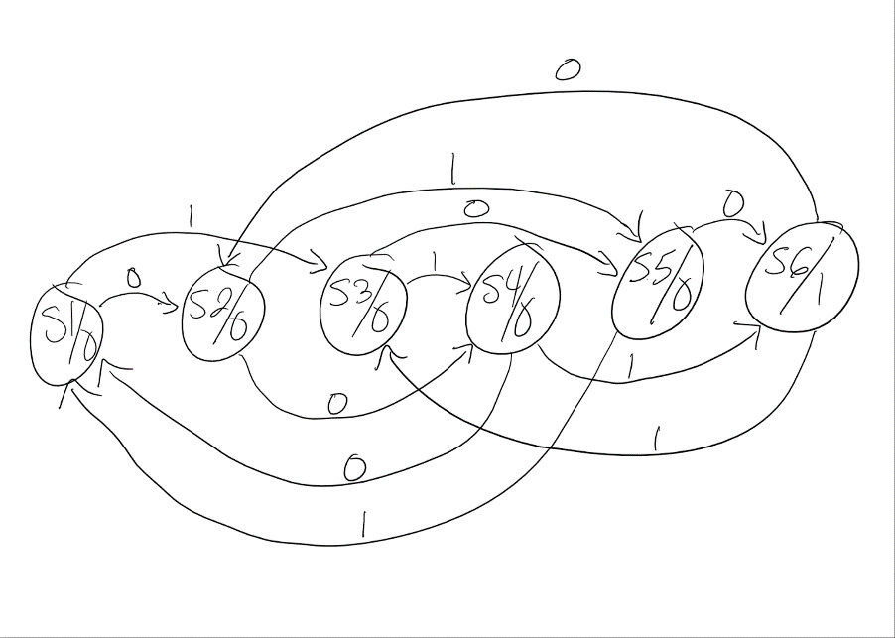**8.12:**

|  |  |  |  |
| --- | --- | --- | --- |
| **Present State** | **Next State** | | **Output**  **z** |
| **w = 0** | **w = 1** |
| S1 | S2 | S3 | 0 |
| S2 | S4 | S5 | 0 |
| S3 | S5 | S4 | 0 |
| S4 | S1 | S6 | 0 |
| S5 | S6 | S1 | 0 |
| S6 | S2 | S3 | 1 |