|  |  |  |  |  |  |  |  |  |
| --- | --- | --- | --- | --- | --- | --- | --- | --- |
| **Q2** | **Q1** | **Q0** | **Q2 next** | **Q1 next** | **Q0 next** | **D2** | **D1** | **D0** |
| 0 | 0 | 0 | 1 | 1 | 1 | 1 | 1 | 1 |
| 0 | 0 | 1 | 0 | 0 | 0 | 0 | 0 | 0 |
| 0 | 1 | 0 | 0 | 0 | 1 | 0 | 0 | 1 |
| 0 | 1 | 1 | 0 | 1 | 0 | 0 | 1 | 0 |
| 1 | 0 | 0 | 0 | 1 | 1 | 0 | 1 | 1 |
| 1 | 0 | 1 | 1 | 0 | 0 | 1 | 0 | 0 |
| 1 | 1 | 0 | 1 | 0 | 1 | 1 | 0 | 1 |
| 1 | 1 | 1 | 1 | 1 | 0 | 1 | 1 | 0 |

|  |  |  |  |
| --- | --- | --- | --- |
| **D0** |  | **Q2** |  |
|  |  | **0** | **1** |
| **Q1Q0** | **00** | 1 | 1 |
|  | **01** | 0 | 0 |
|  | **11** | 0 | 0 |
|  | **10** | 1 | 1 |

|  |  |  |  |
| --- | --- | --- | --- |
| **D2** |  | **Q2** |  |
|  |  | **0** | **1** |
| **Q1Q0** | **00** | 1 | 0 |
|  | **01** | 0 | 1 |
|  | **11** | 0 | 1 |
|  | **10** | 0 | 1 |

|  |  |  |  |
| --- | --- | --- | --- |
| **D1** |  | **Q2** |  |
|  |  | **0** | **1** |
| **Q1Q0** | **00** | 1 | 1 |
|  | **01** | 0 | 0 |
|  | **11** | 1 | 1 |
|  | **10** | 0 | 0 |

$$D2=Q2^{'}Q1^{'}Q0^{'}+Q2Q1+Q2Q0 \\ D1=Q1^{'}Q0^{'}+Q1Q0 \\ D0=Q1^{'}Q0^{'}+Q1Q0'$$

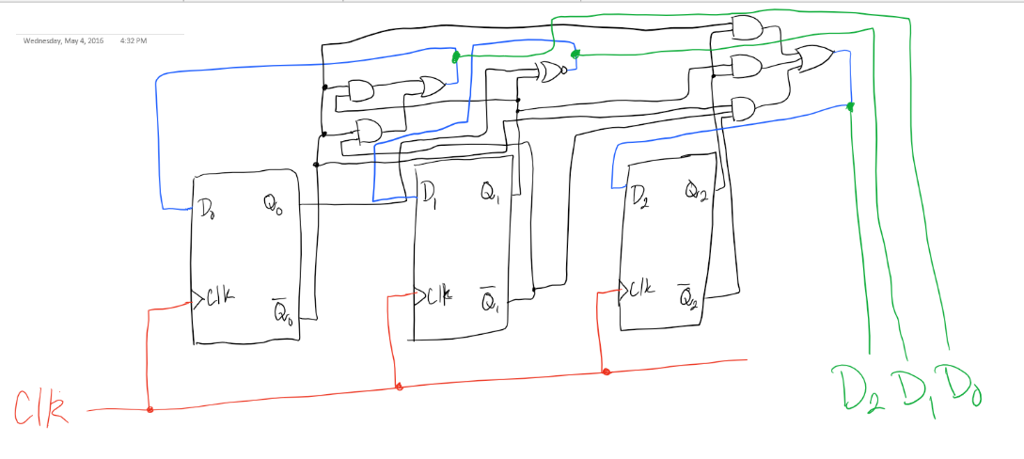

|  |  |  |  |  |  |  |  |  |
| --- | --- | --- | --- | --- | --- | --- | --- | --- |
| **Q2** | **Q1** | **Q0** | **Q2 next** | **Q1 next** | **Q0 next** | **T2** | **T1** | **T0** |
| 0 | 0 | 0 | 0 | 0 | 1 | 0 | 0 | 1 |
| 0 | 0 | 1 | 0 | 1 | 0 | 0 | 1 | 1 |
| 0 | 1 | 0 | 0 | 1 | 1 | 0 | 0 | 1 |
| 0 | 1 | 1 | 1 | 0 | 0 | 1 | 1 | 1 |
| 1 | 0 | 0 | 1 | 0 | 1 | 0 | 0 | 1 |
| 1 | 0 | 1 | 1 | 1 | 0 | 0 | 1 | 1 |
| 1 | 1 | 0 | 0 | 0 | 0 | 1 | 1 | 0 |
| 1 | 1 | 1 | X | X | X | X | X | X |

|  |  |  |  |
| --- | --- | --- | --- |
| **T2** |  | **Q2** |  |
|  |  | **0** | **1** |
| **Q1Q0** | **00** | 0 | 0 |
|  | **01** | 0 | 0 |
|  | **11** | 1 | X |
|  | **10** | 0 | 1 |

|  |  |  |  |
| --- | --- | --- | --- |
| **T1** |  | **Q2** |  |
|  |  | **0** | **1** |
| **Q1Q0** | **00** | 0 | 0 |
|  | **01** | 1 | 1 |
|  | **11** | 1 | X |
|  | **10** | 0 | 1 |



|  |  |  |  |
| --- | --- | --- | --- |
| **T0** |  | **Q2** |  |
|  |  | **0** | **1** |
| **Q1Q0** | **00** | 1 | 1 |
|  | **01** | 1 | 1 |
|  | **11** | 1 | X |
|  | **10** | 1 | 0 |

$$T2=Q1Q0+Q2Q1 \\ T1=Q0+Q2Q1 \\ T0=Q2^{'}+Q1^{'}+Q0$$

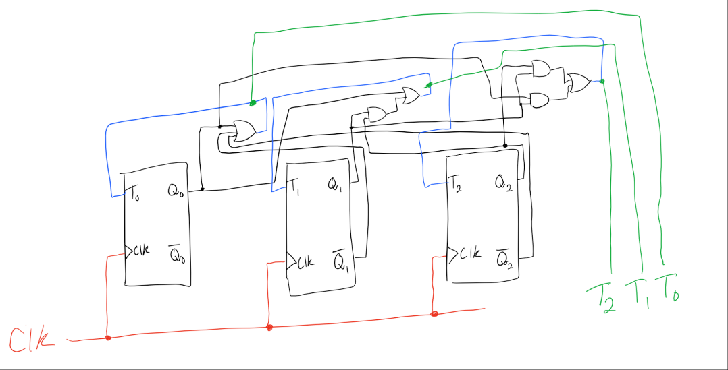



|  |  |  |  |  |  |  |  |  |
| --- | --- | --- | --- | --- | --- | --- | --- | --- |
| **Q2** | **Q1** | **Q0** | **Q2 next** | **Q1 next** | **Q0 next** | **D2** | **D1** | **D0** |
| 0 | 0 | 0 | X | X | X | X | X | X |
| 0 | 0 | 1 | 1 | 1 | 0 | 1 | 1 | 0 |
| 0 | 1 | 0 | X | X | X | X | X | X |
| 0 | 1 | 1 | X | X | X | X | X | X |
| 1 | 0 | 0 | 1 | 1 | 1 | 1 | 1 | 1 |
| 1 | 0 | 1 | 0 | 0 | 1 | 0 | 0 | 1 |
| 1 | 1 | 0 | 1 | 0 | 0 | 1 | 0 | 0 |
| 1 | 1 | 1 | 1 | 0 | 1 | 1 | 0 | 1 |

|  |  |  |  |
| --- | --- | --- | --- |
| **D2** |  | **Q2** |  |
|  |  | **0** | **1** |
| **Q1Q0** | **00** | X | 1 |
|  | **01** | 1 | 0 |
|  | **11** | X | 1 |
|  | **10** | X | 1 |

|  |  |  |  |
| --- | --- | --- | --- |
| **D1** |  | **Q2** |  |
|  |  | **0** | **1** |
| **Q1Q0** | **00** | X | 1 |
|  | **01** | 1 | 0 |
|  | **11** | X | 0 |
|  | **10** | X | 0 |



|  |  |  |  |
| --- | --- | --- | --- |
| **D0** |  | **Q2** |  |
|  |  | **0** | **1** |
| **Q1Q0** | **00** | X | 1 |
|  | **01** | 0 | 1 |
|  | **11** | X | 1 |
|  | **10** | X | 0 |

$$D2=Q0^{'}+Q1+Q2^{'} \\ D1=Q2^{'}+Q1^{'}Q0^{'} \\ D0=Q2Q1^{'}+Q2Q0$$

