**5.1:** (a)

(b)

(c)

(d)

(e)

**5.2:** (a)

(b)

(c)

**5.3:** (a)

(b)

(c)

**5.4:**

(a)

(b)

(c)

(a)

(b)

(c)

(a)

(b)

(c)

(a)

(b)

(c)

**5.5:**

Overflow Occurs

Overflow Occurs

Overflow Occurs

Overflow Occurs

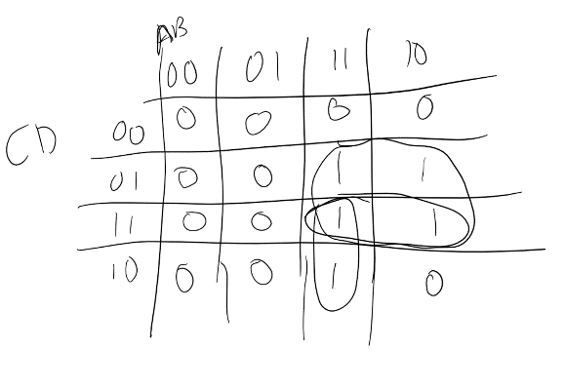**2.:** (a) There are no Static-1 hazards because all of the adjacent 1’s in the K-Map are covered.

(b) No product terms have to be added.

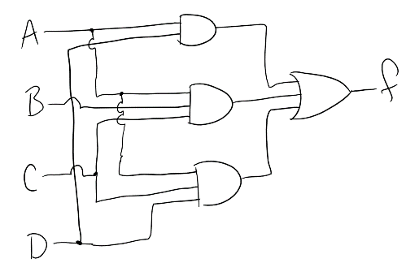 (c)

**3.:** (a)

(b)

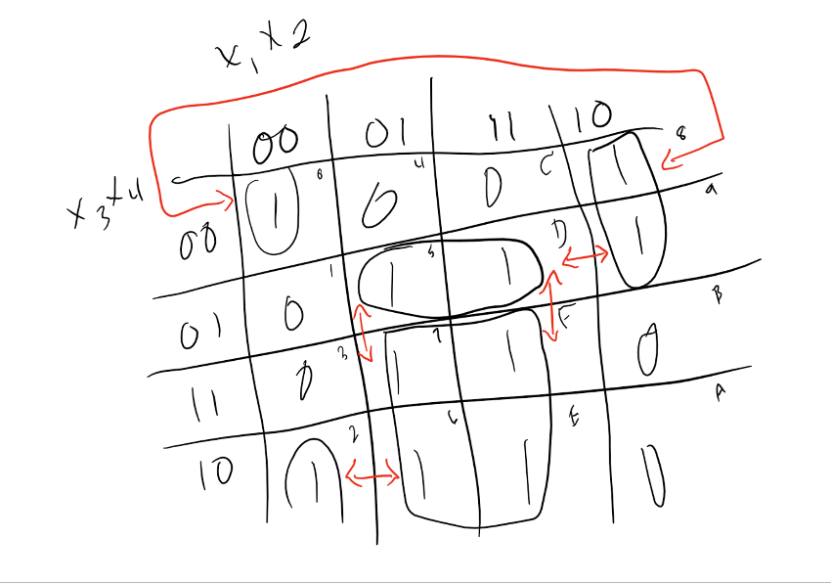 (c)

(d)

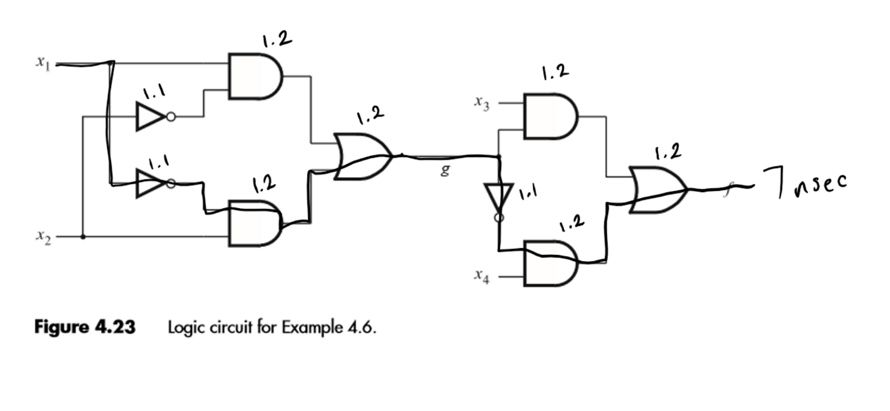**4.:**

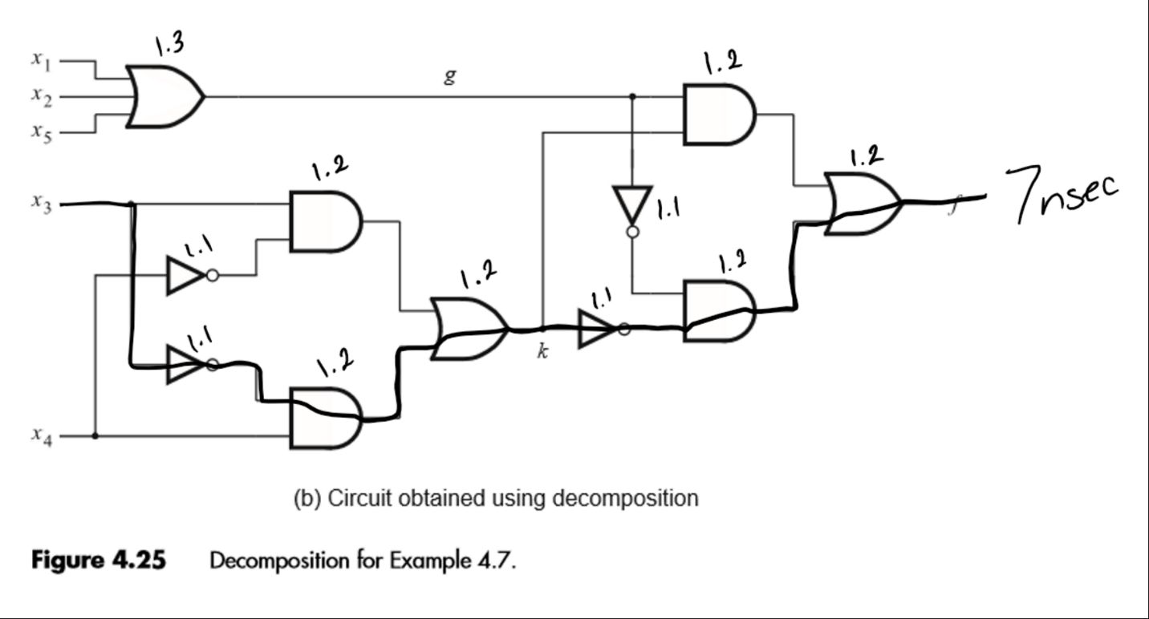**5.:**