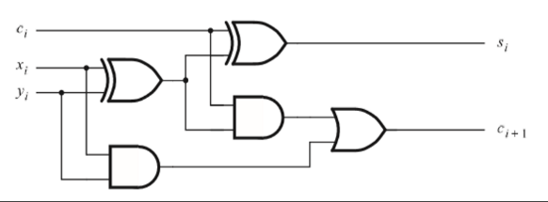 **5.7:**

|  |  |  |  |  |
| --- | --- | --- | --- | --- |
| $$c_{i}$$ | $$x_{i}$$ | $$y_{i}$$ | $$c_{i+1}$$ | $$s_{i}$$ |
| 0 | 0 | 0 | 0 | 0 |
| 0 | 0 | 1 | 0 | 1 |
| 0 | 1 | 0 | 0 | 1 |
| 0 | 1 | 1 | 1 | 0 |
| 1 | 0 | 0 | 0 | 1 |
| 1 | 0 | 1 | 1 | 0 |
| 1 | 1 | 0 | 1 | 0 |
| 1 | 1 | 1 | 1 | 1 |

$(x_{i} ⨁ y_{i}) ⨁ c_{i}=x_{i} ⨁ y_{i} ⨁ c_{i}$ and $(c_{i}⋅(x_{i} ⨁ y_{i}))+\left(x_{i}⋅y_{i}\right)=(x_{i}⋅y_{i})+(x_{i}⋅c_{i})+(y_{i}⋅c_{i})$

|  |  |  |  |  |  |
| --- | --- | --- | --- | --- | --- |
| $$x_{n-1}$$ | $$y_{n-1}$$ | $$c_{n-1}$$ | $$s_{n-1}$$ | $$c_{n}$$ | $$Overflow$$ |
| 0 | 0 | 0 | 0 | 0 | 0 |
| 0 | 0 | 1 | 1 | 0 | 1 |
| 0 | 1 | 0 | 1 | 0 | 0 |
| 0 | 1 | 1 | 0 | 1 | 0 |
| 1 | 0 | 0 | 1 | 0 | 0 |
| 1 | 0 | 1 | 0 | 1 | 0 |
| 1 | 1 | 0 | 0 | 1 | 1 |
| 1 | 1 | 1 | 1 | 1 | 0 |

**5.9:**

The truth table above represents the addition of the most-significant bit and overflow was determined by: Overflow occurs when 1) two positive numbers are added and the result is negative and 2) two negative numbers are added and the result is positive.

Looking at the truth table as well as the statement $Overflow=C_{n}⨁{C_{n-1}}$ we see that overflow occurs in rows 1 and 6. For all the rows in the truth table $Overflow=C_{n}⨁{C_{n-1}}$ stays true. Therefore, it is proven that $Overflow=C_{n}⨁{C_{n-1}}$ for the addition of n-bit signed integers.

**5.10:** Since: $s_{k}=x_{k} ⨁ y_{k }⨁ c_{k}$

Then: $x_{k} ⨁ y_{k} ⨁ s_{k}=(x_{k} ⨁ y_{k}) ⨁ (x_{k} ⨁ y_{k} ⨁ c_{k})$

$=(x_{k} ⨁ y_{k}) ⨁ (x_{k} ⨁ y_{k}) ⨁ c_{k}$

$=0 ⨁ c_{k}$

$=c_{k}$

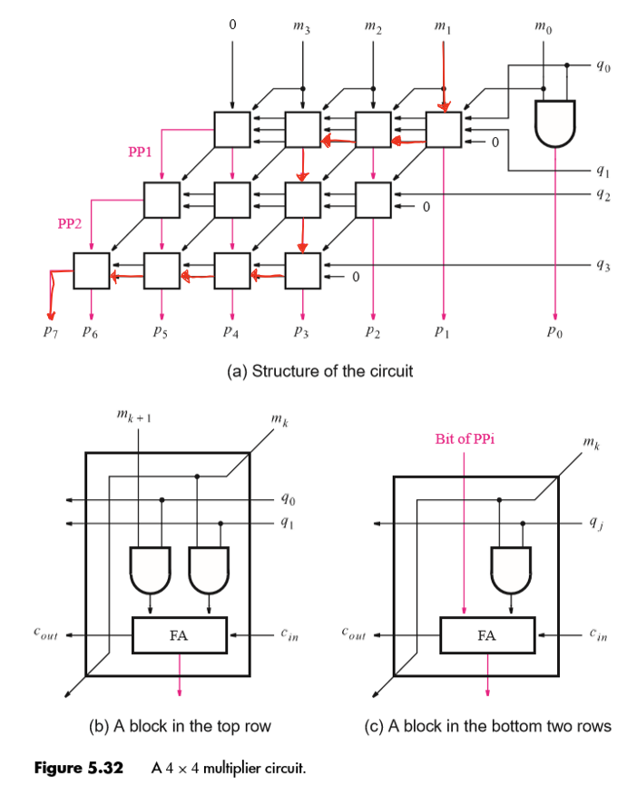**5.15:**

The number of gates along this path is 25 gates, 1 initial and gate in the top row and 3 gates in every Full Adder that occurs 8 times.

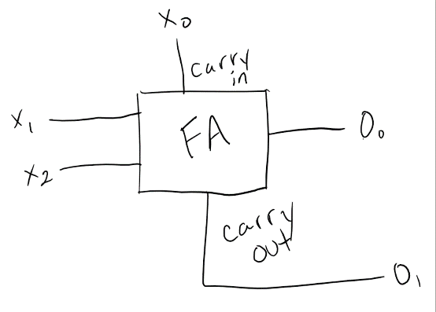**5.21:**

$x_{0} and O_{0}$ are the least significant bit and $x_{2} and O_{1}$ are the most significant bit. The output can be represented as $O_{1}O_{0}.$

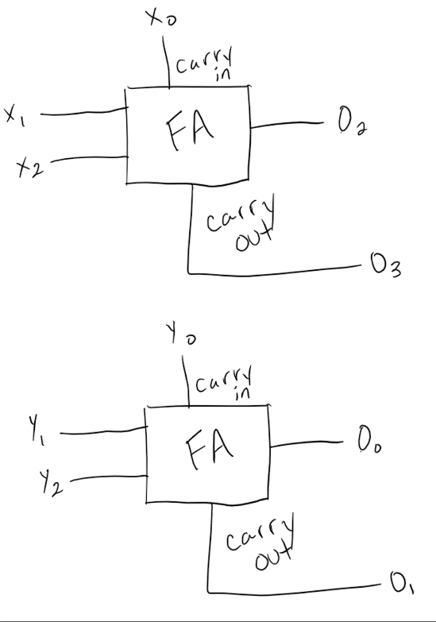**5.22:**

$x_{0}, y_{0}, and O_{0}$ are the least significant bit and $x_{2}, y_{2},and O_{3}$ are the most significant bit. The top circuit is for the last three bits of the 6-bit number and the bottom circuit is for the first three bits for the 6-bit number which can be represented as $x_{2}x_{1}x_{0}y_{2}y_{1}y_{0}$ and the output represented as $O_{3}O_{2}O_{1}O_{0}$.