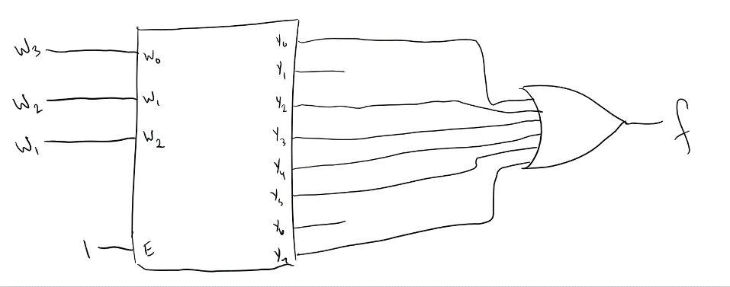**6.1:**

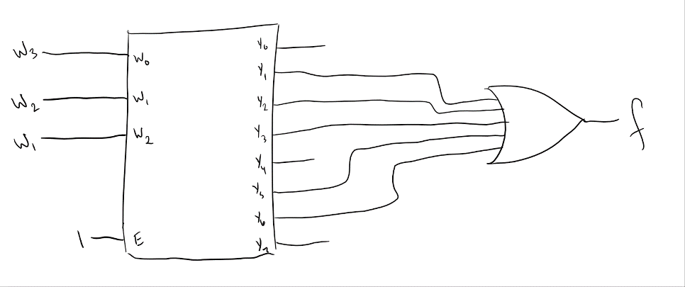**6.2:**

|  |  |  |  |
| --- | --- | --- | --- |
| W1 | W2 | W3 | f |
| 0 | 0 | 0 | 1 |
| 0 | 0 | 1 | 0 |
| 0 | 1 | 0 | 0 |
| 0 | 1 | 1 | 0 |
| 1 | 0 | 0 | 1 |
| 1 | 0 | 1 | 0 |
| 1 | 1 | 0 | 1 |
| 1 | 1 | 1 | 1 |

**6.4:**

|  |  |
| --- | --- |
| W1 | f |
| 0 | ~W2~W3 |
| 1 | W2 + ~W3 |

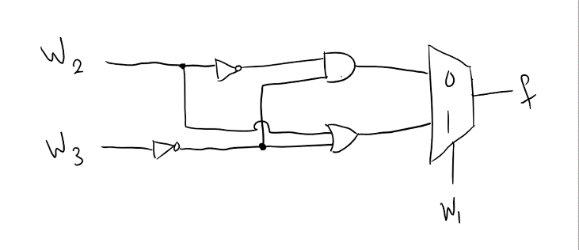

**6.5: $f=\overline{w_{1}}\overline{w_{2}}\overline{w_{3}}+\overline{w_{1}}w_{2}\overline{w_{3}}+\overline{w_{1}}w_{2}w_{3}+w_{1}w_{2}\overline{w_{3}}$**

$= \overline{w_{1}}\left(\overline{w_{3}}+w_{2}\right)+w_{1}(w_{2}\overline{w_{3}})$

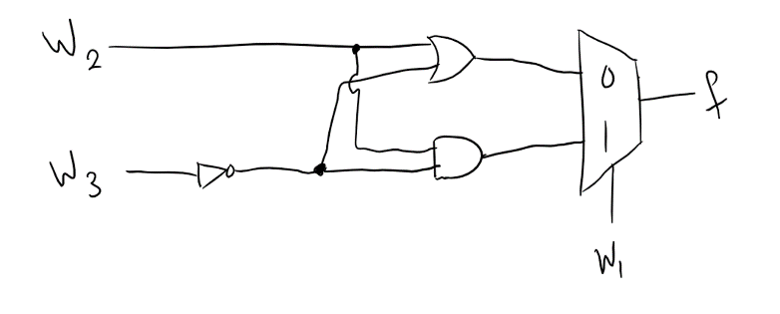

**6.6: $f=\overline{w_{1}}\overline{w_{2}}\overline{w_{3}}+w_{1}\overline{w_{2}}\overline{w_{3}}+w_{1}w_{2}\overline{w_{3}}+w_{1}w_{2}w_{3}$**

$= \overline{w_{2}}\left(\overline{w_{3}}\right)+w_{2}(w_{1})$

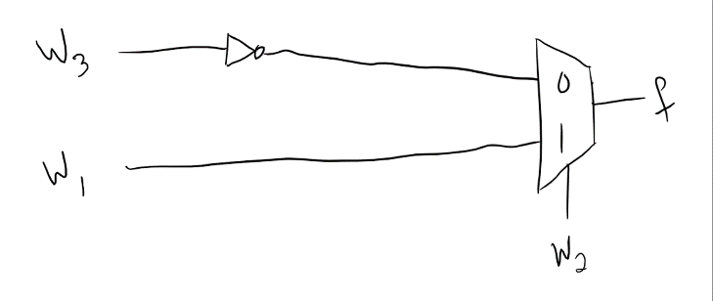

|  |  |  |  |  |  |
| --- | --- | --- | --- | --- | --- |
| X3 | X2 | X1 | X0 | Y1 | Y0 |
| 0 | 0 | 0 | 0 | x | x |
| 0 | 0 | 0 | 1 | 0 | 0 |
| 0 | 0 | 1 | 0 | 0 | 1 |
| 0 | 0 | 1 | 1 | 0 | 1 |
| 0 | 1 | 0 | 0 | 1 | 0 |
| 0 | 1 | 0 | 1 | 1 | 0 |
| 0 | 1 | 1 | 0 | 1 | 0 |
| 0 | 1 | 1 | 1 | 1 | 0 |
| 1 | 0 | 0 | 0 | 1 | 1 |
| 1 | 0 | 0 | 1 | 1 | 1 |
| 1 | 0 | 1 | 0 | 1 | 1 |
| 1 | 0 | 1 | 1 | 1 | 1 |
| 1 | 1 | 0 | 0 | 1 | 1 |
| 1 | 1 | 0 | 1 | 1 | 1 |
| 1 | 1 | 1 | 0 | 1 | 1 |
| 1 | 1 | 1 | 1 | 1 | 1 |

**b.** **Truth Table:**

|  |  |  |  |  |  |
| --- | --- | --- | --- | --- | --- |
| Y1 |  | X3X2 |  |  |  |
|  |  | 00 | 01 | 11 | 01 |
| X1X0 | 00 | 0 | 1 | 1 | 1 |
|  | 01 | 0 | 1 | 1 | 1 |
|  | 11 | 0 | 1 | 1 | 1 |
|  | 10 | 0 | 1 | 1 | 1 |

**Karnaugh Maps:**

|  |  |  |  |  |  |
| --- | --- | --- | --- | --- | --- |
| Y0 |  | X3X2 |  |  |  |
|  |  | 00 | 01 | 11 | 01 |
| X1X0 | 00 | 0 | 0 | 1 | 1 |
|  | 01 | 0 | 0 | 1 | 1 |
|  | 11 | 1 | 0 | 1 | 1 |
|  | 10 | 1 | 0 | 1 | 1 |

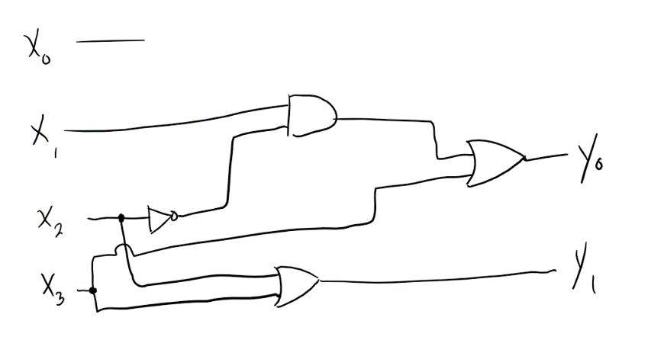

|  |  |
| --- | --- |
| Y1 | X2 + X3 |
| Y0 | ~X2X1 + X3 |

**Expressions:**

|  |  |  |
| --- | --- | --- |
| Num | Multiplied By | Output |
| 00 | 0001 | 0000 |
| 00 | 0010 | 0000 |
| 00 | 0011 | 0000 |
| 00 | 0100 | 0000 |
| 01 | 0001 | 0001 |
| 01 | 0010 | 0010 |
| 01 | 0011 | 0011 |
| 01 | 0100 | 0100 |
| 10 | 0001 | 0010 |
| 10 | 0010 | 0100 |
| 10 | 0011 | 0110 |
| 10 | 0100 | 1000 |
| 11 | 0001 | 0011 |
| 11 | 0010 | 0110 |
| 11 | 0011 | 1001 |
| 11 | 0100 | 1100 |

**c.**

|  |  |  |  |  |  |  |  |  |  |
| --- | --- | --- | --- | --- | --- | --- | --- | --- | --- |
| A1 | A0 | B3 | B2 | B1 | B0 | Y3 | Y2 | Y1 | Y0 |
| 0 | 0 | 0 | 0 | 0 | 1 | 0 | 0 | 0 | 0 |
| 0 | 0 | 0 | 0 | 1 | 0 | 0 | 0 | 0 | 0 |
| 0 | 0 | 0 | 0 | 1 | 1 | 0 | 0 | 0 | 0 |
| 0 | 0 | 0 | 1 | 0 | 0 | 0 | 0 | 0 | 0 |
| 0 | 1 | 0 | 0 | 0 | 1 | 0 | 0 | 0 | 1 |
| 0 | 1 | 0 | 0 | 1 | 0 | 0 | 0 | 1 | 0 |
| 0 | 1 | 0 | 0 | 1 | 1 | 0 | 0 | 1 | 1 |
| 0 | 1 | 0 | 1 | 0 | 0 | 0 | 1 | 0 | 0 |
| 1 | 0 | 0 | 0 | 0 | 1 | 0 | 0 | 1 | 0 |
| 1 | 0 | 0 | 0 | 1 | 0 | 0 | 1 | 0 | 0 |
| 1 | 0 | 0 | 0 | 1 | 1 | 0 | 1 | 1 | 0 |
| 1 | 0 | 0 | 1 | 0 | 0 | 1 | 0 | 0 | 0 |
| 1 | 1 | 0 | 0 | 0 | 1 | 0 | 0 | 1 | 1 |
| 1 | 1 | 0 | 0 | 1 | 0 | 0 | 1 | 1 | 0 |
| 1 | 1 | 0 | 0 | 1 | 1 | 1 | 0 | 0 | 1 |
| 1 | 1 | 0 | 1 | 0 | 0 | 1 | 1 | 0 | 0 |

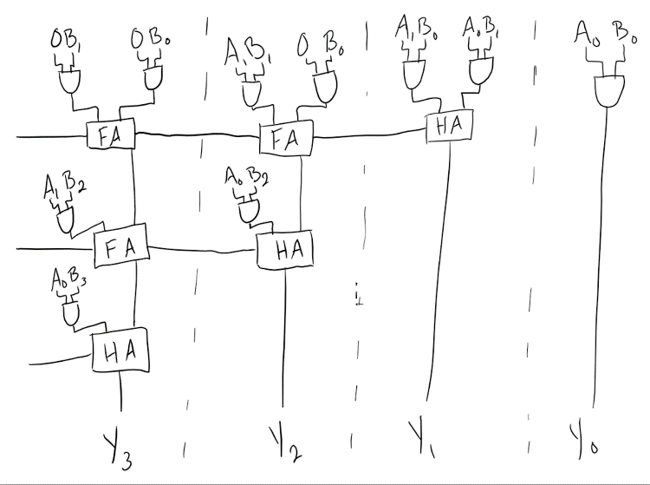

The zeros represent A2 and A3 because the input number A1A0 is only 2 bits but we are multiplying by a 4 bit so we need to make A2 and A3 always zeros.