1. 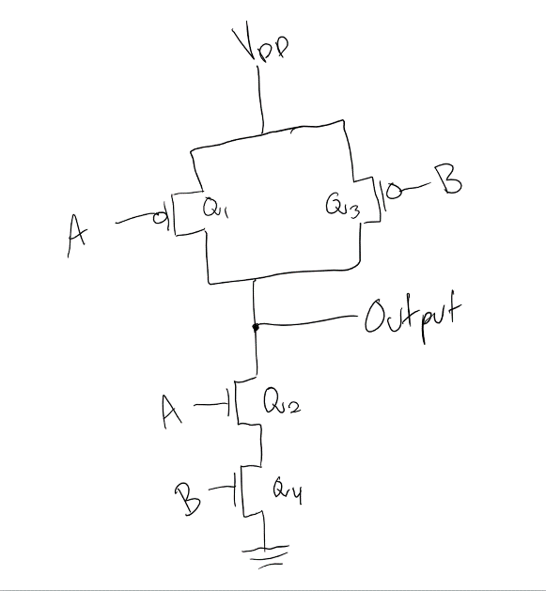AND gate CMOS:

|  |  |  |  |  |  |  |  |  |  |
| --- | --- | --- | --- | --- | --- | --- | --- | --- | --- |
| A | B | C | Q1 | Q2 | Q3 | Q4 | Q5 | Q6 | F |
| 0 | 0 | 0 | ON | OFF | ON | OFF | ON | OFF | 0 |
| 0 | 0 | 1 | ON | OFF | ON | OFF | OFF | ON | 0 |
| 0 | 1 | 0 | ON | OFF | OFF | ON | ON | OFF | 0 |
| 0 | 1 | 1 | ON | OFF | OFF | ON | OFF | ON | 0 |
| 1 | 0 | 0 | OFF | ON | ON | OFF | ON | OFF | 0 |
| 1 | 0 | 1 | OFF | ON | ON | OFF | OFF | ON | 0 |
| 1 | 1 | 0 | OFF | ON | OFF | ON | ON | OFF | 0 |
| 1 | 1 | 1 | OFF | ON | OFF | ON | OFF | ON | 1 |

1. Function table for the give CMOS circuit:

|  |  |  |  |  |  |  |  |  |  |  |  |  |
| --- | --- | --- | --- | --- | --- | --- | --- | --- | --- | --- | --- | --- |
| A | B | C | D | Q1 | Q2 | Q3 | Q4 | Q5 | Q6 | Q7 | Q8 | F |
| 0 | 0 | 1 | 0 | ON | OFF | ON | OFF | OFF | ON | ON | OFF | 1 |
| 0 | 1 | 0 | 0 | ON | OFF | OFF | ON | ON | OFF | ON | OFF | 0 |
| 1 | 1 | 0 | 0 | OFF | ON | OFF | ON | ON | OFF | ON | OFF | 1 |

1. Given input analyzation of the given CMOS circuit:
2. **3.37: $f_{1}\left(x_{1},x_{2},x_{3}\right)=\sum{m\left(0,3,5,6\right)}=\overline{x_{1}}\overline{x_{2}}\overline{x_{3}}+\overline{x_{1}}x_{2}x_{3}+x_{1}\overline{x_{2}}x_{3}+x_{1}x_{2}\overline{x_{3}}$**

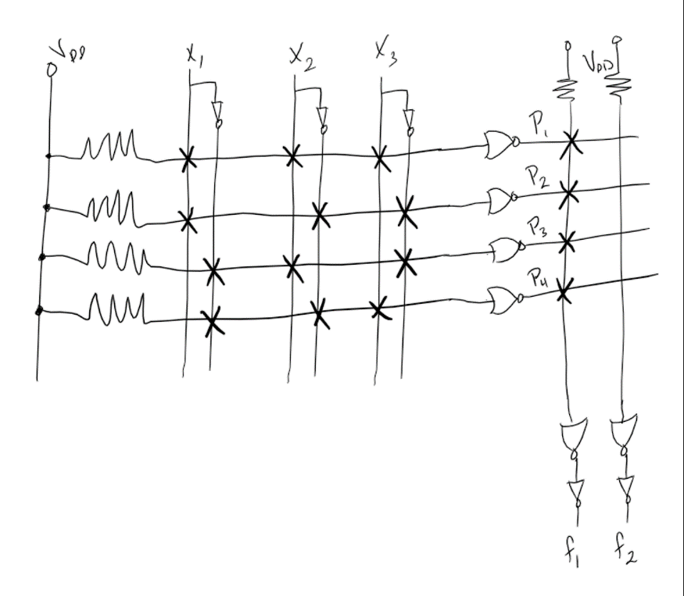

1. 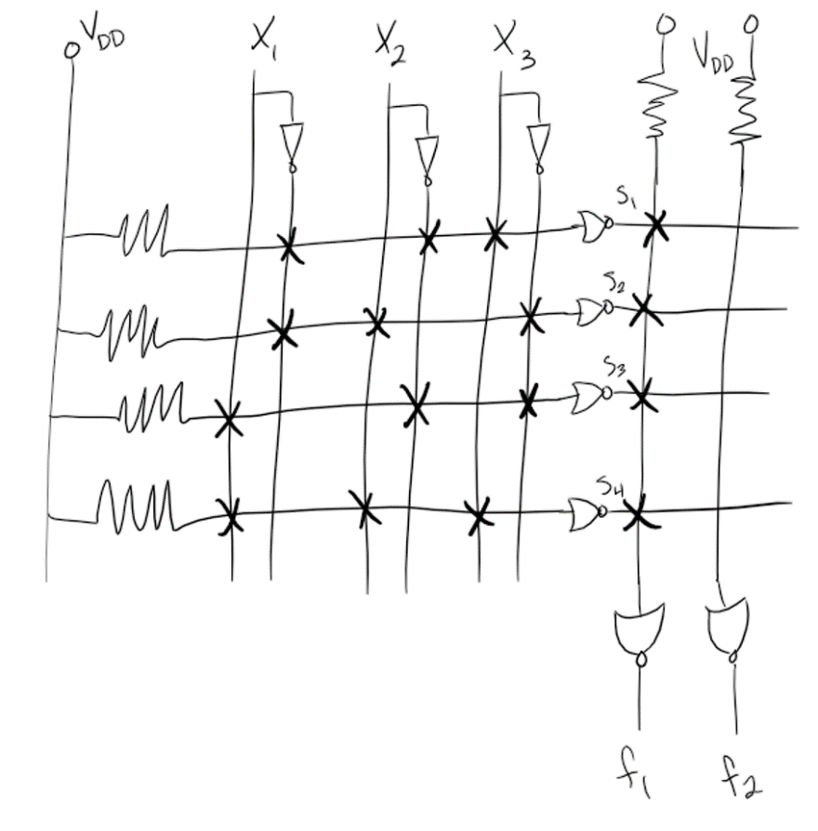**3.39:**