1. 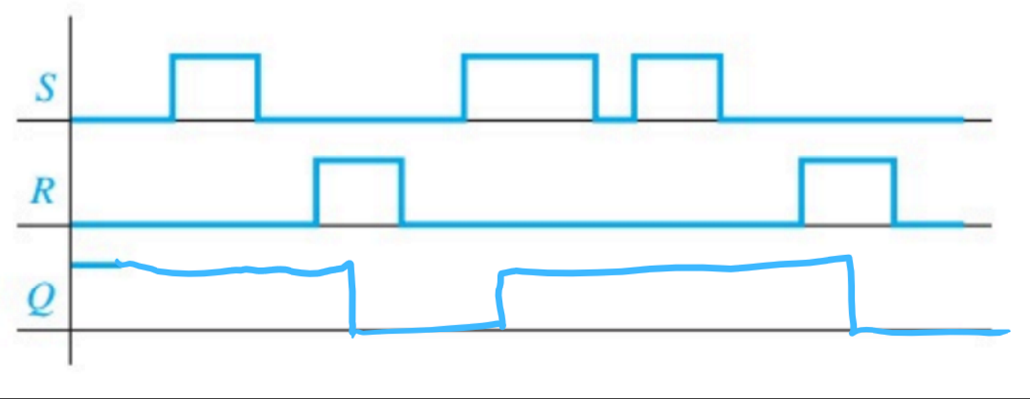
2. 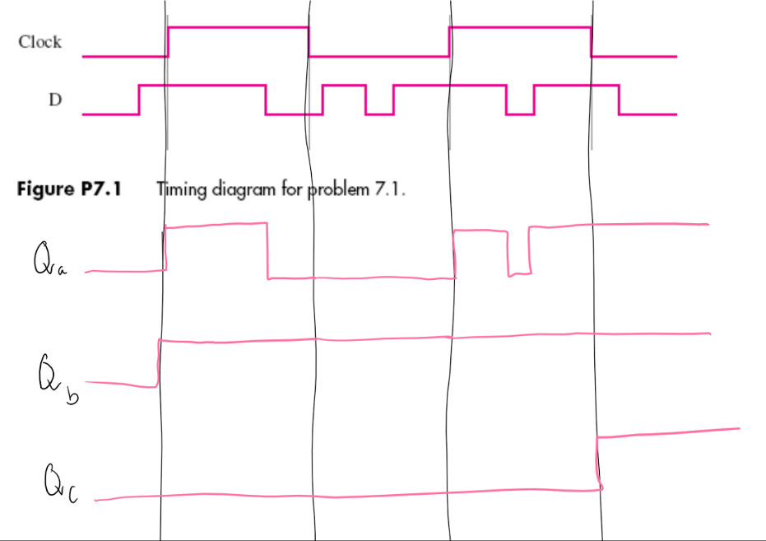**7.1:**
3. 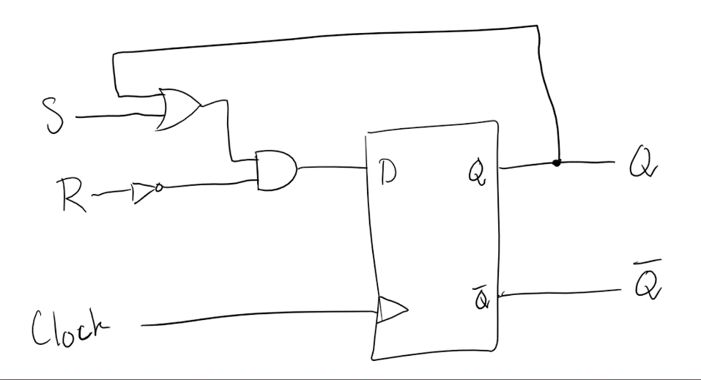**7.6:**
4. 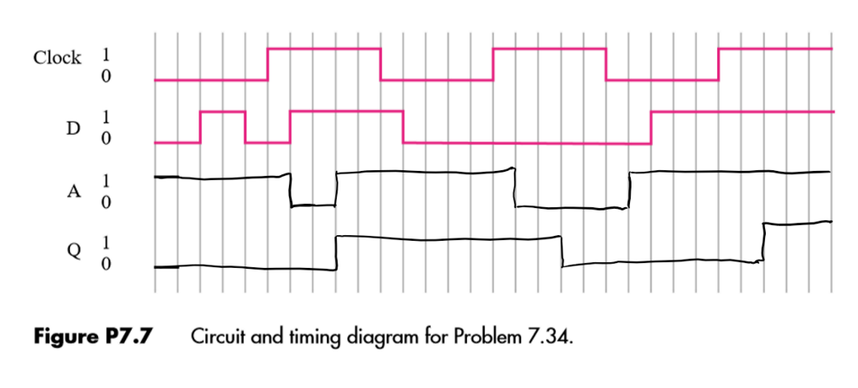**7.34:**

|  |  |  |  |  |
| --- | --- | --- | --- | --- |
| **States** | | **Inputs** | | |
| **Present** | **Next** | **S** | **R** | **C** |
| 0 | 0 | X | X | 0 |
| 1 | 1 | X | X | 0 |
| 0 | 0 | 0 | X | 1 |
| 0 | 1 | 1 | 0 | 1 |
| 1 | 0 | 0 | 1 | 1 |
| 1 | 1 | X | 0 | 1 |

1. **(a)** Gated SR Latch:

From the table we get: Q* = SC + RQ + CQ

|  |  |  |  |
| --- | --- | --- | --- |
| **States** | | **Inputs** | |
| **Present** | **Next** | **D** | **C** |
| 0 | 0 | X | 0 |
| 1 | 1 | X | 0 |
| 0 | 0 | 0 | 1 |
| 0 | 1 | 1 | 1 |
| 1 | 0 | 0 | 1 |
| 1 | 1 | 1 | 1 |

**(b)** Gated D Latch:

From the table we get: Q* = (~C)Q + CD

|  |  |  |
| --- | --- | --- |
| **States** | | **Inputs** |
| **Present** | **Next** | **D** |
| 0 | 0 | 0 |
| 0 | 1 | 1 |
| 1 | 0 | 0 |
| 1 | 1 | 1 |

**(c)** D Flip-Flop:

From the table we get: Q* = D

|  |  |  |
| --- | --- | --- |
| **States** | | **Inputs** |
| **Present** | **Next** | **T** |
| 0 | 0 | 0 |
| 0 | 1 | 1 |
| 1 | 0 | 1 |
| 1 | 1 | 0 |

1. T Flip-Flop:

|  |  |  |  |
| --- | --- | --- | --- |
|  |  | **T** | |
|  |  | **0** | **1** |
| **Q** | **0** | 0 | 1 |
| **1** | 1 | 0 |

Karnaugh Map:

From the Karnaugh Map we get: Q* = (~T)Q + T(~Q) = T $⊕$ Q

1. 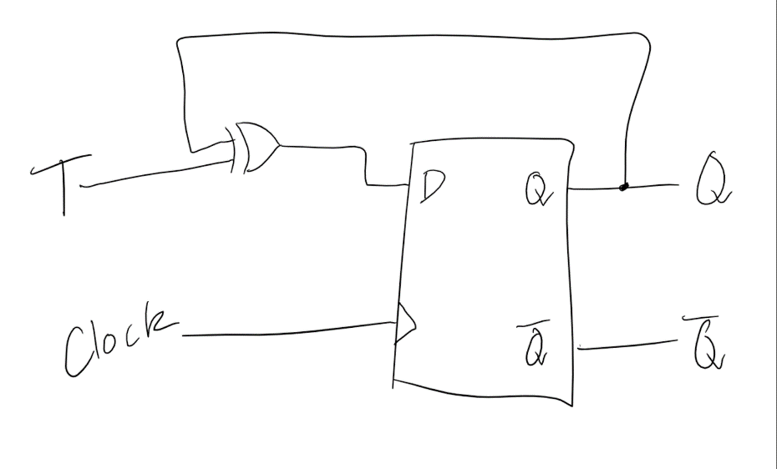
2. 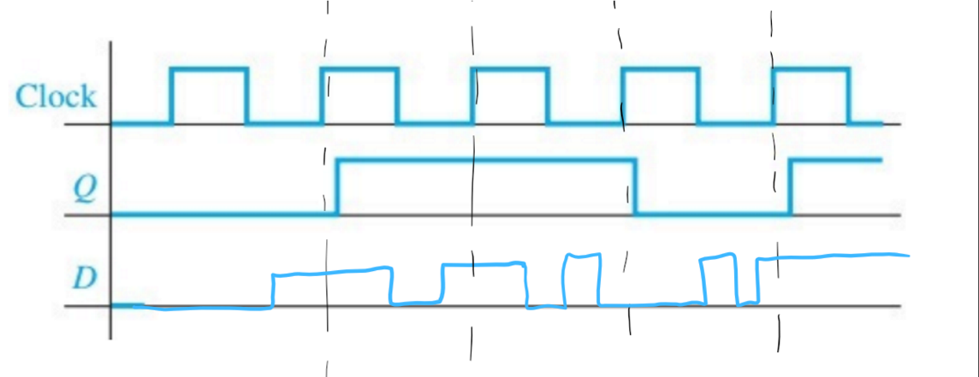
3. 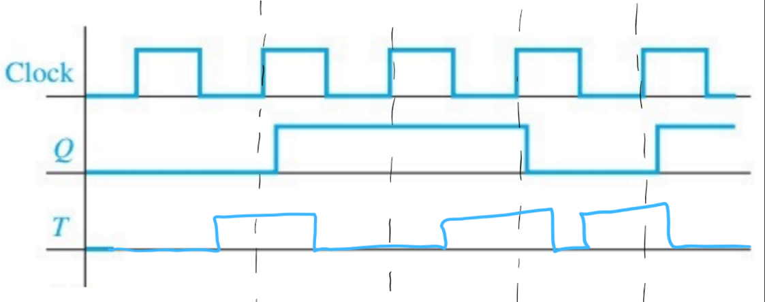
4. 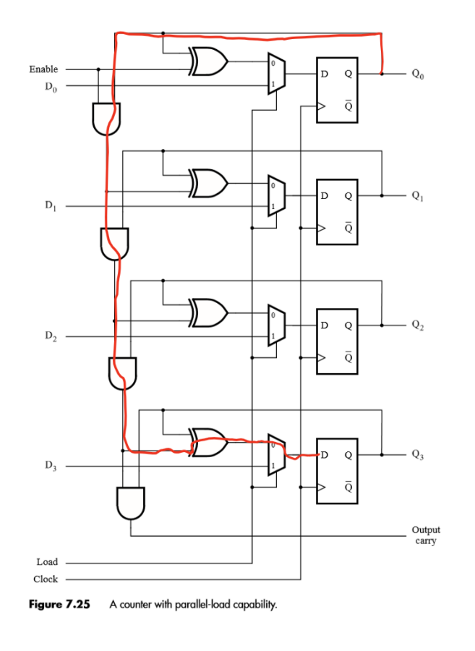**7.24:**

The path shown has a delay of 5 ns thus

$T_{min} = 5 + 3 + 1 = 9 ns$

$f_{max}=\frac{1}{T_{min}}=0.111 Hz=111 MHz$