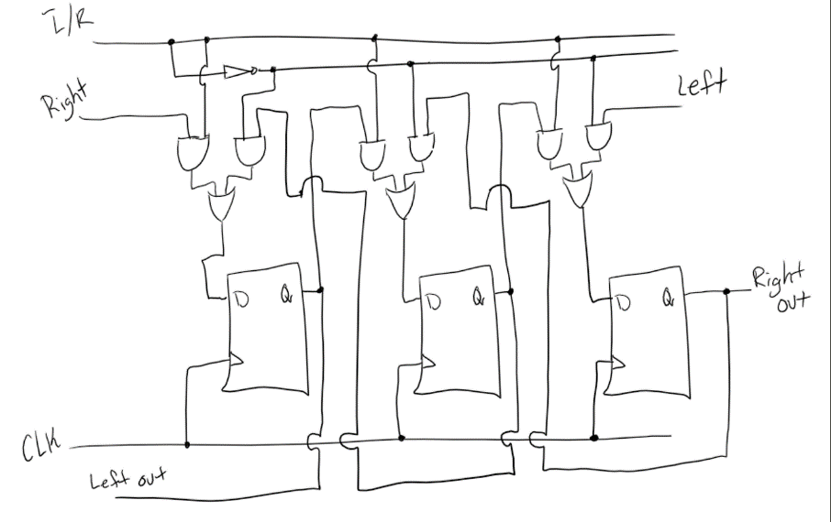**7.13:**

**7.18:** The count starts out at 000, then input into T0 is a 1 so the count is 001. Then output of 1 goes to T1, while input of 1 goes into T0 so the count is then 010. Then the output of 1 goes to T2, while output of 0 goes to T1, while input of 1 goes to T0 so the count is 111. Then back to 000. Therefore, the counting sequence for the counter is 000, 001, 010, 111.

**7.37: $t_{su}=0.6 ns, t_{h}=0.4 ns, 0.8 ns≤t_{cQ}≤1.0 ns$**

$T_{min}=t_{cQ}+3\left(t_{AND}\right)+t_{XOR}+t_{MUX}+t_{su}=1.0+3\left(1.2\right)+1.2+7.0+0.6=13.4ns$

$F_{max}=\frac{1}{T_{min}}=\frac{1}{13.4ns}=74.63 MHz$

**7.38: $T_{min}=t_{cQ}+k\left(t_{REG}\right)+t_{MUX}+t_{su}$**

$F_{max}=\frac{1}{T_{min}}=\frac{1}{t_{cQ}+k\left(t_{REG}\right)+t_{MUX}+t_{su}}$

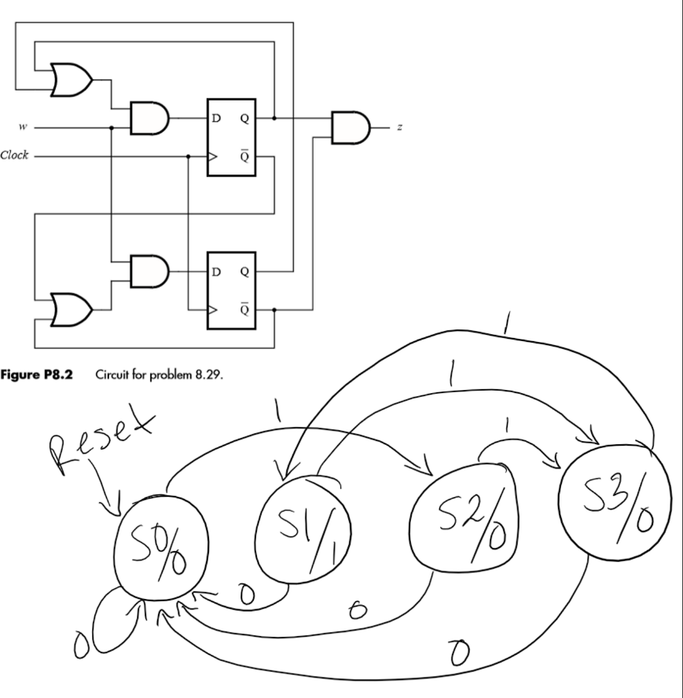**8.29:**

|  |  |  |  |
| --- | --- | --- | --- |
| **Present**  **State** | **Next State** | | **Output $$z$$** |
| **w = 0** | **w = 1** |
| S0 | S0 | S2 | 0 |
| S1 | S0 | S3 | 1 |
| S2 | S0 | S3 | 0 |
| S3 | S0 | S1 | 0 |

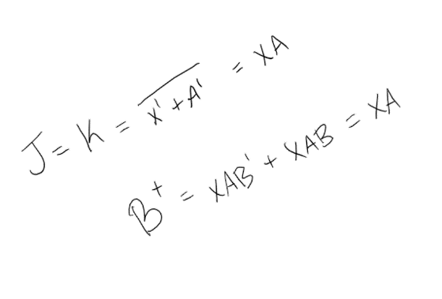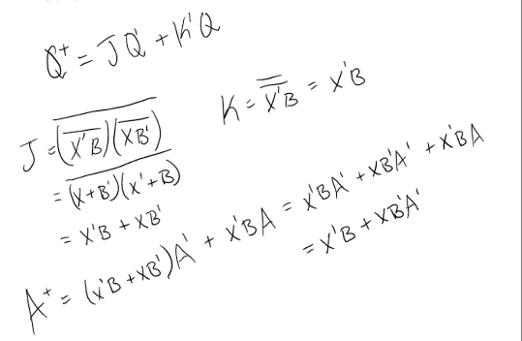**6.**

|  |  |  |  |
| --- | --- | --- | --- |
| **Inputs** | | **Current State** | **Next State** |
| **X** | **B** | **A** | **A\*** |
| 0 | 0 | 0 | 0 |
| 0 | 0 | 1 | 0 |
| 0 | 1 | 0 | 1 |
| 0 | 1 | 1 | 1 |
| 1 | 0 | 0 | 1 |
| 1 | 0 | 1 | 0 |
| 1 | 1 | 0 | 0 |
| 1 | 1 | 1 | 0 |

|  |  |  |  |
| --- | --- | --- | --- |
| **Inputs** | | **Current State** | **Next State** |
| **X** | **A** | **B** | **B\*** |
| 0 | 0 | 0 | 0 |
| 0 | 0 | 1 | 0 |
| 0 | 1 | 0 | 0 |
| 0 | 1 | 1 | 0 |
| 1 | 0 | 0 | 0 |
| 1 | 0 | 1 | 0 |
| 1 | 1 | 0 | 1 |
| 1 | 1 | 1 | 1 |

|  |
| --- |
| **Output** |
| **Z** |
| 1 |
| 1 |
| 0 |
| 0 |
| 0 |
| 1 |
| 0 |
| 0 |

**First JK flip-flop: Second JK flip-flop:**

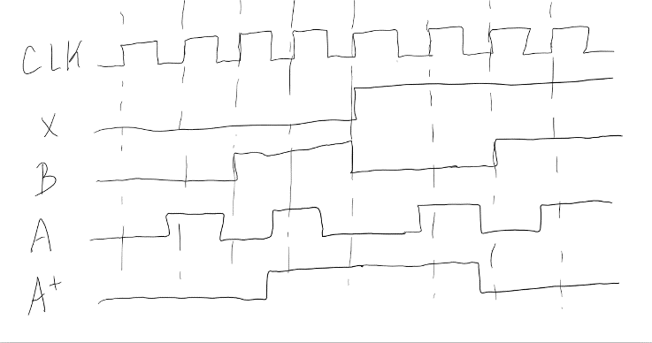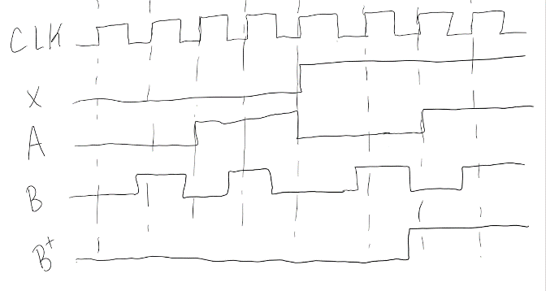The circuit is a Moore machine because the output depends on the current state only.

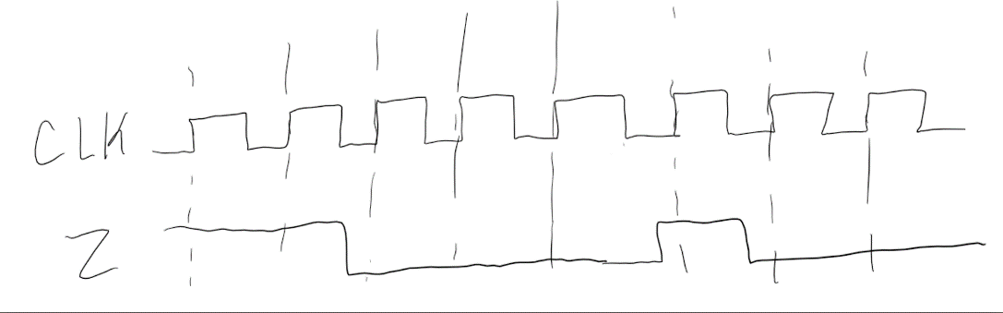

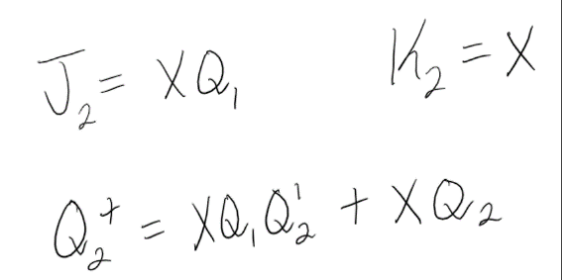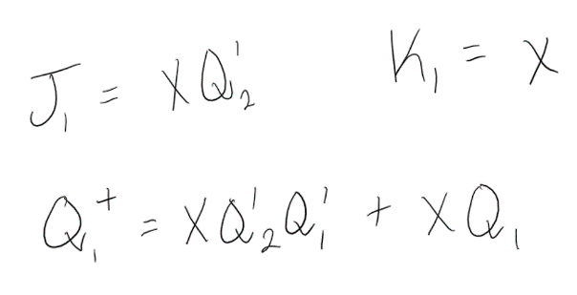**7.**

|  |  |  |  |
| --- | --- | --- | --- |
| **Inputs** | | **Current State** | **Next State** |
| **X** | **Q2** | **Q1** | **Q1\*** |
| 0 | 0 | 0 | 0 |
| 0 | 0 | 1 | 0 |
| 0 | 1 | 0 | 0 |
| 0 | 1 | 1 | 0 |
| 1 | 0 | 0 | 1 |
| 1 | 0 | 1 | 1 |
| 1 | 1 | 0 | 0 |
| 1 | 1 | 1 | 1 |

|  |  |  |  |
| --- | --- | --- | --- |
| **Inputs** | | **Current State** | **Next State** |
| **X** | **Q1** | **Q2** | **Q2\*** |
| 0 | 0 | 0 | 0 |
| 0 | 0 | 1 | 0 |
| 0 | 1 | 0 | 0 |
| 0 | 1 | 1 | 0 |
| 1 | 0 | 0 | 0 |
| 1 | 0 | 1 | 1 |
| 1 | 1 | 0 | 1 |
| 1 | 1 | 1 | 1 |

**First JK flip-flop: Second JK flip-flop:**

|  |
| --- |
| **Output** |
| **Z** |
| 0 |
| 0 |
| 0 |
| 0 |
| 1 |
| 0 |
| 0 |
| 0 |

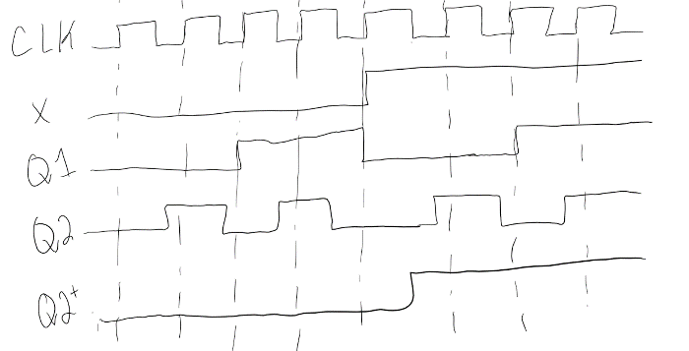This circuit is a Mealy machine because the output depends on the current state and input.

