Marcus Domingo

HW5B

CSC205 section 1 Spring 2015

Homework 5

Part B

1. [1 pt] Translate the following high-level programming code segment into MARIE. Then test your code with the MARIE simulator. Submit your program source code and a screenshot to show that your program works. (You may assume that all the class declarations and exceptions have been properly taken care of).

int x = 0;

int y = 1;

int z = 2;

Scanner s = new Scanner(System.in);

x = s.nextInt();

if (x>y) {

x = -y;

}

else {

x = 1+z;

}

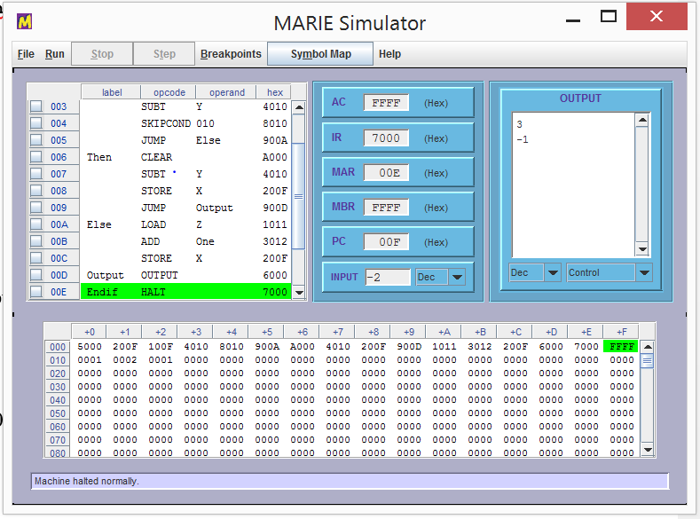System.out.println(x);

Program Code:

Input

Store X

If, Load X

Subt Y

Skipcond 010

Jump Else

Then, Clear

Subt Y

Store X

Jump Output

Else, Load Z

Add One

Store X

Output, Output

Endif, Halt 000

X, Dec 0

Y, Dec 1

Z, Dec 2

One, Dec 1

1. [1 pt] Read Sections 3.1 and 3.2 of *“Stack machine: the new wave” by Philip Koopman*. (http://www.ece.cmu.edu/~koopman/stack_computers/chap3.html) Make a comparison between the generic stack machine and the accumulator-based MARIE, in terms of the following:
   1. How many operands are there in each typical instruction?

* There are no operands in any instructions because this is a 0-operand machine.
  1. What are the common registers in both machines?
* MAR, PC, IR, and Input/Output Registers are common.

Please get started on Proj1a now, so that you may develop sufficient experience to understand the next two parts of chapter 4 on the hardware implementation of machine code.