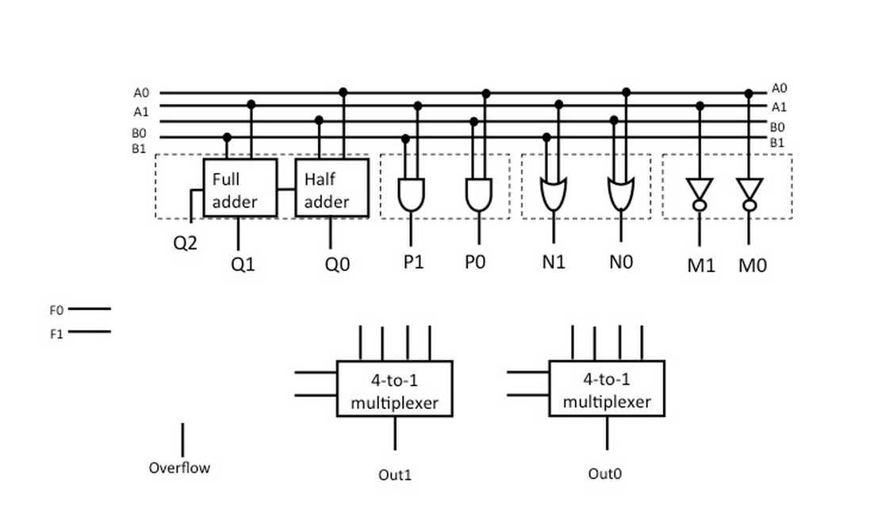Marcus Domingo

CSC 205 2/6/2015

HW3B

5. a. B7 = A0\*A1\*A2, B6 = A0\*A1\*~A2, B5 = A0\*~A1\*A2, B4 = A0\*~A1\*~A2,  
 B3 = ~A0\*A1\*A2, B2 = ~A0\*A1\*~A2, B1 = ~A0\*~A1\*A2, B0 = ~A0\*~A1\*~A2 b. C = (A0\*~B0~B1) + (A1\*~B0\*B1) + (A2\*B0\*~B1) + (A3\*B0\*B1)  
   
 c.