https://golfcourseapi.com - The one and only completely free golf course API on the internet. access data for almost 30,000 golf courses worldwide. Free for up to 300 api calls per day.
- URL: https://api.golfcourseapi.com/v1/search?search_query=Redwood Canyon
- Authorization: Key EWCO6T4GDAZ5DNBBNRJN5SZ75E.
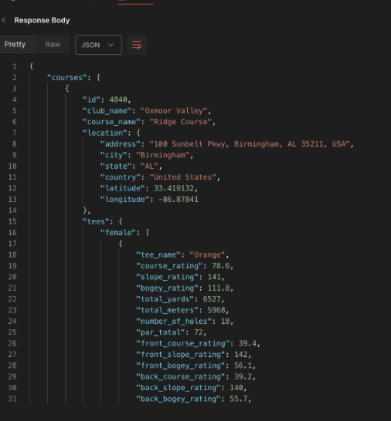

Caddie Baddie Use Cases:
- User enter just name of golf course in Caddie Baddie, and we display other information pertinent to the golf course information on the video.
- Use in orchestration with other APIs. For example, get GPS location from the video file, and use GPS location with API to find the nearest golf course. Then use this API to display pertinent Golf course information on the video.

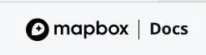
https://docs.mapbox.com/api/maps/static-images/
Login: lduggs
Password: !Rpb4****4**
Email: lyndon.duggs@comcast.net
Static token: pk.eyJ1IjoibGR1Z2dzIiwiYSI6ImNtZ3BtbnNvdzA4cWcybXB3MWN4NW0xbzkifQ.tuGlPRhwN8kNCVika78suA
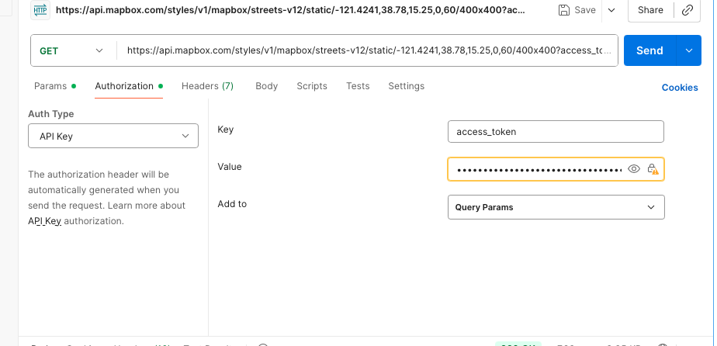

Note:
- Marcus ApI for getting GPS lodation for multiple calls and produces html page.
- Dad’s swing tracer development kit
- AICaddy-A-Golf-Club-Tracer

