
Caddie Baddie

Technical Specification: Golf video playback

Overview
Users of this application can post video clips of their round of golf and this application will edit the video to give the final video update a professional video representation of the clip. Key features include:
- Superimposing location of golf shot into the video image
- Golf Swing Tracing
- Golf tips based on swing.
- Auto identification of the golf course name based on GPS information on the file.

Design Principals:

Leverage contextual data from video and harness the power of automation and intuitive design to create sport highlights that look professional. Contextual information includes:
  - GPS information
  - Image information
    - For example swing analysis
- Allow max flexibility for the user to take a single clip, or multiple clips

Non-Functional Requirements:
- Allow users to upload video for editing via their phone, or computers.
- Be able to accept any video file format that includes GPS.
  - Test with GOPro, Iphone, and Android videos that are gps enabled.
- Notify user if video does not have GPS information available.

Golf Course Visualization
- Use the extracted GPS data to plot swing locations on a digital golf course map.
- Visually mark each spot where the golfer made a swing.

Score Calculation
- Calculate the player's score based on the sequence and location of swings.
- Integrate scoring logic that reflects standard golf rules.

Sample Output after video is uploaded:
Golf Course Overview:
Click on hole, to go to the hole.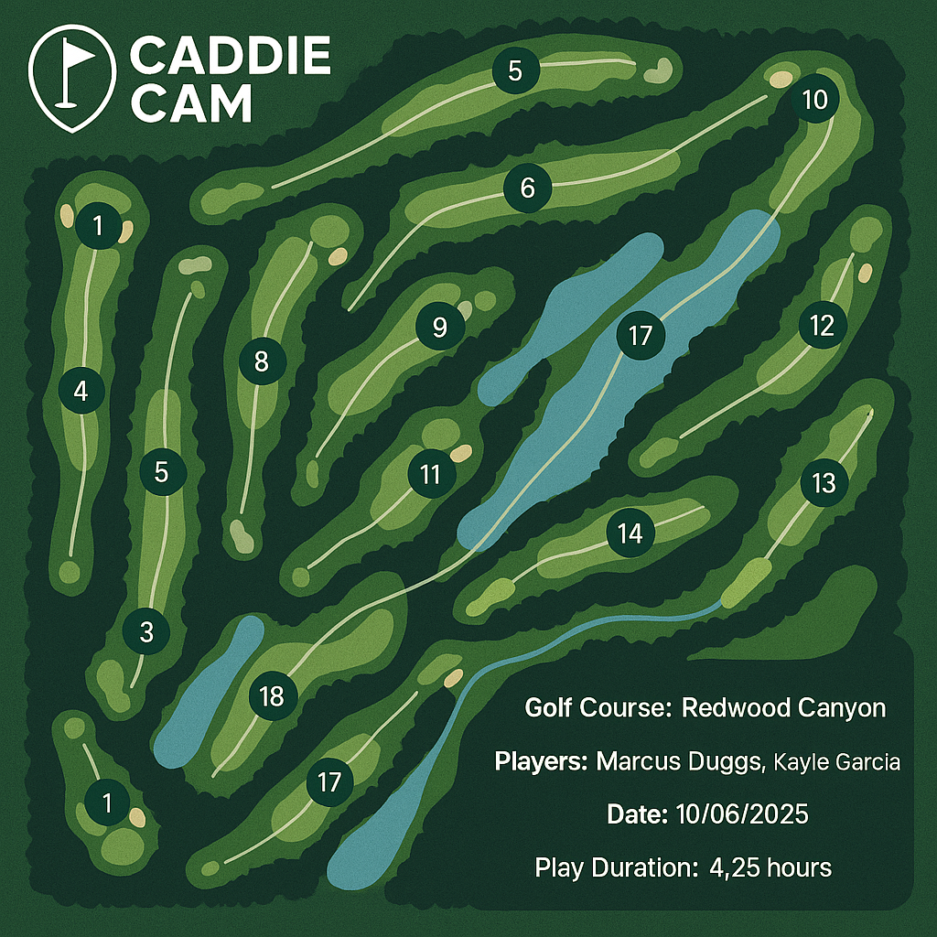

Golf Couse Hole View:
Hole 1: players

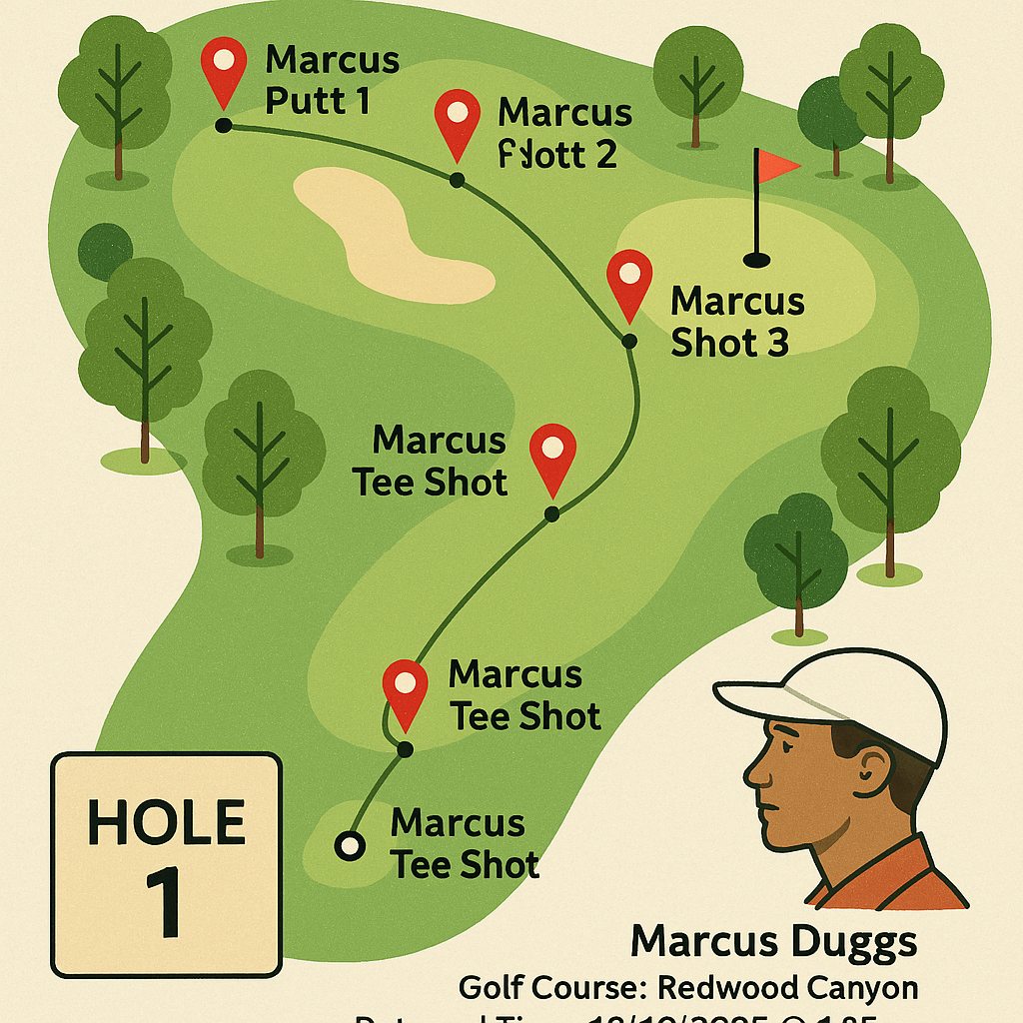

Future Feature: Overlay video
Click on Pin from Golf Course Hole View to show video clip from the hole position with shot tracer:

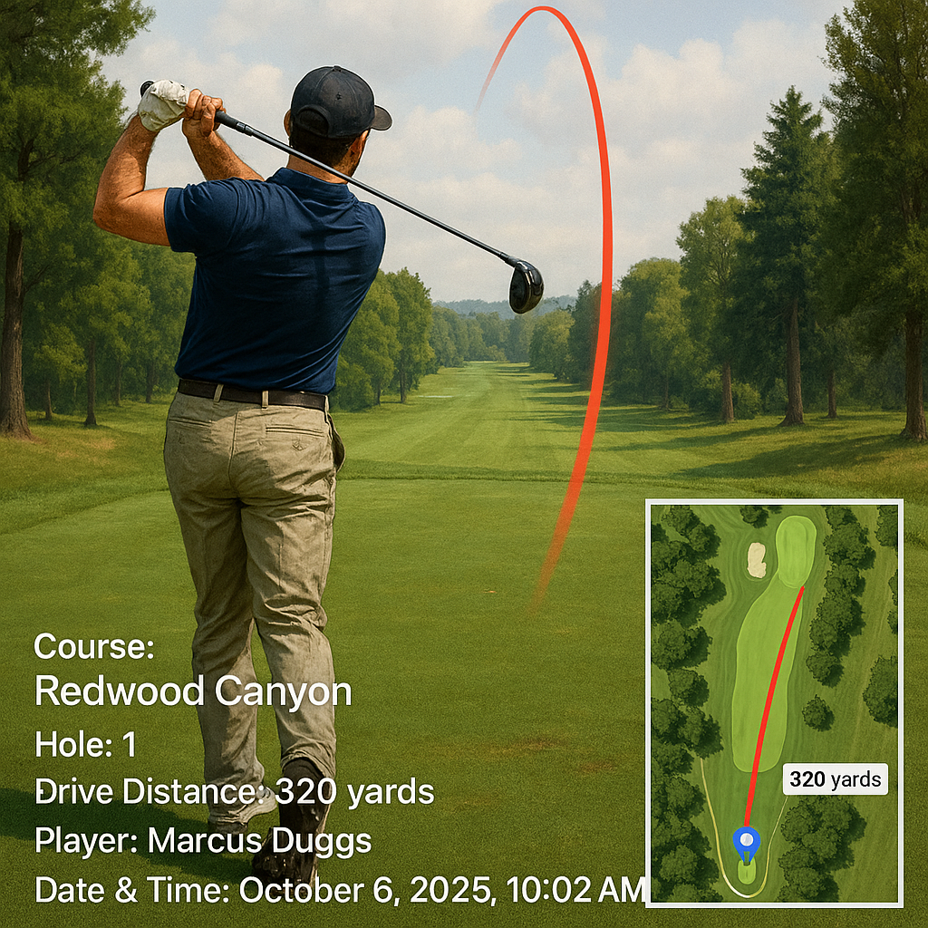

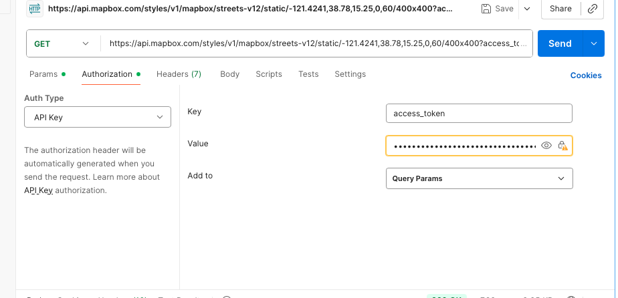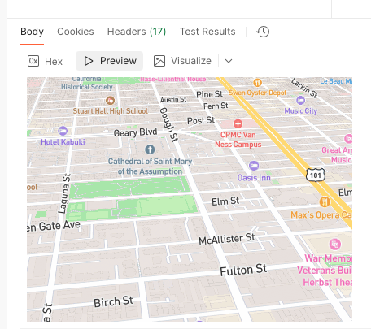
# Retrieve a static map with a GeoJSON overlay
# and save the output as a PNG image
curl -g "https://api.mapbox.com/styles/v1/mapbox/streets-v12/static/geojson(%7B%22type%22%3A%22Point%22%2C%22coordinates%22%3A%5B-73.99%2C40.7%5D%7D)/-73.99,40.70,12/500x300?access_token=pk.eyJ1IjoibGR1Z2dzIiwiYSI6ImNtZ3B1Mmw3dDJmcGUybm9lYjNybnM4YzMifQ.fxUV0UKsyCif2fSyq7vHhw

https://api.mapbox.com/styles/v1/mapbox/streets-v12/static/geojson(%7B%22type%22%3A%22Point%22%2C%22coordinates%22%3A%5B-73.99%2C40.7%5D%7D)/-73.99,40.70,12/500x300?access_token--output example-mapbox-static-overlay-GeoJSON.png
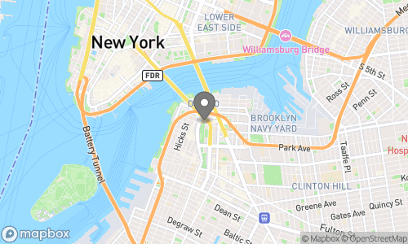

Tools for constructions

- AWS
  - S3 buckets
  - Lamda to host Python Code
- Github – to store documentation and code version management
- CI/CD Pipeline – automate deployment of code from one environment to the next
- Postman – Test API’s and validate how the API works.

List files located in sub directory input, then prompt the user to input the file to be read in to the program. Then prompt the user to write text to be overlayed on the image file using ffmpeg, and then write the final updated file to the subdirectory output using the final name fina.MOV.

"Using Python and OpenCV, write a script that reads the file “marcus-drive.mov” from the “input” sub directory and then breaks out the file into multiple frames. For each frame overaly a red dot over the imafe of the golf ball. At the completion of the the overlay task, re-assemble the farmes in sequence for the final output file called “b.mp4” in the output subdirectory

rack a white golf ball in a video and draw a tracer line behind it. The program should:
1. Read frames from a video file.
2. Convert each frame to the HSV color space for better color detection.
3. Define a color range for a white golf ball.
4. Create a mask to isolate objects within this color range.
5. Perform morphological operations (erosion and dilation) to clean up the mask.
6. Find the contours of the golf ball in the mask.
7. Calculate the centroid of the largest contour.
8. Store the history of the ball's centroid positions.
9. Draw a trail line based on the stored positions.
10. Display the resulting video with the tracer.
11. Handle command-line arguments for the video file path."
12. write the final updated file to the “output” subdirectory as “output.mov”

While you can't use "RACV/golf ball" and "golf tracker" as specific tools in this context, you can build a golf ball tracer using a combination of computer vision and FFmpeg. The key is to first use a computer vision library like OpenCV to track the ball's position, then use FFmpeg to overlay the resulting data onto the video.
Here is a step-by-step guide to building a DIY golf ball tracer.

Step 1: Capture the video
For the most reliable tracking, record your golf shot with a camera that captures a high frame rate (at least 60 fps, but 120 fps or higher is even better). This will reduce motion blur and make it easier for the computer vision script to detect the fast-moving ball.

Step 2: Extract the video frames
Use FFmpeg to break your video file into a sequence of individual image files (frames). This makes it possible for your computer vision script to analyze the video one frame at a time.
FFmpeg command:

sh

ffmpeg -i your_video.mp4 frames/%04d.png
- -i your_video.mp4: The input video file.
- frames/%04d.png: The output file path. FFmpeg will create a sequence of images named 0001.png, 0002.png, etc., inside a frames directory.

Step 3: Track the ball with OpenCV
Write a Python script to iterate through the video frames and find the golf ball's location in each one. You will likely use color-based detection since a white golf ball stands out well against green grass.
Sample Python script using OpenCV:

python

import cv2
import numpy as np

# Adjust these HSV values to match your lighting conditions
# You can use a tool to find the HSV range for white.
hsv_lower = np.array([0, 0, 200])
hsv_upper = np.array([179, 20, 255])

ball_positions = []

for i in range(1, number_of_frames):
frame_path = f"frames/{i:04d}.png"
frame = cv2.imread(frame_path)
if frame is None:
continue

hsv = cv2.cvtColor(frame, cv2.COLOR_BGR2HSV)
mask = cv2.inRange(hsv, hsv_lower, hsv_upper)

# Find contours, which will identify the white objects in the frame.
contours, _ = cv2.findContours(mask, cv2.RETR_EXTERNAL, cv2.CHAIN_APPROX_SIMPLE)

if contours:
# Find the contour with the largest area, which is likely the ball.
max_contour = max(contours, key=cv2.contourArea)
if cv2.contourArea(max_contour) > 10: # Use a size filter to avoid noise
# Get the center of the ball and store it.
M = cv2.moments(max_contour)
if M["m00"] != 0:
cx = int(M["m10"] / M["m00"])
cy = int(M["m01"] / M["m00"])
ball_positions.append((i, cx, cy))
else:
# Predict the next position if the ball is lost.
# Use a Kalman filter for better tracking of fast-moving objects.
# For a simple solution, append a placeholder.
ball_positions.append((i, None, None))

# Save the ball positions to a text file
with open("ball_path.txt", "w") as f:
for frame_num, x, y in ball_positions:
if x is not None:
f.write(f"{frame_num} {x} {y}\n")

Step 4: Create a line drawing sequence
You need to convert the ball_path.txt data into a series of images that FFmpeg can use as an overlay. Each image in this sequence will draw a longer segment of the trajectory line.
Sample Python script to draw the line:

python

import cv2
import numpy as np

# Read ball positions from the text file
with open("ball_path.txt", "r") as f:
positions = [line.strip().split() for line in f.readlines()]
positions = [(int(p[0]), int(p[1]), int(p[2])) for p in positions if p[1] != 'None']

# Get video dimensions (example)
width, height = 1920, 1080

for i in range(len(positions)):
# Create a blank image for the overlay
overlay_img = np.zeros((height, width, 4), dtype=np.uint8) # 4 channels for transparency

# Draw the path up to the current frame
for j in range(i):
p1 = (positions[j][1], positions[j][2])
p2 = (positions[j+1][1], positions[j+1][2])
cv2.line(overlay_img, p1, p2, (0, 255, 0, 255), 3) # Green line, 3px thick, fully opaque

# Save the overlay image
cv2.imwrite(f"overlays/{positions[i][0]:04d}.png", overlay_img)

Step 5: Overlay the tracer with FFmpeg
Finally, use FFmpeg to combine the original video with the sequence of overlay images you just created.
FFmpeg command:

sh

ffmpeg -i your_video.mp4 -framerate 25 -i overlays/%04d.png \
-filter_complex "[0:v][1:v]overlay=0:0" \
-c:a copy -c:v libx264 -pix_fmt yuv420p output.mp4
- -i your_video.mp4: The original video input.
- -framerate 25 -i overlays/%04d.png: The input sequence of overlay images. Match the framerate to your video to ensure the timing is correct.
- -filter_complex "[0:v][1:v]overlay=0:0": This is the core command that places the overlay image sequence on top of the original video.
- -c:a copy: Copies the audio stream from the original video.
- -c:v libx264 -pix_fmt yuv420p: Specifies the video codec and pixel format for the output file.

def application(environ, start_response):
status = '200 OK'
output = b'Hello from mod_wsgi!'
response_headers = [('Content-type', 'text/plain'),
('Content-Length', str(len(output)))]
start_response(status, response_headers)
return [output]

