Caddie Baddie Technical Architecture 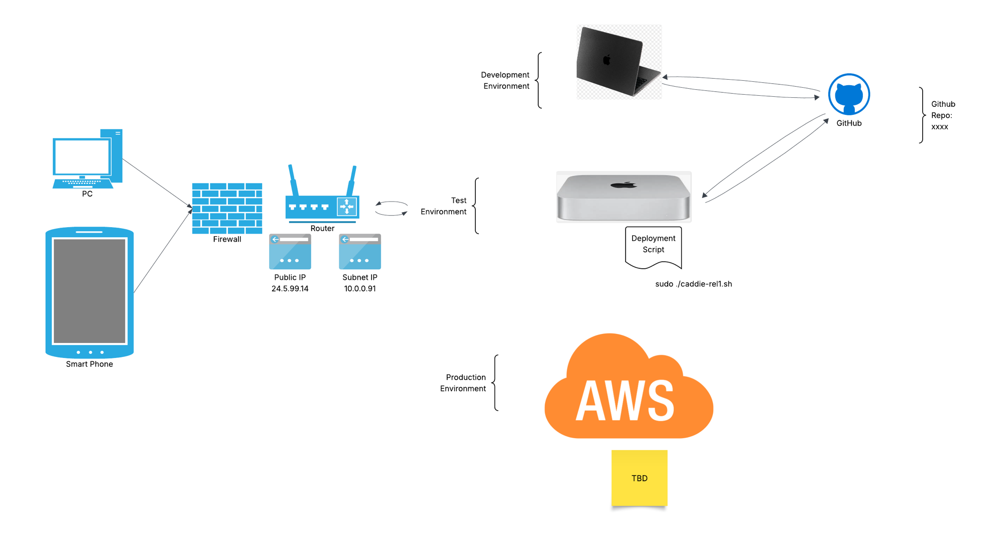 a

