# Identification

|  |  |
| --- | --- |
| **Project** | Global Blue Test |
| **Incident Number** | 002 |
| **Date** | 05/05/2017 |
| **Reporter** | Marcus Vinicius Fantinato |
|  | marcusfantinato@gmail.com |

# Incident Report

|  |  |
| --- | --- |
| **URL:** | <http://www.globalblue.com/customer-services/tax-free-shopping/refund-calculator/> |
| **Description:** | It's possible add purchase amount without filling "Purchase Amount" field |
| **Severity:** | LOW |

**Steps To Reproduce:**

1 – Fill Purchase Amount

2 – Click Calculate

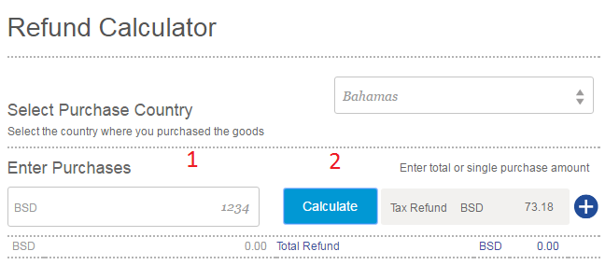

3 – Clean Purchase Amount

4 – Click Add (+)

The Purchases values are displayed such as NaN

