Helping learners find their next course
Learners often finish a course and don't know what to take next. Finding something relevant means scrolling through the whole catalogue, or asking you. The Course Recommender puts suggestions in front of them, on the pages they already use, and AI makes those suggestions sharper, more personal and easier to trust.
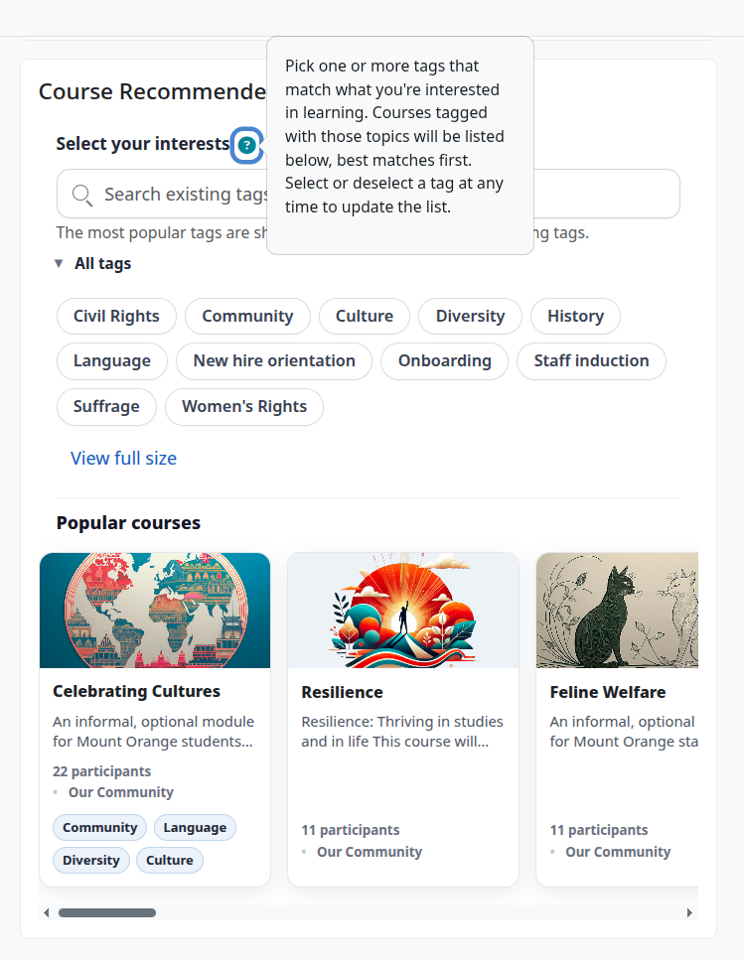

What it does for your learners
- They find relevant courses on their own. Learners click the topics that interest them, such as "Leadership", "Excel" or "First Aid", and see matching courses straight away. No searching, no guessing at course names.
- They see what's new to them. Courses they're already enrolled in or have finished are left out, so every suggestion is something they could actually take next.
- Their next step is easy to spot. Topics linked to what they're studying now are shown first and highlighted. A learner on a leadership course sees more leadership courses at the top.
- It remembers them. When your site turns this on, the topics a learner picked last time are still selected when they come back.

How AI makes it better
- It understands what courses are about, not just their labels. Without AI, courses are ordered by how many of the learner's topics they're tagged with. With AI, the recommender reads each course's title and description too, so the course whose content best fits what the learner is looking for comes first, even when its tags are a looser match.
- The best match comes first. AI looks at each learner's interests, the courses they've already completed and the skills they've shown, and puts the most relevant courses at the front. Two learners picking the same topic can see a different order, each suited to them.
- Every suggestion explains itself. AI can add a short note to each course, such as "Builds on your interest in leadership with practical coaching skills". Learners see why a course suits them, so they're more likely to take the next step.
- Your courses are tagged for you. Good recommendations need good tags, and tagging a whole catalogue by hand is slow. A companion tool, AutoTag, uses AI to read each course's title, description and activities and suggest suitable topics. It often spots topics a busy author would miss, and keeps tagging consistent across the catalogue.

What it does for you
- Fewer "what should I do next?" questions. Learners can answer that themselves, any time, without waiting for a reply.
- Your other courses get noticed. Put the recommender on your course page, and learners finishing your course see related courses, including your follow-on ones.
- No extra work to keep it up to date. The topics come from the tags on your courses, and AutoTag can suggest those for you. Add a new course and it starts appearing in recommendations. There's no separate list to maintain.
- You choose where it appears. Add it to your own course in a couple of clicks. Your site administrator can also put it on every course, or on every learner's Dashboard or profile.

People stay in charge
AI suggests; people decide. By default, every tag AutoTag suggests waits for someone to approve or reject it before it's added, and you can still add or change tags yourself at any time. Each AI feature is optional and is switched on by your site, so it can be introduced at a pace that suits you.
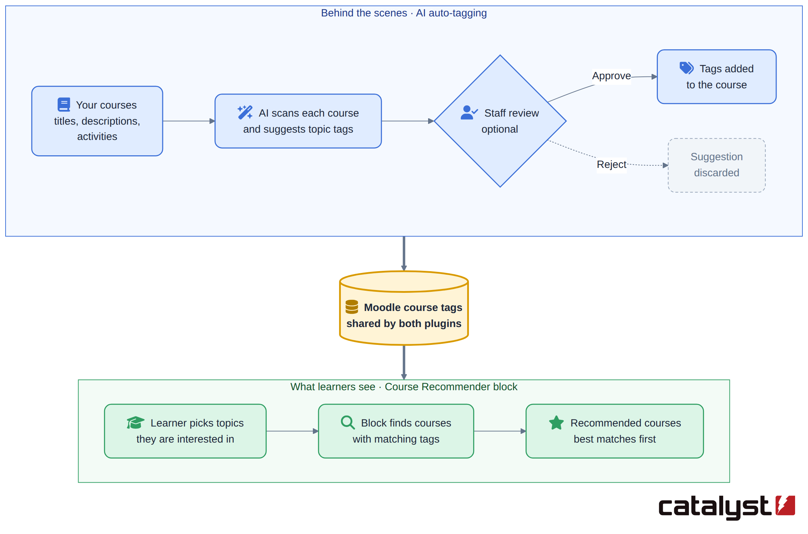

Learners' privacy
The AI features work from course information and learners' topic choices. No names, email addresses or profile details are sent. If the "why this course" notes are turned on, the AI service may receive a scrambled code in place of the learner's identity.
Your site can use an AI service it already trusts, or run one on its own servers so nothing leaves the organisation. Without AI, the recommender still works, matching topics to course tags.

In short
Learners get a clear, personal next step, and AI makes sure it's the right one. You get fewer questions, more visibility for your courses, and tagging done for you. And once it's set up, it runs itself.

