IT Geeks Project Installation Guide

Have JDK Version 9 SE or higher installed into a directory.

Have DERBY version 10.15 downloaded into your JDK folder in a folder named “db”.

# Set Environment Variables

Set JAVA_HOME

Hit the Windows key and type “edit the system environment variables” then press *Enter.*

On the System Properties window click the

 button.

Underneath the bottom “System Variables” Table, click



In the Edit System Variable Window, type “JAVA_HOME” into the ‘Variable Name’ Textfield and the directory to your JDK in the ‘Variable Value’ Textfield.

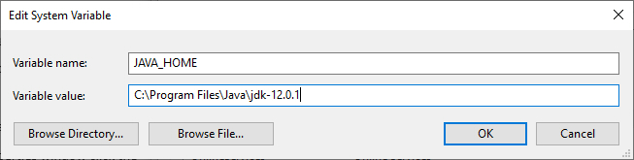

Set DERBY_HOME

Run Notepad++ as an Administrator, From Notepad++ open the batch file “setEmbeddedCP.bat” that’s located in the JDK installation folder’s db\bin folder.

Locate the line “@rem set DERBY_INSTALL=” (on Line 18 by default).

And change it to “@set DERBY_INSTALL=%JAVA_HOME%\db”, then save the file and close.

Open a Command Prompt window and change it to the JDK installation folder’s db\bin folder. Then type “setEmbeddedCP.bat” and press *Enter* to set the environmental variables required by Java DB.

# Setting Up the Client/Server

Server-

Extract the contents of the SERVER.zip file into a folder directory.

Open the command prompt.

Use the ‘cd’ command to change to the SERVER folder directory.

Execute the following command “%JAVA_HOME%\db\bin\ij”.

At the ij> prompt type “run ‘rentaldata.sql’; “ and *Enter*  .

Type “exit;” to exit out of the ij> prompt.

Type “javac *.java” to compile the java code.

Type “java Server” to run the Server App.

Client-

Extract the contents of the CLIENT.zip file into a folder directory

Open a new command prompt.

Use the ‘cd’ command to change to the CLIENT folder directory.

Type “javac *.java” to compile the java code in this directory.

Type “java Client” to run the Client App.