Solution Overview 3
Navigator 3
Document Objective and Scope 3
Chapter 1 Introduction (Marcus ) 3
Chapter 2 Secure Substation Solution Overview (Caldwel/Praveen) 4
Solution Objectives 4
Security and Compliance Drivers 5
Substation Deployment Profiles 5
Small Substation Profile 5
Medium Substation Profile 6
Operations and Migration 6
Summary 7
Chapter 3 Substation Security Reference Architecture (Caldwel/Praveen) 7
Architecture Building Blocks 8
Supported Products and Software Releases 9
Station Bus, Electronic Security Perimeter, and Process Bus Scope 10
Multiservice, Corporate, and Field Area Network Zones 11
Control Center, Security Operations Center, and WAN Components 12
NOC , Catalyst WAN Manager and Substation Spoke Model 12
Security Zones, Secure Conduits, VRFs, and Service VPNs 13
Workforce Enablement and Management Service Models 13
Traffic and Protocol Profiles 14
Summary 15
Chapter 4 Security Design Principles (Praveen) 15
Standards Alignment for Transmission Substations 16
Defense-in-Depth for Substation Environments 16
Electronic Security Perimeter Boundary Protection 17
WAN Encryption and Transport Options 17
Catalyst WAN Manager Operation and Autonomous Mode Considerations 18
Integrated Firewall and Discrete Firewall Design Guidance 19
NGFW, ZBFW, UTD IDS, and IPS Placement 20
SCADA Protocol Inspection and Custom DNP3 Rules 20
Network Access Control with 802.1X and MAB 21
Resiliency, High Availability, and Failure Modes 22
Logging, Monitoring, and Time Synchronization 23
Summary 23
Chapter 5 WAN Edge Aggregation and Service Segmentation Architecture (Arul) 24
WAN Edge Aggregation at Data Center routers: 25
Service Segmentation: 26
Platform Considerations for Data Center Hub Routers: 28
Data Centre Hub Router - Throughput Sizing and Capacity Planning: 30
Headend Redundancy and Traffic Steering Models: 32
Active/Standby Headend Architecture (Deterministic Path): 32
Active/Active Headend Architecture (Load-Sharing): 32
Chapter 6 Medium Substation Design (Praveen) 34
Use Case and Applicability 34
Validated Medium Substation Topology 35
Design Option 1: Integrated Firewall 36
Integrated Firewall Implementation 36
Design Option 2: Discrete Firewall 37
Discrete Firewall Design Considerations 38
Single IR8340 Edge Design 38
WAN Aggregation for the Medium Substation 39
Northbound and Southbound Connectivity 39
Service VPN Architecture for Medium Substation 39
Service VPN/VRF to Zone-Based Firewall Zone Mapping 40
IE9320 LAN Design 41
LAN Design Considerations 41
Firewall and Threat Inspection Placement 42
Raw Socket Transport for Legacy Serial Devices 42
Network Access Control for LAN-Side Devices 43
Cyber Vision Sensor Placement and East-West Visibility 43
Traffic Profile and Scale Considerations 44
Medium Substation Design Summary 44
Chapter 7 Small Substation Design(Arul) 45
Overview: 45
Architecture and Topology: 45
Core components: 46
Network Segmentation and Service VPNs: 47
VLAN-to-Service VPN Mapping: 47
Service Flows using service VPN: 48
Secure Substation – small – Various service Flows: 48
Secure Substation – small – Switch Management Service: 48
Secure Substation – small – Physical Security and VOIP Services: 49
Secure Substation – small – Workforce Enablement: 50
SCADA Service flow using Service VPN: 50
1. Native IP-Based SCADA Communication 51
2. Legacy Serial SCADA Transport via Raw Sockets 52
3. High Availability with Dual Raw Socket Connectivity: 52
The Substation Router as an Integrated Firewall for SCADA: 53
ZBFW Design Considerations: 53
Security and Access Control 55
Visibility and Threat Detection (Cisco Cyber Vision) 55
Traffic Profile considered for small substation: 55
Chapter 9 Firewall and Threat Inspection Design (Maniyan ) 56
Chapter 6 Enabling secure access (owner???) 56
Chapter 10 Cyber Vision Design 56
Chapter 11 Validated Design Summary 57

Solution Overview

Navigator

Document Objective and Scope

Chapter 1 Introduction (Marcus )

Secure Substation CVD Overview
The Secure Substation CVD is a Cisco Validated Design reference for building secure, segmented, and observable utility substations across large transmission, medium distribution, and compact field-site profiles.
The design brings together ruggedized routing and switching, Cisco SD-WAN segmentation, Cisco Cyber Vision visibility, and policy-driven security controls into a repeatable substation blueprint. It is organized around the network behaviors utilities need to preserve:
- Deterministic SCADA reachability
- Resilient WAN transport
- Bounded management access
- Monitored OT assets
- Controlled paths for higher-bandwidth services such as PMU and physical-security video
The design uses three deployment models so the same principles can be applied based on the site type:
- Large substations with dual-router resilience
- Medium substations with a single rugged WAN edge
- Small substations using compact IR1101-based routing
Each tier ties back to service VPN separation, WAN sizing, Cyber Vision telemetry, and security policy placement.

Why Read This CVD
Substations are no longer isolated serial environments. Modern utility sites carry SCADA, management, telemetry, PMU, video, and remote-support traffic across shared IP infrastructure while still needing deterministic operations, cyber separation, and auditable security controls.
This CVD gives engineering, OT operations, and security teams a common reference for turning those requirements into a repeatable architecture. It shows how to structure the substation edge, how to separate critical services, where to apply inspection, and how to size the WAN for large, medium, and small sites.
Key reasons to read the CVD:
- Reduce design ambiguity: Align network, OT, and security teams around one validated blueprint instead of one-off substation builds.
- Protect critical operations: Preserve SCADA reachability while adding segmentation, firewall policy, application recognition, and inspection where it matters.
- Plan before deployment: Relate traffic types, bandwidth assumptions, and product choices before configuration begins.
- Improve audit readiness: Map architecture decisions to zoning, access control, monitoring, and operational evidence expected in regulated utility environments.

Why Cisco
Cisco brings the substation WAN, industrial LAN, security policy, and OT visibility layers into one architecture. Secure substations need more than a router, a switch, or an IPS rule in isolation. They need those controls to work together across the full lifecycle.
Cisco capabilities used in this CVD:
- Rugged OT infrastructure: Industrial routers and switches such as IR8340, IR1101, IE9300, IE3100, and IE3500 support hardened deployment models for utility environments.
- SD-WAN and segmentation: Cisco SD-WAN provides centralized overlay policy, service VPN separation, encrypted transport, and scalable operations for many substations.
- Security policy at the edge: Zone based firewall, application-aware policy, NBAR, and Snort IDS/IPS capabilities can be aligned to the same traffic paths shown in the architecture.
- OT visibility: Cisco Cyber Vision adds asset, protocol, and anomaly context so policy decisions are informed by what is actually running in the substation.

What The CVD Establishes
The CVD establishes a repeatable design model for:
- Service separation: SCADA, MultiService, and Management traffic are treated as distinct service VPNs with different trust, QoS, and inspection requirements.
- Substation profiles: Large, medium, and small designs map platform choices to expected device scale, traffic volume, and resiliency needs.
- Operational visibility: Cyber Vision sensors and center connectivity provide asset discovery, protocol awareness, and anomaly context across OT zones.
- Security alignment: NERC CIP impact categories, NGFW policy, NBAR application recognition, and Snort IPS are positioned against the architecture.

Design Outcomes
The intended outcomes are:
- Standardize the substation edge: Use a common routing, switching, and SD-WAN pattern while still sizing the design for large, medium, and small facilities.
- Protect critical OT paths: Constrain SCADA, management, and multiservice flows with segmentation, zone-based firewalling, application matching, and IPS inspection where required.
- Plan WAN capacity: Relate traffic types such as DNP3, PMU, CCTV, enterprise access, and management telemetry to practical bandwidth and QoS assumptions.
- Connect design to deployment: Carry the same architecture into platform references and configuration examples for routers, switches, and security functions.

Chapter 2 Secure Substation Solution Overview (Caldwel/Praveen)
- Secure Substation Introduction
- Customer and User Success Criteria
- Secure Substation Use Cases (large,medium,small,traffic flows,endpoint scale)
- Design Inputs, Dependencies (US based deployments – DNP3,SCADA), and Out-of-Scope Items (Large substations, Europe deployments)

This chapter provides a high-level overview of the Cisco Secure Substation solution for small and medium transmission substations. The intent is to introduce the solution scope, security objectives, deployment profiles, and traffic categories without duplicating the detailed reference architecture and security design guidance covered in later chapters.

The solution is designed for utilities that need to modernize substation communications while maintaining reliable grid operations and improving cybersecurity posture. It supports SCADA monitoring and control, station bus communications, phasor measurement use cases where required, physical security services, management access, workforce enablement, and integration with centralized control center and security operations environments.

The Secure Substation architecture uses ruggedized Cisco industrial routers and switches to provide secure WAN aggregation, station LAN connectivity, segmentation, firewall enforcement, industrial visibility, and flexible management. Small substations use a compact spoke model, while medium substations support higher device counts, additional zones, and broader service separation. Both profiles use the same architectural principles so that deployment and operations can remain consistent across the utility.

Solution Objectives

The primary objective of the solution is to protect transmission substation communications without disrupting grid operations. The design provides a repeatable framework for connecting substations to utility headend services while separating traffic by function, trust level, and operational requirement.

At a high level, the solution supports the following objectives:

- Secure aggregation of substation LAN traffic at the WAN edge.
- Segmentation using VRFs, VLANs, firewall zones, and service VPNs.
- Electronic Security Perimeter boundary protection for protected OT assets.
- Support for SCADA and station bus protocols such as DNP3, IEC 60870-5-104, Modbus TCP, and IEC 61850 MMS where applicable.
- Integration of legacy serial devices using raw socket or serial pseudowire options where required.
- Industrial asset visibility and east-west traffic monitoring using Cisco Cyber Vision.
- Centralized WAN lifecycle operations using Catalyst WAN Manager, with autonomous operation supported where appropriate.
- Alignment with NERC CIP and ISA/IEC 62443 principles for transmission substation environments.

Security and Compliance Drivers

Security requirements for transmission substation automation are strongly influenced by NERC CIP and ISA/IEC 62443. NERC CIP drives the need to identify protected cyber assets, define Electronic Security Perimeters, control routable communications, manage remote access, monitor security events, maintain configuration baselines, and support evidence-oriented operations.

ISA/IEC 62443 complements this approach through defense-in-depth, zones and conduits, risk-based segmentation, and lifecycle security practices for industrial automation and control systems. In the Secure Substation solution, these concepts are reflected through logical zones, controlled service paths, firewall boundaries, visibility tooling, and separation of SCADA, management, physical security, enterprise, and workforce services.

The solution provides capabilities that support alignment with these frameworks, but compliance depends on the utility's asset classification, regulatory scope, configuration standards, operating procedures, documentation, and audit practices.

The detailed reference architecture, including zones, conduits, VRFs, service VPNs, WAN components, and traffic mapping, is covered in Chapter 3. The security principles used to protect and monitor those services are covered in Chapter 4.

Substation Deployment Profiles

The Secure Substation solution supports small and medium transmission substation deployment profiles. These profiles provide a high-level view of expected scale, traffic characteristics, and platform alignment. Detailed design guidance for each profile is covered in the respective design chapters.

Small Substation Profile

The small substation profile is based on the Cisco IR1101 platform. It provides a compact single-router model for small transmission substations in the 115-230 kV range, where device count and segmentation needs are lower than medium transmission sites but still require secure WAN connectivity, visibility, and controlled access.

Small transmission sites may include SCADA endpoints, station bus devices, legacy serial RTUs, physical security services, workforce enablement endpoints, and management services.

- Typical point count: 200-600 points.
- Average throughput without PMUs: 50-200 kbps.
- Additional PMU throughput: approximately 5-10 Mbps per PMU when PMUs are deployed.
- Typical WAN provisioning: 1-10 Mbps using microwave, fiber, or MPLS.
- Common protocols: DNP3, IEC 61850 MMS where applicable to station bus use cases, and ICCP for tie-lines.

The small substation profile supports the core solution capabilities: SCADA aggregation, VRF or service VPN separation, VLAN segmentation, firewall policy, legacy serial integration, Cyber Vision visibility, and Catalyst WAN Manager-based or autonomous operation.

Medium Substation Profile

The medium substation profile is based on the Cisco IR8340 Substation WAN Router. It provides a higher-scale spoke model for medium transmission substations in the 345-500 kV range, where the number of IEDs, service zones, operational systems, and control center integrations is typically greater.

Medium transmission sites may include a larger station LAN, SCADA and station bus services, PMU or synchrophasor flows where required, physical security systems, workforce enablement, management services, and legacy serial connectivity.

- Typical point count: 500-1,500 points.
- Average throughput without PMUs: 0.5-2 Mbps.
- Additional PMU throughput: approximately 5-10 Mbps per PMU when PMUs are deployed.
- Typical WAN provisioning: 10-50 Mbps using fiber or high-capacity microwave.
- Common protocols: IEC 61850 MMS, DNP3, ICCP, and IEEE C37.118 for PMU traffic.

The medium substation profile can support integrated firewall services on the IR8340 or a discrete firewall at the ESP boundary. The detailed design options for medium substations are covered in the medium substation design chapter.

Operations and Migration

Many transmission substations include a mix of modern Ethernet-connected devices and legacy serial equipment. The Secure Substation solution supports phased migration by allowing legacy RTUs and serial-connected devices to remain operational while the site transitions toward a segmented Ethernet-based architecture.

From an operations perspective, the common architecture allows utilities to standardize WAN connectivity, zone mapping, service VPNs, management access, monitoring, and remote-access workflows across multiple sites. Catalyst WAN Manager can provide centralized lifecycle operations for larger deployments, while autonomous operation can be used where centralized management is not required or not yet available.

Large and EHV substations, process bus design, IEC 61850 GOOSE/Sampled Values engineering, and advanced large-substation timing and redundancy models are outside this version of the CVD unless explicitly included in a later design scope.

Summary

The Cisco Secure Substation solution provides a repeatable framework for securing small and medium transmission substations. It combines ruggedized routing and switching, service separation, ESP boundary protection, firewall enforcement, Cyber Vision visibility, legacy integration, and flexible management options.

This chapter introduced the solution at a high level. Chapter 3 defines the Substation Security Reference Architecture, and Chapter 4 defines the Security Design Principles used to protect the architecture.

Chapter 3 Substation Security Reference Architecture (Caldwel/Praveen)
- Architecture Building Blocks (overview – Head End, WAN , small/medium,zones,end points)
- Supported Products and Software Releases
- Station Bus, Process Bus, and Electronic Security Perimeter
- Multiservice, Corporate, and Field Area Network Zones
- Control Center, Security Operations Center, and WAN Components
- SD-WAN Headend and Substation Spoke Model
- Security Zones, Secure Conduits, VRFs, and Service VPNs
- OT-SCADA-VPN for SCADA Monitoring and Control
- Physical Security Service VPNs for Latency-Sensitive and Delay-Tolerant Traffic
- Workforce Enablement and Management Service Models
- DNP3, T104, Modbus, and IEC 61850 Design Considerations
- SCADA, PMU, Physical Security, Enterprise, and Management Traffic Profiles
- Utility Operations Roles and Responsibilities

This chapter describes the Secure Substation reference architecture for small and medium substations. The purpose of the chapter is to establish the major architectural building blocks, logical zones, WAN model, service VPNs, traffic classes, and operational domains used throughout the CVD. Detailed security design principles, policy enforcement methods, access-control behavior, and protocol-specific protection guidance are covered in the next chapter.

The reference architecture uses a hub-and-spoke model. Centralized services reside in the OT data center, security operations center, network operations center, and related utility operations environments. Each substation operates as a spoke that aggregates local traffic, connects to the utility WAN through a WAN edge router, and maps local services into the appropriate logical zones and service VPNs. This model provides a repeatable structure that can be applied across small and medium substations while allowing each site to scale according to device count, available WAN transport, and operational requirements.

The architecture separates traffic by operational function. SCADA monitoring and control, station bus services, phasor measurement, physical security, management, workforce access, enterprise integration, and field area network communications are represented as distinct architectural domains. These domains are connected through defined conduits and mapped to VRFs or service VPNs where logical separation is required.

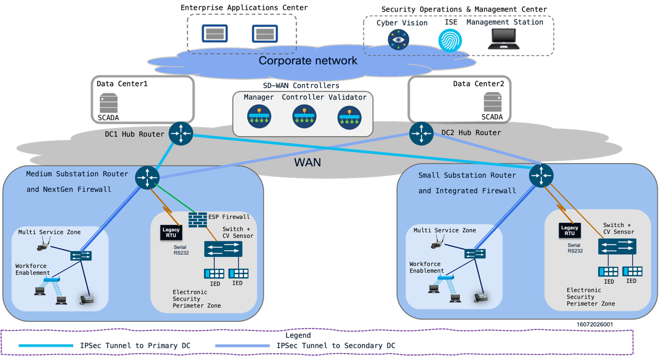

Architecture Building Blocks

The Secure Substation reference architecture is organized around the following operational building blocks:

- OT (TSO/DSO) data center: Hosts SCADA, control center applications, data center WAN edge hubs, and OT services used for transmission substation operations.
- Security Operations Center: Hosts or consumes security monitoring services such as Cisco Cyber Vision, security telemetry, event correlation, and incident response workflows.
- Network Operations Center: Hosts Catalyst WAN Manager and related WAN control components used for onboarding, policy distribution, monitoring, and WAN lifecycle operations.
- WAN edge routers and transport: Provide the hub-and-spoke connectivity between data centers and substations. Cisco Catalyst 8000 Series platforms act as data center WAN edge hubs, while substation routers act as spokes.
- Substation domain: Contains the local WAN edge router, industrial Ethernet switches, station bus devices, ESP assets, physical security endpoints, workforce enablement services, management interfaces, and legacy serial devices.

The OT data center, SOC, and NOC may be physically co-located or operated as separate environments. The reference architecture treats them as distinct logical domains because they have different operational roles. The OT data center is focused on grid operations, the SOC is focused on monitoring and response, and the NOC is focused on WAN and infrastructure operations.

WAN transport provides connectivity between substations and centralized utility locations. The architecture is transport-flexible and may use private circuits, utility-owned fiber, cellular, internet transport with encryption, or a combination of services. The WAN carries multiple logical services between the substation and utility data centers, rather than acting as a single flat network extension.

At the substation, the medium profile uses the Cisco IR8340 as the substation WAN edge router. The small substation uses the Cisco IR1101 as the compact WAN edge router. Industrial Ethernet switches provide station LAN connectivity and may support Cisco Cyber Vision sensor functions for asset visibility. The reference diagrams show IE9300 or IE3x00 switching in the medium profile and IE3100 switching in the small profile.

Substation endpoints include legacy RTUs connected through RS-232 serial interfaces, IEDs, protection relays, gateways, PMUs, cameras, badge readers, door controllers, remote desktop systems, engineering workstations, network infrastructure, and local management systems. These endpoints are grouped into security zones based on their operational function and communication requirements.

Supported Products and Software Releases

Architecture area | Product or platform | Function in the design | Validated software release
Headend WAN edge | Cisco Catalyst 8000 Series Edge Platforms | Data center hub routing, WAN aggregation, IPsec termination, substation aggregation | To be filled
Medium substation WAN edge | Cisco IR8340 | Substation WAN router, service aggregation, segmentation, serial integration | To be filled
Small substation WAN edge | Cisco IR1101 | Compact substation WAN router, service aggregation, segmentation, serial integration | To be filled
Medium substation switching | Cisco IE9300 or IE3x00 Industrial Ethernet switches | Station LAN connectivity, VLAN separation, Cyber Vision sensor support | To be filled
Small substation switching | Cisco IE3100 Industrial Ethernet switches | Compact station LAN connectivity, VLAN separation | To be filled
Small substation switching | Cisco IE3505 Industrial Ethernet switches | Compact station ESP LAN connectivity, Cyber Vision sensor support, VLAN separation. | To be filled
Industrial visibility | Cisco Cyber Vision | Asset discovery, industrial protocol visibility, traffic monitoring | To be filled
WAN management | Cisco Catalyst WAN Manager | WAN policy, device onboarding, monitoring, and lifecycle management | To be filled
WAN overlay control components | Manager, Controller, and Validator components | Overlay control, orchestration, and secure WAN operation | To be filled
Security inspection | IR8340 | ESP boundary and zone inspection functions using UTD,NGFW,etc.Integrated router security or discrete firewall | To be filled
Identity and access services | Cisco ISE or utility-approved identity platform | Device and user identity services | To be filled
Security operations | SIEM, SOC tools, and Cisco security integrations | Event collection, correlation, and incident monitoring | To be filled

Station Bus, Electronic Security Perimeter, and Process Bus Scope

For this version of the CVD, the substation LAN is primarily described through the station bus and the Electronic Security Perimeter. Process bus is referenced only as a scope boundary because large substation deployment is not included in this release of the design.

The station bus connects the systems used for automation, monitoring, control, and local engineering functions. Typical station bus endpoints include RTUs, IEDs, protection relays, gateways, bay controllers, local HMIs, engineering workstations, and SCADA communication devices. Station bus traffic may include DNP3, IEC 60870-5-104, Modbus TCP, IEC 61850 MMS, SNMP, syslog, SSH, HTTPS, and file-transfer traffic.

The Electronic Security Perimeter represents the logical boundary around protected cyber assets. In the reference architecture, ESP placement is described at the architectural level so that Chapter 4 can define the associated security principles, policy controls, and access methods.

Process bus architectures are predominantly associated with large digital substations that use IEC 61850 GOOSE and Sampled Values for high-speed protection and process-level communications. These designs introduce strict timing, latency, redundancy, and validation requirements. Because large substation deployment is outside this CVD version, IEC 61850 GOOSE/SV process bus design is excluded from the validated reference architecture.

Multiservice, Corporate, and Field Area Network Zones

The reference architecture recognizes that substations carry more than traditional SCADA traffic. Physical security, environmental monitoring, workforce access, enterprise services, and field area network communications may also be present. These services are represented as separate architectural zones so they can be mapped cleanly into the WAN and headend model.

The multiservice zone represents non-SCADA operational services that support substation operations. This may include video surveillance, access control, environmental monitoring, local maintenance systems, or other operational support services.

The corporate zone represents approved enterprise services that may need to exchange information with substation systems or supporting infrastructure. Examples include identity services, logging platforms, inventory systems, patch repositories, and enterprise management applications.

The Field Area Network zone represents communication with devices outside the substation fence or distributed across the utility field network. FAN endpoints may include reclosers, capacitor banks, distribution automation devices, meters, sensors, or other remote assets. FAN placement in the architecture depends on the utility topology and the relationship between the substation and the broader field network.

Control Center, Security Operations Center, and WAN Components

The control center is the primary operational destination for SCADA monitoring and control. It may host SCADA masters, energy management systems, distribution management systems, historian services, operator consoles, and operational data collection systems. In the reference architecture, the control center is a headend destination for SCADA service VPN traffic and related operational data flows.

The Security Operations Center provides centralized monitoring and incident response functions. SOC systems may receive logs, events, Cyber Vision alerts, firewall events, authentication events, and network telemetry. The SOC is represented as a monitoring and response domain connected through defined management or security service paths.

WAN components provide the transport and aggregation layer between substations and centralized utility environments. These components may include substation WAN routers, Cisco Catalyst 8000 Series data center WAN edge routers, firewalls, private circuits, internet transport, cellular transport, microwave transport, and WAN overlay components managed through Catalyst WAN Manager.

The reference data center design uses two data center locations. Data Center 1 and Data Center 2 can each host SCADA services and a Catalyst 8000 Series WAN edge router operating as a hub. The same data center pair can aggregate both small and medium substations. The security center, including Cisco Cyber Vision and Cisco ISE, can be co-located with one data center or operated as a separate security services location, depending on the utility operations model.

NOC , Catalyst WAN Manager and Substation Spoke Model

Together, the NOC, Catalyst WAN Manager, and substation spoke model provide the operational framework for managing WAN connectivity across multiple substations. Catalyst WAN Manager is used for device onboarding, policy distribution, monitoring, and lifecycle management of the WAN environment.

In this model, each substation router operates as a spoke. The spoke connects local substation zones to the WAN overlay and advertises the service VPNs or VRFs that are required for that site. The OT data center WAN edge hubs aggregate these services and provide connectivity to control center systems, SOC tools, management platforms, enterprise services, and other authorized destinations.

The spoke model supports different substation sizes. Small substations typically use a compact set of zones and service VPNs. Medium substations may use additional segmentation, more local endpoints, and optional dedicated security components. Both models use the same architectural vocabulary so that design, deployment, and operations remain consistent across the utility.

The data center aggregation model is active/active across two data centers. Catalyst WAN Manager and the associated Manager, Controller, and Validator components provide the WAN management and control functions. These components do not have to be physically co-located with the data center WAN edge routers. Data center WAN edge router selection should account for the number of substation spokes, IPsec session scale, and aggregate crypto throughput required by the combined small and medium substation population. Hub scale is handled through the active/active data center model and data center WAN edge capacity; IKEv2 cluster load balancing is not treated as a baseline design assumption for this CVD version.

Security Zones, Secure Conduits, VRFs, and Service VPNs

Security zones group systems with similar function, ownership, or trust level. Secure conduits describe the communication paths between zones. VRFs and service VPNs provide the logical routing separation used to carry these services across the substation LAN and utility WAN.

A typical small or medium substation may include the following zones:

- ESP or protected OT zone for assets inside the electronic security boundary.
- OT SCADA zone for monitoring and control services.
- Station bus zone for automation, protection, and local operational systems.
- Multiservice zone for local non-SCADA operational services such as remote desktop, local applications, or supporting utility services.
- Physical security zone for cameras, badge readers, door controllers, and video systems.
- Management zone for infrastructure administration and telemetry.
- Workforce enablement zone for controlled engineering and field technician access.
- Corporate services zone for approved enterprise integrations.
- FAN zone for field area and distribution automation endpoints.

The mapping between zones, conduits, VRFs, and service VPNs is a key output of the reference architecture. For example, SCADA monitoring and control can be mapped to a SCADA service VPN, physical security can be mapped to one or more physical security service VPNs, and management or workforce access can be mapped to separate service models. Chapter 3 defines this architectural model; Chapter 4 defines the security principles used to protect these communication paths.

Workforce Enablement and Management Service Models

Workforce enablement represents access for field technicians, protection engineers, maintenance teams, and approved vendors. The architecture treats workforce access as a defined service model rather than an implicit path into the station bus. This allows user access to be described separately from SCADA control and infrastructure management.

Management services include infrastructure administration, telemetry, logging, authentication, software lifecycle functions, configuration backup, and monitoring. These services may use a dedicated management zone, management VRF, or management service VPN depending on the deployment model.

Separating workforce enablement from management services gives the architecture a clearer operational structure. Field access, vendor support, and infrastructure administration can then be documented as separate services with separate destinations and ownership.

Traffic and Protocol Profiles

The reference architecture recognizes five major traffic profiles: SCADA, PMU, physical security, enterprise, and management. These profiles help determine how services are grouped into zones, conduits, VRFs, and service VPNs.

SCADA traffic supports monitoring and control between the substation and control center. Common protocols include DNP3, IEC 60870-5-104, Modbus TCP, and utility-approved SCADA communications between SCADA masters, RTUs, gateways, and IED-facing systems.

PMU traffic supports synchrophasor and wide-area measurement use cases where deployed. PMU traffic may use IEEE C37.118 and is represented separately from traditional SCADA because its bandwidth, timing, and delivery characteristics can differ from polling-based control traffic.

Physical security traffic includes video, alarms, access control, door status, badge systems, and related monitoring. Enterprise traffic represents approved IT or business-system interaction with substation services. Management traffic includes administration, telemetry, logging, backup, authentication, and software lifecycle functions.

IEC 61850 MMS may be present on the station bus for monitoring, control, and configuration use cases. IEC 61850 GOOSE and Sampled Values are process bus services associated primarily with large digital substations and are not part of the validated small and medium substation architecture in this CVD version.

Chapter 3 identifies where traffic and protocols appear in the architecture. Detailed performance, prioritization, inspection, access-control, and protocol-specific security decisions are intentionally deferred to the Security Design Principles chapter and implementation chapters.

Summary

The Substation Security Reference Architecture provides a generalized model for securing small and medium substations. It defines the OT data center, SOC, NOC, WAN edge router roles, Catalyst WAN Manager role, station bus scope, ESP placement, WAN components, zones, conduits, VRFs, service VPNs, traffic profiles, and operational domains.

The next chapter builds on this model by defining the security design principles used to protect the zones, conduits, protocols, service VPNs, and operational workflows introduced here.

Chapter 4 Security Design Principles (Praveen)
- Defense-in-Depth for Substation Environments
- Electronic Security Perimeter Boundary Protection
- WAN Encryption and Transport Options
- SD-WAN Managed Operation and Autonomous Mode Considerations
- Integrated Firewall and Discrete Firewall Design Guidance
- NGFW, ZBFW, UTD IDS, and IPS Placement
- SCADA Protocol Inspection and Custom DNP3 Rules
- Network Access Control with 802.1X and MAB
- Resiliency, High Availability, and Failure Modes
- Logging, Monitoring, and Time Synchronization

This chapter defines the security design principles used by the Secure Substation architecture for small and medium transmission substation deployments. It builds on the reference architecture introduced in Chapter 3 and focuses on how the architecture should be protected, monitored, and operated.

The design principles align with the intent of NERC CIP and ISA/IEC 62443. NERC CIP drives protection of Bulk Electric System Cyber Systems, Electronic Security Perimeter boundary protection, secure remote access, monitoring, change management, and evidence-oriented operations. ISA/IEC 62443 provides a complementary industrial cybersecurity model based on defense-in-depth, zones and conduits, risk-based segmentation, and lifecycle security for industrial automation and control systems.

The guidance in this chapter supports alignment with those frameworks, but it does not by itself establish compliance. Final compliance depends on the utility's asset classification, regulatory scope, documented processes, configuration baselines, operating procedures, evidence retention, and audit practices.

Standards Alignment for Transmission Substations

Transmission substations can include cyber assets that are subject to NERC CIP applicability decisions. The design should therefore support clear identification of protected assets, controlled communication paths, auditable access, and consistent monitoring. The architecture should also preserve operational reliability for SCADA monitoring and control, protection engineering, phasor measurement, physical security, and management functions.

NERC CIP alignment is primarily reflected through the following design outcomes:

- Defined Electronic Security Perimeter boundaries for protected substation cyber assets.
- Controlled routable communication into and out of protected zones.
- Secure handling of remote access and vendor access paths.
- Monitoring of security-relevant events at ESP boundaries and management points.
- Segregation of management access from operational control traffic.
- Configuration and change-management support through documented baselines.
- Logging, time synchronization, and evidence collection to support operations and audits.

ISA/IEC 62443 alignment is reflected through the zone-and-conduit model. Substation services are grouped into zones based on function, risk, and trust level. Communication between zones is represented as conduits and protected using segmentation, firewall policy, monitoring, identity controls, and management processes. The result is a layered architecture in which no single control is expected to protect the environment by itself.

Defense-in-Depth for Substation Environments

Defense-in-depth is the core security principle for the Secure Substation design. Transmission substations require layered controls because the environment includes a mix of legacy and modern devices, operational protocols, remote access needs, physical security systems, and centralized management.

The defense-in-depth model includes the following layers:

- Physical protection of substation assets, cabinets, cabling, and network infrastructure.
- Network segmentation using zones, conduits, VRFs, VLANs, and service VPNs.
- Boundary protection at the ESP and other zone transitions.
- Identity-based access for users and devices where supported.
- Firewall enforcement and protocol-aware inspection for approved conduits.
- Industrial visibility using Cisco Cyber Vision and related monitoring systems.
- Logging, alerting, and time synchronization for operational and audit evidence.
- Change control, configuration management, and vulnerability management processes.
- Resiliency and failure-mode planning for WAN, firewall, and management dependencies.

This layered approach supports both NERC CIP and IEC 62443. NERC CIP emphasizes controlled access, monitoring, and evidence for applicable systems. IEC 62443 emphasizes zones, conduits, and risk-based security requirements across people, process, and technology.

Electronic Security Perimeter Boundary Protection

The Electronic Security Perimeter is the logical boundary around protected substation cyber assets. ESP placement should be based on asset classification, communication requirements, and the utility's regulatory scope. For transmission substations, the ESP commonly includes systems that participate in SCADA monitoring and control, station bus communications, and other protected OT services.

Boundary protection should establish clear access points into and out of the ESP. These access points may be enforced by an integrated firewall on the substation router, a discrete firewall, access control lists, VRF separation, service VPNs, or a combination of controls. The design should identify which systems communicate across the boundary, why the communication is required, which protocols are used, and which devices enforce the policy.

ESP boundary controls should support the following outcomes:

- Known and documented communication paths.
- Separation of SCADA, management, physical security, workforce, and enterprise services.
- Controlled access from control center systems to approved substation endpoints.
- Separation of management interfaces from operational control paths.
- Monitoring of traffic entering and leaving protected zones.
- Ability to produce architecture, configuration, and monitoring evidence.

The ESP model should be simple enough to operate consistently. A design with too many exceptions or undocumented conduits becomes difficult to audit, troubleshoot, and defend.

WAN Encryption and Transport Options

Transmission substations may connect to the OT data center, SOC, NOC, and related utility operations environments using fiber, microwave, MPLS, carrier Ethernet, cellular, private circuits, internet transport, or a combination of transports. The transport choice affects bandwidth, latency, availability, and encryption requirements.

The Secure Substation design treats the WAN as a shared transport for multiple logical services. Service separation is maintained using VRFs, service VPNs, routing policy, encryption, and firewall controls. When traffic crosses untrusted or shared infrastructure, encryption should be used to protect confidentiality and integrity. IPsec is commonly used for encrypted WAN overlay connectivity between substation spokes and OT data center WAN edge hubs.

WAN encryption design should account for:

- Primary and secondary data center paths.
- IPsec tunnel scale across small and medium substation populations.
- Aggregate crypto throughput on Catalyst 8000 Series OT data center WAN edge routers.
- Substation router platform capacity.
- Certificate, key, and lifecycle management.
- Transport failure and reconvergence behavior.
- Monitoring of tunnel state and WAN path availability.

Private transport does not eliminate the need for segmentation or monitoring. Even when fiber or MPLS is used, the architecture should preserve separation between SCADA, management, physical security, enterprise, workforce, and FAN services.

Catalyst WAN Manager Operation and Autonomous Mode Considerations

The architecture supports Catalyst WAN Manager-based operation and autonomous operation. The correct model depends on utility scale, operating model, WAN design, support process, and the required level of centralized control.

Catalyst WAN Manager-based operation provides centralized onboarding, policy distribution, monitoring, configuration templates, and lifecycle management. This model is well suited for utilities that need repeatable deployment across many substations. It also supports consistent segmentation and service VPN policy across primary and secondary data center hubs.

Autonomous operation relies more heavily on local device configuration and traditional network operations processes. This model can be appropriate for smaller deployments, isolated sites, staged migrations, or environments where centralized WAN management is not yet available. It requires strong configuration management because consistency depends on local configuration discipline rather than centralized templates.

The design should identify which mode is used for each deployment and how the following functions are handled:

- Device onboarding and identity.
- Configuration templates and change control.
- Service VPN and VRF mapping.
- Firewall and inspection policy lifecycle.
- Monitoring and alerting.
- Software upgrade and rollback.
- Operation during management-plane loss.

In Catalyst WAN Manager-based designs, substations should continue to forward traffic using the last known operational policy if management connectivity is temporarily unavailable. The failure behavior should be documented and validated before production deployment.

Integrated Firewall and Discrete Firewall Design Guidance

The Secure Substation architecture supports integrated and discrete firewall models. Both models can be valid for transmission substation deployments, but they create different operational and failure-domain tradeoffs.

In the integrated firewall model, the substation router provides routing, WAN connectivity, segmentation, and firewall enforcement. This model reduces device count, simplifies site footprint, and is well suited to compact small and medium substations. It also simplifies cabling and can reduce operational complexity when policies are centrally managed.

In the discrete firewall model, a separate firewall is placed at the ESP boundary or between major substation zones. This model can provide clearer separation between routing and security functions, additional inspection capacity, and more granular firewall administration. It may be preferred where the utility requires dedicated firewall operations, expanded NGFW features, or separate change-control ownership for security policy.

The selection between integrated and discrete firewall should consider:

- Substation size and expected traffic volume.
- Number of zones and conduits.
- Required inspection depth.
- ESP boundary placement.
- Availability and failover requirements.
- Space, power, and environmental constraints.
- Operational ownership between network and security teams.
- Evidence and audit expectations for boundary controls.

The design should avoid mixing firewall models without a clear operational reason. Consistency across sites reduces troubleshooting complexity and improves auditability.

NGFW, ZBFW, UTD IDS, and IPS Placement

Firewall and inspection functions should be placed where they can enforce the intended zone and conduit model. The appropriate placement depends on whether the deployment uses integrated firewall services or a discrete firewall.

Zone-Based Firewall is commonly used to enforce policy between logical zones on the substation WAN edge router. It is useful for controlling traffic between SCADA, management, physical security, enterprise, workforce, and WAN-facing services. ZBFW policy should align to the VRF, VLAN, and service VPN structure defined in the reference architecture.

Next-generation firewall capabilities can be integrated into the substation WAN edge router or deployed on a discrete firewall. NGFW placement is most useful at boundaries where application visibility, threat inspection, and policy enforcement are required. For transmission substations, this commonly includes the ESP boundary, remote access paths, management conduits, and enterprise-to-OT conduits.

Unified Threat Defense can provide IDS and IPS functions where supported by the platform and release. IDS mode is useful where passive detection is preferred or where inline blocking may introduce operational risk. IPS mode is useful where the utility has validated signatures, traffic direction, performance impact, and failure behavior.

Inspection placement should consider the following:

- ESP ingress and egress points.
- Control center to substation conduits.
- Management and remote access conduits.
- Enterprise or corporate service paths.
- Physical security service paths.
- Cyber Vision monitoring points inside the station LAN.
- Platform throughput and latency impact.

Inspection policy should be staged and validated. Detection can be introduced before prevention when the utility needs to establish a baseline for normal industrial protocol behavior.

SCADA Protocol Inspection and Custom DNP3 Rules

SCADA protocol inspection should reflect how utility control traffic actually behaves. Transmission substation communications often include long-lived sessions, polling, periodic telemetry, event reporting, and control operations. A generic IT firewall policy is not sufficient to describe these patterns.

For DNP3, inspection policy should distinguish between expected master-to-outstation communications and unexpected communication attempts. Custom DNP3 rules can be used to monitor or control protocol behavior based on the utility's operating model. Examples include:

- Allowing approved SCADA masters to communicate with known RTUs, gateways, or IED-facing systems.
- Monitoring DNP3 write, select, operate, and direct-operate activity.
- Alerting on unexpected masters, unexpected outstations, or unexpected directionality.
- Monitoring restart, file transfer, time-setting, or configuration-related activity where supported.
- Differentiating normal polling from unusual command frequency or unexpected control actions.
- Applying different handling for monitoring-only paths and control-capable paths.

IEC 60870-5-104 and Modbus TCP should be treated similarly. Policy should reflect the intended source, destination, direction, and role of each system. Modbus TCP requires particular care because the protocol does not provide strong native security controls.

Protocol inspection should be coordinated with operations teams. Blocking rules should be introduced only after the traffic baseline, operational impact, and failback plan are understood.

Network Access Control with 802.1X and MAB

Network access control ( NAC ) provides an additional layer of defense at the LAN edge. In substations, endpoint diversity makes it necessary to support both 802.1X and MAC Authentication Bypass.

802.1X is preferred for endpoints that support supplicant-based authentication. This may include engineering workstations, some managed devices, and modern systems that can integrate with identity infrastructure. 802.1X can support user or device authentication and can be integrated with Cisco ISE or a utility-approved identity platform.

MAB is used for endpoints that cannot support 802.1X. This is common for legacy IEDs, RTUs, cameras, badge readers, controllers, and other embedded devices. MAB should be treated as a compatibility mechanism rather than a strong identity method. It should be paired with asset inventory, static authorization, profiling, port controls, and monitoring.

The NAC design should define:

- Which device classes use 802.1X.
- Which device classes use MAB.
- How unknown or unauthorized endpoints are handled.
- How critical legacy devices are exempted or staged.
- Whether authorization changes VLAN, ACL, or group assignment.
- How authentication failures are logged and monitored.
- How field replacement and maintenance workflows are supported.

NAC deployment should be phased carefully in transmission substations. Monitoring-only or low-impact modes can be used before enforcement so the utility can validate asset inventory and avoid disrupting operational devices.

Resiliency, High Availability, and Failure Modes

Security design must preserve operational reliability. Transmission substation networks support grid operations, and security controls must be engineered with clear failure behavior.

At the OT data center and WAN aggregation layer, resiliency is provided through primary and secondary data centers, Catalyst 8000 Series WAN edge hubs, and active/active aggregation. Substation spokes should have defined paths to primary and secondary OT data center, SOC, and NOC services where the WAN design supports it. Data center WAN edge router sizing should account for the number of substation spokes, IPsec sessions, and aggregate encrypted throughput.

At the substation, resiliency depends on the selected platform, LAN topology, firewall model, and WAN transport. Integrated firewall designs place routing and firewall functions in the same device, which reduces footprint but creates a common failure domain. Discrete firewall designs can separate routing and firewall functions, but they add additional devices and additional failure points.

The design should document expected behavior for:

- Loss of primary WAN path.
- Loss of secondary WAN path.
- Loss of Catalyst WAN Manager connectivity.
- Loss of control center reachability.
- Firewall failure or inspection bypass behavior.
- Authentication service outage.
- Cyber Vision sensor or monitoring path outage.
- Time-source failure.
- Power loss and device restart behavior.

Failure modes should be validated before production deployment. The objective is to preserve safe and predictable grid operations while maintaining the intended security boundary wherever possible.

Logging, Monitoring, and Time Synchronization

Logging and monitoring provide the operational visibility needed to detect abnormal behaviour, investigate events, support incident response, and maintain evidence. Transmission substation deployments should collect logs and telemetry from the substation WAN edge, firewall functions, industrial switches, Cyber Vision sensors, identity systems, management systems, and OT data center, SOC and NOC components.

Important log and telemetry sources include:

- Firewall events and policy hits.
- IDS and IPS events.
- Catalyst WAN Manager device and tunnel state.
- Router and switch syslog.
- Authentication events from Cisco ISE or the approved identity system.
- 802.1X and MAB success and failure events.
- Cyber Vision asset, protocol, and anomaly events.
- VPN, VRF, and routing state changes.
- Configuration change events.
- Time synchronization status.

Time synchronization is essential for correlating events across substations, control centers, SOC systems, and management platforms. Logs from different systems are difficult to use if timestamps do not align. Transmission substation designs should use trusted time sources and define the time synchronization method for network infrastructure, security systems, Cyber Vision components, management platforms, and logging systems.

NTP is commonly used for network and management systems. PTP or GPS-based timing may be required by specific protection, PMU, or automation use cases, but advanced timing architecture should be treated as project-specific unless included in the validated design scope. Time-source redundancy and monitoring should be included so that loss of synchronization can be detected.

Monitoring should support both operational and security outcomes. Network operations need availability, tunnel, routing, device health, and interface status. Security operations need events, alerts, anomalous traffic, authentication failures, and policy violations. Compliance teams need evidence that controls are implemented and operating according to documented procedures.

Summary

The Security Design Principles chapter defines how the Secure Substation architecture is protected in transmission substation deployments. The design uses defense-in-depth, ESP boundary protection, encrypted WAN transport, Catalyst WAN Manager or autonomous operation models, integrated or discrete firewall placement, industrial protocol inspection, network access control, resiliency planning, and logging with synchronized time.

These principles support alignment with NERC CIP and ISA/IEC 62443 by applying controlled communication, segmentation, zone-and-conduit modeling, monitoring, access control, and lifecycle management to the small and medium transmission substation architecture.

Chapter 5 WAN Edge Aggregation and Service Segmentation Architecture (Arul)

WAN Edge aggregation:

This section details the aggregation strategy for small and medium substation routers, which utilizes a Hub-and-Spoke SD-WAN topology. In this architecture, substation routers function as spokes, terminating at primary and secondary DC hub routers located in geographically redundant data centers (DC1 and DC2). This design ensures high availability and resilient connectivity for all substation routers, regardless of their specific size or deployment model.

Northbound and Southbound Connectivity:

In this architecture, the Data Center 1 and Data Center 2 hubs serve as the primary aggregation points for the WAN. Southbound, these data centers connect to the WAN infrastructure to aggregate spoke traffic. Northbound, they connect to the corporate network, which acts as the transport medium for extended service delivery.

The Enterprise Applications Center and the Security Operations & Management Center are also integrated into the corporate network. This connectivity allows for the extension of dedicated Service VPNs from the data center hubs to these application centers, ensuring that traffic remains logically segmented and secure across the entire transit path.

Service segmentation:
This section outlines how Service VPNs facilitate traffic segmentation and delineates the two primary termination strategies: local processing within the data centre and extension across the corporate network.

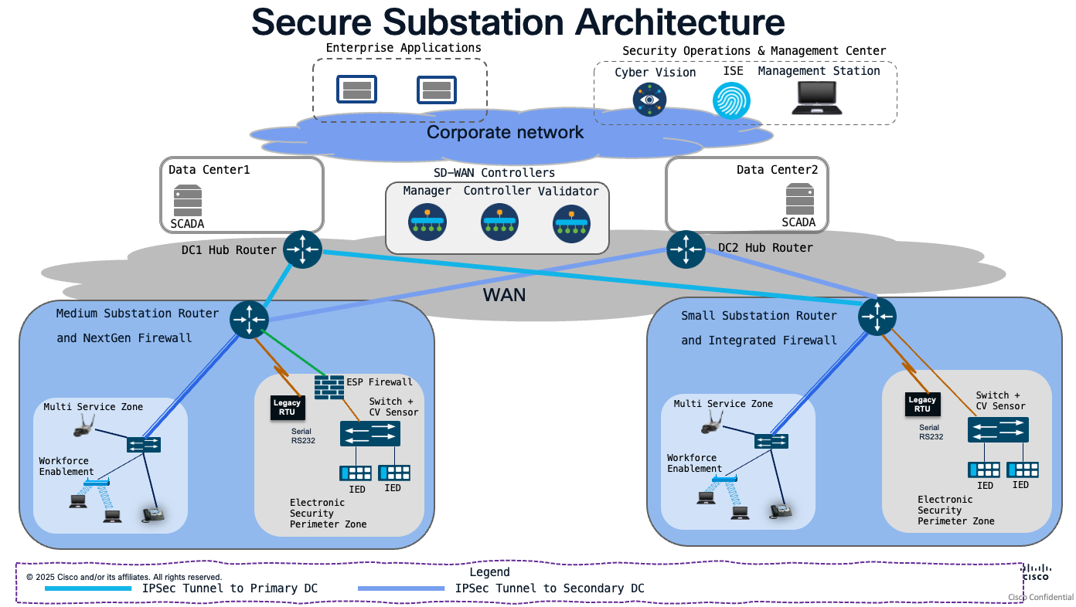

WAN Edge Aggregation at Data Center routers:
The secure substation architecture utilizes a robust WAN edge aggregation strategy, where substation spokes terminate at primary and secondary hub routers located in Data Center 1 (DC1) and Data Center 2 (DC2). These hub routers serve as the critical transit points for traffic between the substation environment and the corporate network.

The dual-hub deployment across geographically redundant data centers ensures high availability through automated path failover, while the centralized SD-WAN control plane guarantees consistent security and routing policy enforcement across all substation spokes.

Path Redundancy:

Deploying hub routers in two geographically separate data centers (DC1 and DC2) creates a dual-homed environment for substation spokes. The tunnels from substation routers to both DC1 and DC2 hubs are typically established and remain active by default, resulting in an Active/Active state at the IPsec tunnel level. If one data center or hub router becomes unreachable, the SD-WAN fabric automatically reroutes traffic to the secondary hub.

Active/Standby behaviour can be configured through control policies or routing preferences, where one hub serves as the primary and the other as the backup; however, this is a design choice rather than the default configuration.

Consistent Policy Enforcement:

Policies (security, QoS, routing) are defined centrally on the vManage controller and pushed to the vSmart controllers. Because the vSmart controllers distribute the same policy sets to all hub routers, you ensure that a "SCADA" or "Management" service VPN is treated exactly the same way, regardless of which data center the traffic traverses. This eliminates the "configuration drift" common in traditional, box-by-box managed environments.

WAN Edge Scaling and Deployment Considerations:

For guidance on scaling of WAN Edge routers and SD-WAN deployment best practices, for SD-WAN controller positioning, please consult the Cisco SD-WAN Design Guide. This documentation assumes that SD-WAN data tunnels are already established and operational, providing the necessary foundation for service VPN communication between spokes and hubs.

Service Segmentation:
To ensure strict logical isolation, the architecture employs Service VPNs (or VRFs) that terminate directly on the DC1 and DC2 hub routers. This approach maintains end-to-end segregation of traffic, ensuring that distinct functional domains—such as SCADA applications, enterprise applications, security operations, and management services—remain isolated from one another throughout the transit path.

Various services are segregated using service VPNs. Example of services include SCADA service, Physical security service, VOIP service, Security Operations & Management Service, Work Force service, and so on.

The following table outlines the mapping of functional requirements to specific Service VPNs, ensuring consistent policy enforcement across the substation environment.

Device/Functionality | Service VPN (SVC) name
SCADA communication traffic | SCADA-SVC
Physical security (Surveillance/Cameras) | PHYSEC-SVC
VOIP Phone/Voice Communication | VOIP-SVC
Security Operations, Management, 802.1X/ISE | SEC-OPS-MGMT-SVC
User access and workforce enablement | WORKFORCE-SVC

The architecture supports two primary models for service termination, providing the flexibility to accommodate diverse application requirements:
  - Local Service Termination: Services are processed and terminated directly within the Data Center environment.
  - Extended Service Connectivity: Services are segregated at the WAN edge but extended across the corporate network

Deployment Flexibility: The architecture supports both local data center hosting and extended service connectivity, allowing for a hybrid approach to application placement. This allows architects to optimize traffic paths based on specific service requirements.

Local Service Termination:

This model is utilized for applications that are co-located within the data center environment, ensuring minimal latency and direct injection into the service fabric.

As an example, the SCADA application resides directly within the data center. It is connected locally to the DC Hub Router, where it is mapped to the SCADA-specific Service VPN. This provides a direct, high-performance path for time-sensitive industrial control traffic.

Extended Service Connectivity:

For applications hosted outside the data centre, the architecture extends the specific Service VPNs across the corporate network. This allows for secure, segmented access while maintaining the logical separation of the traffic flows.

Security Operations & Management Applications such as Cisco ISE, Cyber Vision, and other management stations are hosted within the Security Operations & Management Center. These are accessed by extending the dedicated “Security Operations & Management Service VPN” (SEC-OPS-MGMT-SVC) across the corporate network to the hub routers.

Enterprise/IT Applications: General enterprise applications reside within the Enterprise Applications Center. These could be physical security monitoring applications, voice management applications, email & instant messaging access. These are similarly reached via a separate, dedicated Enterprise Service VPNs (like PHYSEC-SVC, VOIP-SVC, WORKFORCE-SVC) that are extended across the corporate network.

Summary of Service Segregation – with connectivity model:

Device/Functionality | Service VPN (SVC) name | Connectivity Model
SCADA communication traffic | SCADA-SVC | Local Service Termination
Physical security (Surveillance/Cameras) | PHYSEC-SVC | Extended Service Connectivity
VOIP Phone/Voice Communication | VOIP-SVC | Extended Service Connectivity
Security Operations, Management, 802.1X/ISE | SEC-OPS-MGMT-SVC | Extended Service Connectivity
User access and workforce enablement | WORKFORCE-SVC | Extended Service Connectivity

Summary of Architectural Considerations:
The following points summarize the key design principles for this WAN and service integration:

- Scalable Aggregation: Centralized hub routers in dual data centers provide high availability.
- Logical Isolation: The use of Service VPNs ensures that sensitive SCADA, Enterprise/IT services, management and security services, and workforce traffic remain cryptographically and logically separated.
- Scalability: This modular approach allows you to add new services in the future simply by defining a new Service VPN and extending it to the required destination, without impacting existing traffic flows.
- Deployment Flexibility: The architecture supports both local data center hosting and extended connectivity, allowing for a hybrid approach to application placement.
- Policy Consistency: Extending the Service VPN/VRF over the corporate network ensures that security policies applied at the substation edge are maintained consistently across the entire transit path to the application source.

Platform Considerations for Data Center Hub Routers:

When selecting a Data Center (DC) Hub router, the choice must be driven by the specific scale and performance requirements of the SD-WAN overlay. Key factors include SD-WAN IPsec throughput, the number of transports required at spoke, the total number of concurrent SD-WAN overlay tunnels, and the required port density.

References:
Cisco 8500 Series (PQC ready) Secure Routers Data Sheet
Cisco Catalyst 8500 Series Edge Platforms Data Sheet
Cisco Catalyst 8300 Series Edge Platforms Data Sheet

SD-WAN Scaling Considerations:

The number of overlay tunnels is determined by the TLOC configuration at both the substation router (spoke) and the Data Center router (hub). The following scenarios define the scale requirements:

TLOC Configuration:

Router role | Ethernet | Cellular | Total TLOCs | Description
Substation Router (Dual Transport) | Yes | Yes | 2 | 1 TLOC per Ethernet WAN +  1 TLOC per Cellular WAN
Substation Router (Single Transport) | Yes | - | 1 | 1 TLOC per Ethernet WAN
Substation Router (Single Transport) | - | Yes | 1 | 1 TLOC per Cellular WAN
Data Center Hub Router | Yes | - | 1* | 1 TLOC per Hub Router  (1x Ethernet WAN interface)

The TLOC counts above assume that all Spoke transport types (Ethernet and Cellular) can reach the Hub router’s Ethernet interface.
(*) Refer NAT requirements for Mixed Transport below.

NAT requirements for Mixed Transport:
In deployments where the Hub router’s Ethernet interface resides on a private network, the Spoke’s Ethernet transport can establish tunnels via direct private routing. However, if the Cellular transport (Public Internet) lacks direct reachability to the Hub’s private Ethernet interface, NAT/Port Forwarding must be deployed at the Data Center’s public internet boundary. This configuration maps the public-facing NAT IP to the Hub’s private Ethernet interface, ensuring that Cellular-originated tunnel traffic is correctly translated and forwarded to the Hub.

Tunnel Calculation (Per Substation):

The total number of IPsec tunnels per substation is calculated based on the connectivity to two geographically redundant hubs (DC1 and DC2):

Substation Router transport type | TLOCs per spoke | TLOCs per Hub | Total Tunnels (DC1 + DC2)
Dual-Transport | 2 | 1 | 4 Tunnels (2 Tunnels per DC)
Single-Transport | 1 | 1 | 2 Tunnels (1 Tunnel per DC)

Formula: Total Tunnels = (Spoke TLOCs) × (Hub TLOCs per DC) × (Number of DCs)
Note: Total tunnel count is a critical factor for OMP scale and control plane stability. Ensure the selected router models for Hub router(Catalyst 8300/8500) are sized to support the aggregate tunnel count across all sites.

Hub Aggregation Capacity

Based on the Cisco Catalyst 8300 limit of *6,000 tunnels:

Substation Router transport type | TLOCs per spoke | TLOCs per Hub | Number of substations that can be aggregated
Dual-Transport | 2 | 1 | 6000/2 = 3000 substations
Single-Transport | 1 | 1 | 6000/1 = 6000 substations

Based on the Cisco Catalyst 8500 limit of 8,000-*10,000 tunnels:

Substation Router transport type | TLOCs per spoke | TLOCs per Hub | Number of substations that can be aggregated
Dual-Transport | 2 | 1 | 10000/2 = 5000 substations
Single-Transport | 1 | 1 | 10000/1 = 10000 substations

“*6000/*10000 tunnels” please refer to data sheet for latest numbers. The example mentioned above is for reference purpose only.

Data Centre Hub Router - Throughput Sizing and Capacity Planning:

To maintain optimal network performance and low latency, the Data Center Hub router must be sized to accommodate the aggregate volume of traffic from all remote substations.

Performance Calculation:
The required hub capacity is determined by the following formula:
Total Aggregate Traffic = (Average Throughput per Substation) × (Total Number of Substations)

Platform Selection Recommendation:

It is recommended to select a Hub router with an SD-WAN IPsec (IMIX) throughput rating that meets or exceeds the calculated aggregate traffic. Designers should refer to the platform’s data sheet and account for a 20–30% headroom to accommodate future growth, bursty traffic patterns, and the overhead of additional services (such as Firewall or DPI).

Standard Performance: For aggregate throughput requirements below 7.6 Gbps (IPsec IMIX), the Cisco Catalyst 8300 Series is recommended

High Performance: For aggregate throughput requirements exceeding 7.8 Gbps (IPsec IMIX), the Cisco Catalyst 8500 Series (e.g., C8500-12X) is required

PQC-Ready High Performance: For high-performance deployments requiring Post-Quantum Cryptography (PQC) readiness, the Cisco Catalyst 8500 Series Secure Routers (e.g., C8550-G2) are the required platforms.

Platform Selection Scenarios (Scale vs. Throughput):

The following examples illustrate how to select a platform based on the number of substations and their transport configurations, assuming a dual-homed environment (DC1 and DC2) where each hub has one WAN TLOC.

Substation Router transport type | Tunnels per Hub | Max Substations (Cat 8300) | Max Substations  (Cat 8500)
Single Transport  (Cellular or Ethernet) | 1 | Up to 6,000 | Up to 10,000
Dual Transport  (Cellular and Ethernet) | 2 | Up to 3,000 | Up to 5,000

Platform Selection - Scenario-Based Examples:

Combine this decision along with the throughput-based platform selection recommendation mentioned earlier.

Example 1: A deployment of 6,000 substations using Single Transport (Cellular only).
Total Tunnels per Hub: 6,000.
Choice: Cisco Catalyst 8300 Series (meeting the maximum scale limit).

Example 2: A deployment of 3,000 substations using Dual Transport (Cellular + Ethernet).
Total Tunnels per Hub: 6,000.
Choice: Cisco Catalyst 8300 Series (meeting the maximum scale limit).

For the high-scale scenarios listed below, the Cisco Catalyst 8500 Series is required, with the Secure variant strongly recommended to ensure enhanced security, PQC readiness and future-proof capabilities.

Example 3: A deployment of more than 3,000 substations using Dual Transport.
Total Tunnels per Hub: > 6,000.
Choice: Required for higher tunnel density

Example 4: A deployment of more than 6,000 substations using Single Transport.
Total Tunnels per Hub: > 6,000.
Choice: Required for higher tunnel density

Example 5: A deployment of 5,000 substations using Dual Transport.
Total Tunnels per Hub: 10,000.
Choice: Required for high-scale headend aggregation

Example 6: A deployment of 10,000 substations using Single Transport.
Total Tunnels per Hub: 10,000.
Choice: Required for high-scale headend aggregation

Headend Redundancy and Traffic Steering Models:
In Cisco SD-WAN, the distinction between these architectures is primarily driven by TLOC (Transport Locator) Preference and OMP (Overlay Management Protocol) Path Selection.

Active/Standby Headend Architecture (Deterministic Path):
In an Active/Standby design, control plane can be influenced in such a way that the spokes prefer one hub over the other. This is achieved using TLOC Preference or OMP Cost.

Active/Standby architecture is best for Architectures where traffic predictability is paramount, or where security policies require all traffic to pass through a specific primary inspection point (e.g., a specific firewall cluster).

Technical Mechanism:

The Primary hub (DC1) is configured to advertise routes with a higher TLOC preference (or lower OMP cost) than the secondary hub (DC2). The substation routers will install the DC1 path into their Forwarding Information Base (FIB) and keep the DC2 path in the routing table as a backup.

Failover Mechanism:

If the primary DC1 hub becomes unreachable (TLOC disappears), the SD-WAN fabric automatically promotes the DC2 path to the active state. Because the tunnels to DC2 are already established (pre-warmed), the failover is rapid.

Operational Benefits:

Provides a highly deterministic traffic flow. Troubleshooting is simplified because the path taken by packets is consistent and predictable.

Active/Active Headend Architecture (Load-Sharing):
In an Active/Active headend architecture, substation spokes maintain concurrent, active IPsec tunnels to both DC1 and DC2 hub routers. Traffic is load-balanced across both paths, effectively utilizing the bandwidth of both data centres simultaneously. By default, the Cisco SD-WAN control plane advertises identical OMP (Overlay Management Protocol) route metrics from both hubs, enabling the spokes to perform Equal-Cost Multi-Path (ECMP) load sharing.

Active/Active architecture is best for environments requiring maximum bandwidth utilization. This design provides high availability and ensures that both primary and secondary data centers are providing value.

Technical Mechanism:

- ECMP & OMP: Spokes receive identical routing information from both DCs and load-balance traffic across both paths at the flow level. Both hubs advertise the same service routes (or subnets) with the same OMP cost. The spokes see two TLOCs for the same destination and utilize both for traffic forwarding.

- Application-Aware Routing (AAR): Policies are applied to steer specific applications over the optimal path. For example, SCADA traffic can be pinned to the path with the lowest latency, while management traffic utilizes the alternative path.

- BFD-Driven Resiliency: BFD runs continuously on all tunnels. If a tunnel to DC1 fails, BFD detects the loss, and the spoke immediately redirects all traffic to the active DC2 tunnel with sub-second convergence.

Operational Benefits:

- Optimized Resource Utilization: Maximizes the return on investment for data center infrastructure by ensuring both hubs are actively processing traffic.

- Failover: Because tunnels are already established and actively passing traffic, the SD-WAN fabric can reroute traffic instantly if one path fails, minimizing disruption to sensitive SCADA applications.

- Dynamic Load Balancing: The SD-WAN control plane can dynamically distribute traffic flows based on real-time path performance metrics (e.g., latency, jitter, and loss).
Consideration: Requires careful monitoring of path symmetry. If your firewalls or security appliances are stateful, ensure that return traffic is handled correctly across the dual-hub environment.

Active/Active vs Active/Standby - Architectural Comparison Summary:

Feature | Active/Active (Load-Sharing) | Active/Standby (Deterministic)
Primary Mechanism | Equal OMP Cost / ECMP | TLOC Preference / OMP Cost
Bandwidth Usage | Aggregated across both hubs | Utilizes primary hub only
Traffic Flow | Dynamic / Load-balanced | Deterministic / Predictable
Complexity | Moderate (Requires symmetry checks) | Low (Easier to audit/troubleshoot)
Failover | Immediate (Path-based) | Immediate (Control plane update)

Chapter 6 Medium Substation Design (Praveen)
- Use Case and Applicability
- Validated Medium Substation Topology
- Single IR8340 Edge Design
- IE9320 and IE3x00 LAN Zone Design
- Integrated Firewall Design
- Discrete Firewall Design
- WAN Connectivity and SD-WAN Onboarding
- Service VPN and Zone Segmentation Model
- VRF Design for SCADA, Physical Security, Workforce, and Management Services
- NGFW Policy for DNP3 and SCADA Traffic
- UTD IDS and IPS Design
- DNP3 Inspection and Custom SNORT Rules
- RAW Socket Transport for Legacy Serial Devices
- Network Access Control for LAN-Side Devices
- Cyber Vision Sensor Placement and East-West Visibility
- Traffic Profile and Scale Considerations
- Medium Deployment Configuration Catalogue

This chapter describes the medium transmission substation design for the Secure Substation CVD. It applies the security reference architecture and security design principles from earlier chapters to a validated medium substation profile using the Cisco IR8340 as the substation WAN edge router and Cisco Industrial Ethernet switching for the station LAN.

Use Case and Applicability
The medium substation profile and solution-wide requirements are defined in earlier chapters. This chapter applies those requirements to the site-level design for a medium transmission substation using a Cisco IR8340 WAN edge router, Cisco Industrial Ethernet switching, service VPN segmentation, and integrated or discrete firewall enforcement.
The validated design supports the following use cases:
- SCADA monitoring and control between the substation and OT data center.
- Station bus communication for substation automation and monitoring.
- PMU or synchrophasor traffic where deployed.
- Physical security services such as cameras, badge readers, alarms, and associated monitoring systems.
- Controlled workforce enablement for field technicians, protection engineers, and approved vendors.
- Management access for routers, switches, firewall functions, Cyber Vision, identity services, logging, and software lifecycle operations.
- Legacy serial integration using RS-232, raw socket transport, or serial pseudowire where legacy devices remain in service.

Validated Medium Substation Topology
The validated medium topology uses a single Cisco IR8340 as the substation WAN edge router. The IR8340 connects the medium substation to the utility WAN and aggregates services from the station LAN, physical security systems, management services, workforce access services, PMU devices, and legacy serial devices.
The station LAN uses a Cisco IE9320 Industrial Ethernet switch to connect IEDs, RTUs, gateways, protection relays, PMU devices, engineering systems, management endpoints, physical security devices, and Cyber Vision sensor functions.
The OT data center provides SCADA and control center applications. Primary and secondary OT data center WAN edge hubs in DC1 and DC2 terminate substation WAN connectivity. The SOC consumes Cyber Vision data, firewall events, authentication events, IDS/IPS events, and other security telemetry. The NOC operates Catalyst WAN Manager and related WAN lifecycle functions.
Figure 7-1 shows the validated medium substation topology. To be filled.

Figure 7-1. Validated Medium Substation Topology
The topology supports two firewall placement options:
- Design Option 1: Integrated Firewall - The IR8340 provides WAN edge routing, service VPN/VRF termination, segmentation, and firewall enforcement on the same platform.
- Design Option 2: Discrete Firewall - The IR8340 provides WAN edge routing and service aggregation, while a separate firewall enforces policy at the ESP boundary or between major service segments.
Both options use the same logical service-separation model. The selection depends on inspection requirements, operational ownership, footprint, power, availability requirements, policy lifecycle, and utility security standards.

Design Option 1: Integrated Firewall
In the integrated firewall option, the IR8340 provides WAN edge routing, service VPN/VRF termination, station LAN handoff, segmentation, and firewall enforcement on the same platform. This model is useful when the utility wants a compact medium substation design with fewer devices, simplified cabling, lower power consumption, and centralized lifecycle operations.
The IR8340 is the substation WAN edge router and the ESP boundary policy enforcement point. It is mapped as the Electronic Access Point for routable connectivity into and out of the ESP and as an Electronic Access Control or Monitoring System because it provides firewall enforcement, access control, logging, and monitoring for ESP-bound traffic. Interactive Remote Access is handled through the approved workforce access service path and associated remote access control components.

Integrated Firewall Implementation
The integrated firewall option is implemented by using the IR8340 as the WAN edge router, service VPN/VRF termination point, and ESP boundary enforcement point. The design uses routed interfaces or subinterfaces, service VPNs implemented as VRFs, firewall zones, and explicit inter-zone policy to control traffic between the WAN, station LAN, protected OT assets, management services, physical security services, workforce access services, and legacy serial services.
Throughput is validated by building a traffic profile for the medium substation and comparing it against the validated IR8340 platform and software release. The profile should include baseline SCADA traffic, PMU traffic where deployed, Cyber Vision telemetry, physical security traffic, management traffic, logging, software updates, and WAN encryption overhead. PMU and video traffic should be accounted for separately because either service can materially change the WAN and inspection load. The final design should reserve capacity for burst traffic and future service growth.
The ESP boundary is implemented at the IR8340 policy enforcement point. The interfaces, subinterfaces, service VPNs/VRFs, and firewall zones that carry routable traffic into or out of the ESP are documented as the EAP mapping for the integrated firewall design. This mapping also identifies the IR8340 as EACMS because the platform enforces firewall policy, logs access events, and monitors ESP-bound traffic.
Firewall and threat inspection placement is identified by service path. Zone-Based Firewall provides the baseline segmentation between IR8340 zones, while NGFW, UTD IDS/IPS, and SCADA protocol inspection are applied only to the traffic paths selected in the validated design. Detailed firewall policy, signature selection, DNP3 inspection behavior, and custom Snort rule design are covered in the Firewall and Threat Inspection Design chapter.
Management traffic is carried in a separate management or security operations service VPN/VRF. Device administration, AAA, ISE, logging, Cyber Vision, backup, and software lifecycle traffic should not share the same unrestricted path as SCADA control traffic. Access from the NOC, SOC, and approved management systems is explicitly permitted; all other management access is denied by default.
Inter-service communication is controlled through least-privilege policy. Broad permits between service VPNs/VRFs are avoided. Required flows are defined by source, destination, protocol, port, and direction. Route leaking between service VPNs/VRFs is used only where required by the design and is paired with firewall policy so that routing reachability does not imply application access.
Security events are forwarded to the SOC or approved security monitoring platform. The integrated firewall design should forward firewall logs, IDS/IPS events where used, authentication events, system events, and relevant WAN or tunnel events. Time synchronization should be consistent across the IR8340, switches, Cyber Vision, identity services, and logging systems so that events can be correlated during operations and incident response.

Design Option 2: Discrete Firewall
In the discrete firewall option, the IR8340 remains the substation WAN edge router and service aggregation point. A separate firewall is placed at the ESP boundary or between major substation service segments to provide dedicated policy enforcement.
This option is useful when the utility requires dedicated firewall administration, expanded NGFW inspection, independent policy lifecycle, separate SOC ownership, or a stronger separation between routing and security enforcement functions.
The discrete firewall option can provide:
- IR8340-based WAN edge routing and service aggregation.
- Dedicated firewall placement for ESP boundary enforcement.
- Separation between WAN routing and firewall inspection functions.
- Expanded NGFW policy options where required by utility policy.
- Independent firewall software lifecycle and rule-management process.
- Clearer operational separation between NOC-managed WAN functions and SOC-managed security policy.
In the discrete firewall option, the separate firewall is the ESP boundary policy enforcement point and is mapped as the Electronic Access Point and Electronic Access Control or Monitoring System. The IR8340 remains the substation WAN edge router and service aggregation point. Interactive Remote Access is handled through the approved workforce access service path and associated remote access control components.

Discrete Firewall Design Considerations
The discrete firewall option adds hardware, cabling, power, and operational handoff points. It can be selected when the utility requires a dedicated security enforcement platform between the WAN edge and the protected station LAN services.
In this option, the firewall placement should make the ESP boundary clear and enforceable. Traffic between the IR8340, station LAN, and protected service segments should pass through the discrete firewall where policy enforcement is required, and the topology should avoid alternate paths that bypass the firewall.
Routing between the IR8340, firewall, station LAN, and service segments should align with the service VPN/VRF and VLAN design. Firewall policy, route exchange, interface zoning, and log forwarding to the SOC should be treated as one coordinated design so that segmentation, inspection, and monitoring remain consistent across the WAN edge and local LAN boundary.
Where the firewall platform supports fail-open, fail-close, or bypass behavior, the selected mode should match the utility's operational policy for the protected service. The behavior should be applied deliberately because the selected mode affects both ESP boundary enforcement and service continuity.

Single IR8340 Edge Design
The single IR8340 edge design consolidates WAN connectivity, routing, service VPN/VRF termination, segmentation, firewall integration, and legacy serial support into one ruggedized substation platform.
The IR8340 provides the following functions in the medium substation design:
- WAN edge connectivity to primary and secondary OT data center WAN edge hubs.
- Service aggregation for SCADA, physical security, workforce, management, security operations, PMU, voice, enterprise, and legacy serial traffic.
- Service VPN/VRF separation for traffic classes with different trust levels.
- VLAN termination or routed handoff from the station LAN.
- Zone-Based Firewall and integrated security functions where used.
- UTD IDS or IPS functions where supported by the platform and validated software release.
- Serial integration using raw socket or serial pseudowire options.
- Catalyst WAN Manager-based lifecycle operation where centralized management is used.
The single-edge model reduces site footprint and simplifies deployment. The tradeoff is that WAN connectivity, routing, segmentation, and integrated firewall functions share a common platform. Failure behavior, restart behavior, management-plane loss, and WAN failover should be documented and validated before production deployment.

WAN Aggregation for the Medium Substation
The medium substation IR8340 operates as a WAN spoke and follows the WAN edge aggregation recommendations defined in Chapter 5, WAN Edge Aggregation and Service Segmentation Architecture. The IR8340 is aggregated by OT data center WAN edge hub routers located in geographically redundant data centers, DC1 and DC2.
Chapter 5 defines the common aggregation model, including hub-and-spoke connectivity, active/active and active/standby headend steering options, TLOC and tunnel-count scaling, hub platform sizing, northbound and southbound connectivity, local service termination, and extended service connectivity. This chapter does not repeat those details.
For the medium substation, the site design identifies the following IR8340-specific values:
- WAN transport type, such as fiber, MPLS/SR, or Cellular/LTE.
- Single-transport or dual-transport spoke model.
- DC1 and DC2 hub routers used for aggregation.
- Active/active or active/standby headend steering model.
- Transport Locator count for the medium substation spoke.
- IPsec tunnel requirements and expected tunnel count.
- Service VPN/VRF mapping at the substation IR8340 and OT data center hubs.
- Local service termination and extended service connectivity requirements.

Northbound and Southbound Connectivity
The medium substation design uses the northbound and southbound connectivity model defined in Chapter 5. This chapter identifies only the medium-substation service placement: which services terminate locally in the OT data center and which services extend northbound to approved SOC, NOC, security operations, enterprise, or corporate application environments.

Service VPN Architecture for Medium Substation
Service VPNs provide overlay service segmentation. On the IR8340 and OT data center WAN edge hubs, these service VPNs are implemented as VRFs or equivalent routing instances. This chapter uses service VPN/VRF to describe the service segment carried across the WAN and enforced on the router.
The medium substation uses the service segmentation recommendations from Chapter 5. The service VPN/VRF mapping below applies that model to the medium substation design and adds medium-substation-specific services, such as PMU and legacy serial transport where deployed.
The following table provides a baseline service mapping for the medium substation design.
Device or Function | Service VPN Name
SCADA communication traffic | SCADA-SVC
Physical security, surveillance, cameras, alarms | PHYSEC-SVC
Voice and phone services | VOIP-SVC
Security operations, management, Cyber Vision, ISE, logging | SEC-OPS-MGMT-SVC
Workforce enablement and approved user access | WORKFORCE-SVC
PMU or synchrophasor traffic where deployed | PMU-SVC
Legacy serial traffic mapped to IP transport | mapped to SCADA-SVC
The service names shown in the table are illustrative. Utilities may use a different naming convention, but the design should preserve the Chapter 5 service segmentation intent and document the mapping between service VPNs/VRFs, VLANs, firewall zones, and application destinations.

Service VPN/VRF to Zone-Based Firewall Zone Mapping

In the integrated firewall option, service VPNs provide routing and overlay segmentation, while Zone-Based Firewall zones define the local policy enforcement boundary on the IR8340. A service VPN is implemented as a VRF or routing instance, and the IR8340 interfaces or subinterfaces associated with that service are assigned to the appropriate firewall zone. Firewall policy is applied when traffic crosses between zones.
The recommended design is to align ZBFW zones with trust and policy boundaries. A service VPN/VRF should map to a dedicated firewall zone when the service has a distinct trust level, destination set, inspection requirement, or operational behaviour. Multiple VLANs or interfaces can share a firewall zone only when they belong to the same service boundary and require the same policy treatment. Services with different trust levels, such as SCADA, management, workforce access, physical security, and enterprise support traffic, should not be combined in the same firewall zone.

Service | Service VPN/VRF | Typical ZBFW Zone | Design Intent
SCADA and station bus traffic | SCADA-SVC | ESP-ZONE | Protect routable communication to OT assets inside the ESP.
PMU traffic | PMU-SVC or SCADA-SVC | ESP-ZONE or PMU-ZONE | Keep PMU flows aligned to the SCADA service model or separate them when bandwidth, policy, or destination requirements differ.
Physical security traffic | PHYSEC-SVC | PHYSEC-ZONE | Separate camera, badge, and physical security services from SCADA control traffic.
Workforce access traffic | WORKFORCE-SVC | WORKFORCE-ZONE | Control field engineering, remote desktop, and approved workforce access paths.
Security operations and management traffic | SEC-OPS-MGMT-SVC | MGMT-ZONE | Carry device administration, ISE, Cyber Vision, logging, backup, and software lifecycle traffic separately from control traffic.
Legacy serial traffic mapped to IP transport | LEGACY-SERIAL-SVC or SCADA-SVC | ESP-ZONE | Keep raw socket or serial pseudowire traffic aligned to the protected OT service it supports.
The zone assignment should reflect the policy intent for the service. SCADA, station bus, and legacy serial traffic remain aligned to the protected OT service. Physical security, workforce access, and management or security operations traffic are separated from SCADA control traffic because they have different trust levels, destinations, and operational behavior.
For the discrete firewall option, the same service VPN/VRF intent is preserved, but firewall zone enforcement is provided by the discrete firewall rather than by ZBFW on the IR8340. The IR8340 remains the WAN edge and service aggregation point, and the firewall interfaces or subinterfaces provide the policy boundaries for traffic entering or leaving protected service segments.

IE9320 LAN Design
The medium substation LAN uses a Cisco IE9320 Industrial Ethernet switch to provide ruggedized station LAN connectivity. The switch connects station bus devices, IEDs, RTUs, gateways, PMU devices, engineering workstations, physical security endpoints, management interfaces, and Cyber Vision sensor functions.
The LAN design should separate endpoints based on function, criticality, and required communication paths. VLANs provide local Layer 2 separation. Routed interfaces, service VPNs/VRFs, and firewall policy zones provide higher-level separation and policy enforcement.

LAN Design Considerations
The LAN design should avoid a flat station network. Endpoints should be assigned to VLANs or routed segments according to their function and communication requirements.
Key design considerations include:
- Keep SCADA and station bus communication paths tightly scoped.
- Separate physical security traffic from SCADA control traffic.
- Separate management access from control traffic.
- Use trunking only where required and limit allowed VLANs.
- Apply storm control and multicast controls where required by the traffic profile.
- Avoid unmanaged switch placement inside protected areas.
- Document Cyber Vision monitoring points and expected east-west visibility.
- Validate spanning tree or ring behavior if redundant Layer 2 paths are used.

Firewall and Threat Inspection Placement
Firewall and threat inspection design is covered in a separate chapter. In this medium substation chapter, the design identifies where inspection functions are placed in the validated topology.
In the integrated firewall option, the IR8340 is the ESP boundary enforcement point. ZBFW, NGFW, UTD IDS/IPS, and SCADA protocol inspection are applied on the IR8340 where supported by the validated platform and software release. In the discrete firewall option, the separate firewall is the primary ESP boundary inspection point, while the IR8340 remains the WAN edge router and service aggregation point.
The detailed policy definition, service-path selection, IDS or IPS mode selection, DNP3 inspection behavior, custom Snort rule logic, signature update model, and blocking criteria are defined in the Firewall and Threat Inspection Design chapter.

Raw Socket Transport for Legacy Serial Devices
Medium substations may include legacy serial RTUs, meters, protection devices, or automation systems that must remain operational during modernization. The IR8340 supports serial integration options that allow legacy serial traffic to be carried across the IP architecture.
Raw socket transport is a design option for carrying serial traffic as IP flows. VRF-aware raw socket options allow serial traffic to remain aligned with the same segmentation model used for Ethernet services. For example, serial SCADA traffic can be mapped to the SCADA-SVC service VPN/VRF while management traffic remains in a separate management service VPN/VRF.
In this option, a legacy RTU or serial device can be associated with a specific control center destination, such as a SCADA front-end processor, headend serial gateway, or SCADA application that can consume raw socket traffic directly. The IR8340 provides the local RS-232 serial attachment and carries the serial stream as an IP flow using the selected service VPN/VRF, source interface, destination address, and TCP or UDP port.
A TCP-based raw socket session can be used when the application requires a connection-oriented client/server model and benefits from TCP session retry behavior. A UDP-based raw socket session can be used when the application expects peer-to-peer transport and the utility application handles loss or retry behavior. Packetization can be tuned to the serial protocol and application behavior, using criteria such as packet length, delimiter character, or timeout so that the IP flow preserves the expected serial exchange pattern.
Where redundant serial or headend connectivity is required, the RTU, serial interface, service VPN/VRF, and primary or secondary control center endpoint should be mapped consistently. This allows operational teams to troubleshoot the serial circuit, raw socket session, WAN path, and SCADA application endpoint as one service path rather than as unrelated components.
Serial pseudowire is another design option where the utility-owned MPLS/SR service requires circuit-like transport for legacy serial traffic. In this model, the IR8340 at the substation and the control center provider edge can terminate the pseudowire, with either serial-to-serial or serial-to-Ethernet interworking toward the SCADA front-end processor. Raw socket is generally the simpler option when the control center application or redirector can consume serial traffic over IP without preserving a Layer 2 circuit.

Network Access Control for LAN-Side Devices
Network Access Control provides device admission control for LAN-side devices. In medium substations, endpoint diversity requires support for both 802.1X and MAC Authentication Bypass.
802.1X is appropriate for endpoints that support supplicant-based authentication, such as engineering workstations or managed systems. MAB is used for devices that cannot support 802.1X, such as legacy IEDs, RTUs, cameras, badge readers, or embedded controllers.
An 802.1X-based access model can be used for managed endpoints where supplicant configuration, certificate handling, and user or device authentication are operationally supportable. A MAB-based access model can be used for fixed-function OT devices that cannot run a supplicant. Cisco ISE, or the approved identity platform, can profile these endpoints and return an authorization result that places the device into the appropriate VLAN, applies an ACL, or assigns the endpoint to the required service segment.
Unknown or unauthorized endpoints can be handled with a restricted authorization result, quarantine segment, or denied access based on the utility policy. This model allows field replacement workflows to support approved device swaps while still preventing uncontrolled endpoint attachment to the station LAN.
NAC should be introduced carefully in medium substations. Monitor mode or low-impact mode can be used before enforcement so the utility can validate the inventory, confirm expected 802.1X and MAB behavior, and review authentication events without disrupting operational devices. Authentication success, failure, profiling, and authorization events should be forwarded to the SOC or approved monitoring platform.

Cyber Vision Sensor Placement and East-West Visibility
Cisco Cyber Vision provides asset visibility, protocol awareness, baseline creation, and anomaly detection inside the medium substation LAN. The IE9320-based station LAN provides the monitoring point for observing east-west traffic between station LAN endpoints.
Cyber Vision placement should provide visibility into:
- SCADA and station bus communication patterns.
- IED, RTU, gateway, and PMU communication relationships.
- Physical security and multiservice traffic where included in monitoring scope.
- Baseline behavior for known assets, protocols, and communication relationships.
- Anomaly detection for deviations from established traffic and asset behavior.
- Unexpected or unauthorized device communication.
- Protocol behavior that supports incident investigation.
Cyber Vision communications should be mapped to the security operations and management service model and forwarded to the appropriate SOC or security center systems. The sensor communication path should be separated from SCADA control traffic and documented as part of the design.

Traffic Profile and Scale Considerations
Medium transmission substations typically have larger telemetry, control, and monitoring requirements than small transmission substations. Scale planning should account for the full mix of SCADA, PMU, Cyber Vision, physical security, workforce, management, logging, software update, voice, and legacy serial traffic.
The baseline planning profile is:
- Typical point count: 500-1,500 points.
- Average throughput without PMUs: 0.5-2 Mbps.
- Additional PMU throughput: approximately 5-10 Mbps per PMU.
- Typical WAN provisioning: 10-50 Mbps using fiber, MPLS/SR, or Cellular/LTE, based on site availability and service requirements.
- Common protocols: IEC 61850 MMS, DNP3, ICCP, Modbus TCP, IEEE C37.118, HTTPS, SCP, SSH, and serial traffic.
Sizing should include encryption overhead, firewall inspection overhead, event bursts, PMU reporting rates, video or physical security traffic, Cyber Vision telemetry, and software update behavior. PMU traffic should be planned independently from baseline SCADA traffic because a single PMU can materially change the WAN bandwidth profile.
For the hub aggregation design, medium substation bandwidth should also be included in the aggregate OT data center hub capacity calculation. The hub capacity requirement is based on average or engineered throughput per substation multiplied by the number of substations, with additional headroom for burst traffic, encryption overhead, security inspection, and future service growth.

Medium Substation Design Summary
The medium substation design provides a repeatable architecture for securing transmission substations with higher point counts, broader service separation needs, and larger WAN profiles than small substations. The Cisco IR8340 acts as the substation WAN edge router and supports WAN connectivity, DC1/DC2 aggregation, service VPN/VRF separation, integrated or discrete firewall models, UTD IDS/IPS, legacy serial integration, and Catalyst WAN Manager-based lifecycle operation where centralized management is used.
The design uses a Cisco IE9320 Industrial Ethernet switch for LAN-side connectivity and Cyber Vision visibility. It supports SCADA, PMU, physical security, workforce access, management, security operations, voice, enterprise, and legacy serial traffic through a structured model based on NERC CIP boundary constructs, service segments, and service VPNs implemented as VRFs.

Chapter 7 Small Substation Design(Arul)

Overview:

The Small Substation design is tailored for smaller distribution substations and Distribution Automation (DA) field sites. Typically accommodating a minimal footprint of devices (usually fewer than 5, and rarely exceeding 10), this architecture provides robust, secure, and highly available connectivity.

Central to this design is the Cisco Catalyst IR1101 Rugged Series Router, designated throughout this guide as the “small substation router”. Acting as the WAN edge and security boundary device, it facilitates secure southbound access for critical operational technology (IEDs and RTUs) located in Electronic Security Perimeter (ESP Zone).

The substation router also provides connectivity to other multi service applications (physical security, VoIP, and workforce access). Simultaneously, the small substation router enforces secure northbound communication by encrypting all traffic destined for the Data Center Hub routers within IPsec tunnels over the WAN.

Architecture and Topology:

The architecture is divided into distinct northbound (WAN) and southbound (LAN) connectivity models, managed centrally via Cisco SD-WAN to simplify operations and ensure consistent policy enforcement.

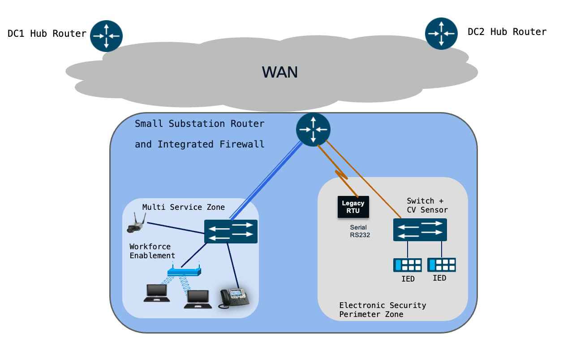
The architecture is built around a single Cisco IR1101 acting as the small substation router (secure WAN edge gateway), supported by two Industrial Ethernet switches for LAN connectivity.

Core components:
Component | Funcitonal Role
Cisco IR1101 (Small Substation Router) | Acts as Secure WAN edge gateway, providing routing, ZBFW, WAN encryption (IPsec), SD-WAN edge functions, and serial device connectivity
Cisco IE3500 | Deployed within the ESP Zone to facilitate secure connectivity for critical IEDs/utility controller devices. Cyber Vision sensor is installed on this switch.
Cisco IE3100 | Deployed within the Multi-Service Zone to aggregate non-critical traffic, including physical security, VoIP, and workforce access.
Legacy serial RTUs | Connected directly into the small substation router to support serial-to-IP transport.
IEDs and Utility controller devices | Connected to the network via the IE3500 ESP switch.
Physical Cameras, VOIP, User laptops | Connected to the network via the IE3100 Multi-Service Zone switch.
4-port expansion module (IRM-1100-4S8I) | Optional modular hardware used to increase LAN port density; one port can be optionally provisioned as an additional WAN interface.

- Northbound (WAN) Connectivity:

The small substation router connects to the WAN utilizing either single or dual transport links (e.g., Cellular and Ethernet). Functioning as an SD-WAN spoke, it establishes secure IPsec tunnels to the headend Hub routers located in DC1 and DC2, supporting both Active/Active and Active/Standby routing designs.

To accommodate scalable connectivity requirements, an optional 4-port expansion module (IRM-1100-4S8I) can be integrated. This module not only expands the number of available LAN interfaces but also provides the flexibility to provision one of its ports specifically for WAN transport.

- Southbound (LAN) Connectivity: The IR1101 provides downstream connectivity to two primary zones:
  - Electronic Security Perimeter (ESP) Zone: Utilizes the Cisco Catalyst IE3500 switch to enable secure connectivity to critical IEDs and protection assets. The IR1101 acts as the ESP boundary device, hosting the Electronic Access Point (EAP).
  - Multi-Service Zone: Utilizes the Cisco Catalyst IE3100 switch for non-critical services, including physical security cameras, workforce mobility, and VoIP.
  - Switch Management: Switch management connectivity resides in both the ESP Zone and the Multi Service Zone, delivered inline over the dedicated management VLAN.
  - Legacy Serial Devices: The router directly connects to legacy serial RTUs. Raw-socket connections are established within a dedicated service VPN, enabling serial SCADA traffic to be transported securely over IP to the SCADA FEPs in both the data centers.

Network Segmentation and Service VPNs:
Services are delivered using Service VPNs (VRFs). To maintain strict isolation between critical and non-critical traffic, services are segregated using SD-WAN Service VPNs on the small substation router, mirroring the service VPN architecture at the DC Hubs. The services located behind the hub-side service VPNs can be seamlessly reached by connecting to the corresponding service VPN on the small substation router.

VLAN-to-Service VPN Mapping:
The Layer 2 connection between the IE switches and the small substation router is configured in trunk mode, carrying the subset of VLANs required for the configured services. Management access to the IE3100 and IE3500 switches is provided inline using a dedicated management VLAN (e.g., VLAN 100).

At the substation router, there is a strict 1:1 mapping between the local VLANs and the overlay Service VPNs.

Example VLAN to Service VPN Mapping:
Device or Function | VLAN | Service VPN Name
Security Operations (Cyber Vision, ISE)  Management Services (switch management, SSH, SNMP, Syslog) | 100 | SEC-OPS-MGMT-SVC
Physical security, surveillance, cameras, alarms | 101 | PHYSEC-SVC
Workforce enablement and approved user access | 102 | WORKFORCE-SVC
Voice and phone services | 103 | VOIP-SVC
SCADA communication traffic, including legacy serial traffic | 201 | SCADA-SVC

Service Flows using service VPN:

Secure Substation – small – Various service Flows:
The figure below illustrates the end-to-end service flows for the small substation, encompassing switch management, security operations (ISE and Cyber Vision), physical security, VoIP, workforce services, and SCADA communications.

Figure x: Small Secure Substation – Various Service Flows
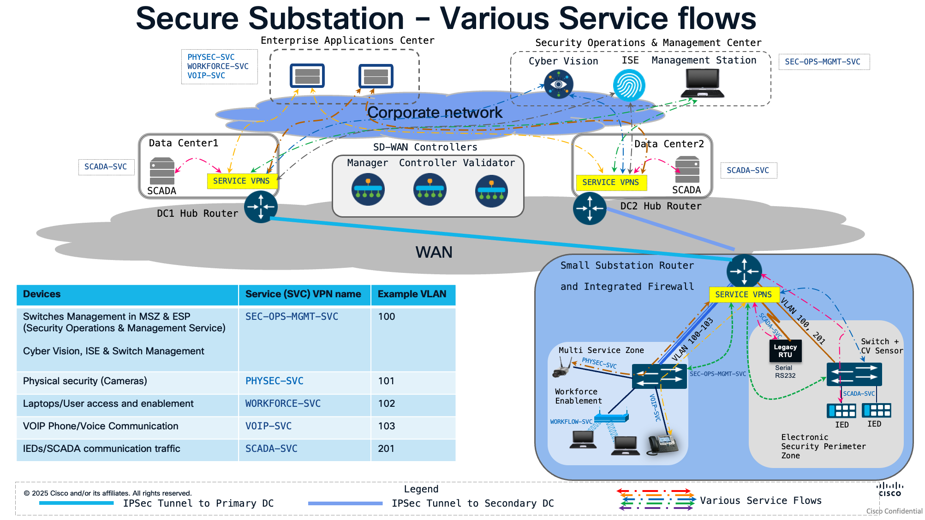

Secure Substation – small – Switch Management Service:
The following diagram illustrates management access to the switches from the central management station. This established service path is utilized for all management-plane traffic, including SSH, SNMP, and Syslog.
This path is mapped to the SEC-OPS-MGMT-SVC service VPN
Figure x: Small Secure Substation – switch management service

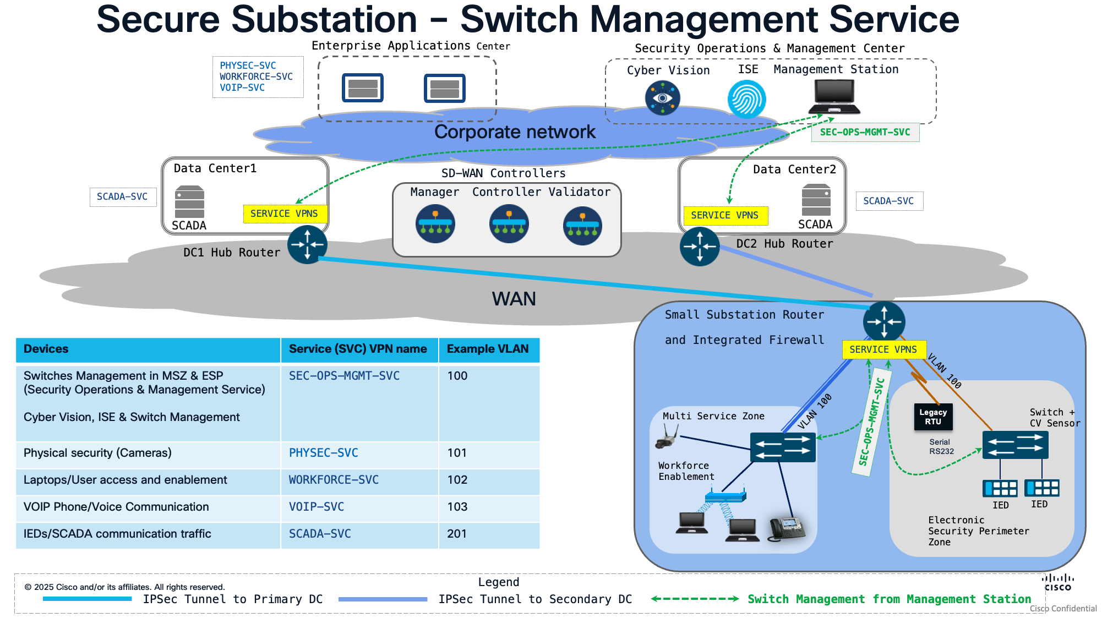

Secure Substation – small – Physical Security and VOIP Services:

The following diagram illustrates the physical security and VoIP service flows extending from the Multi-Service Zone to the Enterprise Application Center.
These traffic flows are isolated and secured using the dedicated Physical Security (PHYSEC-SVC) and Voice (VOIP-SVC) service VPNs
Figure x: Small Secure Substation – Physical security service and VOIP service

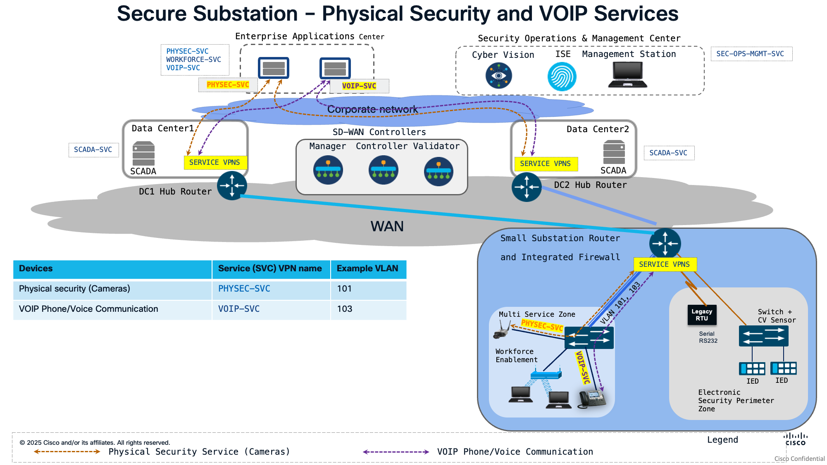

Secure Substation – small – Workforce Enablement:

The workforce enablement workflow is implemented as a two-stage process to ensure secure, policy-driven connectivity:

- Authentication and Authorization: The endpoint performs 802.1X authentication and authorization against the ISE server over the SEC-OPS-MGMT-SVC service VPN.
- Dynamic VLAN Assignment: Upon successful authorization, the device is dynamically transitioned to a dedicated VLAN mapped to the WORKFORCE-SVC service VPN.

The diagram below illustrates this workflow, showing the service path extending from the Multi-Service Zone to the Enterprise Application Center.
Figure x: Small Secure Substation – Workforce enablement service

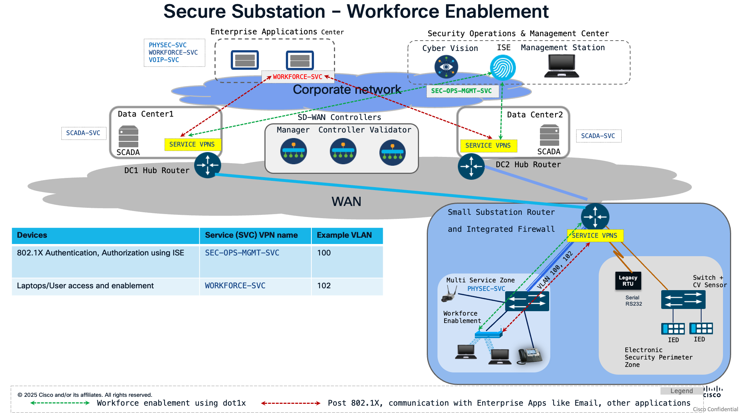

SCADA Service flow using Service VPN:
This section describes how SCADA traffic flows through the Small Substation architecture using the dedicated SCADA-SVC service VPN. SCADA is the most critical service in the Small Substation design, carrying DNP3-based control and telemetry between substation IEDs/RTUs and the SCADA systems located in the data centres (DC1 and DC2).

The Small Substation supports two distinct SCADA connectivity methods, both carried within the SCADA-SVC service VPN:
- IP-based SCADA — For modern Ethernet/IP-connected IEDs in the ESP Zone.
- Serial-based SCADA — For legacy serial RTUs, tunnelled over IP using RAW Sockets.
NOTE: The SCADA FEP is architected to communicate exclusively over the SCADA-SVC service VPN. Therefore, all SCADA traffic—whether from IP-capable IEDs or legacy serial RTUs—must be transported via this VPN to ensure end-to-end connectivity.
The small substation router utilizes the SCADA-SVC service VPN to provide a logically isolated and secure path for all SCADA-related traffic. This segmentation ensures that critical grid control communications are separated from non-critical data, meeting the stringent security requirements of utility environments.

Figure X: Small Secure Substation – SCADA service:
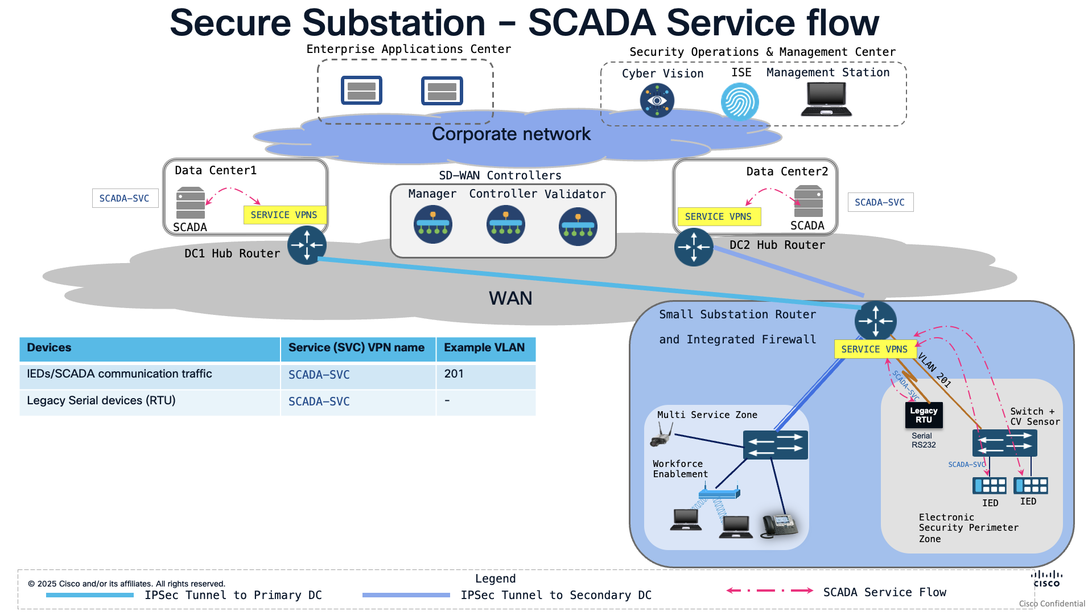

1. Native IP-Based SCADA Communication
For modern Intelligent Electronic Devices (IEDs) that support native Ethernet and IP connectivity, the small substation router facilitates direct communication with SCADA FEP in the data centres (DC1 and DC2), with the help of SCADA-SVC service VPN.

Flow Description:

- IED (ESP Zone): An Ethernet/IP-capable IED originates DNP3 traffic onto the ESP LAN.
- IE3500 switch: Receives the IED traffic on an access port, tags it with SCADA VLAN 201, and forwards it toward the small substation router across the Layer 2 trunk.
- IR1101 (ESP boundary device): Terminates VLAN 201 into the SCADA-SVC service VPN. Acting as the ESP boundary device that hosts the Electronic Access Point (EAP), the IR1101 applies the SCADA security policy through its Zone-Based Firewall (ZBFW).

IP-based SCADA traffic, such as DNP3/IP, is mapped directly into the SCADA-SVC service VPN at the small substation router. This ensures a secure, direct communication with the SCADA Front-End Processors (FEPs) located in DC1 and DC2.

2. Legacy Serial SCADA Transport via Raw Sockets
The small substation router integrates legacy Remote Terminal Units (RTUs) by utilizing TCP Raw Socket technology, which wraps raw serial data into standard TCP segments to facilitate IP-based transport.

Flow Description:
- Serial RTU — Connects directly to the IR1101 via an async serial interface.
- Small Substation Router (TCP RAW Sockets) — The router receives the serial DNP3 data from the RTU and encapsulates it into IP using TCP RAW Sockets, mapping the traffic into the SCADA-SVC service VPN.
- WAN transport (IPsec) — The encapsulated serial-over-IP traffic is carried within the SCADA-SVC service VPN and encrypted over the WAN toward DC1 and DC2.
- DC1 / DC2 Hub routers — Terminate the IPsec tunnels and place the traffic into the matching SCADA-SVC service VPN.
- SCADA systems (data centre) — The RAW Sockets TCP session is terminated and the serial DNP3 data is delivered to the SCADA systems in both data centers, enabling the serial RTU to communicate with SCADA masters located across the two data centers.
Similar to native IP traffic, the encapsulated serial data is transported within the SCADA-SVC service VPN. This maintains consistent security policies across the entire SCADA environment, regardless of whether the underlying device is serial or IP-based.

3. High Availability with Dual Raw Socket Connectivity:
The architecture leverages dual-homed connectivity to enable the small substation router to maintain simultaneous RAW socket sessions with SCADA masters in both the primary and secondary data centers. By establishing these redundant paths, the design eliminates the single point of failure inherent in traditional serial deployments. This provides the high level of reliability required for critical infrastructure, ensuring continuous, real-time grid visibility and control of legacy RTUs, as utilities transition from legacy serial environments to a modernized, IP-based SD-WAN architecture.

The Substation Router as an Integrated Firewall for SCADA:
The small substation router additionally performs the role of an integrated firewall, establishing a secure conduit for the Electronic Security Perimeter (ESP). By implementing a Zone-Based policy Firewall (ZBFW), the router provides stateful inspection and granular control of traffic flowing between the SEC-OPS-MGMT- ZONE, the ESP Zone, and the Multi-Service Zone.

Table XX: Creation of zones based on service VPN – An Example
Security Zone Name | Associated Service VPN(s) | Associated Interface
SEC-OPS-MGMT- ZONE | SEC-OPS-MGMT-SVC | -
MSP-ZONE | PHYSEC-SVC  WORKFORCE-SVC  VOIP-SVC | -
SCADA-ZONE | SCADA-SVC | -
ESP-ZONE | - | VLAN 201 acting as  Electronic Access Point (EAP)

Zone Mapping Overview
The security architecture leverages logical grouping to simplify policy enforcement. By mapping one or more Service VPNs to a single Security Zone, you can apply uniform firewall policies across all associated services.
- ESP-ZONE: This Zone is mapped to Electronic Access Point (EAP) on small substation router.
- SCADA-ZONE: This zone is dedicated to critical infrastructure and is mapped exclusively to the SCADA-SVC service VPN.
- MSP-ZONE (Multi-Service Perimeter): This zone aggregates non-critical services, including physical security, workforce mobility, and VoIP, by mapping the PHYSEC-SVC, WORKFORCE-SVC, and VOIP-SVC service VPNs into a single security container.
- SEC-OPS-MGMT-ZONE: This zone is reserved for management-plane traffic and is mapped to the SEC-OPS-MGMT-SVC service VPN.

ZBFW Design Considerations:
The Zone-Based Policy Firewall (ZBFW) on the small substation router provides granular security by grouping network segments into logical zones and defining explicit policies for inter-zone communication.

- Security Zones: A security zone represents a logical grouping of network interfaces or Service VPNs that share a common security posture. Multiple interfaces or VPNs can be mapped to a single zone, ensuring consistent security policy application across the substation architecture.

- Zone Pairs: Zone pair configurations define the directional security policies applied to traffic traversing between two distinct zones. Policies are applied unidirectionally, allowing for precise control over traffic flow (e.g., blocking traffic from any "Untrusted" zone to a "Trusted" ESP zone).
- Traffic Classification: The small substation router utilizes class-maps to perform granular traffic classification for ZBFW policy enforcement. Traffic can be classified based on the following criteria:
  - Access Control Lists (ACLs): Standard or extended named ACLs that filter traffic based on source/destination IP addresses and port numbers.
  - Protocol Matching: Identification of Layer 4 protocols (TCP, UDP, ICMP) and specific application services (e.g., HTTP, DNP3, MODBUS, FTP, SMTP, DNS, Syslog).
  - Nested Class-maps: Hierarchical class-map structures that allow for complex, multi-criteria matching to support sophisticated security requirements.
"Logging" should be enabled on ZBFW rules to provide the audit trail required for NERC CIP compliance.

ZBFW Roles and DNP3-Specific Security Policies

The following policies are implemented within the ZBFW to secure the Electronic Security Perimeter (ESP):

- Authorized SCADA Master Access Control: The ZBFW enforces stateful inspection of DNP3 traffic (TCP/UDP Port 20000). The policy mandates that connections must be initiated by the authorized SCADA Master located in the data center toward the IEDs in the substation. All unsolicited inbound traffic from unauthorized sources is implicitly dropped.
  - Implementation Note: When defining the zone pair for traffic entering the ESP, configure an explicit permit rule for the authorized SCADA Master IP, followed by an implicit deny for all other traffic.
- Zone Segregation (Lateral Movement Prevention): The ZBFW explicitly denies East-West routing between the Multi-Service Zone (Workforce/Cameras) and the ESP Zone (SCADA). This segmentation mitigates the risk of lateral movement, ensuring that a compromise of a non-critical endpoint—such as an IP camera or workstation—cannot be leveraged to pivot into the ESP and threaten critical IED infrastructure.
- ESP Perimeter Hardening: To minimize the attack surface, the ZBFW enforces a "Default Deny" posture for the ESP Zone. All inter-zone communication directed at the ESP is explicitly blocked unless specifically required and authorized by the security policy, effectively shielding the ESP from unauthorized access originating from other zones or the external network.
  - Selectively permit the communication from SCADA Zone to ESP Zone using security policy.

Security and Access Control
The Small Substation design implements a defense-in-depth security model, leveraging Network Access Control (NAC) at the switching layer and Zone-Based Policy Firewall (ZBFW) at the routing layer.

Network Access Control (NAC)
To secure LAN-side access, ports on the IE3100 and IE3500 switches are integrated with Cisco Identity Services Engine (ISE) hosted in the Security Operations & Management Center.
- 802.1X Authentication: Capable endpoints (with supplicants) must authenticate via 802.1X before being assigned specific security policies, dedicated VLANs, or bandwidth limits.
- MAC Authentication Bypass (MAB): For endpoints lacking 802.1X support (e.g., IoT sensors, IP cameras, legacy IP phones), MAB is utilized. Because MAC addresses can be spoofed, it is highly recommended to pair MAB with static IP-MAC-Port bindings or profiling policies in ISE to enforce an additional layer of security.

Visibility and Threat Detection (Cisco Cyber Vision)
To align with NERC CIP 015-1 INSM (Internal Network Security Monitoring) requirements, Cisco Cyber Vision is deployed to provide deep visibility into the substation network.
- Sensor Deployment: The Cyber Vision sensor is hosted as an edge compute application on the IE3500 switch within the ESP.
- Traffic Monitoring: The sensor monitors both North-South communication (between the IEDs and the DC SCADA systems) and East-West communication (peer-to-peer GOOSE/MMS between IEDs).
- Telemetry Transport: The sensor communicates securely with the Cyber Vision Center (hosted in the SecOps Center) over the dedicated SEC-OPS-MGMT-SVC Service VPN.
- Capabilities: This deployment enables active discovery for DNP3, asset baselining, traffic flow analysis, and so on.

Traffic Profile considered for small substation:
Following traffic profile is considered for small substation.
- SCADA Traffic (50–200 points): ~10–50 kbps average throughput. Requires strict priority queuing (LLQ) to ensure low latency.
- Management Traffic: Minimal bandwidth for SSH, SNMP, and Syslog.
- Physical Security (1-3 Cameras):
  - A standard 1080p IP camera (H.264, 6-10 fps) consumes ~1-2 Mbps.
  - A high-frame-rate 1080p CCTV camera (H.264, 30 fps) consumes ~2-4 Mbps.
- Total Expected WAN Throughput: Typically ranges between 3 Mbps and 15 Mbps, depending heavily on the physical security video feeds and workforce mobility usage.

Chapter 9 Firewall and Threat Inspection Design (Maniyan )
The firewall design should implement the Electronic Security Perimeter (ESP) as a clearly documented set of Electronic Access Points. Communication between security zones must follow the ISA/IEC 62443 zone-and-conduit model and use least-privilege, default-deny policies. Each permitted flow should identify its business purpose, source, destination, protocol, port, direction, inspection requirement, and enforcement point. Management, physical-security, workforce, enterprise, and SCADA services must remain separated.

- NGFW Design for IR8340 Deployments
For medium substations, the IR8340 can serve simultaneously as:
- WAN edge router.
- Service VPN/VRF termination point.
- ESP boundary enforcement point.
- ZBFW and integrated NGFW platform.
- UTD IDS/IPS enforcement point where supported by the validated software release.
- Security event and access-log source.
Service VPNs/VRFs provide routing separation, while firewall zones provide the policy boundary. Assign a dedicated zone when a service has a distinct trust level, destination set, inspection requirement, or operational behavior. Do not combine SCADA, management, workforce, physical-security, and enterprise traffic in the same zone. Multiple interfaces or VLANs may share a zone only when they require identical security treatment.
Use ZBFW as the baseline inter-zone control. Apply NGFW, UTD IDS/IPS, and SCADA protocol inspection only to selected conduits where the operational benefit justifies the processing and failure-domain impact. Route leaking between VRFs must always be paired with firewall policy; routing reachability must not imply application access.

- ZBFW Design for IR1101 Deployments
For small substations, the IR1101 should act as the WAN edge and ESP boundary device. A recommended zone model is:
- ESP-ZONE: Electronic Access Point and protected IED/RTU-facing interfaces.
- SCADA-ZONE: Dedicated SCADA-SVC service VPN.
- SEC-OPS-MGMT-ZONE: Device administration, logging, ISE, and security-management services.
- MSP-ZONE: Physical security, workforce, and voice services, provided these services share an approved policy posture.
Zone pairs are directional and must be created only for required communication. Use class maps to classify traffic by source and destination address, Layer 4 protocol, application port, and, where necessary, nested matching criteria.
Apply the following controls:
- Permit DNP3 sessions only from authorized SCADA masters to approved IEDs, RTUs, or gateways.
- Use an explicit permit for authorized master addresses followed by an implicit deny.
- Deny routing between the multiservice zone and the ESP to prevent lateral movement.
- Permit SCADA-to-ESP communication selectively, not through broad subnet-level rules.
- Enable logging on security-relevant ZBFW rules.
- Maintain a default-deny posture for all traffic directed toward the ESP.

- Unified Threat Defense for IDS and IPS (review with Firewall team post authoring)
Use IDS mode first when operational traffic has not yet been baselined or when inline blocking could affect grid operations. IDS deployment should establish normal protocol behavior, identify false positives, and validate signature relevance.
Enable IPS blocking only after validating:
- The inspected traffic direction.
- Applicable signatures and rule behavior.
- False-positive handling.
- Latency and throughput impact.
- Platform resource consumption.
- Signature-update and rollback procedures.
- Fail-open, fail-close, or bypass behavior.
- Operational recovery and failback procedures.
Apply prevention selectively to well-understood threats. Detection-only handling is appropriate for ambiguous industrial-protocol events until operations and security teams agree that blocking is safe

- Firewall Policy Model for SCADA and DNP3 Traffic

SCADA policy must reflect industrial communication behavior rather than use a generic IT firewall policy. Account for long-lived sessions, periodic polling, telemetry, unsolicited event reporting, and control operations.
Every rule should document:
- Source and destination zones.
- Source and destination addresses.
- Authorized initiator.
- Protocol and destination port.
- Permitted direction.
- Required application or protocol inspection.
- Logging requirement.
- IDS, IPS, or pass action.
- Operational owner and justification.
For DNP3/IP:
- Restrict TCP or UDP port 20000 to known masters and approved outstations.
- Enforce the expected master-to-outstation direction.
- Reject unexpected masters, outstations, and communication direction.
- Separate monitoring-only paths from control-capable paths.
- Avoid broad any-to-any permits between SCADA-SVC and the ESP.
Apply the same source, destination, role, and direction principles to IEC 60870- 5-104 and Modbus TCP. Modbus requires especially restrictive controls because it lacks strong native security

- IDS and IPS Policy Design

Inspection policies should be organized by conduit rather than applied indiscriminately to all traffic. Prioritize:
- Control-center-to-substation SCADA conduits.
- ESP ingress and egress.
- Remote and workforce-access paths.
- Management conduits.
- Enterprise-to-OT paths.
- Physical-security paths where they cross trust boundaries.
Maintain separate policy sets for detection and prevention. Document enabled signatures, disabled signatures, suppressions, thresholds, affected assets, update cadence, rollback method, and the owner authorized to approve blocking.

- Custom SNORT Rules for DNP3 Message Inspection

Custom DNP3 rules should focus on deviations from the utility’s documented operating model. Candidate detections include:
- DNP3 traffic from an unauthorized master.
- Communication with an unknown outstation.
- Unexpected communication direction.
- Write, select, operate, or direct-operate activity on monitoring-only paths.
- Unexpected restart, file-transfer, time-setting, or configuration activity.
- Unusual control-command frequency.
- A significant departure from the established polling baseline.
Deploy custom rules in alert-only mode first. Validate them against representative SCADA traffic, maintenance operations, failover events, and recovery procedures before enabling blocking. Rule development must be coordinated with SCADA operations so that legitimate protection or control activity is not interrupted.

- Integrated Firewall Suitability by Deployment Model

Use the integrated model when:
- Site footprint, power, or cabling is constrained.
- Traffic and zone scale fit the validated router capacity.
- A common network and firewall lifecycle is acceptable.
- Centralized templates can maintain consistent policies.
- The utility accepts routing and firewall functions sharing one failure domain.
It is particularly suitable for the IR1101 small-substation design and compact IR8340 medium-substation deployments.

- Discrete Firewall Insertion Options

Use a discrete firewall when the utility requires:
- Dedicated security administration.
- Expanded NGFW inspection capacity or features.
- Independent firewall software and policy lifecycle.
- Separate NOC and SOC ownership.
- Stronger separation between routing and security enforcement.
- Additional policy granularity at the ESP or between major service segments.
Place the firewall so all applicable routable ESP traffic crosses it. Avoid alternate routing or switching paths that bypass enforcement. Coordinate firewall interfaces, zones, route exchange, service VPN/VRF mappings, and SOC log forwarding as one design.

- Security Event Monitoring and Troubleshooting

Forward the following events to the SOC or approved monitoring platform:
- Firewall permits, denies, and policy hits.
- IDS/IPS alerts and blocking actions.
- Authentication, 802.1X, and MAB events.
- Configuration changes.
- Router, switch, and system events.
- IPsec tunnel, WAN-path, routing, VRF, and interface state changes.
- Cyber Vision asset, protocol, and anomaly events.
- Time-synchronization failures.
Use trusted, redundant time sources across routers, switches, firewalls, Cyber Vision, ISE, WAN management, and logging platforms. Consistent timestamps are required for incident reconstruction and audit evidence.

Chapter 6 Enabling secure access (owner???)
- SD-WAN Fabric Overview for Substation Security
- Catalyst WAN Manager Architecture and Roles
- Catalyst SD-WAN Manager Configuration Groups
- Policy Groups for NGFW Configuration
- Hub-and-Spoke Topology Configuration
- Service VPN Design for Traffic Segregation
- Service Provisioning, Modification, and Removal
- WAN Encryption Policy
- CLI Template Requirements and Limitations
- Security Monitoring for Firewall Rules and IPS Events
- Device Management for IR8340 and IR1101
- SD-WAN Manager RBAC for Security Operations
- SD-WAN Configuration Catalogue Structure

Chapter 10 Cyber Vision Design
- Cyber Vision Architecture for Substation Security
- Cyber Vision Center Placement
- Sensor Placement on IE9300, IE3400, IE3x00, and IR Platforms
- East-West Visibility within the ESP
- North-South Visibility for SCADA Traffic
- Asset Discovery and Inventory
- OT Asset Vulnerability Visibility (should we showcase this ??? Review with Kevin Holcomb post authoring)
- Traffic Flow Analysis
- Baseline Creation and Change Reporting
- Anomaly Detection in the ESP
- DNP3 Active Discovery
- Compliance Reporting Options
- Cyber Vision Deployment Guidance by Substation Model

Chapter 11 Validated Design Summary
- Medium Substation Integrated Firewall Design
- Medium Substation Discrete Firewall Design
- Small Substation Integrated Firewall Design
- SD-WAN Headend and Hub-and-Spoke Design
- SCADA Monitoring and Control Traffic
- DNP3-IP, T104, Modbus, HTTPS, SCP, and SSH Traffic
- OT-SCADA-VPN Traffic Segregation
- Physical Security Service VPN Traffic Segregation
- Legacy Serial Transport with RAW Socket
- Dual Data Center RAW Socket Connectivity
- ZBFW, NGFW, UTD IDS, and IPS Capabilities
- Cyber Vision Asset and Flow Visibility
- Cyber Vision Baseline, Anomaly Detection, and DNP3 Active Discovery
- NERC CIP-015 Visibility Considerations
Appendix A Product and Software Bill of Materials
Appendix B Validated Hardware and Software Matrix
Appendix C Configuration Examples
Appendix D SD-WAN Configuration Catalogues
Appendix E Sample Security Policies
Appendix G Acronyms and Glossary
Appendix H Reference Documents

