

GIM6010-8 Micro Motor User Manual
Rev 2.2 · Jiangxi Sitaiwei Automation Equipment Co., Ltd. (SteadyWin) · English translation

Contents
1 Motor Specifications — 1.1 Drawings and Dimensions · 1.2 Electrical Characteristics · 1.3 Mechanical Characteristics
2 Driver Information — 2.1 Appearance and 3D Dimensions · 2.2 Interface Overview · 2.3 Specifications · 2.4 Detailed Interface Definitions · 2.5 Main Components and Specifications
3 Commissioning — 3.1 Getting Started Guide · 3.2 Firmware Update and Download
4 Communication Protocols and Examples — 4.1 CAN Simple Protocol · 4.2 CANopen Protocol · 4.3 RS485 Protocol (Modbus RTU) · 4.4 PWM Input Control · 4.5 Pulse/Direction Control · 4.6 SDK
5 FAQ and Error Codes (to be updated) — 5.6 Frequently Asked Questions (FAQ) · 5.7 Error Codes

Revision History
Version | Date | Revision / Description
0.1 | 2023.12.5 | First version supporting odrivetool
0.2 | 2023.12.15 | Added command list and command categories
0.3 | 2023.12.19 | Added Python, Arduino, ROS SDK
0.4 | 2023.12.23 | Added description of switching between USB and CAN compatibility
0.5 | 2023.12.29 | Added hands-on PC-software commissioning examples
0.6 | 2024.1.2 | Added CAN protocol and hands-on Python commissioning examples
0.7 | 2024.1.8 | Added 120 Ω CAN termination resistor switch option
0.8 | 2024.2.15 | Added second-encoder content and user zero-point setting
0.9 | 2024.2.23 | Added CAN commands for modifying parameters and calling interface functions
0.91 | 2024.3.12 | Added driver download address for the Nations (N32) download software
0.92 | 2024.3.22 | Added description of default CAN baud rate, and of the rotor initial-position range when using the second encoder
1.0 | 2024.3.26 | Added motor temperature protection description
1.1 | 2024.5.20 | Added commissioning Getting Started guide
1.2 | 2024.5.24 | Corrected errors in the CAN MIT protocol
1.3 | 2024.7.2 | Added error code table
1.4 | 2024.8.18 | Added instructions for changing the ID
1.5 | 2024.8.21 | Added instructions for using the brake resistor
1.6 | 2024.8.31 | Added download addresses of endpoints.json for different versions
1.7 | 2024.9.5 | Added CANopen protocol description
1.8 | 2024.10.8 | Reorganized error types and added encoder error code list
1.9 | 2024.10.15 | Added operating instructions for the "Motor Wizard" PC software
2.0 | 2024.12.6 | Added Modbus RTU protocol description and C/C++ SDK
2.1 | 2025.1.23 | Added description of Modbus random endpoint access
2.2 | 2025.5.20 | Added description of PWM control and pulse/direction control

Precautions
1. Use the product within the operating parameters in this manual; otherwise the product may be irreversibly damaged!
2. While the motor is running, provide over-current and over-voltage protection for the power supply to avoid damaging the driver.
3. Check that all parts are intact before use. If any part is missing or damaged, contact technical support promptly.
4. The driver has no reverse-polarity protection. Before connecting power, refer to Section 2.4.1 and make sure the supply polarity is correct.
5. Do not touch exposed parts of the driver with your hands, to avoid electrostatic damage!

Legal Notice
Before using this product, be sure to read this manual carefully and operate the product according to its contents. The company accepts no liability for any property damage or personal injury caused by use of this product contrary to this manual. Because this product consists of many parts, keep it away from children to avoid accidents. To extend product life, do not use this product in high-temperature or high-pressure environments. This manual has, at the time of printing, covered the functions and usage instructions as fully as possible. However, due to continuous product improvement and design changes, there may still be discrepancies with the product you purchased.
This manual may differ from the actual product in color, appearance, etc.; the actual product prevails. The company may at any time make necessary improvements and changes to this manual for printing errors or inaccurate, out-of-date information, or make improvements to programs and/or equipment, without prior notice. Such changes will be included in new versions of this manual; contact technical support to obtain them. All pictures are for functional illustration only; the actual product prevails.

After-Sales Policy
After-sales service for this product is provided strictly in accordance with the Law of the People's Republic of China on the Protection of Consumer Rights and Interests and the Product Quality Law of the People's Republic of China, as follows:

1. Warranty Period and Coverage
1) Users who order this product through online channels are entitled to a no-reason return within seven days from the day after receipt. When returning, the user must present valid proof of purchase and return the invoice. The user must ensure the returned goods retain their original quality and function, are intact in appearance, and that trademarks and markings on the goods and accessories are complete; any gifts must be returned as well. Returns will not be accepted if the goods show man-made damage, have been disassembled, or are missing the packaging box or accessories. Logistics costs of the return are borne by the user; if unpaid, the actual amount will be deducted from the refund. Payment will be refunded within seven days of receiving the returned goods, by the same method as payment. The actual date funds arrive may be affected by banks, payment institutions, and similar factors.
2) Within 7 days from the day after receipt, if a non-man-made performance fault occurs and is confirmed by the company's after-sales service center, a return will be processed. The user must present valid proof of purchase and return the invoice. Any gifts must be returned as well.
3) From 7 to 15 days after the day after receipt, if a non-man-made performance fault occurs and is confirmed by the company's after-sales service center, an exchange will be processed and the complete set of goods replaced. After exchange, the warranty period of the goods restarts.
4) From 15 to 365 days after the day after receipt, if confirmed by the company's after-sales service center to be a quality fault of the product itself, free repair service is provided. Replaced faulty parts become the property of the company. Products with no fault will be returned as-is. This product leaves the factory after strict testing; for faults not caused by the product's own quality, we reserve the right to refuse return or exchange requests.
Where the after-sales policy in this manual differs from the store's after-sales policy, the store's policy prevails.

2. Warranty Exclusions
The following are not covered by warranty:
1) Beyond the warranty period specified in the warranty terms.
2) Damage caused by misuse not in accordance with this manual.
3) Damage caused by improper operation, repair, installation, modification, testing, or other improper use.
4) Normal mechanical wear and tear not caused by quality defects.
5) Damage under abnormal conditions, including but not limited to drops, impacts, liquid ingress, violent collisions, etc.
6) Damage caused by natural disasters (floods, fire, lightning, earthquakes, etc.) or force majeure.
7) Damage caused by use exceeding the peak torque.
8) Not a genuine original product of the company, or no valid proof of purchase can be provided.
9) Other faults or damage not caused by the product's design, technology, manufacturing, or quality.
10) Damage caused by unauthorized disassembly of this product.
In the above cases, the user bears the costs.

1 Motor Specifications

1.1 Drawings and Dimensions
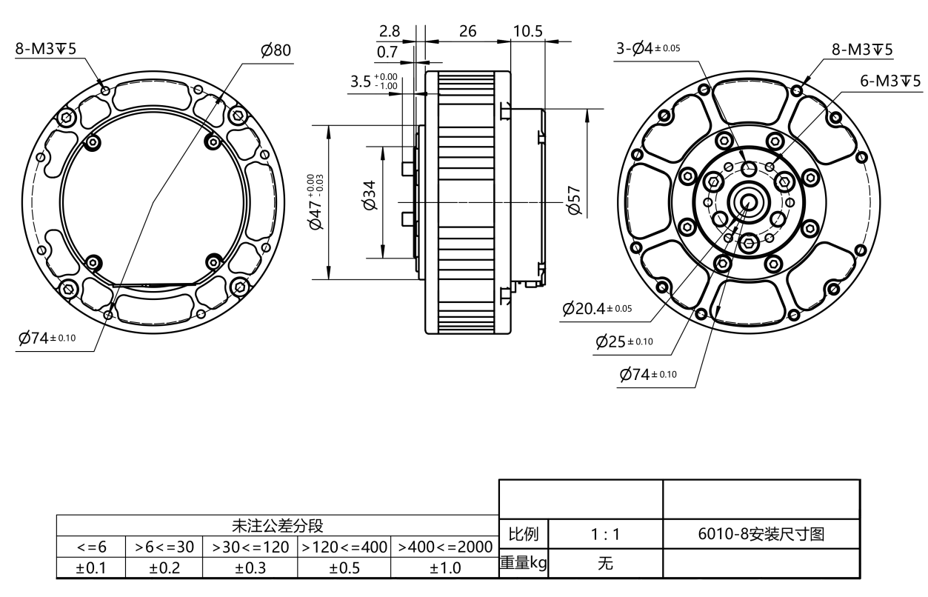
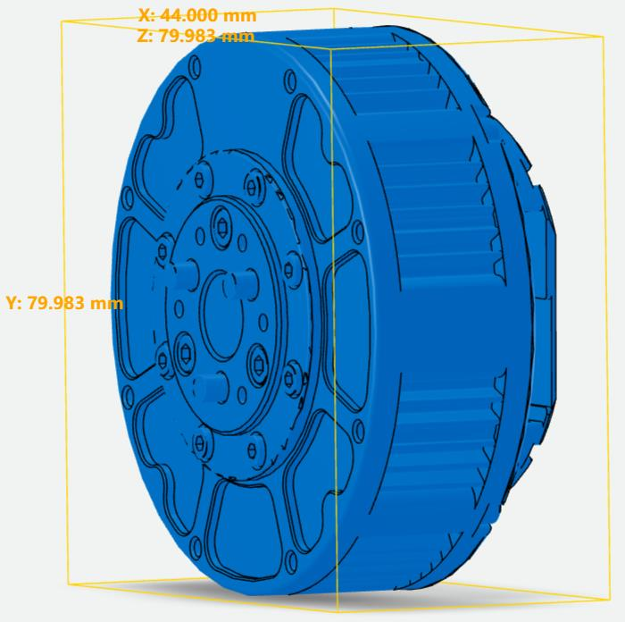

1.2 Electrical Characteristics
Parameter | Value
Rated speed | 120 rpm ±10%
Maximum speed | 420 rpm ±10%
Rated torque | 5 N·m
Stall torque | 11 N·m
Rated current | 10.5 A
Stall current | 25 A
No-load current | 0.4 A
Insulation resistance / stator winding | DC 500 VAC, 100 MΩ
High-voltage withstand / stator to housing | 600 VAC, 1 s, 2 mA
Motor back-EMF | 0.054–0.057 Vrms/rpm
Phase-to-phase resistance | 0.48 Ω ±10%
Phase-to-phase inductance | 368 μH ±10%
Speed constant | 12.3 rpm/V
Torque constant | 0.47 N·m/A

The characteristic curves are shown below:
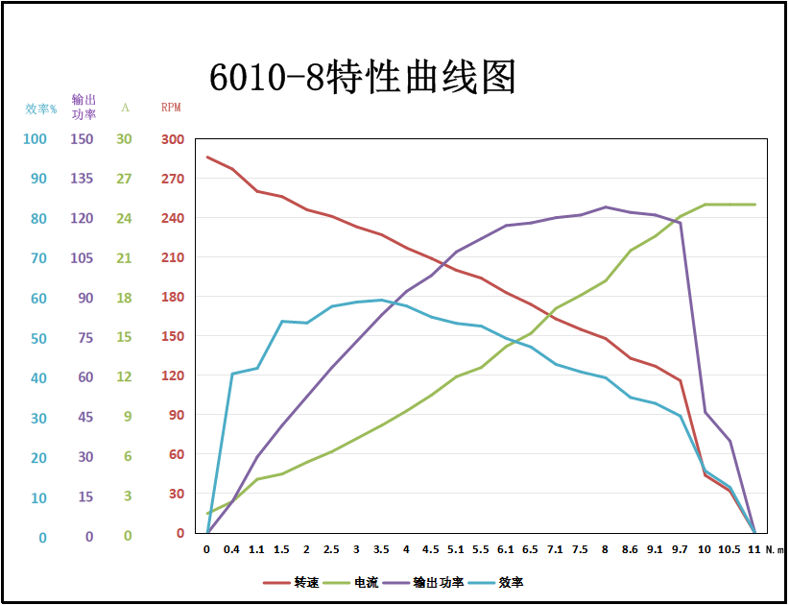

1.3 Mechanical Characteristics
Parameter | Value
Weight | 388 g ±3
Pole pairs | 14
Phases | 3
Drive method | FOC
Reduction ratio | 8:1

2 Driver Information

2.1 Appearance and 3D Dimensions
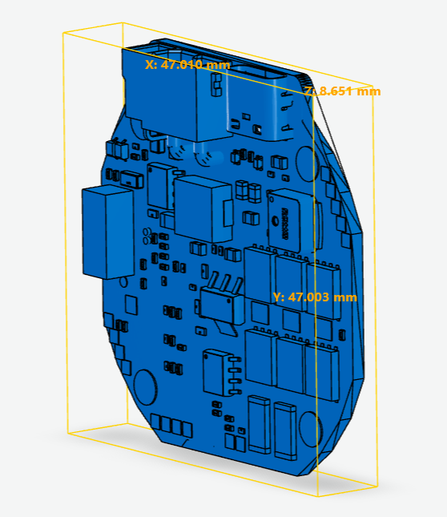

2.2 Interface Overview
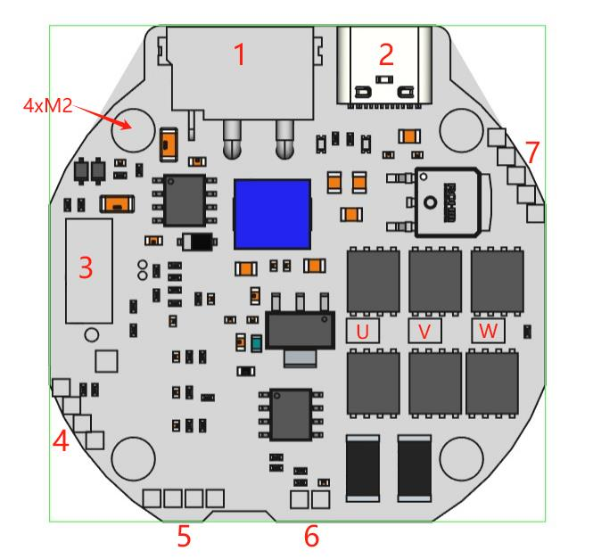
No. | Definition
1 | 15–60 V power and CAN communication integrated terminal
2 | Type-C debug port and PC-software communication port
3 | Interface expansion slot (expandable to RS485, EtherCAT, RC, pulse/direction, throttle control and other interfaces/protocols)
4 | SWD debug and download port
5 | Second encoder port (supports I2C and UART)
6 | Motor temperature port (NTC)
7 | Holding brake / brake resistor port, 12 V supply, min/max limit switch port
U/V/W | Three-phase winding solder holes
4×M2 | Mounting holes

2.3 Specifications
Parameter | Value
Rated voltage | 15–48 V DC
Min/max voltage | 12/72 V DC
Rated current | 6 A
Maximum line current | 30 A
Maximum phase current | 120 A
Standby consumption | <10 mA
CAN bus max baud rate | 1 Mbps
Type-C rate | 10 Mbps
Encoder resolution | 14-bit (single-turn absolute)
Operating ambient temperature | −20 °C to 70 °C
Motor temperature alarm | 90 °C (adjustable)
Driver board temperature alarm | 90 °C (adjustable)

2.4 Detailed Interface Definitions

2.4.1 Power and CAN Communication / RS485 / PWM Terminal
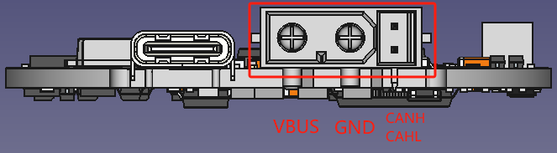
The board-side connector is model XT30PB(2+2)-M; the cable-side connector is model XT30(2+2)-F, both made by AMASS. In PWM mode, CANH is the PWM signal input; in pulse mode, CANH is the pulse signal input and CANL is the pulse direction input. Note that on versions supporting RS485, CANH/CANL also serve as RS485 A/B.

2.4.2 Type-C Debug Port
The Type-C port uses a standard data-cable specification; common PC or phone Type-C data cables are all compatible.

2.4.3 Interface Expansion Slot
This slot uses the design below and provides a rich set of board-to-board expansion interfaces, so third parties can develop any kind of expansion board. Note that hardware version 3.9 and later no longer provide this expansion interface.
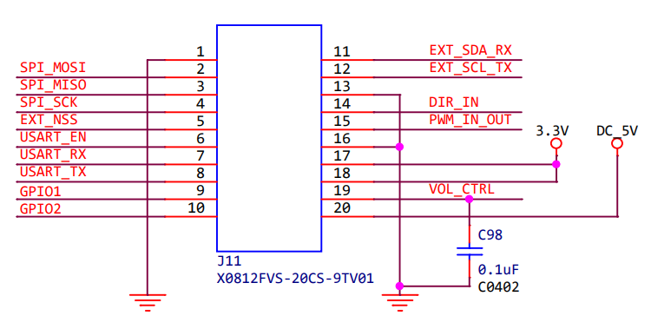
Third parties can interact with the driver via SPI, USART, I2C, PWM, ADC, GPIO, etc. to implement various extended functions.
The on-board slot is model X0812FVS-20CS-9TV01 (female); the expansion-board connector is model X0812WVS-20AS-9TV01 (male); the manufacturer is Xingkun (XKB).
Female X0812FVS-20CS-9TV01 / Male X0812WVS-20AS-9TV01:
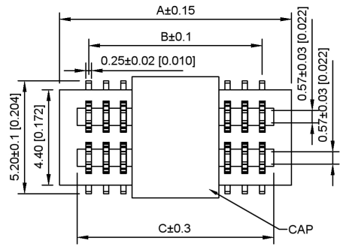
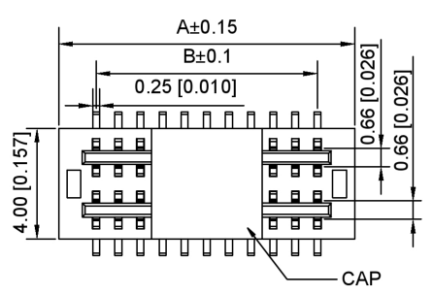

2.4.4 SWD Debug Port
Pin holes at 2 mm pitch; users can solder a 2 mm straight single-row pin header, as shown below:
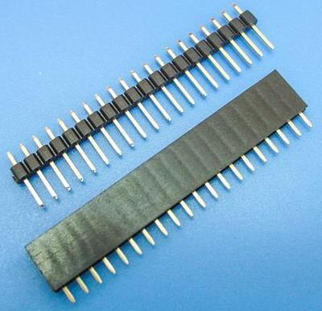
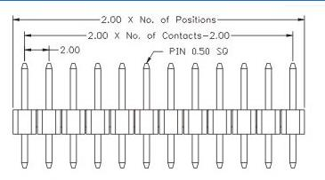
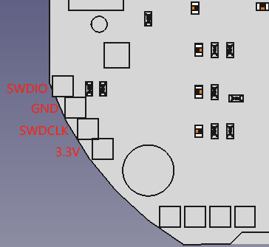

2.4.5 Second Encoder Port
Pin holes at 2 mm pitch; users can solder a 2 mm straight single-row pin header — see 2.4.4.
This port can communicate with a second encoder via USART (TX/RX) or I2C (SCL/SDA).
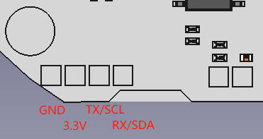

2.4.6 Motor Temperature Port
The motor has a built-in 10 kΩ NTC resistor; its two leads are soldered to MOT_TEMP and GND, with no polarity.
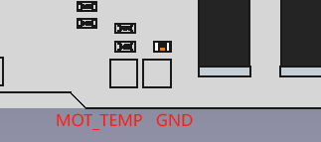

2.4.7 Holding Brake / Brake Resistor Port
The upper two solder holes of the 5-pin port shown are the holding brake / brake resistor port: 2 mm pitch pin holes, where users can solder a 2 mm straight single-row pin header — see 2.4.4.
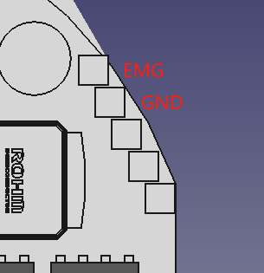
When used as a holding-brake port, the driver continuously outputs a current to this port while powered, keeping the brake released so the motor can run normally. If the driver loses power, this current stops, the brake engages, and the motor locks in its position at power-off.
When used as a brake-resistor port, an external brake resistor (also called a bleed/dump resistor) can be connected. When the back-EMF exceeds the threshold voltage, current is dissipated through this resistor, preventing loss of emergency braking or damage to the driver from back-EMF.

2.4.8 Limit Switch Port
The driver provides two limit-switch inputs and supplies 12 V to external limit switches. 2 mm pitch pin holes; users can solder a 2 mm straight single-row pin header — see 2.4.4.
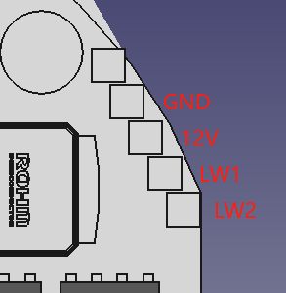
LW1 is the minimum-position limit switch and LW2 is the maximum-position limit switch. Two-wire switches or three-wire NPN switches can be connected.

2.5 Main Components and Specifications
No. | Component | Model / Specification | Qty
1 | MCU | N32G455 | 1
2 | Gate driver chip | FD6288Q | 1
3 | Magnetic encoder chip | MA732, 14-bit absolute | 1
4 | MOSFET | JMSH1004NG, 100 V/120 A | 6

3 Commissioning

3.1 Getting Started Guide

3.1.1 Preparation
To get the motor working, you need:
✓ Power supply
Refer to Chapter 1 for supply voltage requirements; a regulated power supply or a battery is recommended. A question users often ask is: how should I choose a power supply? Here are some simple suggestions, for reference only.
Points to consider when choosing a power supply:
◆ Current requirement
Generally it should be at least greater than 5 A. The exact value depends on the system's power requirement and voltage.
◆ Voltage requirement
The voltage requirement depends on two factors: the motor's Kv and the system's required maximum speed RPMmax. The maximum supply voltage required can be estimated with:
Vmax = (RPMmax / Kv) × 1.25
where 1.25 is an empirical factor giving the system a safe voltage margin.
◆ Power requirement
Simply put, power depends on the maximum current Imax at the highest speed, and can be estimated with:
Pmax = Imax × (RPMmax / Kv) × 1.25
✓ Power + communication cable
The 6010-8 has a 2+2 power/communication socket; contact after-sales for a recommended 2+2 cable. Refer to 2.4.1 and be sure to connect the supply positive and negative correctly, otherwise the driver may burn out, as it has no reverse-polarity protection. Also note the order of the 2 communication wires, e.g. CANH/CANL — wiring them incorrectly will cause abnormal communication.
Warning
• Avoid touching the communication bus with your hands, so static electricity does not damage the driver's interface chip — especially in dry regions and dry seasons!
• Never plug or unplug the power terminal while powered!
• Avoid using a circuit breaker as the power switch — it risks destroying the power chip on the driver!
• Do not exceed 72 V supply voltage!
✓ Type-C data cable
In the early stages of commissioning, it is strongly recommended to test the motor using a USB Type-C data cable. The most common phone Type-C data cable is fine; charge-only Type-C cables cannot be used.
Note: the Type-C data cable cannot power the driver, let alone make the motor turn!
✓ Powering up
First turn off the power supply, connect the power cable, then turn the supply on. Never plug/unplug while powered, and do not switch only the positive or negative lead with a circuit breaker — this causes excessive inrush current that can burn out the driver.
After power-up, the USB Type-C data cable can be plugged and unplugged at any time.

3.1.2 Getting Started with the PC Software
◆ Motor Wizard
1. Install Motor Wizard
Download the Windows installer (https://bl.cyberbeast.cn/actuator/steadywin_motorwizard.exe) and install following the default steps.
2. Install the USB driver
Go to https://zadig.akeo.ie and download the USB driver tool Zadig. Connect the driver to the computer with a Type-C data cable (the driver's power LED lights up), open Zadig, and select "CyberBeast Motor Driver Device (Interface 2)" from the drop-down list:
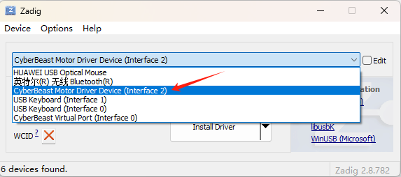
Use the up/down arrows to choose among USB drivers; select the "libusb" driver version for this interface and click "Install Driver" or "Replace Driver" to install the driver for this interface:
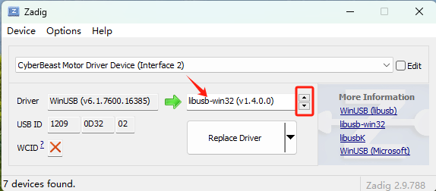
◆ odrivetool
The driver is compatible with ODrive (https://github.com/odriverobotics/odrive.git), so odrivetool can be used as PC software for commissioning.
Install odrivetool as follows:
➢ Windows
1. Install Python
Go to the official Python website https://www.python.org, download the latest Python installer and install following the prompts. Do not download Python from third-party websites or the Microsoft Store.
2. Install the Visual C++ Build Tools
Install the Visual C++ Build Tools from https://visualstudio.microsoft.com/visual-cpp-build-tools/. During installation, check "Desktop development with C++", as shown below.
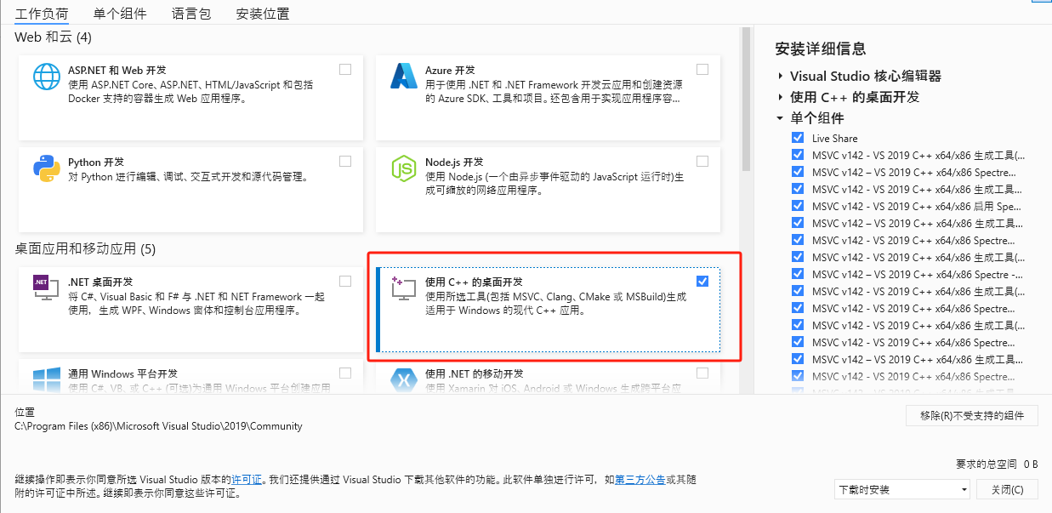
3. Install odrivetool
Run Windows PowerShell as administrator, type pip install odrive and press Enter to install. If an error occurs midway, retry. If errors keep occurring, restart the computer and retry.
4. Install the USB driver
Go to https://zadig.akeo.ie and download the USB driver tool Zadig. Connect the driver to the computer with a Type-C data cable (the driver's power LED lights up), open Zadig, and select "CyberBeast Motor Driver Device (Interface 2)" from the drop-down list:
Use the up/down arrows to choose among USB drivers; select the "WinUSB" driver version for this interface and click "Install Driver" to install the driver for this interface:
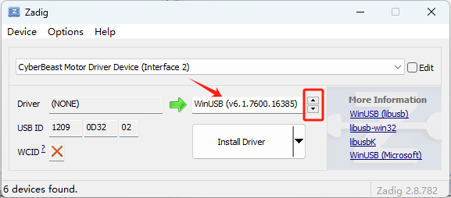
➢ WSL (Windows Subsystem for Linux)
1) Install python / usb / odrivetool
If WSL2 is installed, open the WSL2 command line and install as follows (assuming Ubuntu is installed in WSL):
sudo apt install python3 python3-pip
sudo apt install libusb-1.0-0
sudo pip install odrive numpy matplotlib
The first line installs Python, the second installs the USB driver, and the third installs the odrivetool PC software.
2) Connect the driver to WSL
When the Type-C cable is plugged into Windows, by default Windows loads the driver for this USB port but WSL does not. You need to attach this USB port to WSL; follow the Microsoft documentation (https://learn.microsoft.com/windows/wsl/connect-usb).
➢ Ubuntu
Installation on Ubuntu is very similar to WSL; see the previous subsection.

3.1.3 Configuring Motor Parameters Properly
Warning
• Read this section carefully — it is key to successful operation and to avoid burning out the motor!
After successfully installing the PC software (Motor Wizard or odrivetool) as described in the previous section, with the motor powered and the USB Type-C cable connected:
◆ Motor Wizard
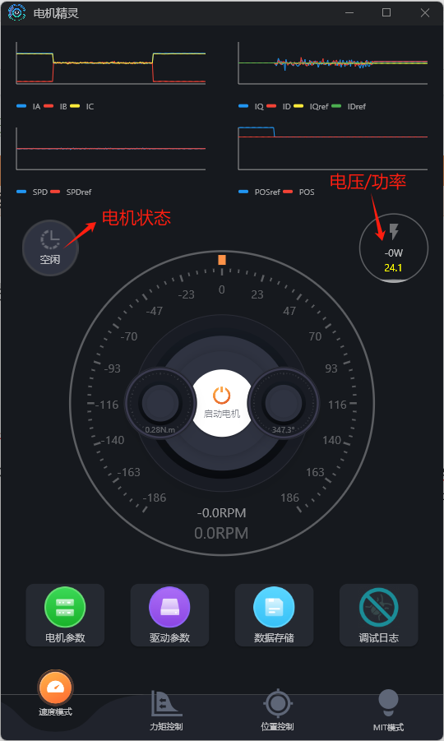
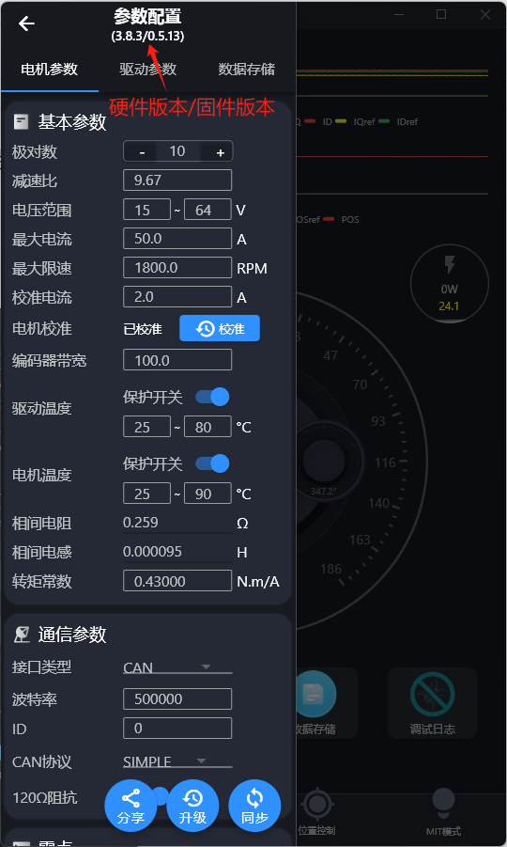
Open Motor Wizard. If the connection succeeds, as shown on the left above, the motor status and voltage are displayed; if not, the voltage information cannot be displayed normally.
Click "Motor Parameters"; the driver's hardware and firmware versions appear at the top of the interface, as shown on the right above: hardware version 3.8.3, firmware version 0.5.13.
◆ odrivetool
In a shell (Windows PowerShell or Linux Terminal), run odrivetool (type odrivetool and press Enter). The figure below shows a successful connection under Windows (connection information displayed in green):
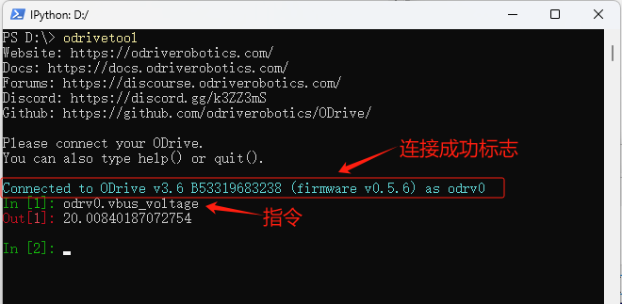
Command example: odrv0.axis0.controller.input_vel. odrv0 represents the currently connected motor — by default the first connected motor is called odrv0, the second odrv1, and so on; axis0 represents the first motor connected to the driver (the current version supports only one motor). This command queries the driver's current velocity-control target value.
Tips
- Use the TAB key often — it gives command hints similar to Linux, and you can select commands with the arrow keys;
- The up/down keys show command history;
- While typing, similar historical commands are suggested; press the right arrow key to auto-complete.
➢ Setting key limits
◆ Motor Wizard
Click "Motor Parameters" in Motor Wizard; as shown in the red box below, you can set the following key limit parameters: voltage range, current limit (max current), velocity limit (max speed), and calibration current.
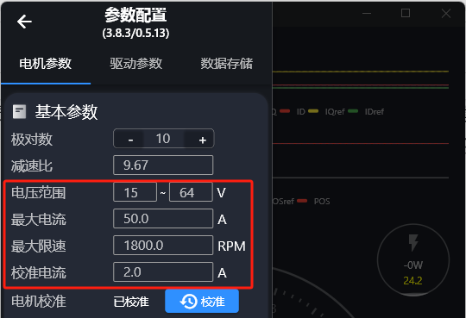
The current limit is also affected by temperature; see the related description in the next subsection (odrivetool).
The velocity limit normally applies in velocity or position control mode, but a velocity-limit switch can also be enabled in torque control mode. Click "Drive Parameters" in Motor Wizard to turn on this switch, as in the red box below:
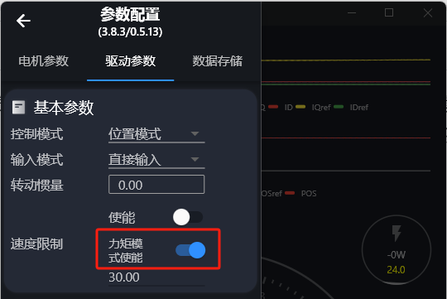
◆ odrivetool
● Current limit
odrv0.axis0.motor.config.current_lim = 30
The command above sets the current limit to 30 A. Note that this limit refers to the Q-axis current, not the supply current. This limit directly limits the output torque. For the 6010-8, do not set this limit above 50 A!
Other factors affecting the current limit
◆ Motor temperature
If motor temperature protection is enabled (odrv0.axis0.motor.motor_thermistor.config.enabled=1), the current motor temperature also affects the Q-axis current.
◆ Driver board temperature
If driver board temperature protection is enabled (odrv0.axis0.motor.fet_thermistor.config.enabled=1), the current driver board temperature also affects the Q-axis current.
The effects of the two temperatures are very similar and can be expressed by the following formula:
I′lim = (T − Tl) / (Tu − Tl) × Ilim
where I′lim is the effective current limit, Ilim is the configured current limit, T is the current temperature (motor or driver board temperature), Tl is the configured lower temperature limit (motor_thermistor.config.temp_limit_lower and fet_thermistor.config.temp_limit_lower), and Tu is the configured upper temperature limit (motor_thermistor.temp_limit_upper and fet_thermistor.config.temp_limit_upper).
● Velocity limit
odrv0.axis0.controller.config.vel_limit = 30
Global system velocity limit; the command above limits it to 30 turn/s (revolutions per second). Note that by default this limit has no effect in pure torque mode, but it can be enabled with the following switch:
odrv0.axis0.controller.config.enable_torque_mode_vel_limit = 1
● Calibration current
This current defaults to 5 A and normally does not need changing. However, if your power supply's current capacity is small, reduce this value, otherwise a low-voltage alarm will occur during calibration.
odrv0.axis0.motor.config.calibration_current = 2
➢ Setting key hardware parameters
◆ Motor Wizard
Click "Motor Parameters" in Motor Wizard; the red box below shows some key hardware parameters:
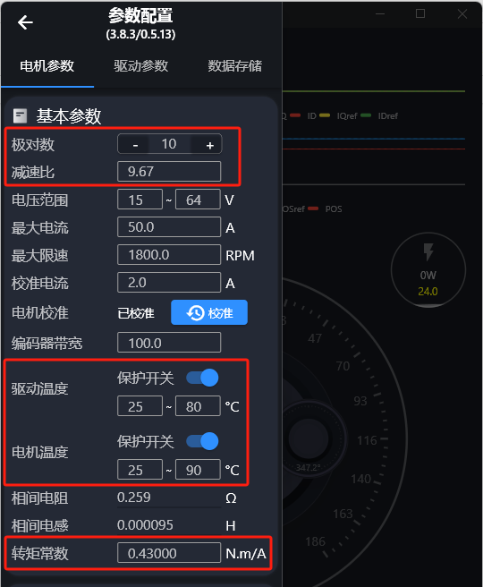
For the meaning of these parameters, see the description in the next subsection (odrivetool).
◆ odrivetool
● Maximum discharge / charge current
Discharge current is the forward current supplied by the power supply to the driver and motor; charge current is the reverse current flowing back into the supply. Both values depend on the power supply; set them to suitable values to prevent the supply voltage from being pulled down when it cannot deliver enough current, or the supply from being damaged by back-EMF. Note, however, that setting these to small absolute values easily triggers alarms.
odrv0.config.dc_max_negative_current
odrv0.config.dc_max_positive_current
● Pole pairs
The number of pole pairs is the number of magnetic poles in the rotor divided by 2. This value must be set correctly for calibration to succeed; otherwise a calibration alarm will occur.
odrv0.axis0.motor.config.pole_pairs
● Torque constant
The torque constant is the torque produced by the motor divided by the Q-axis current. Its relation to the motor Kv is:
Torque_Constant = 8.27 / Kv
odrv0.axis0.motor.config.torque_constant
Whether the torque constant is correct does not affect motor operation, but it affects the unit conversion of the value you input during torque control. If you want to do torque control in amps (A) instead of N·m, simply set this value to 1.
● Temperature sensing
Both the driver board and the motor contain NTC temperature sensors. If enabled, the driver controls the output current (torque) according to temperature, protecting the driver and motor.
# Motor temperature protection
odrv0.axis0.motor.motor_thermistor.config.enabled = 1
odrv0.axis0.motor.motor_thermistor.config.temp_limit_lower = 20
odrv0.axis0.motor.motor_thermistor.config.temp_limit_upper = 100
# Driver board temperature protection
odrv0.axis0.motor.fet_thermistor.config.enabled = 1
odrv0.axis0.motor.fet_thermistor.config.temp_limit_lower = 20
odrv0.axis0.motor.fet_thermistor.config.temp_limit_upper = 100
# Read temperatures
odrv0.axis0.motor.motor_thermistor.temperature # motor temperature
odrv0.axis0.motor.fet_thermistor.temperature # driver board temperature
➢ PID tuning
The following procedure provides a reference for tuning the PID parameters:
1. Set initial PID values
odrv0.axis0.controller.config.pos_gain=20.0
odrv0.axis0.controller.config.vel_gain=0.16
odrv0.axis0.controller.config.vel_integrator_gain=0.32
2. Set vel_integrator_gain to 0
odrv0.axis0.controller.config.vel_integrator_gain=0
3. Tuning vel_gain:
1) Rotate the motor in velocity control mode. If rotation is not smooth, with jitter or vibration, reduce vel_gain until rotation is smooth.
2) Then increase vel_gain by about 30% at a time until obvious jitter appears.
3) At that point, reduce vel_gain by about 50% and it will be stable.
4. Tuning pos_gain:
1) Try rotating the motor in position mode. If rotation is not smooth, with jerking or vibration, reduce pos_gain until rotation is smooth.
2) Then increase pos_gain by about 30% at a time until position control shows obvious overshoot (i.e. each time the motor overshoots the target position and then oscillates back to it).
3) Then gradually reduce pos_gain until the overshoot disappears.
5. After the 4 steps above, set vel_integrator_gain to 0.5 × bandwidth × vel_gain, where bandwidth is the system control bandwidth. What is control bandwidth? For example, if the time from the user setting a target position to the motor actually reaching it is 10 ms, the control bandwidth is 100 Hz, so vel_integrator_gain = 0.5 × 100 × vel_gain.
During tuning, it is recommended to use the graphical tools in 3.1.8 to view the tuning effect in real time and avoid errors of visual perception. With Motor Wizard, PID tuning is "what you see is what you get"; the figure below illustrates the PID parameters (Drive Parameters page: current-loop control bandwidth, velocity-loop KP/KI, position-loop KP highlighted):
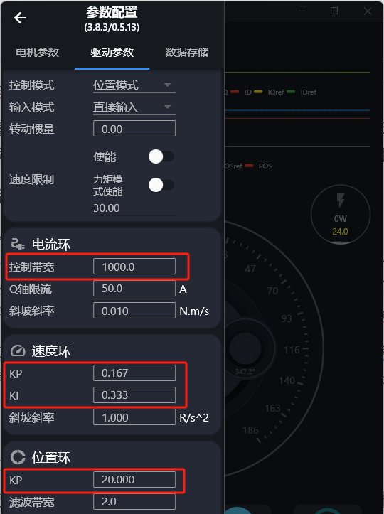

3.1.4 Power-up Calibration
When using the micro motor for the first time, the motor and encoder must be calibrated. Before calibrating, secure the motor or hold it firmly, with no load on the output shaft. The calibration process is as follows:
Warning
• Before calibration, make sure the motor is unloaded and firmly secured!
◆ Motor Wizard
Open Motor Wizard and click "Start Motor". If the motor is not calibrated, the following prompt appears ("Motor not calibrated. Calibrate now?" — OK / Cancel):
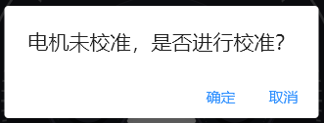
Click "OK" to enter the calibration process. Alternatively, click "Motor Parameters" on the main interface; the motor's calibration status is shown under "Basic Parameters". If it shows the uncalibrated status, click the "Calibrate" button to the right of the status to enter the calibration process as well.
Once calibration starts, the interface shows ("Motor is calibrating… The motor starts turning after a beep. Click 'Stopped' once it stops turning; if it keeps going for a long time or does not turn, click 'Cancel'!"):
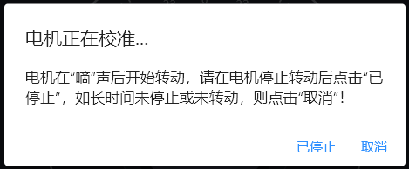
The motor will emit a "beep" and start rotating. Watch the motor: if it stops after rotating for a while, click "Stopped" to end calibration; if it does not rotate, or is still going after more than 5 minutes, click "Cancel".
After calibration finishes, the driver restarts; wait 1–3 seconds. You can then go into "Motor Parameters" again and check that the calibrated status is shown.
◆ odrivetool
odrv0.axis0.requested_state = AXIS_STATE_MOTOR_CALIBRATION
dump_errors(odrv0)
odrv0.axis0.requested_state = AXIS_STATE_ENCODER_OFFSET_CALIBRATION
dump_errors(odrv0)
odrv0.axis0.motor.config.pre_calibrated = 1
odrv0.axis0.encoder.config.pre_calibrated = 1
odrv0.save_configuration()
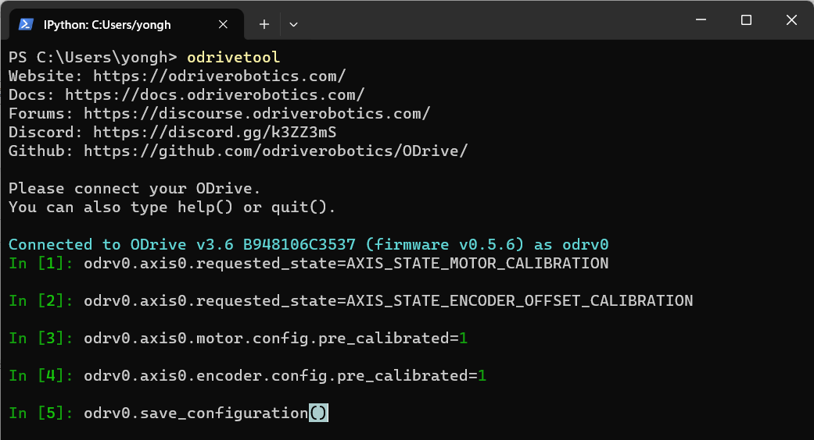
Step-by-step explanation:
➢ Step 1: Motor parameter self-identification
Measures the motor's phase resistance and phase inductance; you will hear a sharp "beep". The measured phase resistance and inductance can be viewed with:
odrv0.axis0.motor.config.phase_resistance
odrv0.axis0.motor.config.phase_inductance
➢ Step 2: Check error codes
Check the system error codes after Step 1. If any red error codes appear, restart the motor and retry, or report to after-sales.
➢ Step 3: Encoder calibration
Calibrates the encoder, including calibrating the encoder mounting angle against the motor's mechanical angle, and calibrating the encoder itself. During this process the motor slowly rotates forward through an angle, then backward through an angle. If it stops after only rotating forward, an error has occurred; check the error codes as in Step 4.
➢ Step 4: Check error codes
After the encoder calibration in Step 3, check the system error codes. The most common error is ERROR_CPR_POLEPAIRS_MISMATCH, meaning the encoder CPR or the motor's pole-pair count is set incorrectly. Check/set them with:
odrv0.axis0.encoder.config.cpr
odrv0.axis0.motor.config.pole_pairs
➢ Step 5: Write the motor-calibrated flag
➢ Step 6: Write the encoder-calibrated flag
➢ Step 7: Save calibration results and restart
odrv0.axis0.encoder.config.pre_calibrated = 1
odrv0.axis0.motor.config.pre_calibrated = 1
odrv0.save_configuration()

3.1.5 Changing the ID
The driver ID must be unique on the bus; the range is 0–63 and the default ID is 0. If you have several motors connected on one bus, each motor needs a different ID. The ID can be changed via USB or via the bus:
➢ Changing the ID in Motor Wizard
Open Motor Wizard, connect to the motor, click "Motor Parameters", change the ID in the "Communication Parameters" section, and click "Sync" to store it in the driver.
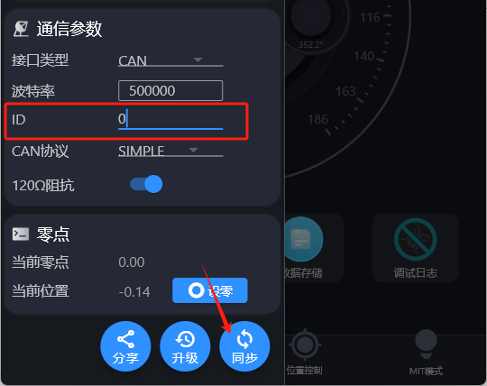
➢ Changing the ID via USB
After connecting to the driver with odrivetool, change the ID with:
odrv0.axis0.config.can.node_id = xxx
➢ Changing the ID via the bus
See the Set_Axis_Node_ID command message in 4.1.2.

3.1.6 Saving and Backing Up Parameters
After changing any parameter, be sure to save; otherwise changes are lost after power-off or restart. The driver restarts after parameters are saved.
odrv0.save_configuration()
Parameter backup:
odrivetool backup-config "d:/test.json"
where "d:/test.json" is a save path and file name you can change freely.
The command to restore parameters is:
odrivetool restore-config "d:/test.json"

3.1.7 Four Control Modes
After the preparation and parameter configuration above, you can try controlling the motor in different modes. The 6010-8 supports position control, velocity control, torque control, and motion control modes.
In position control mode, it supports Filtered Position Control, Trajectory Control (trapezoidal profile), and Circular Position Control;
In velocity control mode, it supports direct Velocity Control and Ramped Velocity Control;
In torque control mode, it supports direct Torque Control and Ramped Torque Control.
Motion control mode combines position, velocity and torque control, and is typically used where strong instantaneous bursts of force are needed, such as robot knee joints. Some in the industry call it MIT control mode, a name that comes from the MIT open-source robot dog, which uses this motion control mode to control its motors.
In the detailed descriptions of each control mode below, this document uses the PC software and USB control commands as examples, but the same control can be done over a communication protocol (e.g. CAN) with the same logic.
How to make the motor turn?
◆ Start the motor (enter closed-loop control state)
For all subsequent control operations, the motor must be in closed-loop control state in order to turn.
In Motor Wizard, simply click "Start Motor"; in odrivetool the command is:
odrv0.axis0.requested_state = 8
◆ Stop the motor (enter idle state)
To stop the motor, or to change and save parameters, first put the motor into idle state.
In Motor Wizard, simply click "Stop Motor"; in odrivetool the command is:
odrv0.axis0.requested_state = 1
◆ Motor Wizard
Open Motor Wizard; the four tabs at the bottom represent the four control modes: "Velocity Control", "Torque Control", "Position Control" and "MIT Mode".
➢ Basic interface operations
After the motor is started, the dial is highlighted in color; almost all operations are performed on the dial:
✓ Left-click on the dial
Clicking on the dial commands velocity/torque/position to the dial value at that point. Each click is one control command. You can click repeatedly to control the motor continuously.
✓ Right-click on the dial
Right-clicking on the dial opens a dialog where you can enter an exact target velocity/torque/position value, then press Enter to execute; clicking outside the dialog cancels.
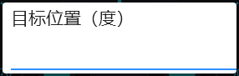
✓ Click and drag on the dial
Holding and dragging on the dial performs continuous control, continuously sending velocity/torque/position commands to the motor with the dial value under the mouse as the target.
➢ Modifying drive parameters
Click "Drive Parameters" to adjust drive parameters such as control mode, speed limit, and the gains (bandwidths) of the three loops. It is recommended to stop the motor first, then change the parameters and sync.
◆ odrivetool
➢ Filtered Position Control
If you want to generate your own position trajectory and send position commands at a certain frequency, filtered position control is recommended, because this mode joins the commands together smoothly. Using trapezoidal trajectory control in this situation may make the motor's motion feel jerky or grainy.
In this mode, adjust the filter bandwidth according to the command frequency. A good rule of thumb is to set the bandwidth to half the command frequency (in Hz); for example, when sending commands at 50 Hz:
odrv0.axis0.controller.config.input_filter_bandwidth = 25
Enable filtered position control:
odrv0.axis0.controller.config.control_mode = 3
odrv0.axis0.controller.config.input_mode = 3
Then perform position control:
odrv0.axis0.controller.input_pos = 10 # unit: turns
➢ Trajectory Control (trapezoidal)
This mode lets you set acceleration, cruise velocity and deceleration to move the motor smoothly from one position to another. "Trapezoidal" refers to the shape of the velocity profile, as shown below (orange is velocity, blue is position):
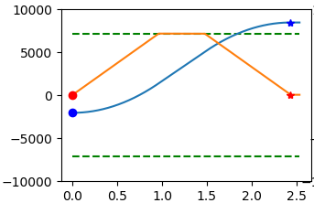
Adjustable control parameters:
odrv0.axis0.trap_traj.config.vel_limit # max cruise velocity, turn/s
odrv0.axis0.trap_traj.config.accel_limit # max acceleration, turn/s^2
odrv0.axis0.trap_traj.config.decel_limit # max deceleration, turn/s^2
odrv0.axis0.controller.config.inertia # inertia, Nm/(turn/s^2)
Note that inertia × acceleration = torque; this value defaults to 0. It can improve system response but depends directly on the motor's load. All four values above must be ≥ 0. Also note that the current and velocity limits mentioned earlier still apply globally; for example, if the max cruise velocity above is set higher than the system-level vel_limit, the global vel_limit takes effect.
To enable trapezoidal trajectory control mode, first:
odrv0.axis0.controller.config.control_mode = 3
odrv0.axis0.controller.config.input_mode = 5
Then perform position control:
odrv0.axis0.controller.input_pos = 10 # unit: turns
➢ Circular Position Control
This mode suits continuous incremental position control, such as a robot wheel hub turning in one direction for a long time, or a conveyor track running continuously. With the normal position control mode, the target position would gradually grow to a very large value, causing positioning errors due to floating-point precision.
Enable:
odrv0.axis0.controller.config.circular_setpoints = 1
In this mode each small step stays within one turn, and the range of input_pos is [0, 1). If input_pos increases beyond this range, it is converted to a value within one turn. If you want a single step to exceed one turn, set the following parameter to a number greater than 1:
odrv0.axis0.controller.config.circular_setpoint_range = <N>
➢ Velocity Control (direct)
This is the simplest velocity control mode. Enable as follows:
odrv0.axis0.controller.config.control_mode = 2
odrv0.axis0.controller.config.input_mode = 1
Then enter a target velocity to control:
odrv0.axis0.controller.input_vel = 10 # unit: turn/s
➢ Ramped Velocity Control
Ramped velocity control raises the velocity gradually to the target at a set slope, which is gentler than direct velocity control. Enable as follows:
odrv0.axis0.controller.config.control_mode = 2
odrv0.axis0.controller.config.input_mode = 2
Control acceleration by adjusting the ramp rate:
odrv0.axis0.controller.config.vel_ramp_rate = 0.5 # ramp rate unit: turn/s^2
Then enter a target velocity to control:
odrv0.axis0.controller.input_vel = 10 # unit: turn/s
➢ Torque Control (direct)
This is the simplest torque (current) control mode. Enable as follows:
odrv0.axis0.controller.config.control_mode = 1
odrv0.axis0.controller.config.input_mode = 1
Torque control uses N·m, while the driver firmware's current unit is A, so the torque constant must also be set so the driver can convert N·m to current and drive the motor to produce the required torque.
# torque constant is approximately 8.23 / Kv
odrv0.axis0.motor.config.torque_constant = 8.23/12.3
Then enter a target to control (the original says "target velocity"; this is the target torque):
odrv0.axis0.controller.input_torque = 1.2 # unit: Nm
Also note: if you want to limit the maximum speed in torque mode, turn on enable_torque_mode_vel_limit and set vel_limit, e.g.:
odrv0.axis0.controller.config.enable_torque_mode_vel_limit = 1
odrv0.axis0.controller.config.vel_limit = 30 # unit: turn/s
➢ Ramped Torque Control
Ramped torque control is very similar to ramped velocity control. Enable as follows:
odrv0.axis0.controller.config.control_mode = 1
odrv0.axis0.controller.config.input_mode = 6
Adjust the ramp rate as follows:
odrv0.axis0.controller.config.torque_ramp_rate = 0.1 # ramp rate unit: Nm/s
➢ Motion Control (MIT Control)
Motion control mode drives the motor to the target position by jointly controlling position, velocity and torque, as expressed by:
T_target = Kp × P_diff + Kd × V_diff + T_ff
P_diff = P_target − P_current
V_diff = V_target − V_current
where T_target is the target torque, P_diff is the position error, V_diff is the velocity error, Kp is the position control gain, Kd is the velocity control gain (or damping coefficient), and T_ff is the feed-forward torque.
Enable motion control mode as follows:
odrv0.axis0.controller.config.control_mode = 3
odrv0.axis0.controller.config.input_mode = 9
Adjust the gains:
odrv0.axis0.controller.input_mit_kp = <float> # position gain, Nm/turn
odrv0.axis0.controller.input_mit_kd = <float> # damping coefficient, Nm/turn/s
Then perform motion control by entering input_pos, input_vel and input_torque:
odrv0.axis0.controller.input_pos = 5 # unit: turns
odrv0.axis0.controller.input_vel = 30 # unit: turn/s
odrv0.axis0.controller.input_torque = 2 # unit: Nm
Note
• The position, velocity and torque entered under USB control all refer to the rotor side, whereas in MIT control over CAN, the position, velocity and torque in the protocol all refer to the output-shaft side. This is for consistency with the MIT open-source protocol!

3.1.8 Advanced
1) Common command list
Once connected, you can control the motor with commands and read its operating parameters. The table below lists common commands for commissioning, with explanations:
Type | Command | Description
Basic | dump_errors(odrv0) | Print all error information
Basic | odrv0.clear_errors() | Clear all error information
Basic | odrv0.save_configuration() | After changing parameters, or after the motor auto-identifies parameters or is calibrated, be sure to run this command to save the changes; otherwise all changes are lost on power-off.
Basic | odrv0.reboot() | Reboot the driver
Basic | odrv0.vbus_voltage | Get supply voltage (V)
Basic | odrv0.ibus | Get supply current (A)
Basic | odrv0.hw_version_major | Hardware major version; the 6010-8's current major version is 3
Basic | odrv0.hw_version_minor | Hardware minor version; the 6010-8's current minor version is 8
Basic | odrv0.hw_version_variant | Model code for different models with the same hardware configuration; the 6010-8's code is 1
Parameter configuration | odrv0.can.config.r120_gpio_num | GPIO number controlling the CAN interface's 120 Ω termination resistor switch
Parameter configuration | odrv0.can.config.enable_r120 | Controls the CAN interface's 120 Ω termination resistor switch
Parameter configuration | odrv0.can.config.baud_rate | CAN baud rate setting
Parameter configuration | odrv0.config.dc_bus_undervoltage_trip_level | Undervoltage alarm threshold (V)
Parameter configuration | odrv0.config.dc_bus_overvoltage_trip_level | Overvoltage alarm threshold (V)
Parameter configuration | odrv0.config.dc_max_positive_current | Maximum line current (positive) (A)
Parameter configuration | odrv0.config.dc_max_negative_current | Maximum reverse charging line current (negative) (A)
Parameter configuration | odrv0.axis0.motor.config.resistance_calib_max_voltage | Maximum voltage during motor parameter identification; generally slightly less than half the supply voltage, e.g. 10 for a 24 V supply
Parameter configuration | odrv0.axis0.motor.config.calibration_current | Maximum current during motor parameter identification; generally 2–5 A — neither too large nor too small.
Parameter configuration | odrv0.axis0.motor.config.torque_constant | Motor torque constant (Nm/A)
Parameter configuration | odrv0.axis0.min_endstop.config / odrv0.axis0.max_endstop.config | Configuration of the minimum (LW1) / maximum (LW2) limit switches: enabled — whether enabled; gpio_num — corresponding IO number; set the minimum limit's IO number to 1 and the maximum limit's to 2
Parameter configuration | odrv0.axis0.encoder.config.index_offset | User-set zero offset: the offset of the user zero relative to the encoder zero. After setting and saving this offset, all user-entered position control targets are referenced to this user zero.
Parameter configuration | odrv0.axis0.motor.motor_thermistor.config / odrv0.axis0.motor.fet_thermistor.config | Configure temperature sensors: enabled — whether enabled; temp_limit_lower — lower temperature limit; temp_limit_upper — upper temperature limit
Parameter configuration | odrv0.axis0.motor.motor_thermistor.temperature | Motor temperature
Parameter configuration | odrv0.axis0.motor.fet_thermistor.temperature | Driver temperature
Calibration | odrv0.axis0.requested_state=4 | Motor parameter identification, including phase resistance, phase inductance, and calibration of three-phase current balance. This takes 3–6 seconds and the motor emits a sharp sound. After the sound stops, or if there is no sound after 6 seconds, run dump_errors(odrv0) to check for errors, and confirm there are none before doing anything else.
Calibration | odrv0.axis0.requested_state=7 | Encoder calibration. Before doing this, make sure the motor output shaft has no load and hold the motor by hand or with a fixture. The motor will then rotate forward and backward for some time to identify and calibrate the encoder. After the motor stops, run dump_errors(odrv0) to check for errors, and confirm there are none before continuing.
Calibration | odrv0.axis0.encoder.config.pre_calibrated=1 | Writes "pre-calibration successful", meaning calibration is not needed at every power-up. This parameter can only be written after the calibration above succeeds; otherwise the write fails.
Calibration | odrv0.axis0.controller.config.load_encoder_axis=0 | Ensures the currently operated motor is motor 0. Only needed in BETA; has no effect in production versions.
Control | odrv0.axis0.requested_state=1 | Stop the motor, enter idle state
Control | odrv0.axis0.requested_state=8 | Start the motor, enter closed-loop state
Control | odrv0.axis0.motor.config.current_lim | Maximum motor line current during operation (A); exceeding it raises an overcurrent alarm. Note: this value must not exceed 100.
Control | odrv0.axis0.controller.config.vel_limit | Maximum motor speed during operation (turn/s); if rotor speed exceeds it an overspeed alarm is raised.
Control | odrv0.axis0.controller.config.enable_vel_limit | Velocity limit switch: when True the vel_limit above takes effect; when False it does not.
Control | odrv0.axis0.controller.config.control_mode | Control mode. 0: voltage control; 1: torque control; 2: velocity control; 3: position control
Control | odrv0.axis0.controller.config.input_mode | Input mode — how the user's control input drives the motor: 0: idle; 1: direct control; 2: velocity ramp; 3: position filter; 5: trapezoidal trajectory; 6: torque ramp; 9: motion control (MIT)
Control | odrv0.axis0.controller.config.vel_gain | P value of the velocity-loop PID
Control | odrv0.axis0.controller.config.vel_integrator_gain | I value of the velocity-loop PID
Control | odrv0.axis0.controller.input_mit_kp | Motion control (MIT) position gain
Control | odrv0.axis0.controller.input_mit_kd | Motion control (MIT) velocity gain (damping coefficient)
Control | odrv0.axis0.controller.config.pos_gain | P value of the position-loop PID
Control | odrv0.axis0.controller.input_torque | Target for torque control, or torque feed-forward for velocity/position control (Nm)
Control | odrv0.axis0.controller.input_vel | Target for velocity control, or velocity feed-forward for position control (turn/s)
Control | odrv0.axis0.controller.input_pos | Target for position control (turns)
Control | odrv0.axis0.encoder.set_linear_count() | Set the encoder's absolute position; enter a 32-bit integer in the parentheses whose absolute value must be less than odrv0.axis0.encoder.config.cpr
Control | odrv0.axis0.trap_traj.config | Contains three parameters: accel_limit — max acceleration (rev/s^2); decel_limit — max deceleration (rev/s^2); vel_limit — max velocity (rev/s). These take effect when odrv0.axis0.controller.config.input_mode is trapezoidal trajectory, adjusting the acceleration/deceleration of position control.
Control | odrv0.axis0.controller.config.input_filter_bandwidth | Position filter bandwidth; takes effect when odrv0.axis0.controller.config.input_mode is position filter, adjusting the acceleration/deceleration of position control.

2) Graphical commissioning
When commissioning the motor, if you need to monitor certain operating parameters in real time, you can use Python's powerful computation and graphics libraries together with the high throughput of the Type-C interface to output motor parameters in real time.
1. Environment preparation
Install the computation and graphics libraries:
pip install numpy matplotlib
2. Graphical parameter output
In the odrivetool command line, invoke the graphics library to read any motor operating metrics, e.g.:
start_liveplotter(lambda:[odrv0.ibus, odrv0.axis0.encoder.pos_estimate,
odrv0.axis0.controller.input_pos], ["ibus","pos","pos_target"])
This command opens a graphical window that plots three metrics in real time: line current, position, and target position. Then, when you perform position control on the motor, you will see the real-time position control curves:
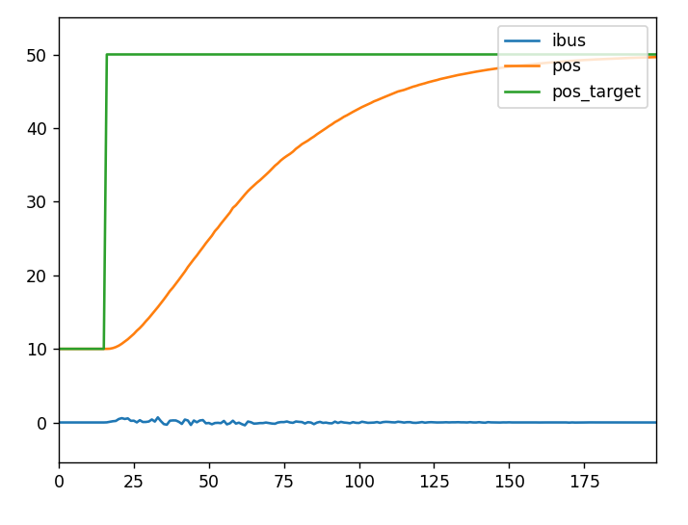
3) USB and CAN compatibility
In early versions of this product (hardware version ≤ 3.7, obtainable with the commands odrv0.hw_version_major and odrv0.hw_version_minor in 3.1.8), USB and CAN are not compatible; you can switch between the two communication modes as follows (ignore this section for hardware versions above 3.7):
➢ Switching to CAN while communicating over USB
When CAN is disabled, you can communicate through the Type-C port; switch to CAN with the following commands:
odrv0.config.enable_can_a = True
odrv0.axis0.requested_state = AXIS_STATE_IDLE
odrv0.save_configuration()
➢ Switching to USB while communicating over CAN
When CAN is enabled, first send the Set_Axis_State message (with parameter 1, meaning IDLE state) to put the motor into idle, then send the Disable_Can message to switch to USB (see 4.1.2).
Note: whether switching from USB to CAN or from CAN to USB, the motor must first be in IDLE state, otherwise the switch will fail.
4) CAN termination resistor switch
The driver has an on-board 120 Ω impedance-matching resistor, which can be switched on or off as needed. Example commands:
odrv0.can.config.r120_gpio_num = 5
odrv0.can.config.enable_r120 = True
5) User zero-point configuration
By default, the position you read from the motor, and the input value for position control, are both referenced to the zero of the absolute encoder on the driver. In real applications, however, the encoder zero is usually not the user's zero, so you need to set this zero offset manually.
Generally there are two ways to locate this zero: using a limit switch, or manually setting the zero offset — the offset of the user zero relative to the encoder zero:
# After rotating to the desired user zero position, manually or via position control:
odrv0.axis0.encoder.config.index_offset = odrv0.axis0.encoder.pos_estimate
6) Limit switches
The driver supports two limit switches (LW1 and LW2): LW1 is the minimum position and also the homing position; LW2 is the maximum position. To use both limit switches, configure as follows:
odrv0.axis0.min_endstop.config.enabled = True
odrv0.axis0.min_endstop.config.gpio_num = 1
odrv0.axis0.max_endstop.config.enabled = True
odrv0.axis0.max_endstop.config.gpio_num = 2
When a limit switch is triggered, the system reports a MIN_ENDSTOP_PRESSED or MAX_ENDSTOP_PRESSED error, and the host can take appropriate action at that point.
Note: hardware version 3.7 does not support the limit switch function.
7) Brake resistor
You can connect a brake resistor (also called a bleed resistor) across the brake-resistor port (EMG and GND) described in 2.4.7, to shunt and dissipate transient current when bus current flows back into the supply.
Enable it with the following configuration:
odrv0.config.enable_brake_resistor = True
odrv0.config.brake_resistance = xxx # resistance of the external brake resistor
odrv0.save_configuration()
How do you make the driver dissipate automatically? The following two methods can be combined to let the controller adjust the dissipation current automatically:
➢ By adjusting the maximum reverse current
odrv0.config.max_regen_current = xxx # maximum reverse current, positive number
When the reverse current exceeds the set value, the driver shunts the excess current into the bleed resistor.
➢ By adjusting the back-EMF voltage range
odrv0.config.enable_dc_bus_overvoltage_ramp = True
odrv0.config.dc_bus_overvoltage_ramp_start = xxx # lower voltage limit for shunting
odrv0.config.dc_bus_overvoltage_ramp_end = xxx # upper voltage limit for shunting
When the voltage caused by back-EMF rises above the lower limit, the driver begins shunting to the bleed resistor; when the voltage reaches or exceeds the upper limit, the driver applies the full voltage across the bleed resistor to try to shunt. When the voltage is between the lower and upper limits, the driver applies the supply voltage (back-EMF voltage) across the bleed resistor proportionally.
Note that both methods can be enabled at the same time; the driver will try to combine them for dissipation.

3.2 Firmware Update and Download
Firmware can be flashed via the SWD port (2.4.4) or the Type-C port (2.4.2), using any of the following three methods:

3.2.1 Nations (N32) Download Software
1. USB (DFU) flashing
Note: the Nations download software can flash via the Type-C port, or via the SWD port (JLink and DAP only). This section mainly uses Type-C flashing as the example.
First, download the USB driver for the Nations flashing software (https://www.cyberbeast.cn/filedownload/789489) and install the driver for your OS; then download the Nations flashing software (https://cyberbeast.cn/filedownload/766844), unzip it to any directory, and run it.
Next, connect the Type-C port, enter odrivetool, and run the following command to put the driver into DFU mode:
odrv0.enter_dfu_mode()
Finally, flash with the Nations software as shown below. After flashing completes, click "Common Operations" and then "Reset" to restart the driver; you can then connect and commission normally with odrivetool.
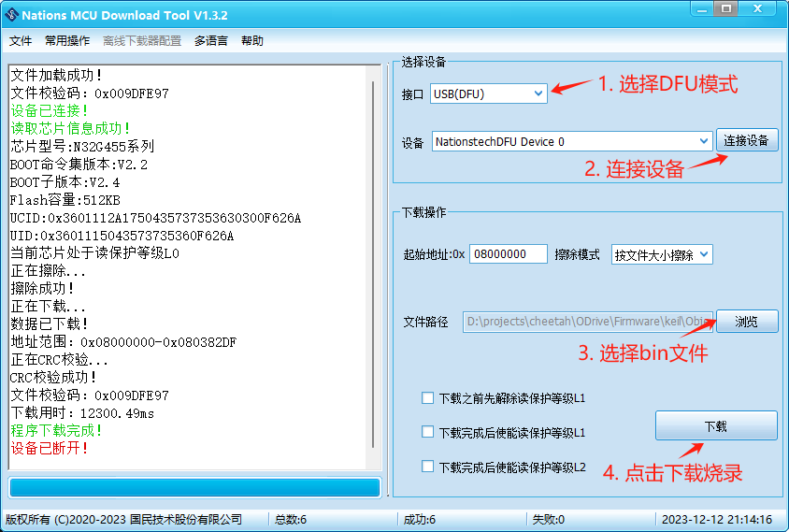
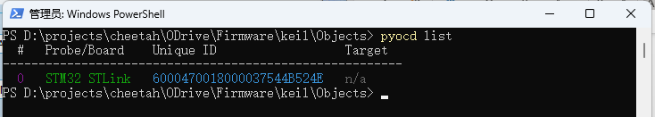
2. SWD (JLink or DAP) flashing
Downloading via SWD is similar to DFU mode, but you connect through the SWD debug port (2.4.4) and select the corresponding debug tool (JLink or DAP) in the figure above.

3.2.2 pyocd
pyocd is a Python counterpart of OpenOCD that supports common debug probes such as STLink, JLink and DAP for erasing, flashing, resetting, etc. Note: the driver must be connected via the SWD port; for the SWD pinout see 2.4.4. The SWD port carries a 3.3 V supply — do not wire it in the wrong order, or the driver may be destroyed!
1. Installation
pip install pyocd
2. Flashing
First, list the connected debug probes:
pyocd list
Then run the following command to flash the bin file:
pyocd load .\ODrive_N32G455.bin -a 0x8000000
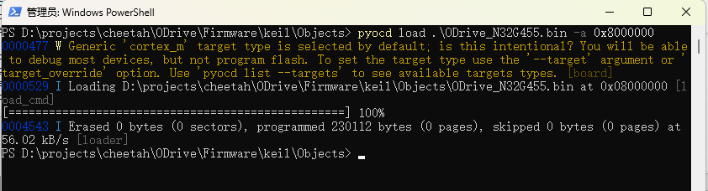

4 Communication Protocols and Examples

4.1 CAN Simple Protocol
The default communication interface is CAN, with a maximum rate of 1 Mbps (readable and settable via odrv0.can.config.baud_rate); the factory default rate is 500 kbps. Note: on early hardware versions (≤ 3.7), USB and CAN are not compatible; see item 3) in 3.1.8 for how to switch from USB to CAN.
The driver's default protocol is CAN Simple. If you have switched to the CANopen protocol, switch back to CAN Simple with:
odrv0.can.config.protocol = 1
Note that on hardware versions ≥ 3.10, the communication interface also supports RS485, pulse/direction and PWM. Make sure the communication interface is CAN with:
odrv0.config.comm_intf_mux = 0
In Motor Wizard, you can also switch the physical interface and the CAN protocol version under Communication Parameters.

4.1.1 Frame Format
CAN communication uses standard frames (data frames) with an 11-bit ID and 8 data bytes, as shown below (MSB on the left, LSB on the right):
Field | CAN ID (11 bits) | CAN ID (11 bits) | Data (8 bytes)
Segment | Bit10 – Bit5 | Bit4 – Bit0 | Byte0 – Byte7
Description | node_id | cmd_id | Communication data

- node_id: the motor's unique ID on the bus; read and set in odrivetool with odrv0.axis0.config.can.node_id.
- cmd_id: command code, indicating the protocol message type; see the rest of this section.
- Communication data: 8 bytes. The parameters carried in each message are encoded as integers or floats in little-endian byte order; floats are encoded per IEEE 754 (you can test encodings at https://www.h-schmidt.net/FloatConverter/IEEE754.html).
Take the Set_Input_Pos message described in 4.1.2 as an example. Suppose its three parameters are Input_Pos = 3.14, Vel_FF = 1000 (meaning 1 rev/s), Torque_FF = 5000 (meaning 5 Nm); the Set_Input_Pos CMD ID = 0x00C; and the driver's node_id is set to 0x05. Then:
- 11-bit CAN ID = (0x05 << 5) + 0x0C = 0xAC
- From the description of Set_Input_Pos in 4.1.2, Input_Pos occupies 4 bytes starting at byte 0, encoded as C3 F5 48 40 (the float 3.14 encoded per IEEE 754 as the 32-bit value 0x4048F5C3); Vel_FF occupies 2 bytes starting at byte 4, encoded as E8 03 (1000 = 0x03E8); Torque_FF occupies 2 bytes starting at byte 6, encoded as 88 13 (5000 = 0x1388). So the 8 data bytes are:
Byte0 | Byte1 | Byte2 | Byte3 | Byte4 | Byte5 | Byte6 | Byte7
C3 | F5 | 48 | 40 | E8 | 03 | 88 | 13

4.1.2 Frame Messages
The table below lists all available messages:
CMD ID | Name | Direction | Parameters
0x001 | Heartbeat | Motor → Host | Axis_Error, Axis_State, Motor_Flag, Encoder_Flag, Controller_Flag, Traj_Done, Life
0x002 | Estop | Host → Motor
0x003 | Get_Error | Motor → Host | Error_Type
0x004 | RxSdo | Motor → Host
0x005 | TxSdo | Motor → Host
0x006 | Set_Axis_Node_ID | Host → Motor | Axis_Node_ID
0x007 | Set_Axis_State | Host → Motor | Axis_Requested_State
0x008 | Mit_Control | Host → Motor
0x009 | Get_Encoder_Estimates | Motor → Host | Pos_Estimate, Vel_Estimate
0x00A | Get_Encoder_Count | Motor → Host | Shadow_Count, Count_In_Cpr
0x00B | Set_Controller_Mode | Host → Motor | Control_Mode, Input_Mode
0x00C | Set_Input_Pos | Host → Motor | Input_Pos, Vel_FF, Torque_FF
0x00D | Set_Input_Vel | Host → Motor | Input_Vel, Torque_FF
0x00E | Set_Input_Torque | Host → Motor | Input_Torque
0x00F | Set_Limits | Host → Motor | Velocity_Limit, Current_Limit
0x010 | Start_Anticogging | Host → Motor
0x011 | Set_Traj_Vel_Limit | Host → Motor | Traj_Vel_Limit
0x012 | Set_Traj_Accel_Limits | Host → Motor | Traj_Accel_Limit, Traj_Decel_Limit
0x013 | Set_Traj_Inertia | Host → Motor | Traj_Inertia
0x014 | Get_Iq | Motor → Host | Iq_Setpoint, Iq_Measured
0x016 | Reboot | Host → Motor
0x017 | Get_Bus_Voltage_Current | Motor → Host | Bus_Voltage, Bus_Current
0x018 | Clear_Errors | Host → Motor
0x019 | Set_Linear_Count | Host → Motor | Linear_Count
0x01A | Set_Pos_Gain | Host → Motor | Pos_Gain
0x01B | Set_Vel_Gains | Host → Motor | Vel_Gain, Vel_Integrator_Gain
0x01C | Get_Torques | Motor → Host | Torque_Setpoint, Torque
0x01D | Get_Powers | Motor → Host | Electrical_Power, Mechanical_Power
0x01E | Disable_Can | Host → Motor
0x01F | Save_Configuration | Host → Motor

Detailed descriptions of all messages follow:

Heartbeat
CMD ID: 0x001 (Motor → Host)
Heartbeat format for firmware versions ≤ 0.5.11:
Start byte | Name | Type | Description
0 | Axis_Error | uint32 | Drive error code (odrv0.axis0.error)
4 | Axis_State | uint8 | Driver state (odrv0.axis0.current_state)
5 | Motor_Flag | uint8 | 1: motor error (odrv0.axis0.motor.error non-zero); 0: motor normal (odrv0.axis0.motor.error is 0)
6 | Encoder_Flag | uint8 | 1: encoder error (odrv0.axis0.encoder.error non-zero); 0: encoder normal (odrv0.axis0.encoder.error is 0)
7 | Controller_Flag | uint8 | bit7: odrv0.axis0.controller.trajectory_done, i.e. whether the position trajectory has finished. bit0: 1 = controller error (odrv0.axis0.controller.error non-zero); 0 = controller normal (odrv0.axis0.controller.error is 0)

Heartbeat format for firmware versions ≥ 0.5.12:
Start byte | Name | Type | Description
0 | Axis_Error | uint32 | Drive error code (odrv0.axis0.error)
4 | Axis_State | uint8 | Driver state (odrv0.axis0.current_state)
5 | Flags | uint8 | bit0: motor error bit (whether odrv0.axis0.motor.error is 0); bit1: encoder error bit (whether odrv0.axis0.encoder.error is 0); bit2: controller error bit (whether odrv0.axis0.controller.error is 0); bit7: odrv0.axis0.controller.trajectory_done, i.e. whether the position trajectory has finished
6 | Reserved | uint8 | Reserved
7 | Life | uint8 | Life counter of the periodic message, incremented by 1 with each heartbeat, range 0–255. If it is not continuous, heartbeat messages have been lost, i.e. communication is unstable.

Heartbeat format for firmware versions ≥ 0.5.13:
Start byte | Name | Type | Description
0 | Axis_Error | uint32 | Drive error code (odrv0.axis0.error)
4 | Axis_State | uint8 | Driver state (odrv0.axis0.current_state)
5 | Flags | uint8 | bit0: motor error bit (whether odrv0.axis0.motor.error is 0); bit1: encoder error bit (whether odrv0.axis0.encoder.error is 0); bit2: controller error bit (whether odrv0.axis0.controller.error is 0); bit3: system error bit (whether odrv0.error is 0); bit7: odrv0.axis0.controller.trajectory_done, i.e. whether the position trajectory has finished
6 | Reserved | uint8 | Reserved
7 | Life | uint8 | Life counter of the periodic message, incremented by 1 with each heartbeat, range 0–255. If it is not continuous, heartbeat messages have been lost, i.e. communication is unstable.

Estop
CMD ID: 0x002 (Host → Motor). No parameters, no data.
This command makes the motor perform an emergency stop and report an ESTOP_REQUESTED error.

Get_Error
CMD ID: 0x003 (Motor → Host)
Input (Host → Motor):
Start byte | Name | Type | Description
0 | Error_Type | uint8 | 0: get motor error; 1: get encoder error; 3: get controller error; 4: get system error

Output (Motor → Host):
Start byte | Name | Type | Description
0 | Error | uint32/uint64 | Data returned and its length for each input Error_Type: 0: motor error (odrv0.axis0.motor.error), uint64, 8 bytes; 1: encoder error (odrv0.axis0.encoder.error), uint32, 4 bytes; 3: controller error (odrv0.axis0.controller.error), uint32, 4 bytes; 4: system error (odrv0.error), uint32, 4 bytes

RxSdo
CMD ID: 0x004 (Host → Motor)
Input:
Start byte | Name | Type | Description
0 | opcode | uint8 | 0: read; 1: write
1 | Endpoint_ID | uint16 | Download the JSON file giving the IDs for all parameters and interface functions: version 0.5.13 — https://bl.cyberbeast.cn/actuator/endpoints_0.5.13.json; version 0.5.14 — https://bl.cyberbeast.cn/actuator/endpoints_0.5.14.json
3 | Reserved | uint8
4 | Value | uint8[4] | Depends on the Endpoint_ID; see the descriptions in the JSON above. For example, if the Endpoint_ID corresponds to a readable/writable float, these 4 bytes are the IEEE-encoded float value, which is written to that float when opcode = 1.

Output (when opcode = 0 above):
Start byte | Name | Type | Description
0 | opcode | uint8 | Always 0
1 | Endpoint_ID | uint16 | Download the JSON file giving the IDs for all parameters and interface functions: version 0.5.13 — https://bl.cyberbeast.cn/actuator/endpoints_0.5.13.json; version 0.5.14 — https://bl.cyberbeast.cn/actuator/endpoints_0.5.14.json
3 | Reserved | uint8
4 | Value | uint8[4] | Depends on the Endpoint_ID; see the descriptions in the JSON above. For example, if the Endpoint_ID corresponds to a readable uint32 value, these 4 bytes are the uint32 in little-endian byte order.

TxSdo
CMD ID: 0x005 (Motor → Host)
Used the same way as RxSdo with opcode = 1.

Set_Axis_Node_ID
CMD ID: 0x006 (Host → Motor)
Start byte | Name | Type | Description
0 | Axis_Node_ID | uint32 | odrv0.axis0.config.can.node_id — the motor's unique ID on the CAN bus

Set_Axis_State
CMD ID: 0x007 (Host → Motor)
Start byte | Name | Type | Description
0 | Axis_Requested_State | uint32 | odrv0.axis0.requested_state — 0: undefined; 1: idle; 3: calibration (motor calibration + encoder calibration); 4: motor calibration; 7: encoder calibration; 8: closed loop

Mit_Control
CMD ID: 0x008
This is an implementation emulating the MIT open-source motion control protocol (https://github.com/mit-biomimetics/Cheetah-Software).
Note
• The position, velocity and torque entered under USB control all refer to the rotor side, whereas in MIT control over CAN, the position, velocity and torque in the protocol all refer to the output-shaft side. This is for consistency with the MIT open-source protocol!
✓ Host → Motor
CAN data bytes | Meaning | Description
BYTE0–BYTE1 | Position: 16 bits total; BYTE0 is the high 8 bits, BYTE1 the low 8 bits. Multi-turn position of the output shaft, in radians (RAD) | The actual position is a double and must be converted to a 16-bit int: pos_int = (pos_double + 12.5) × 65535 / 25
BYTE2–BYTE3[7-4] | Velocity: 12 bits total; BYTE2 is its high 8 bits, BYTE3[7-4] (high 4 bits) its low 4 bits. Angular velocity of the output shaft, in RAD/s | The actual velocity is a double and must be converted to a 12-bit int: vel_int = (vel_double + 65) × 4095 / 130
BYTE3[3-0]–BYTE4 | KP value: 12 bits total; BYTE3[3-0] (low 4 bits) is its high 4 bits, BYTE4 its low 8 bits | KP is actually a double and must be converted to a 12-bit int: kp_int = kp_double × 4095 / 500
BYTE5–BYTE6[7-4] | KD value: 12 bits total; BYTE5 is its high 8 bits, BYTE6[7-4] (high 4 bits) its low 4 bits | KD is actually a double and must be converted to a 12-bit int: kd_int = kd_double × 4095 / 5
BYTE6[3-0]–BYTE7 | Torque: 12 bits total; BYTE6[3-0] (low 4 bits) is its high 4 bits, BYTE7 its low 8 bits. Unit: N·m | The actual torque is a double and must be converted to a 12-bit int: t_int = (t_double + 50) × 4095 / 100. The torque constant unit is N·m/A

✓ Motor → Host
CAN data bytes | Meaning | Description
BYTE0 | node id | Driver node id
BYTE1–BYTE2 | Position: 16 bits total; BYTE1 is the high 8 bits, BYTE2 the low 8 bits. Multi-turn position of the output shaft, in radians (RAD) | The actual position is a double converted from the 16-bit int: pos_double = pos_int × 25 / 65535 − 12.5
BYTE3–BYTE4[7-4] | Velocity: 12 bits total; BYTE3 is its high 8 bits, BYTE4[7-4] (high 4 bits) its low 4 bits. Angular velocity of the output shaft, in RAD/s | The actual velocity is a double converted from the 12-bit int: vel_double = vel_int × 130 / 4095 − 65
BYTE4[3-0]–BYTE5 | Torque: 12 bits total; BYTE4[3-0] (low 4 bits) is its high 4 bits, BYTE5 its low 8 bits. Unit: N·m | The actual torque is a double converted from the 12-bit int: t_double = t_int × 100 / 4095 − 50. The torque constant unit is N·m/A

Get_Encoder_Estimates
CMD ID: 0x009 (Motor → Host)
Start byte | Name | Type | Unit | Description
0 | Pos_Estimate | float32 | rev | odrv0.axis0.encoder.pos_estimate — current position of the motor rotor
4 | Vel_Estimate | float32 | rev/s | odrv0.axis0.encoder.vel_estimate — current speed of the motor rotor

Get_Encoder_Count
CMD ID: 0x00A (Motor → Host)
Start byte | Name | Type | Description
0 | Shadow_Count | int32 | odrv0.axis0.encoder.shadow_count — encoder multi-turn count
4 | Count_In_Cpr | int32 | odrv0.axis0.encoder.count_in_cpr — encoder single-turn count

Set_Controller_Mode
CMD ID: 0x00B (Host → Motor)
Start byte | Name | Type | Description
0 | Control_Mode | uint32 | odrv0.axis0.controller.config.control_mode — control mode: 0: voltage control; 1: torque control; 2: velocity control; 3: position control
4 | Input_Mode | uint32 | odrv0.axis0.controller.config.input_mode — input mode, i.e. how the user's control input drives the motor: 0: idle; 1: direct control; 2: velocity ramp; 3: position filter; 5: trapezoidal trajectory; 6: torque ramp; 9: motion control (MIT)

Set_Input_Pos
CMD ID: 0x00C (Host → Motor)
Start byte | Name | Type | Unit | Description
0 | Input_Pos | float32 | rev | odrv0.axis0.controller.input_pos — target value for position control
4 | Vel_FF | int16 | 0.001 rev/s | odrv0.axis0.controller.input_vel — velocity feed-forward for position control
6 | Torque_FF | int16 | 0.001 Nm | odrv0.axis0.controller.input_torque — torque feed-forward for position control

Set_Input_Vel
CMD ID: 0x00D (Host → Motor)
Start byte | Name | Type | Unit | Description
0 | Input_Vel | float32 | rev/s | odrv0.axis0.controller.input_vel — target value for velocity control
4 | Torque_FF | float32 | Nm | odrv0.axis0.controller.input_torque — torque feed-forward for velocity control

Set_Input_Torque
CMD ID: 0x00E (Host → Motor)
Start byte | Name | Type | Unit | Description
0 | Input_Torque | float32 | Nm | odrv0.axis0.controller.input_torque — target value for torque control

Set_Limits
CMD ID: 0x00F (Host → Motor)
Start byte | Name | Type | Unit | Description
0 | Velocity_Limit | float32 | rev/s | odrv0.axis0.controller.config.vel_limit — global velocity limit
4 | Current_Limit | float32 | A | odrv0.axis0.motor.config.current_lim — motor current limit

Start_Anticogging
CMD ID: 0x010 (Host → Motor)
Performs torque-ripple (anti-cogging) calibration.

Set_Traj_Vel_Limit
CMD ID: 0x011 (Host → Motor)
Start byte | Name | Type | Unit | Description
0 | Traj_Vel_Limit | float32 | rev/s | odrv0.axis0.trap_traj.config.vel_limit — velocity limit for trapezoidal position control

Set_Traj_Accel_Limits
CMD ID: 0x012 (Host → Motor)
Start byte | Name | Type | Unit | Description
0 | Traj_Accel_Limit | float32 | rev/s^2 | odrv0.axis0.trap_traj.config.accel_limit — acceleration limit for trapezoidal position control
4 | Traj_Decel_Limit | float32 | rev/s^2 | odrv0.axis0.trap_traj.config.decel_limit — deceleration limit for trapezoidal position control

Set_Traj_Inertia
CMD ID: 0x013 (Host → Motor)
Start byte | Name | Type | Unit | Description
0 | Traj_Inertia | float32 | Nm/(rev/s^2) | odrv0.axis0.controller.config.inertia — inertia

Get_Iq
CMD ID: 0x014 (Motor → Host)
Start byte | Name | Type | Unit | Description
0 | Iq_Setpoint | float32 | A | odrv0.axis0.motor.current_control.Idq_setpoint — Q-axis current target value
4 | Iq_Measured | float32 | A | odrv0.axis0.motor.current_control.Iq_measured — Q-axis current actual measured value

Reboot
CMD ID: 0x016 (Host → Motor)

Get_Bus_Voltage_Current
CMD ID: 0x017 (Motor → Host)
Start byte | Name | Type | Unit | Description
0 | Bus_Voltage | float32 | V | odrv0.vbus_voltage — bus voltage
4 | Bus_Current | float32 | A | odrv0.ibus — bus current

Clear_Errors
CMD ID: 0x018 (Host → Motor)
Clears all errors and faults.

Set_Linear_Count
CMD ID: 0x019 (Host → Motor)
Sets the encoder's absolute position.
Start byte | Name | Type | Description
0 | Linear_Count | int32 | odrv0.axis0.encoder.set_linear_count() — sets the encoder's absolute position (count value)

Set_Pos_Gain
CMD ID: 0x01A (Host → Motor)
Start byte | Name | Type | Unit | Description
0 | Pos_Gain | float32 | (rev/s)/rev | odrv0.axis0.controller.config.pos_gain — position loop gain Kp

Set_Vel_Gains
CMD ID: 0x01B (Host → Motor)
Start byte | Name | Type | Unit | Description
0 | Vel_Gain | float32 | Nm/(rev/s) | odrv0.axis0.controller.config.vel_gain — velocity loop gain Kp
4 | Vel_Integrator_Gain | float32 | Nm/rev | odrv0.axis0.controller.config.vel_integrator_gain — velocity loop gain Ki

Get_Torques
CMD ID: 0x01C (Motor → Host)
Start byte | Name | Type | Unit | Description
0 | Torque_Setpoint | float32 | Nm | odrv0.axis0.controller.torque_setpoint — current-loop torque target value
4 | Torque | float32 | Nm | Current torque value

Get_Powers
CMD ID: 0x01D (Motor → Host)
Start byte | Name | Type | Description
0 | Electrical_Power | float32 | odrv0.axis0.controller.electrical_power — electrical power
4 | Mechanical_Power | float32 | odrv0.axis0.controller.mechanical_power — mechanical power

Disable_Can
CMD ID: 0x01E (Host → Motor)
Disables CAN and reboots the driver.

Save_Configuration
CMD ID: 0x01F (Host → Motor)
Saves the current configuration, applies it, and reboots.

4.1.3 CAN Protocol in Practice

4.1.3.1 Example: Power-up Calibration
The sequence of CAN messages to send is:
CAN ID | Frame type | Frame data | Description
0x007 | Data frame | 04 00 00 00 00 00 00 00 | Message: Set_Axis_State; parameter: 4; calibrate the motor
0x007 | Data frame | 07 00 00 00 00 00 00 00 | Message: Set_Axis_State; parameter: 7; calibrate the encoder

4.1.3.2 Example: Velocity Control
The sequence of CAN messages to send is:
CAN ID | Frame type | Frame data | Description
0x00B | Data frame | 02 00 00 00 02 00 00 00 | Message: Set_Controller_Mode; parameters: 2/2; set control mode to velocity control and input mode to velocity ramp
0x007 | Data frame | 08 00 00 00 00 00 00 00 | Message: Set_Axis_State; parameter: 8; enter closed-loop control state
0x0D | Data frame | 00 00 20 41 00 00 00 00 | Message: Set_Input_Vel; parameters: 10/0; set target velocity and torque feed-forward: target velocity 10 (float 0x41200000), torque feed-forward 0 (float 0x00000000)

4.1.3.3 Example: Position Control
The sequence of CAN messages to send is:
CAN ID | Frame type | Frame data | Description
0x00B | Data frame | 03 00 00 00 03 00 00 00 | Message: Set_Controller_Mode; parameters: 3/3; set control mode to position control and input mode to position filter
0x007 | Data frame | 08 00 00 00 00 00 00 00 | Message: Set_Axis_State; parameter: 8; enter closed-loop control state
0x0C | Data frame | CD CC 0C 40 00 00 00 00 | Message: Set_Input_Pos; parameters: 2.2/0/0; set target position, velocity feed-forward and torque feed-forward: target position 2.2 (float 0x400CCCCD), torque and velocity feed-forward 0

(Note: the CAN IDs in these examples assume node_id = 0.)

4.1.4 CANopen Compatibility
If node IDs are assigned appropriately, this protocol can coexist with CANopen. The table below lists valid node ID combinations for CANopen and this protocol:
CANopen node IDs | This protocol's node IDs
32 … 127 | 0x10, 0x18, 0x20, 0x28
64 … 127 | 0x10, 0x11, 0x18, 0x19, 0x20, 0x21, 0x28, 0x29
96 … 127 | 0x10, 0x11, 0x12, 0x18, 0x19, 0x1A, 0x20, 0x21, 0x22, 0x28, 0x29, 0x2A

4.1.5 Periodic Messages
You can configure the motor to send messages to the host periodically, without the host sending request messages. Periodic messages are turned on/off through a set of settings under odrv0.axis0.config.can (0 means off; any other value is the period in ms), as in the table below:
Message | odrivetool setting | Default
Heartbeat | odrv0.axis0.config.can.heartbeat_rate_ms | 100
Get_Encoder_Estimates | odrv0.axis0.config.can.encoder_rate_ms | 10
Get_Motor_Error | odrv0.axis0.config.can.motor_error_rate_ms | 0
Get_Encoder_Error | odrv0.axis0.config.can.encoder_error_rate_ms | 0
Get_Controller_Error | odrv0.axis0.config.can.controller_error_rate_ms | 0
Get_Sensorless_Error | odrv0.axis0.config.can.sensorless_error_rate_ms | 0
Get_Encoder_Count | odrv0.axis0.config.can.encoder_count_rate_ms | 0
Get_Iq | odrv0.axis0.config.can.iq_rate_ms | 0
Get_Sensorless_Estimates | odrv0.axis0.config.can.sensorless_rate_ms | 0
Get_Bus_Voltage_Current | odrv0.axis0.config.can.bus_vi_rate_ms | 0

By default the first two periodic messages are enabled at the factory, so when you monitor the CAN bus you will see these two messages broadcast at their set periods. You can turn them off with:
odrv0.axis0.config.can.heartbeat_rate_ms = 0
odrv0.axis0.config.can.encoder_rate_ms = 0
For the details of each message, see 4.1.2.

4.2 CANopen Protocol
CANopen is a communication protocol specification used in automation. This product implements it following CiA 301, CiA 302 and CiA 402. Before using this product's CANopen protocol, switch the CAN protocol to CANopen with the following odrivetool command:
odrv0.can.config.protocol = 2

4.2.1 Electronic Data Sheet (EDS)
The EDS file describes the device's functions and communication parameters. To communicate with this product over CANopen, you must import its EDS file. Download it from: https://bl.cyberbeast.cn/actuator/cb_0.1.eds

4.2.2 Frame Format
CANopen is based on standard CAN; its 11-bit ID is divided into a 4-bit function code and a 7-bit node ID (node_id), which means the bus supports at most 127 nodes (0 is used for broadcast). The frame format is illustrated below:
Field | COB-ID / CAN ID (11 bits) | COB-ID / CAN ID (11 bits) | Data (8 bytes)
Segment | Bit10 – Bit7 | Bit6 – Bit0 | Byte0 – Byte7
Description | Function code | node_id | Communication data

The function codes are:
Communication function | COB-ID | Description
NMT | 0x000 | Network management
SYNC | 0x080 | Synchronization
EMCY | 0x080 + node_id | Emergency
TPDO1–TPDO4 | 0x180/0x280/0x380/0x480 + node_id | Real-time process data transmit
RPDO1–RPDO4 | 0x200/0x300/0x400/0x500 + node_id | Real-time process data receive
TSDO | 0x600 + node_id | Service data transmit
RSDO | 0x580 + node_id | Service data receive
NMT (heartbeat) | 0x700 + node_id | Heartbeat

4.2.3 Frame Messages
The frame message format differs according to the CAN ID (COB-ID).

4.2.3.1 NMT (Network Management)
NMT is used to issue state-change commands to all nodes on the bus or to a specific node. Its COB-ID is always 0 and the data contains 2 bytes:
COB-ID | Data Byte0 | Data Byte1
0x000 | State command word | node_id

The state command words are:
State command word | Description
0x01 | Change state to "operational"
0x02 | Change state to "stopped"
0x80 | Change state to "pre-operational"
0x81 | "Reset node"
0x82 | "Reset communication"

For example, after connecting to the driver, first send the following NMT command to start all nodes on the bus:
COB-ID | Data
0x000 | 01 00

4.2.3.2 SYNC
The sync function synchronizes all nodes on the bus, mainly for synchronizing PDO messages. Its COB-ID is fixed at 0x80 and the data field is empty.
For example, after starting the nodes with the NMT command, you would typically send a SYNC message to make the nodes start transmitting PDO data.

4.2.3.3 PDO
PDO is the communication method for real-time data transfer. Whenever you want to read node data periodically, or have data reported on events, PDO is used. PDOs are only used when the node is in the "operational" state, so you must first change the node state with an NMT message.
The format of the PDO data field is determined by its mapping structure, which is not standard but defined by the EDS file.

4.2.3.4 SDO
SDO communication allows access to this product's object dictionary data (the object dictionary is defined by the EDS). Object dictionary data can be understood as the product's parameter information. Generally SDO is used only during configuration, not for data exchange during operation; for real-time operating data exchange, PDO is recommended.
SDO has separate read and write procedures. The table below is the write procedure (also called download in CANopen terms; the original labels it "upload"):
 | COB-ID | Byte0 | Byte1–2 | Byte3 | Byte4 | Byte5 | Byte6 | Byte7
write | 0x600 + node_id | 0x23 | index | subindex | data | data | data | data
write | 0x600 + node_id | 0x27 | index | subindex | data | data | data | /
write | 0x600 + node_id | 0x2B | index | subindex | data | data | / | /
write | 0x600 + node_id | 0x2F | index | subindex | data | / | / | /
response | 0x580 + node_id | 0x60 | index | subindex | / | / | / | /
response | 0x580 + node_id | 0x80 | index | subindex | abort code | abort code | abort code | abort code

Read procedure (also called upload in CANopen terms; the original labels it "download"):
 | COB-ID | Byte0 | Byte1–2 | Byte3 | Byte4 | Byte5 | Byte6 | Byte7
read | 0x600 + node_id | 0x40 | index | subindex | / | / | / | /
response | 0x580 + node_id | 0x43 | index | subindex | data | data | data | data
response | 0x580 + node_id | 0x47 | index | subindex | data | data | data | /
response | 0x580 + node_id | 0x4B | index | subindex | data | data | / | /
response | 0x580 + node_id | 0x4F | index | subindex | data | / | / | /
response | 0x580 + node_id | 0x80 | index | subindex | abort code | abort code | abort code | abort code

4.2.3.5 NMT (Heartbeat)
The heartbeat message is used only to show the node's state to the bus, indicating the node is working normally. Frame format:
COB-ID | Data Byte0
0x700 + node_id | State

4.3 RS485 Protocol (Modbus RTU)
Note that on hardware versions ≥ 3.10, the communication interface also supports RS485, pulse/direction and PWM. Make sure the communication interface is RS485 with:
odrv0.config.comm_intf_mux = 1
In Motor Wizard, you can also switch the physical interface under Communication Parameters.
Modbus RTU over RS485 has a maximum rate of 115200 bps; the factory default is 115200 bps.

4.3.1 Modbus RTU
Based on the industry-standard Modbus RTU; the currently supported function codes are:
Function code | Meaning
0x04 | Read one or more input registers
0x03 | Read multiple holding registers
0x06 | Write a single holding register
0x10 | Write multiple holding registers

4.3.2 Input Registers
Input registers are read-only; they represent system states or dynamic metrics such as error information, voltage/current, etc. The currently supported input registers are listed below. In each frame table, the byte sizes are: address 1 byte, function code 1 byte, register address 2 bytes, register count 2 bytes (request) / byte length 1 byte (response), checksum (CRC) 2 bytes.

0x01: Motor state
Frame | Address | Function code | Register address / Byte length | Register count / Register value | Checksum
Host request | XX | 04 | 00 01 | 00 01 | XX XX
Motor response | XX | 04 | 02 | State0 State1 | XX XX

State0 is always 0; State1 is the motor state code:
Motor state code | Description
1 | Idle
3 | Full calibration
4 | Motor calibration
7 | Encoder calibration
8 | Closed-loop running
11 | Homing

0x02: Error flags
Frame | Address | Function code | Register address / Byte length | Register count / Register value | Checksum
Host request | XX | 04 | 00 02 | 00 01 | XX XX
Motor response | XX | 04 | 02 | Flag0 Flag1 | XX XX

Flag0 is always 0; Flag1 contains the error flags — each bit set to 1 indicates the corresponding error has occurred:
bit7–bit5 | bit4 | bit3 | bit2 | bit1 | bit0
No meaning | Drive error | System error | Controller error | Encoder error | Motor error

0x03: Drive error code 1 / 0x04: Drive error code 2
The drive error code is a 32-bit unsigned integer: drive error code 1 is its high 16 bits and drive error code 2 its low 16 bits. You can only obtain the complete drive error code by accessing register address 0x03 and reading both registers at once. Neither register can be accessed individually.
Frame | Address | Function code | Register address / Byte length | Register count / Register value | Checksum
Host request | XX | 04 | 00 03 | 00 02 | XX XX
Motor response | XX | 04 | 04 | E0 E1 E2 E3 | XX XX

E0 E1 E2 E3 form the drive error code; see the error code tables in Section 5.2.

0x05–0x08: Motor error codes 1–4
The motor error code is a 64-bit unsigned integer: motor error code 1 is bits 63–48, code 2 is bits 47–32, code 3 is bits 31–16, and code 4 is bits 15–0. You can only obtain the complete motor error code by accessing register address 0x05 and reading all four registers at once. No register can be accessed individually.
Frame | Address | Function code | Register address / Byte length | Register count / Register value | Checksum
Host request | XX | 04 | 00 05 | 00 04 | XX XX
Motor response | XX | 04 | 08 | E0 E1 E2 E3 E4 E5 E6 E7 (8 bytes) | XX XX

E0–E7 form the motor error code; see the error code tables in Section 5.2.

0x09: Encoder error code 1 / 0x0A: Encoder error code 2
The encoder error code is a 32-bit unsigned integer: encoder error code 1 is its high 16 bits and code 2 its low 16 bits. You can only obtain the complete encoder error code by accessing register address 0x09 and reading both registers at once. Neither register can be accessed individually.
Frame | Address | Function code | Register address / Byte length | Register count / Register value | Checksum
Host request | XX | 04 | 00 09 | 00 02 | XX XX
Motor response | XX | 04 | 04 | E0 E1 E2 E3 | XX XX

E0 E1 E2 E3 form the encoder error code; see the error code tables in Section 5.2.

0x0B: Controller error code 1 / 0x0C: Controller error code 2
The controller error code is a 32-bit unsigned integer: controller error code 1 is its high 16 bits and code 2 its low 16 bits. You can only obtain the complete controller error code by accessing register address 0x0B and reading both registers at once. Neither register can be accessed individually.
Frame | Address | Function code | Register address / Byte length | Register count / Register value | Checksum
Host request | XX | 04 | 00 0B | 00 02 | XX XX
Motor response | XX | 04 | 04 | E0 E1 E2 E3 | XX XX

E0 E1 E2 E3 form the controller error code; see the error code tables in Section 5.2.

0x0D: System error code 1 / 0x0E: System error code 2
The system error code is a 32-bit unsigned integer: system error code 1 is its high 16 bits and code 2 its low 16 bits. You can only obtain the complete system error code by accessing register address 0x0D and reading both registers at once. Neither register can be accessed individually.
Frame | Address | Function code | Register address / Byte length | Register count / Register value | Checksum
Host request | XX | 04 | 00 0D | 00 02 | XX XX
Motor response | XX | 04 | 04 | E0 E1 E2 E3 | XX XX

E0 E1 E2 E3 form the system error code; see the error code tables in Section 5.2.

0x0F: Position feedback 1 / 0x10: Position feedback 2
Position feedback is a 32-bit float: position feedback 1 is its high 16 bits and position feedback 2 its low 16 bits. You can only obtain the complete position feedback by accessing register address 0x0F and reading both registers at once. Neither register can be accessed individually.
Frame | Address | Function code | Register address / Byte length | Register count / Register value | Checksum
Host request | XX | 04 | 00 0F | 00 02 | XX XX
Motor response | XX | 04 | 04 | P0 P1 P2 P3 | XX XX

P0 P1 P2 P3 form the position feedback, a 32-bit float encoded per IEEE 754 (you can test encodings at https://www.h-schmidt.net/FloatConverter/IEEE754.html).

0x11: Velocity feedback 1 / 0x12: Velocity feedback 2
Velocity feedback is a 32-bit float: velocity feedback 1 is its high 16 bits and velocity feedback 2 its low 16 bits. You can only obtain the complete velocity feedback by accessing register address 0x11 and reading both registers at once. Neither register can be accessed individually.
Frame | Address | Function code | Register address / Byte length | Register count / Register value | Checksum
Host request | XX | 04 | 00 11 | 00 02 | XX XX
Motor response | XX | 04 | 04 | V0 V1 V2 V3 | XX XX

V0 V1 V2 V3 form the velocity feedback, a 32-bit float encoded per IEEE 754 (you can test encodings at https://www.h-schmidt.net/FloatConverter/IEEE754.html).

0x13: Bus voltage feedback 1 / 0x14: Bus voltage feedback 2
Bus voltage is a 32-bit float: bus voltage 1 is its high 16 bits and bus voltage 2 its low 16 bits. You can only obtain the complete bus voltage by accessing register address 0x13 and reading both registers at once. Neither register can be accessed individually.
Frame | Address | Function code | Register address / Byte length | Register count / Register value | Checksum
Host request | XX | 04 | 00 13 | 00 02 | XX XX
Motor response | XX | 04 | 04 | V0 V1 V2 V3 | XX XX

V0 V1 V2 V3 form the bus voltage, a 32-bit float encoded per IEEE 754 (you can test encodings at https://www.h-schmidt.net/FloatConverter/IEEE754.html).

0x15: Bus current feedback 1 / 0x16: Bus current feedback 2
Bus current feedback is a 32-bit float: bus current feedback 1 is its high 16 bits and bus current feedback 2 its low 16 bits. You can only obtain the complete bus current feedback by accessing register address 0x15 and reading both registers at once. Neither register can be accessed individually.
Frame | Address | Function code | Register address / Byte length | Register count / Register value | Checksum
Host request | XX | 04 | 00 15 | 00 02 | XX XX
Motor response | XX | 04 | 04 | I0 I1 I2 I3 | XX XX

I0 I1 I2 I3 form the bus current feedback, a 32-bit float encoded per IEEE 754 (you can test encodings at https://www.h-schmidt.net/FloatConverter/IEEE754.html).

0x17: Q-axis current target 1 / 0x18: Q-axis current target 2
The Q-axis current target is a 32-bit float: Q-axis current target 1 is its high 16 bits and target 2 its low 16 bits. You can only obtain the complete Q-axis current target by accessing register address 0x17 and reading both registers at once. Neither register can be accessed individually.
Frame | Address | Function code | Register address / Byte length | Register count / Register value | Checksum
Host request | XX | 04 | 00 17 | 00 02 | XX XX
Motor response | XX | 04 | 04 | I0 I1 I2 I3 | XX XX

I0 I1 I2 I3 form the Q-axis current target, a 32-bit float encoded per IEEE 754 (you can test encodings at https://www.h-schmidt.net/FloatConverter/IEEE754.html).

0x19: Q-axis current feedback 1 / 0x1A: Q-axis current feedback 2
Q-axis current feedback is a 32-bit float: Q-axis current feedback 1 is its high 16 bits and feedback 2 its low 16 bits. You can only obtain the complete Q-axis current feedback by accessing register address 0x19 and reading both registers at once. Neither register can be accessed individually.
Frame | Address | Function code | Register address / Byte length | Register count / Register value | Checksum
Host request | XX | 04 | 00 19 | 00 02 | XX XX
Motor response | XX | 04 | 04 | I0 I1 I2 I3 | XX XX

I0 I1 I2 I3 form the Q-axis current feedback, a 32-bit float encoded per IEEE 754 (you can test encodings at https://www.h-schmidt.net/FloatConverter/IEEE754.html).

0x31: Random endpoint access return value 1 / 0x32: Random endpoint access return value 2
Random endpoint access lets you read/write any supported parameter. An "endpoint" simply means a parameter; each parameter has a unique endpoint number. To read a parameter, get its endpoint number from the endpoint description file, write it to holding register 0xA1, then read input register 0x31 to obtain the parameter value. See the description of holding register 0xA1 for the address to download the endpoint description file.
The random endpoint access return value is a 32-bit quantity, which may be a 16-bit integer, a 32-bit integer or a 32-bit float: return value 1 is its high 16 bits and return value 2 its low 16 bits. You can only obtain the complete return value (parameter value) by accessing register address 0x31 and reading both registers at once. Neither register can be accessed individually.
Frame | Address | Function code | Register address / Byte length | Register count / Register value | Checksum
Host request | XX | 04 | 00 31 | 00 02 | XX XX
Motor response | XX | 04 | 04 | V0 V1 V2 V3 | XX XX

V0 V1 V2 V3 are the 4 bytes of the random endpoint access return value from high to low; 32-bit floats are encoded per IEEE 754 (you can test encodings at https://www.h-schmidt.net/FloatConverter/IEEE754.html).

4.3.3 Holding Registers
Holding registers are readable and writable. The currently supported registers and their functions are listed below. Write frames with function code 06 have the layout: address (1 byte), function code (1 byte), register address (2 bytes), register value (2 bytes), checksum (2 bytes). Write frames with function code 10 have: address, function code, register address (2 bytes), register count (2 bytes), byte length (1 byte), register values (4 bytes), checksum (2 bytes). Read frames with function code 03 are as for input registers.

0x61: Emergency stop
Writing any value to this register makes the motor stop immediately.
Frame | Address | Function code | Register address | Register value | Checksum
Host request | XX | 06 | 00 61 | XX XX | XX XX
Motor response | XX | 06 | 00 61 | XX XX | XX XX

0x62: Node ID
Write a node ID to this register with function code 06, or read the current node ID with function code 03.
Write node ID:
Frame | Address | Function code | Register address | Register value | Checksum
Host request | XX | 06 | 00 62 | ID0 ID1 | XX XX
Motor response | XX | 06 | 00 62 | ID0 ID1 | XX XX

ID0 and ID1 are the high 8 bits and low 8 bits of the new node ID.
Read current node ID:
Frame | Address | Function code | Register address / Byte length | Register count / Register value | Checksum
Host request | XX | 03 | 00 62 | 00 01 | XX XX
Motor response | XX | 03 | 02 | ID0 ID1 | XX XX

0x63: State control
Write a motor state to this register with function code 06 (changes the motor state).
Frame | Address | Function code | Register address | Register value | Checksum
Host request | XX | 06 | 00 63 | S0 S1 | XX XX
Motor response | XX | 06 | 00 63 | S0 S1 | XX XX

S0 and S1 are the high 8 bits and low 8 bits of the motor state. States are defined as follows:
Motor state code | Description
1 | Idle
3 | Full calibration
4 | Motor calibration
7 | Encoder calibration
8 | Closed-loop running
11 | Homing

For example, setting the motor state to 8 (closed-loop running) is what is usually meant by "starting the motor"; setting it to 1 (idle) is what is usually meant by "stopping the motor".

0x64: Control mode
Change this register's value with function code 06 to enter torque, velocity or position control mode, or read the current control mode with function code 03.
Change control mode:
Frame | Address | Function code | Register address | Register value | Checksum
Host request | XX | 06 | 00 64 | M0 M1 | XX XX
Motor response | XX | 06 | 00 64 | M0 M1 | XX XX

Read control mode:
Frame | Address | Function code | Register address / Byte length | Register count / Register value | Checksum
Host request | XX | 03 | 00 64 | 00 01 | XX XX
Motor response | XX | 03 | 02 | M0 M1 | XX XX

M0 and M1 are the high 8 bits and low 8 bits of the control mode. Control modes are defined as follows:
Control mode | Description
1 | Torque control
2 | Velocity control
3 | Position control

0x65: Input mode
Change this register's value with function code 06 to select a different target input mode, such as direct input or filtered input, or read the current input mode with function code 03.
Change input mode:
Frame | Address | Function code | Register address | Register value | Checksum
Host request | XX | 06 | 00 65 | M0 M1 | XX XX
Motor response | XX | 06 | 00 65 | M0 M1 | XX XX

Read input mode:
Frame | Address | Function code | Register address / Byte length | Register count / Register value | Checksum
Host request | XX | 03 | 00 65 | 00 01 | XX XX
Motor response | XX | 03 | 02 | M0 M1 | XX XX

M0 and M1 are the high 8 bits and low 8 bits of the input mode. Input modes are defined as follows:
Input mode | Description | Detailed explanation
1 | Direct input | The user's input target is used directly as the driver's target
2 | Velocity ramp | The driver's velocity target reaches the user's input velocity target at a set slope over time; velocity control only
3 | Position filter | The driver's position target is the user's input position target after filtering; position control only
5 | Trapezoidal trajectory | The driver moves the motor to the user's input target following a trapezoidal velocity profile; the rising slope (acceleration), falling slope (deceleration) and cruise velocity are all configurable — see registers 0x70–0x75 below
6 | Torque ramp | The driver's torque target reaches the user's input torque target at a set slope over time; torque control only

0x66: Position control target 1 / 0x67: Position control target 2
The position control target is a 32-bit float: position control target 1 is its high 16 bits and target 2 its low 16 bits. You can only read/modify the complete position control target by accessing register address 0x66 and reading/writing both registers at once. Neither register can be accessed individually.
Modify/update position control target:
Frame | Address | Function code | Register address | Register count | Byte length | Register values | Checksum
Host request | XX | 10 | 00 66 | 00 02 | 04 | P0 P1 P2 P3 | XX XX
Motor response | XX | 10 | 00 66 | 00 02 |  |  | XX XX

Read position control target:
Frame | Address | Function code | Register address / Byte length | Register count / Register value | Checksum
Host request | XX | 03 | 00 66 | 00 02 | XX XX
Motor response | XX | 03 | 04 | P0 P1 P2 P3 | XX XX

P0 P1 P2 P3 are the 4 bytes of the position control target from high to low; 32-bit floats are encoded per IEEE 754 (you can test encodings at https://www.h-schmidt.net/FloatConverter/IEEE754.html).

0x68: Velocity control target 1 / 0x69: Velocity control target 2
The velocity control target is a 32-bit float: velocity control target 1 is its high 16 bits and target 2 its low 16 bits. You can only read/modify the complete velocity control target by accessing register address 0x68 and reading/writing both registers at once. Neither register can be accessed individually.
Modify/update velocity control target:
Frame | Address | Function code | Register address | Register count | Byte length | Register values | Checksum
Host request | XX | 10 | 00 68 | 00 02 | 04 | V0 V1 V2 V3 | XX XX
Motor response | XX | 10 | 00 68 | 00 02 |  |  | XX XX

Read velocity control target:
Frame | Address | Function code | Register address / Byte length | Register count / Register value | Checksum
Host request | XX | 03 | 00 68 | 00 02 | XX XX
Motor response | XX | 03 | 04 | V0 V1 V2 V3 | XX XX

V0 V1 V2 V3 are the 4 bytes of the velocity control target from high to low; 32-bit floats are encoded per IEEE 754 (you can test encodings at https://www.h-schmidt.net/FloatConverter/IEEE754.html).

0x6A: Torque control target 1 / 0x6B: Torque control target 2
The torque control target is a 32-bit float: torque control target 1 is its high 16 bits and target 2 its low 16 bits. You can only read/modify the complete torque control target by accessing register address 0x6A and reading/writing both registers at once. Neither register can be accessed individually.
Modify/update torque control target:
Frame | Address | Function code | Register address | Register count | Byte length | Register values | Checksum
Host request | XX | 10 | 00 6A | 00 02 | 04 | T0 T1 T2 T3 | XX XX
Motor response | XX | 10 | 00 6A | 00 02 |  |  | XX XX

Read torque control target:
Frame | Address | Function code | Register address / Byte length | Register count / Register value | Checksum
Host request | XX | 03 | 00 6A | 00 02 | XX XX
Motor response | XX | 03 | 04 | T0 T1 T2 T3 | XX XX

T0 T1 T2 T3 are the 4 bytes of the torque control target from high to low; 32-bit floats are encoded per IEEE 754 (you can test encodings at https://www.h-schmidt.net/FloatConverter/IEEE754.html).

0x6C: Velocity limit 1 / 0x6D: Velocity limit 2
The velocity limit is a 32-bit float: velocity limit 1 is its high 16 bits and velocity limit 2 its low 16 bits. You can only read/modify the complete velocity limit by accessing register address 0x6C and reading/writing both registers at once. Neither register can be accessed individually.
Modify/update velocity limit:
Frame | Address | Function code | Register address | Register count | Byte length | Register values | Checksum
Host request | XX | 10 | 00 6C | 00 02 | 04 | V0 V1 V2 V3 | XX XX
Motor response | XX | 10 | 00 6C | 00 02 |  |  | XX XX

Read velocity limit:
Frame | Address | Function code | Register address / Byte length | Register count / Register value | Checksum
Host request | XX | 03 | 00 6C | 00 02 | XX XX
Motor response | XX | 03 | 04 | V0 V1 V2 V3 | XX XX

V0 V1 V2 V3 are the 4 bytes of the velocity limit from high to low; 32-bit floats are encoded per IEEE 754 (you can test encodings at https://www.h-schmidt.net/FloatConverter/IEEE754.html).

0x6E: Current limit 1 / 0x6F: Current limit 2
The current limit is a 32-bit float: current limit 1 is its high 16 bits and current limit 2 its low 16 bits. You can only read/modify the complete current limit by accessing register address 0x6E and reading/writing both registers at once. Neither register can be accessed individually.
Modify/update current limit:
Frame | Address | Function code | Register address | Register count | Byte length | Register values | Checksum
Host request | XX | 10 | 00 6E | 00 02 | 04 | I0 I1 I2 I3 | XX XX
Motor response | XX | 10 | 00 6E | 00 02 |  |  | XX XX

Read current limit:
Frame | Address | Function code | Register address / Byte length | Register count / Register value | Checksum
Host request | XX | 03 | 00 6E | 00 02 | XX XX
Motor response | XX | 03 | 04 | I0 I1 I2 I3 | XX XX

I0 I1 I2 I3 are the 4 bytes of the current limit from high to low; 32-bit floats are encoded per IEEE 754 (you can test encodings at https://www.h-schmidt.net/FloatConverter/IEEE754.html).

0x70: Trapezoidal position control velocity limit 1 / 0x71: … velocity limit 2
The trapezoidal position control velocity limit is a 32-bit float: limit 1 is its high 16 bits and limit 2 its low 16 bits. You can only read/modify the complete value by accessing register address 0x70 and reading/writing both registers at once. Neither register can be accessed individually.
Modify/update:
Frame | Address | Function code | Register address | Register count | Byte length | Register values | Checksum
Host request | XX | 10 | 00 70 | 00 02 | 04 | V0 V1 V2 V3 | XX XX
Motor response | XX | 10 | 00 70 | 00 02 |  |  | XX XX

Read:
Frame | Address | Function code | Register address / Byte length | Register count / Register value | Checksum
Host request | XX | 03 | 00 70 | 00 02 | XX XX
Motor response | XX | 03 | 04 | V0 V1 V2 V3 | XX XX

V0 V1 V2 V3 are the 4 bytes of the trapezoidal position control velocity limit from high to low; 32-bit floats are encoded per IEEE 754 (you can test encodings at https://www.h-schmidt.net/FloatConverter/IEEE754.html).

0x72: Trapezoidal position control acceleration limit 1 / 0x73: … acceleration limit 2
The trapezoidal position control acceleration limit is a 32-bit float: limit 1 is its high 16 bits and limit 2 its low 16 bits. You can only read/modify the complete value by accessing register address 0x72 and reading/writing both registers at once. Neither register can be accessed individually.
Modify/update:
Frame | Address | Function code | Register address | Register count | Byte length | Register values | Checksum
Host request | XX | 10 | 00 72 | 00 02 | 04 | A0 A1 A2 A3 | XX XX
Motor response | XX | 10 | 00 72 | 00 02 |  |  | XX XX

Read:
Frame | Address | Function code | Register address / Byte length | Register count / Register value | Checksum
Host request | XX | 03 | 00 72 | 00 02 | XX XX
Motor response | XX | 03 | 04 | A0 A1 A2 A3 | XX XX

A0 A1 A2 A3 are the 4 bytes of the trapezoidal position control acceleration limit from high to low; 32-bit floats are encoded per IEEE 754 (you can test encodings at https://www.h-schmidt.net/FloatConverter/IEEE754.html).

0x74: Trapezoidal position control deceleration limit 1 / 0x75: … deceleration limit 2
The trapezoidal position control deceleration limit is a 32-bit float: limit 1 is its high 16 bits and limit 2 its low 16 bits. You can only read/modify the complete value by accessing register address 0x74 and reading/writing both registers at once. Neither register can be accessed individually.
Modify/update:
Frame | Address | Function code | Register address | Register count | Byte length | Register values | Checksum
Host request | XX | 10 | 00 74 | 00 02 | 04 | D0 D1 D2 D3 | XX XX
Motor response | XX | 10 | 00 74 | 00 02 |  |  | XX XX

Read:
Frame | Address | Function code | Register address / Byte length | Register count / Register value | Checksum
Host request | XX | 03 | 00 74 | 00 02 | XX XX
Motor response | XX | 03 | 04 | D0 D1 D2 D3 | XX XX

D0 D1 D2 D3 are the 4 bytes of the trapezoidal position control deceleration limit from high to low; 32-bit floats are encoded per IEEE 754 (you can test encodings at https://www.h-schmidt.net/FloatConverter/IEEE754.html).

0x76: Inertia 1 / 0x77: Inertia 2
Inertia is a 32-bit float: inertia 1 is its high 16 bits and inertia 2 its low 16 bits. You can only read/modify the complete inertia by accessing register address 0x76 and reading/writing both registers at once. Neither register can be accessed individually.
Modify/update:
Frame | Address | Function code | Register address | Register count | Byte length | Register values | Checksum
Host request | XX | 10 | 00 76 | 00 02 | 04 | I0 I1 I2 I3 | XX XX
Motor response | XX | 10 | 00 76 | 00 02 |  |  | XX XX

Read:
Frame | Address | Function code | Register address / Byte length | Register count / Register value | Checksum
Host request | XX | 03 | 00 76 | 00 02 | XX XX
Motor response | XX | 03 | 04 | I0 I1 I2 I3 | XX XX

I0 I1 I2 I3 are the 4 bytes of the inertia from high to low; 32-bit floats are encoded per IEEE 754 (you can test encodings at https://www.h-schmidt.net/FloatConverter/IEEE754.html).

0x78: Position gain 1 / 0x79: Position gain 2
Position gain is a 32-bit float: position gain 1 is its high 16 bits and position gain 2 its low 16 bits. You can only read/modify the complete position gain by accessing register address 0x78 and reading/writing both registers at once. Neither register can be accessed individually.
Modify/update:
Frame | Address | Function code | Register address | Register count | Byte length | Register values | Checksum
Host request | XX | 10 | 00 78 | 00 02 | 04 | G0 G1 G2 G3 | XX XX
Motor response | XX | 10 | 00 78 | 00 02 |  |  | XX XX

Read:
Frame | Address | Function code | Register address / Byte length | Register count / Register value | Checksum
Host request | XX | 03 | 00 78 | 00 02 | XX XX
Motor response | XX | 03 | 04 | G0 G1 G2 G3 | XX XX

G0 G1 G2 G3 are the 4 bytes of the position gain from high to low; 32-bit floats are encoded per IEEE 754 (you can test encodings at https://www.h-schmidt.net/FloatConverter/IEEE754.html).

0x7A: Velocity gain 1 / 0x7B: Velocity gain 2
Velocity gain is a 32-bit float: velocity gain 1 is its high 16 bits and velocity gain 2 its low 16 bits. You can only read/modify the complete velocity gain by accessing register address 0x7A and reading/writing both registers at once. Neither register can be accessed individually.
Modify/update:
Frame | Address | Function code | Register address | Register count | Byte length | Register values | Checksum
Host request | XX | 10 | 00 7A | 00 02 | 04 | G0 G1 G2 G3 | XX XX
Motor response | XX | 10 | 00 7A | 00 02 |  |  | XX XX

Read:
Frame | Address | Function code | Register address / Byte length | Register count / Register value | Checksum
Host request | XX | 03 | 00 7A | 00 02 | XX XX
Motor response | XX | 03 | 04 | G0 G1 G2 G3 | XX XX

G0 G1 G2 G3 are the 4 bytes of the velocity gain from high to low; 32-bit floats are encoded per IEEE 754 (you can test encodings at https://www.h-schmidt.net/FloatConverter/IEEE754.html).

0x7C: Velocity integrator gain 1 / 0x7D: Velocity integrator gain 2
The velocity integrator gain is a 32-bit float: gain 1 is its high 16 bits and gain 2 its low 16 bits. You can only read/modify the complete velocity integrator gain by accessing register address 0x7C and reading/writing both registers at once. Neither register can be accessed individually.
Modify/update:
Frame | Address | Function code | Register address | Register count | Byte length | Register values | Checksum
Host request | XX | 10 | 00 7C | 00 02 | 04 | G0 G1 G2 G3 | XX XX
Motor response | XX | 10 | 00 7C | 00 02 |  |  | XX XX

Read:
Frame | Address | Function code | Register address / Byte length | Register count / Register value | Checksum
Host request | XX | 03 | 00 7C | 00 02 | XX XX
Motor response | XX | 03 | 04 | G0 G1 G2 G3 | XX XX

G0 G1 G2 G3 are the 4 bytes of the velocity integrator gain from high to low; 32-bit floats are encoded per IEEE 754 (you can test encodings at https://www.h-schmidt.net/FloatConverter/IEEE754.html).

0x7E: Reboot
Writing any value to this register reboots the motor driver.
Frame | Address | Function code | Register address | Register value | Checksum
Host request | XX | 06 | 00 7E | XX XX | XX XX
Motor response | XX | 06 | 00 7E | XX XX | XX XX

0x7F: Clear errors
Writing any value to this register clears all errors and faults.
Frame | Address | Function code | Register address | Register value | Checksum
Host request | XX | 06 | 00 7F | XX XX | XX XX
Motor response | XX | 06 | 00 7F | XX XX | XX XX

0x80: Save configuration
Writing any value to this register saves all current parameters permanently to the driver's Flash.
Frame | Address | Function code | Register address | Register value | Checksum
Host request | XX | 06 | 00 80 | XX XX | XX XX
Motor response | XX | 06 | 00 80 | XX XX | XX XX

0xA1: Random endpoint access — endpoint number
Random endpoint access lets you read/write any supported parameter. An "endpoint" simply means a parameter; each parameter has a unique endpoint number. To read/write a parameter, get its endpoint number from the endpoint description file and write it to holding register 0xA1; then read input register 0x31 to obtain the parameter value, or write holding register 0xA2 to update it.
The endpoint number is a 16-bit unsigned integer. Download the JSON file giving the endpoint numbers of all parameters and interface functions:
- Version 0.5.13: https://bl.cyberbeast.cn/actuator/endpoints_0.5.13.json
- Version 0.5.14: https://bl.cyberbeast.cn/actuator/endpoints_0.5.14.json
Write random endpoint number:
Frame | Address | Function code | Register address | Register value | Checksum
Host request | XX | 06 | 00 A1 | E0 E1 | XX XX
Motor response | XX | 06 | 00 A1 | E0 E1 | XX XX

E0 E1 are the 2 bytes of the 16-bit endpoint number from high to low.

0xA2: Random endpoint access write value 1 / 0xA3: Random endpoint access write value 2
The random endpoint access write value is a 32-bit quantity, which may be a 16-bit integer, a 32-bit integer or a 32-bit float: write value 1 is its high 16 bits and write value 2 its low 16 bits. You can only update the endpoint value (parameter value) by accessing register address 0xA2 and writing both registers at once. Neither register can be accessed individually.
Write:
Frame | Address | Function code | Register address | Register count | Byte length | Register values | Checksum
Host request | XX | 10 | 00 A2 | 00 02 | 04 | V0 V1 V2 V3 | XX XX
Motor response | XX | 10 | 00 A2 | 00 02 |  |  | XX XX

V0 V1 V2 V3 are the 4 bytes of the write value from high to low; if the endpoint is a 32-bit float, it is encoded per IEEE 754 (you can test encodings at https://www.h-schmidt.net/FloatConverter/IEEE754.html).

4.3.4 Modbus Protocol in Practice
Assume the motor's address is 1.
1) Example: velocity control
The sequence of frames to send is:
Frame data | Register | Description
01 06 00 64 00 02 XX XX | Holding register 0x64 | Set control mode to 2 (velocity control)
01 06 00 65 00 02 XX XX | Holding register 0x65 | Set input mode to 2 (velocity ramp)
01 06 00 63 00 08 XX XX | Holding register 0x63 | Change motor state to 8 (closed-loop running)
01 10 00 68 00 02 04 40 13 33 33 XX XX | Holding register 0x68 | Set target velocity to 2.3 r/s; as a 32-bit float this is 40 13 33 33

2) Example: position control
The sequence of frames to send is:
Frame data | Register | Description
01 06 00 64 00 03 XX XX | Holding register 0x64 | Set control mode to 3 (position control)
01 06 00 65 00 03 XX XX | Holding register 0x65 | Set input mode to 3 (position filter)
01 06 00 63 00 08 XX XX | Holding register 0x63 | Change motor state to 8 (closed-loop running)
01 10 00 68 00 02 04 40 49 0F F9 XX XX | Holding register 0x68 | Set target to 3.1416 r; as a 32-bit float this is 40 49 0F F9

(Translator's note: the original lists register 0x68 — the velocity target — and describes this last step as "set target velocity" in the position-control example. For a position target, holding register 0x66 (position control target, see above) would be expected, i.e. 01 10 00 66 00 02 04 40 49 0F F9 XX XX. Verify against the device.)

4.4 PWM Input Control
Make sure the hardware version is 3.10 or later before using this function.
This function supports controlling various writable parameters — such as position, velocity or torque — via a standard RC PWM signal (1 ms–2 ms pulse width, 50 Hz). By configuring a GPIO pin for PWM mode and setting up the mapping, the motor can be controlled directly from an RC receiver or another PWM controller.

4.4.1 Wiring
Connect the PWM signal line to the CANH position described in 2.4.1. This interface supports PWM signals of 5 V and below; the PWM signal must share a common ground with the motor driver.

4.4.2 Software Configuration
➢ Switch the communication interface to PWM:
odrv0.config.comm_intf_mux = 3
In Motor Wizard, you can also switch the physical interface under Communication Parameters — open Motor Parameters to find this item (Interface type: PWM/Voltage).
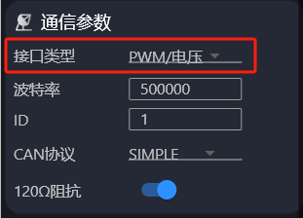
➢ Set the GPIO to PWM mode
odrv0.config.gpio1_mode = GPIO_MODE_PWM
➢ Set the PWM mapping control mode
PWM can be mapped to velocity, position or torque mode; configure just one of the three as needed.
Velocity mode — set the motor control mode to velocity ramp (control_mode = 2, input_mode = 2):
odrv0.config.gpio1_pwm_mapping.endpoint = odrv0.axis0.controller._input_vel_property
Position mode — set the motor control mode to trapezoidal trajectory (control_mode = 3, input_mode = 5):
odrv0.config.gpio1_pwm_mapping.endpoint = odrv0.axis0.controller._input_pos_property
Torque mode — set the motor control mode to torque ramp (control_mode = 1, input_mode = 6; the original says "velocity ramp mode" here, but the values given are for torque ramp):
odrv0.config.gpio1_pwm_mapping.endpoint = odrv0.axis0.controller._input_torque_property
➢ Set the PWM mapping parameters
odrv0.config.gpio1_pwm_mapping.min = -8.0
odrv0.config.gpio1_pwm_mapping.max = 8.0
min and max define the range of control values that the PWM pulse width (1 ms–2 ms) maps to. The driver internally maps the pulse width linearly to a real value in [min, max] and writes it to the endpoint control target you configured. min and max can be set to any values as required.
➢ Save configuration (optional)
odrv0.save_configuration()
After completing the configuration above, put the motor into closed loop and PWM control is ready.

4.5 Pulse/Direction Control
Make sure the hardware version is 3.10 or later before using this function. This function conflicts with the limit switch function. It is the simplest way to control the driver, but also the most primitive and fragile. Therefore, do not use this control method unless your situation specifically requires it.
This function supports controlling the brushless motor through a traditional Step/Dir (pulse/direction) interface, providing control compatible with ordinary stepper motor drivers. In this mode:
- Step (pulse) signal: each rising edge moves the motor by a preset step distance (determined by steps_per_circular_range); maximum recommended step frequency: 50 kHz.
- Dir (direction) signal: the level determines the direction of motion (high = clockwise / low = counter-clockwise).

4.5.1 Wiring
Connect the Step (pulse) signal line to the CANH position described in 2.4.1 and the Dir (direction) signal line to the CANL position described in 2.4.1. This interface supports pulse signals of 5 V and below. Make sure the Step and Dir signals share a common ground with the motor driver, otherwise the signals may not be recognized.

4.5.2 Software Configuration
➢ Switch the communication interface to Step/Dir:
odrv0.config.comm_intf_mux = 2
In Motor Wizard, you can also switch the physical interface under Communication Parameters — open Motor Parameters to find this item (Interface type: Pulse/Direction).
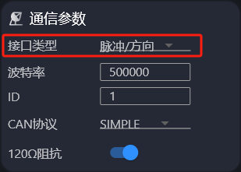
➢ Set the GPIOs for Step/Dir
odrv0.axis0.config.step_gpio_pin = 6
odrv0.axis0.config.dir_gpio_pin = 7
➢ Configure the Step/Dir pins
odrv0.config.gpio6_mode = GPIO_MODE_DIGITAL_PULL_UP
odrv0.config.gpio7_mode = GPIO_MODE_DIGITAL_PULL_UP
➢ Enable Step/Dir
odrv0.axis0.config.enable_step_dir = True
Note: to exit pulse/direction control, set enable_step_dir to False, then enter idle state, and then return to closed-loop control.
➢ Enable circular setpoints (optional)
To handle precision drift when target positions span a large range, ODrive provides circular setpoint support — a wrap-around mode for the target position. Circular setpoints keep floating-point error within a controlled range. If the motor is commanded beyond the circular range, the position setpoint automatically wraps around to stay within range.
Enable the controller's circular setpoint mode:
odrv0.axis0.controller.config.circular_setpoints = True
Set the circular position range (unit: turns); setpoint values are limited to 0 – this range and wrap around beyond it:
# 128 turns form one loop
odrv0.axis0.controller.config.circular_setpoint_range = 128.0
Set how many STEP pulses correspond to the circular position range, which determines the displacement of 1 step:
# 1024 steps per turn
odrv0.axis0.controller.config.steps_per_circular_range = 128 * 1024
➢ Save configuration (optional)
odrv0.save_configuration()
After completing the configuration above, put the motor into closed loop in position mode and pulse/direction control is ready (the original says "PWM control" here).

4.6 SDK

4.6.1 C/C++ SDK
Based on the CAN Simple protocol, the following C/C++ SDK can be downloaded for integration: https://gitee.com/cyberbeast/mwmotorsdk. Refer to the detailed test examples on that open-source site for integration testing.

4.6.2 Python SDK
First install odrivetool following the steps in Section 3.1 (pip install --upgrade odrive). See 3.1.8 — all the commands described there can be used for Python development.
Below are some examples:
1) Example: power-up calibration
import odrive
import time

odrv0 = odrive.find_any()
odrive.utils.dump_errors(odrv0)
odrv0.clear_errors()

odrv0.axis0.requested_state=odrive.utils.AxisState.MOTOR_CALIBRATION
time.sleep(5)
while (odrv0.axis0.current_state!=1):
time.sleep(0.5)
odrive.utils.dump_errors(odrv0)

odrv0.axis0.requested_state=odrive.utils.AxisState.ENCODER_OFFSET_CALIBRATION
time.sleep(6)
while (odrv0.axis0.current_state!=1):
time.sleep(0.5)
odrive.utils.dump_errors(odrv0)

odrv0.axis0.motor.config.pre_calibrated=1
odrv0.axis0.encoder.config.pre_calibrated=1
odrv0.save_configuration()
2) Example: velocity control
import odrive
import time

odrv0 = odrive.find_any()
odrv0.axis0.controller.config.control_mode=odrive.utils.ControlMode.VELOCITY_CONTROL
odrv0.axis0.controller.config.input_mode=odrive.utils.InputMode.VEL_RAMP
odrv0.axis0.controller.config.vel_ramp_rate=50
odrv0.axis0.requested_state=odrive.utils.AxisState.CLOSED_LOOP_CONTROL
odrv0.axis0.controller.input_vel=15
odrive.utils.dump_errors(odrv0)
time.sleep(5)
odrv0.axis0.controller.input_vel=0
3) Example: position control
import odrive

odrv0 = odrive.find_any()
odrv0.axis0.controller.config.control_mode=odrive.utils.ControlMode.POSITION_CONTROL
odrv0.axis0.controller.config.input_mode=odrive.utils.InputMode.POS_FILTER
odrv0.axis0.requested_state=odrive.utils.AxisState.CLOSED_LOOP_CONTROL
odrv0.axis0.controller.input_pos=10
4) Example: data capture
During development and integration you often need to capture motor operating data, such as changes in voltage and current, or position and velocity. The Python SDK integrates powerful data capture capabilities, letting you capture large amounts of operating data with simple scripts and making development and integration easier.
The code below builds on the previous position control example, adding real-time capture of position and current data and saving the data to a CSV file.
import odrive
import numpy as np

odrv0 = odrive.find_any()
cap = odrive.utils.BulkCapture(lambda:[odrv0.axis0.motor.current_control.Iq_measured,
odrv0.axis0.encoder.pos_estimate], data_rate=500, duration=2.5)
odrv0.axis0.controller.config.control_mode=odrive.utils.ControlMode.POSITION_CONTROL
odrv0.axis0.controller.config.input_mode=odrive.utils.InputMode.POS_FILTER
odrv0.axis0.requested_state=odrive.utils.AxisState.CLOSED_LOOP_CONTROL
odrv0.axis0.controller.input_pos=10
np.savetxt("d:/test.csv",cap.data,delimiter=',')
In the BulkCapture statement, data_rate is the sampling frequency in Hz and duration is the sampling time in seconds; the lambda expression can include any mathematical operation to make data analysis easier.

4.6.3 Arduino SDK
With Arduino you can control the motor over the CAN bus; the underlying protocol is as described in 4.1. Compatible hardware/libraries:
- Arduinos with a built-in CAN interface, such as Arduino UNO R4 Minima, Arduino UNO R4 WiFi, etc.
- Teensy boards with a built-in CAN interface can use the matching FlexCAN_T4 library (Teensy 4.0 and Teensy 4.1)
- Other Arduino-compatible boards can use an MCP2515-based CAN expansion board
The following example shows how to configure the motor to respond to position control commands from an Arduino:
➢ Configure the motor
In addition to the basic configuration in 3.1.3, configure the control bandwidth to 20 rad/s (the Arduino Uno's transmit rate is limited, so the control bandwidth need not be high; with a faster Arduino this bandwidth can be increased). (The original manual gives no commands after this item.)
➢ Configure CAN
Configure CAN as follows: (the original manual gives no commands after this item.)
➢ Install the ODriveArduino library
Install the ODriveArduino library as follows (assuming the Arduino IDE is already installed):
1) Open the Arduino IDE
2) Sketch → Include Library → Manage Libraries
3) Search for "ODriveArduino"
4) Click the ODriveArduino library found and install it
➢ Arduino source code
#include <Arduino.h>
#include "ODriveCAN.h"
// Documentation for this example can be found here:
// https://docs.odriverobotics.com/v/latest/guides/arduino-can-guide.html
/* Configuration of example sketch -------------------------------------------*/
// CAN bus baudrate. Make sure this matches for every device on the bus
#define CAN_BAUDRATE 500000
// ODrive node_id for odrv0
#define ODRV0_NODE_ID 0
// Uncomment below the line that corresponds to your hardware.
// See also "Board-specific settings" to adapt the details for your hardware setup.
// #define IS_TEENSY_BUILTIN // Teensy boards with built-in CAN interface (e.g. Teensy 4.1). See below to select which interface to use.
// #define IS_ARDUINO_BUILTIN // Arduino boards with built-in CAN interface (e.g. Arduino Uno R4 Minima)
// #define IS_MCP2515 // Any board with external MCP2515 based extension module. See below to configure the module.
/* Board-specific includes ---------------------------------------------------*/
#if defined(IS_TEENSY_BUILTIN) + defined(IS_ARDUINO_BUILTIN) + defined(IS_MCP2515) != 1
#warning "Select exactly one hardware option at the top of this file."
#if CAN_HOWMANY > 0 || CANFD_HOWMANY > 0
#define IS_ARDUINO_BUILTIN
#warning "guessing that this uses HardwareCAN"
#else
#error "cannot guess hardware version"
#endif
#endif
#ifdef IS_ARDUINO_BUILTIN
// See https://github.com/arduino/ArduinoCore-API/blob/master/api/HardwareCAN.h
// and https://github.com/arduino/ArduinoCore-renesas/tree/main/libraries/Arduino_CAN
#include <Arduino_CAN.h>
#include <ODriveHardwareCAN.hpp>
#endif // IS_ARDUINO_BUILTIN
#ifdef IS_MCP2515
// See https://github.com/sandeepmistry/arduino-CAN/
#include "MCP2515.h"
#include "ODriveMCPCAN.hpp"
#endif // IS_MCP2515
#ifdef IS_TEENSY_BUILTIN
// See https://github.com/tonton81/FlexCAN_T4
// clone https://github.com/tonton81/FlexCAN_T4.git into /src
#include <FlexCAN_T4.h>
#include "ODriveFlexCAN.hpp"
struct ODriveStatus; // hack to prevent teensy compile error
#endif // IS_TEENSY_BUILTIN
/* Board-specific settings ---------------------------------------------------*/
/* Teensy */
#ifdef IS_TEENSY_BUILTIN
FlexCAN_T4<CAN1, RX_SIZE_256, TX_SIZE_16> can_intf;
bool setupCan() {
can_intf.begin();
can_intf.setBaudRate(CAN_BAUDRATE);
can_intf.setMaxMB(16);
can_intf.enableFIFO();
can_intf.enableFIFOInterrupt();
can_intf.onReceive(onCanMessage);
return true;
}
#endif // IS_TEENSY_BUILTIN
/* MCP2515-based extension modules -*/
#ifdef IS_MCP2515
MCP2515Class& can_intf = CAN;
// chip select pin used for the MCP2515
#define MCP2515_CS 10
// interrupt pin used for the MCP2515
// NOTE: not all Arduino pins are interruptable, check the documentation for your board!
#define MCP2515_INT 2
// freqeuncy of the crystal oscillator on the MCP2515 breakout board.
// common values are: 16 MHz, 12 MHz, 8 MHz
#define MCP2515_CLK_HZ 8000000
static inline void receiveCallback(int packet_size) {
if (packet_size > 8) {
return; // not supported
}
CanMsg msg = {.id = (unsigned int)CAN.packetId(), .len = (uint8_t)packet_size};
CAN.readBytes(msg.buffer, packet_size);
onCanMessage(msg);
}
bool setupCan() {
// configure and initialize the CAN bus interface
CAN.setPins(MCP2515_CS, MCP2515_INT);
CAN.setClockFrequency(MCP2515_CLK_HZ);
if (!CAN.begin(CAN_BAUDRATE)) {
return false;
}
CAN.onReceive(receiveCallback);
return true;
}
#endif // IS_MCP2515
/* Arduinos with built-in CAN */
#ifdef IS_ARDUINO_BUILTIN
HardwareCAN& can_intf = CAN;
bool setupCan() {
return can_intf.begin((CanBitRate)CAN_BAUDRATE);
}
#endif
/* Example sketch ------------------------------------------------------------*/
// Instantiate ODrive objects
ODriveCAN odrv0(wrap_can_intf(can_intf), ODRV0_NODE_ID); // Standard CAN message ID
ODriveCAN* odrives[] = {&odrv0}; // Make sure all ODriveCAN instances are accounted for here
struct ODriveUserData {
Heartbeat_msg_t last_heartbeat;
bool received_heartbeat = false;
Get_Encoder_Estimates_msg_t last_feedback;
bool received_feedback = false;
};
// Keep some application-specific user data for every ODrive.
ODriveUserData odrv0_user_data;
// Called every time a Heartbeat message arrives from the ODrive
void onHeartbeat(Heartbeat_msg_t& msg, void* user_data) {
ODriveUserData* odrv_user_data = static_cast<ODriveUserData*>(user_data);
odrv_user_data->last_heartbeat = msg;
odrv_user_data->received_heartbeat = true;
}
// Called every time a feedback message arrives from the ODrive
void onFeedback(Get_Encoder_Estimates_msg_t& msg, void* user_data) {
ODriveUserData* odrv_user_data = static_cast<ODriveUserData*>(user_data);
odrv_user_data->last_feedback = msg;
odrv_user_data->received_feedback = true;
}
// Called for every message that arrives on the CAN bus
void onCanMessage(const CanMsg& msg) {
for (auto odrive: odrives) {
onReceive(msg, *odrive);
}
}
void setup() {
Serial.begin(115200);
// Wait for up to 3 seconds for the serial port to be opened on the PC side.
// If no PC connects, continue anyway.
for (int i = 0; i < 30 && !Serial; ++i) {
delay(100);
}
delay(200);
Serial.println("Starting ODriveCAN demo");
// Register callbacks for the heartbeat and encoder feedback messages
odrv0.onFeedback(onFeedback, &odrv0_user_data);
odrv0.onStatus(onHeartbeat, &odrv0_user_data);
// Configure and initialize the CAN bus interface. This function depends on
// your hardware and the CAN stack that you're using.
if (!setupCan()) {
Serial.println("CAN failed to initialize: reset required");
while (true); // spin indefinitely
}
Serial.println("Waiting for ODrive...");
while (!odrv0_user_data.received_heartbeat) {
pumpEvents(can_intf);
delay(100);
}
Serial.println("found ODrive");
// request bus voltage and current (1sec timeout)
Serial.println("attempting to read bus voltage and current");
Get_Bus_Voltage_Current_msg_t vbus;
if (!odrv0.request(vbus, 1)) {
Serial.println("vbus request failed!");
while (true); // spin indefinitely
}
Serial.print("DC voltage [V]: ");
Serial.println(vbus.Bus_Voltage);
Serial.print("DC current [A]: ");
Serial.println(vbus.Bus_Current);
Serial.println("Enabling closed loop control...");
while (odrv0_user_data.last_heartbeat.Axis_State != ODriveAxisState::AXIS_STATE_CLOSED_LOOP_CONTROL) {
odrv0.clearErrors();
delay(1);
odrv0.setState(ODriveAxisState::AXIS_STATE_CLOSED_LOOP_CONTROL);
// Pump events for 150ms. This delay is needed for two reasons;
// 1. If there is an error condition, such as missing DC power, the ODrive might
// briefly attempt to enter CLOSED_LOOP_CONTROL state, so we can't rely
// on the first heartbeat response, so we want to receive at least two
// heartbeats (100ms default interval).
// 2. If the bus is congested, the setState command won't get through
// immediately but can be delayed.
for (int i = 0; i < 15; ++i) {
delay(10);
pumpEvents(can_intf);
}
}
Serial.println("ODrive running!");
}
void loop() {
pumpEvents(can_intf); // This is required on some platforms to handle incoming feedback CAN messages
float SINE_PERIOD = 2.0f; // Period of the position command sine wave in seconds
float t = 0.001 * millis();
float phase = t * (TWO_PI / SINE_PERIOD);
odrv0.setPosition(
sin(phase), // position
cos(phase) * (TWO_PI / SINE_PERIOD) // velocity feedforward (optional)
);
// print position and velocity for Serial Plotter
if (odrv0_user_data.received_feedback) {
Get_Encoder_Estimates_msg_t feedback = odrv0_user_data.last_feedback;
odrv0_user_data.received_feedback = false;
Serial.print("odrv0-pos:");
Serial.print(feedback.Pos_Estimate);
Serial.print(",");
Serial.print("odrv0-vel:");
Serial.println(feedback.Vel_Estimate);
}
}

4.6.4 ROS SDK
The following steps have been tested on Ubuntu 23.04 with ROS2 Iron. macOS and Windows are not supported, and other ROS2 versions have not been verified and may need modification before use.

4.6.4.1 Installing the odrive_can package
1. Create a new ROS2 workspace (see https://docs.ros.org/en/iron/index.html)
2. Use git clone https://github.com/odriverobotics/odrive_can to download the code into the src directory of that workspace
3. In a terminal, go to the workspace root and run:
colcon build --packages-select odrive_can
4. Prepare the environment before running:
source ./install/setup.bash
5. Run the example node:
ros2 launch odrive_can example_launch.yaml

4.6.4.2 Calling services and viewing messages
Assume the odrive_can_node above runs in the namespace odrive_axis0 (configurable in ./launch/example_launch.yaml). Once the node from 4.6.4.1 is running, you can view the published topic messages, e.g.:
ros2 topic echo /odrive_axis0/controller_status
ros2 topic echo /odrive_axis0/odrive_status
and call the exposed services; for example, the following call starts motor calibration:
ros2 service call /odrive_axis0/request_axis_state /odrive_can/srv/AxisState "{axis_requested_state: 4}"

5 FAQ and Error Codes (to be updated)

5.6 Frequently Asked Questions (FAQ)
(No content in the original.)

5.7 Error Codes
(Elsewhere the manual refers to these tables as "Section 5.2".)
Error category | Error code | odrivetool display | Description
System error | 0x00000002 | DC_BUS_UNDER_VOLTAGE | Supply voltage too low
System error | 0x00000004 | DC_BUS_OVER_VOLTAGE | Supply voltage too high
System error | 0x00000008 | DC_BUS_OVER_REGEN_CURRENT | Supply reverse (charging) current too high
System error | 0x00000010 | DC_BUS_OVER_CURRENT | Supply forward (discharging) current too high
Drive error | 0x00000001 | INVALID_STATE | Invalid driver state
Drive error | 0x00000040 | MOTOR_FAILED | Motor error
Drive error | 0x00000100 | ENCODER_FAILED | Encoder error
Drive error | 0x00000200 | CONTROLLER_FAILED | Controller error
Drive error | 0x00001000 | MIN_ENDSTOP_PRESSED | Minimum limit switch triggered
Drive error | 0x00002000 | MAX_ENDSTOP_PRESSED | Maximum limit switch triggered
Drive error | 0x00004000 | ESTOP_REQUESTED | Emergency stop
Drive error | 0x00020000 | HOMING_WITHOUT_ENDSTOP | Homing requested but no limit switch
Drive error | 0x00080000 | UNKNOWN_POSITION | No position information
Motor error | 0x00000001 | PHASE_RESISTANCE_OUT_OF_RANGE | Phase-to-phase resistance out of normal range
Motor error | 0x00000002 | PHASE_INDUCTANCE_OUT_OF_RANGE | Phase-to-phase inductance out of normal range
Motor error | 0x00000010 | CONTROL_DEADLINE_MISSED | FOC frequency too high
Motor error | 0x00000080 | MODULATION_MAGNITUDE | SVM modulation error
Motor error | 0x00000400 | CURRENT_SENSE_SATURATION | Phase current saturation
Motor error | 0x00001000 | CURRENT_LIMIT_VIOLATION | Motor current too high
Motor error | 0x00020000 | MOTOR_THERMISTOR_OVER_TEMP | Motor temperature too high
Motor error | 0x00040000 | FET_THERMISTOR_OVER_TEMP | Driver temperature too high
Motor error | 0x00080000 | TIMER_UPDATE_MISSED | FOC processing not in time
Motor error | 0x00100000 | CURRENT_MEASUREMENT_UNAVAILABLE | Phase current sample lost
Motor error | 0x00200000 | CONTROLLER_FAILED | Control error
Motor error | 0x00400000 | I_BUS_OUT_OF_RANGE | Bus current out of range
Motor error | 0x00800000 | BRAKE_RESISTOR_DISARMED | Brake resistor drive error
Motor error | 0x01000000 | SYSTEM_LEVEL | System-level error
Motor error | 0x02000000 | BAD_TIMING | Phase current sampling not in time
Motor error | 0x04000000 | UNKNOWN_PHASE_ESTIMATE | Motor position unknown
Motor error | 0x08000000 | UNKNOWN_PHASE_VEL | Motor velocity unknown
Motor error | 0x10000000 | UNKNOWN_TORQUE | Torque unknown
Motor error | 0x20000000 | UNKNOWN_CURRENT_COMMAND | Torque control unknown
Motor error | 0x40000000 | UNKNOWN_CURRENT_MEASUREMENT | Current sample value unknown
Motor error | 0x80000000 | UNKNOWN_VBUS_VOLTAGE | Voltage sample value unknown
Motor error | 0x100000000 | UNKNOWN_VOLTAGE_COMMAND | Voltage control unknown
Motor error | 0x200000000 | UNKNOWN_GAINS | Current loop gains unknown
Motor error | 0x400000000 | CONTROLLER_INITIALIZING | Controller initialization error
Motor error | 0x800000000 | UNBALANCED_PHASES | Three phases unbalanced
Controller error | 0x00000001 | OVERSPEED | Speed too high
Controller error | 0x00000002 | INVALID_INPUT_MODE | Incorrect control input mode
Controller error | 0x00000004 | UNSTABLE_GAIN | Phase-locked loop gain unstable
Controller error | 0x00000020 | INVALID_ESTIMATE | Position/velocity unstable
Controller error | 0x00000080 | SPINOUT_DETECTED | Mechanical and electrical power mismatch (incorrect encoder calibration, or unstable magnet)
Encoder error | 0x00000001 | UNSTABLE_GAIN | Encoder bandwidth too high
Encoder error | 0x00000002 | CPR_POLEPAIRS_MISMATCH | CPR and pole-pair count mismatch
Encoder error | 0x00000004 | NO_RESPONSE | Encoder not responding
Encoder error | 0x00000400 | SEC_ENC_COM_FAIL | Second encoder communication error

