**A Modeling Framework for Bioretention Systems Analysis: Assessing the Hydrological Performance under System’s Uncertainty**

Marcus Nóbrega Gomes Junior*1, Marcio H. Giacomoni2, Marina Batalini de Macedo3, Thalita Raquel Pereira de Oliveira4, José Artur Texeira Brasil5, Eduardo Mario Mendiondo6

Supplementary Material

# 1. Software TC-Hydro V1

To run the model is required a licensed version of Microsoft Excel 2013 or above. Moreover, add-ins as the Solver and Developer modes should be activated for better performance of the software. Although most of the calculations are performed in spreadsheets, the integration within the data entry and the spreadsheet is fully done using guided user forms (GUI). After opening the file, the user must habilitate the content and enable macros. The initial user form in the software is activated after enabling edition and macros. It guides the user to the watershed data entry, and through the bioretention system analysis modules. The user must follow steps (a), (b), and (c) to start the bioretention system analysis.

Figure 1 - Initial Interface of the TC-Hydro V1

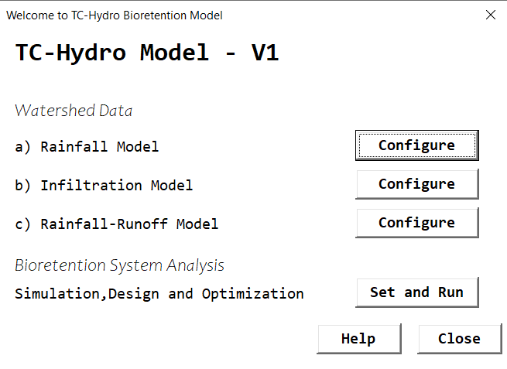

### 1.1 Rainfall Temporal Distribution Models

Four temporal rainfall distribution models are available in the model, including Huff, Alternated Blocks, Rational Method and Constant Rainfall methods.

Figure 2 - Rainfall Temporal Distribution Models

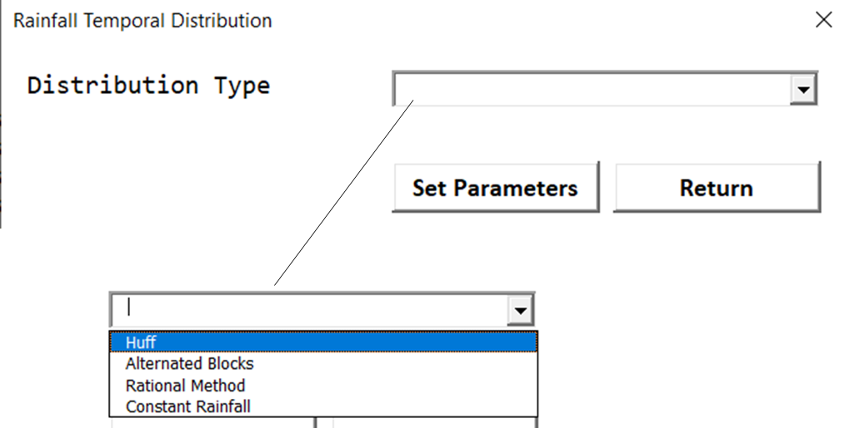

#### 1.1.1 Huff Hyetograph

The Huff hyetographs are a set of polynomial equations and are developed for the 1st, 2nd, 3rd and 4th quartile, depending on the rainfall duration. Basically, it distributes the entered precipitation according to the respective quartile equation. It is required a Sherman Type IDF curve, such that:

where i is the rainfall intensity in mm/h, K, a, b and c are fitted parameters for the IDF and RP is the return period of the rainfall.

Figure 3 - Huff Hyetograph parameters. After clicking in Run, a calculated precipitation is shown, and the user needs to enter the assumed precipitation in the respective textbox.

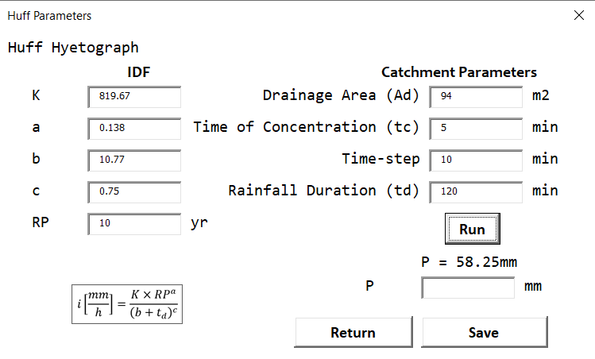

The polynomial equations used in the software to represent the Huff temporal distribution are presented in the following equations for the 1st, 2nd, 3rd and 4th quartile, respectively.

* Huff 1st quartile
* Huff 2nd quartile
* Huff 3rd quartile
* Huff 4th quartile

#### 1.1.2 Alternated Blocks

The alternated blocks also require the IDF Sherman type parameters and the catchment properties and has two main governing equations for rainfall intensity before and after the rainfall peak.

1. Before rainfall peak
2. After rainfall peak

where γ is a peak factor assumed as 0.5 to represent the rainfall peak at 50% of the storm duration

Figure 4 - Alternated Blocks User Interface

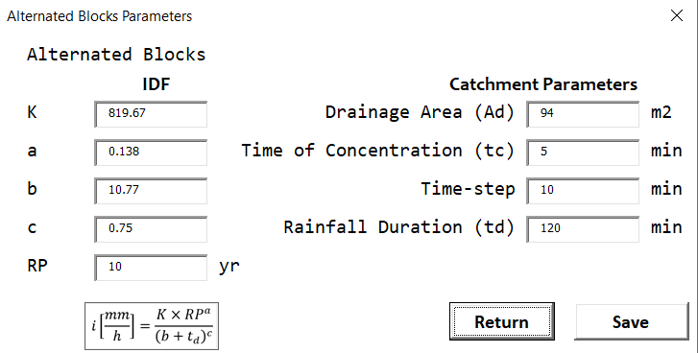

#### 1.1.3 Rational Method

The rational method hyetograph assumes a constant rainfall with an intensity given by the IDF curve through the duration of the storm *td*.

Figure 5 - Rational Method Parameters

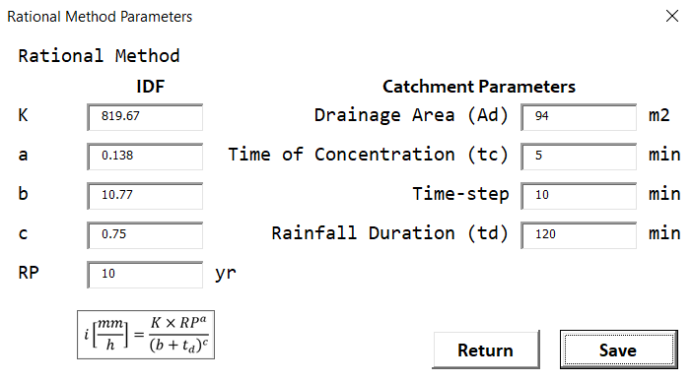

#### 1.1.4 Constant Rainfall

The constant rainfall basically assumes a constant rainfall intensity entered in the respective textbox. In the case of the constant rainfall equals the calculated rainfall from the IDF, the method is hence equivalent to the Rational Method.

Figure 6 - Parameters for the Constant Rainfall Module

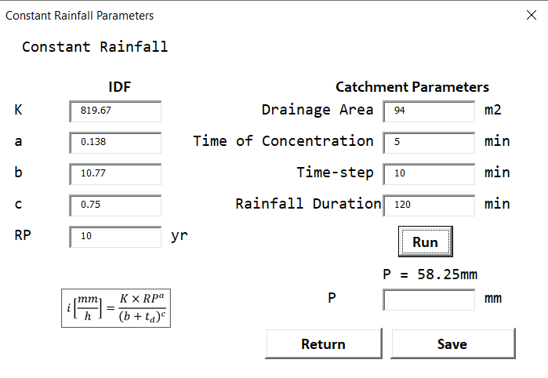

### 1.2 Catchment Infiltration Model

For the infiltration, three models are available – the SCS-CN, the Horton Method, and the Rational Method. For the SCS method is required the CN and for the Horton, the initial and final infiltration rates as well as the decreasing exponential factor k are required, whereas for the Rational Method, only the runoff coefficient is necessary. The Rational Method, however, is only possible to be selected in case the Rational Method was chosen for the rainfall temporal distribution method.

#### 1.2.1 SCS Method

The standard equations for the SCS-CN method are solved to estimate the effective precipitation and infiltration rates. The effective precipitation, accumulated rainfall, catchment storage capacity, accumulated infiltration, infiltration rate, and incremental effective precipitation are presented below, respectively.

where Pef is the accumulated effective precipitation in mm, P is the accumulated rainfall, k is a time-step index, S is the storage capacity in mm, F(t) is the accumulated infiltration, f(t) is the infiltration rate, and ΔPef is the incremental precipitation.

#### 1.2.2 Horton Method

The infiltration capacity equation is given by an exponential equation that requires three parameters, fc (final infiltration in mm/h), f0 (initial infiltration in mm/h) and k (decreasing exponential factor in 1/h). The infiltration rate, accumulated infiltration, effective precipitation rate, accumulated precipitation and incremental precipitation are presented below, respectively. All calculations, however, are limited by the flow hortonian or non-hortonian flow conditions. In other words, when the infiltration capacity is smaller than the inflow rate, all water infiltrates following the infiltration capacity. However the when the inflow rate is smaller, then the infiltration rate is the inflow rate.

where i(t) is the rainfall intensity and pef(t) is the effective precipitation rate in mm/h.

Figure 7 - Infiltration models

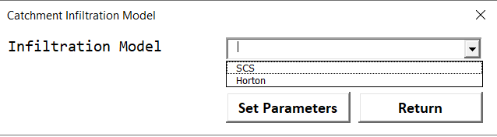

Figure 8 - SCS-CN user form

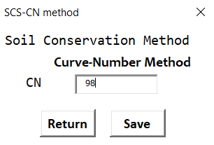

Figure 9 - Horton Parameters

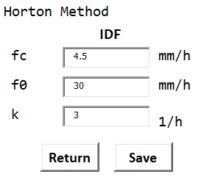

Figure 10 - Rational Method Runoff Coefficient

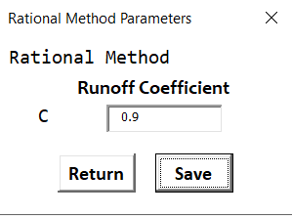

### 1.3 Rainfall Runoff

For the conversion of excess of precipitation into flow discharge, three models are available – the Santa Barbara Urban Hydrograph (SBUH), the SCS PRF 484 unit hydrograph and the Rational Method Hydrograph.

Figure 11 - Rainfall-Runoff model

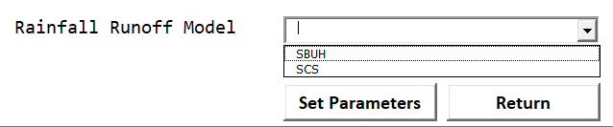

For all methods is required to set the simulation time in minutes.

#### 1.3.1 SBUH

Assuming a linear reservoir with a damping constant Kr proportional to the time of concentration of the catchment, the hydrograph of the SBUH method is developed assuming the flow discharge linearly proportional to the runoff volume, as a linear reservoir. The governing equations of this method are presented below.

where I is the effective precipitation for pervious and impervious areas, d is the percentage of impervious areas directly connected to the catchment, ie is the effective precipitation for the pervious areas, Kr is the reservoir damping parameter and Q is the flow discharge in the outlet of the catchment.

Figure 12 - Parameters of the SBUH, where d is the percentage of impervious directly connected areas

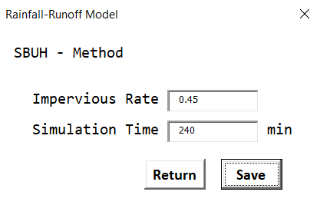

#### 1.3.2 SCS Method

The software allows the convolution of 432 unit hydrographs, which is equivalent as a daily rainfall with 5-min time-steps in a impermeable watershed (i.e., C = 1, d = 1, CN = 100, f0 = fc = 0). The following equations present the parameters required for the unit hydrograph and for the convolution of all blocks of effective precipitation.

where Δt is the simulation time in minutes, τ is a convolution parameter, U is the ordinate of the unit hydrograph and can be calculated defining two slopes, and , such that:

Figure 13 - SCS Unit Hydrograph Scheme for a given block of effective precipitation dislocated ti from the beginning of the storm event

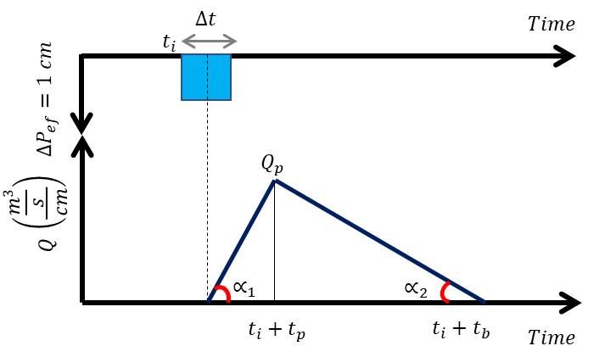

Therefore, using geometry relationships we can determine two functions for the ordinates of the unit hydrograph and hence solve the convolution integral in a time-step fashion. Assuming a block of effective precipitation with a timespan of ti from the beginning of the event, the flow conversion for this block is:

Therefore, the total flow observed in a time t can be expressed as:

where k is the number of blocks of effective precipitation and n represents the ordinality of the blocks of effective precipitation.

### 1.3.3 Rational Method

The rational method hydrograph be either a trapezoid or an isosceles triangle, depending on the rainfall duration and time of concentration of the catchment. Essentially, three cases are possible:

where C is the runoff coefficient and tc is the time of concentration of the catchment.

In cases where the rainfall duration is larger than , a trapezoidal hydrograph is developed assuming the constant inflow peak through a duration from .

### 1.4 Bioretention System Analysis

After the configuration of the catchment models, a main user form is shown presenting the dimensions and parameters required to simulate the bioretention system.

Figure 14 - Main Interface of the TC-Hydro showing the Plant View, Orifice, Weir, GA-1D, Exfiltration and Modeling Options.

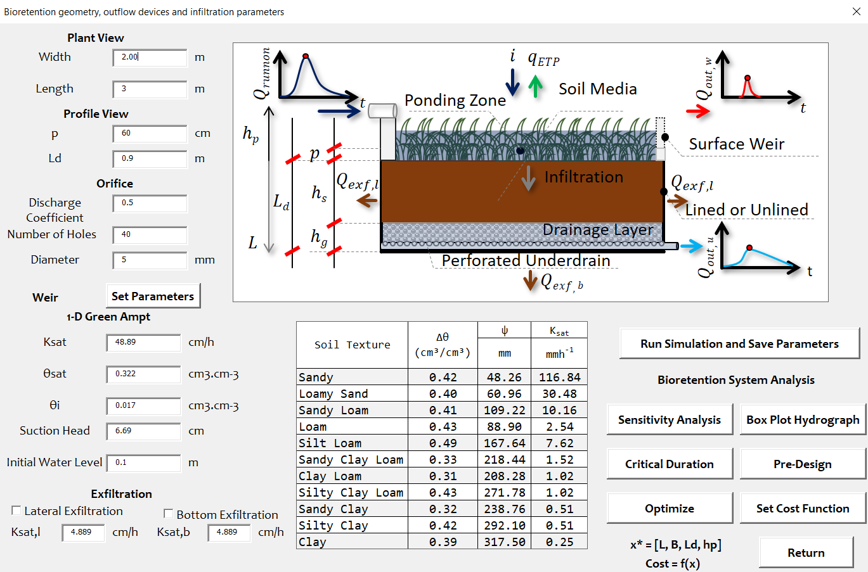

#### 1.4.1 Weir Parameters

For the weir configuration, two options are allowed. The triangular weir, also called as Thompson or V-notch weir and the Francis weir or rectangular weir with a lateral contraction.

Figure 15 - Weir equations, types, and parameters

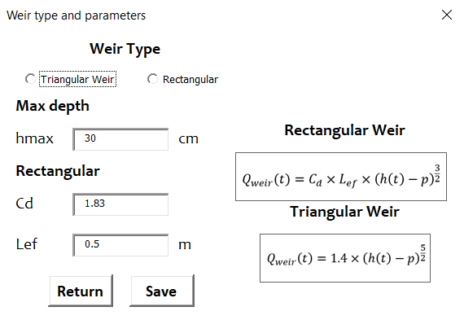

#### 1.4.2 Run Simulation and Save Parameters

The simulation results are showed according to the data entered in the main interface.

Figure 16 - Results of the simulation

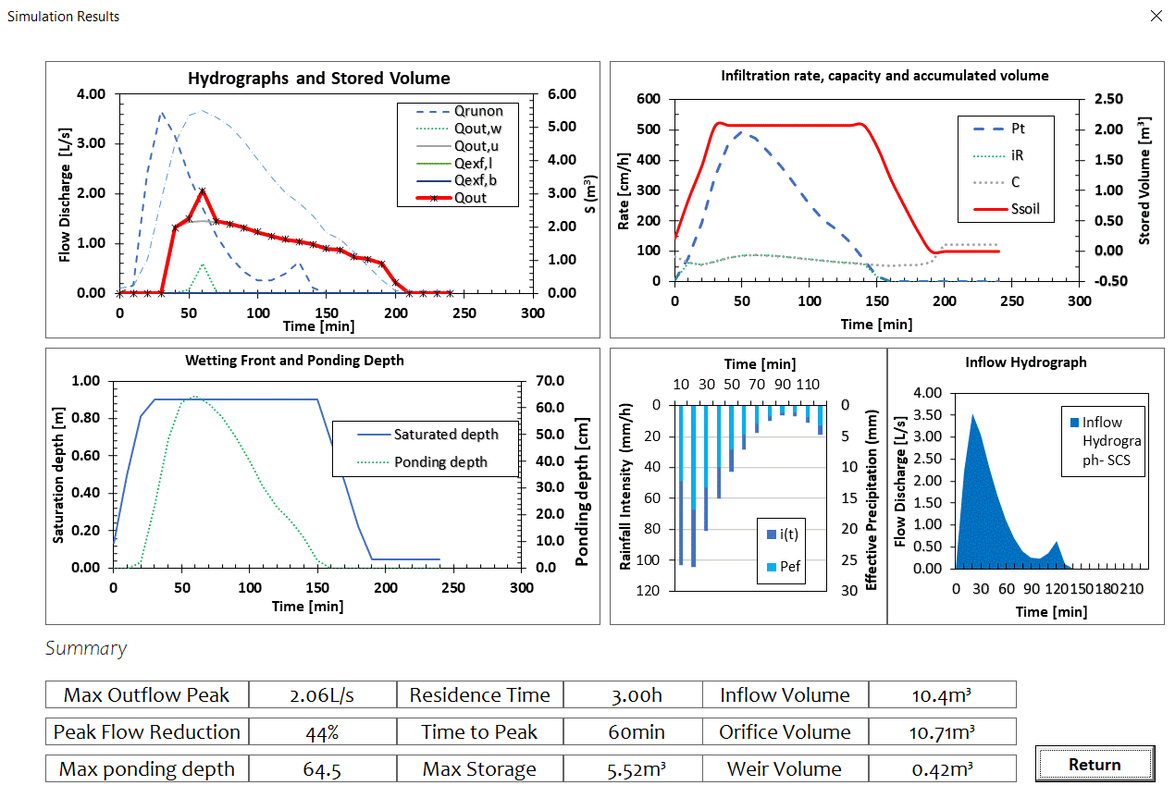

#### 1.4.3 One-at-time sensitivity analysis

The one-at-time sensitivity analysis is performed considering the base scenario provided by the entered data in the main userform. Moreover, it is required to enter the begin (e.g., 0%), the interval (e.g., 90% positive and negative variation) and the steps. The exfiltration parameters must be entered in this userform even with the bioretention is lined, in order to assess the role of exfiltration in the modeled system.

Figure 17 - Sensitivity Analysis Parameters

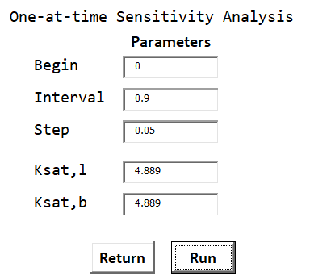

Figure 18 - Sensitivity Analysis Results

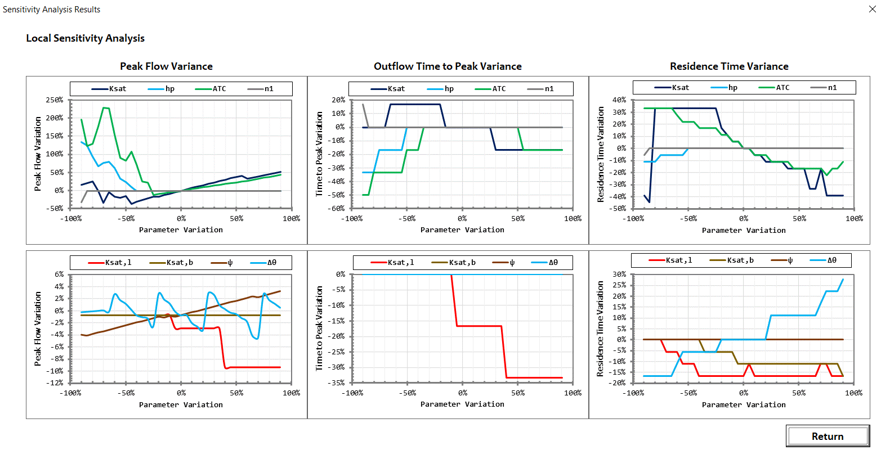

#### 1.4.5 Critical Rainfall Duration

The critical duration is calculated and presented in a graph, as showed in this figure.

Figure 19 - Critical Duration Analysis

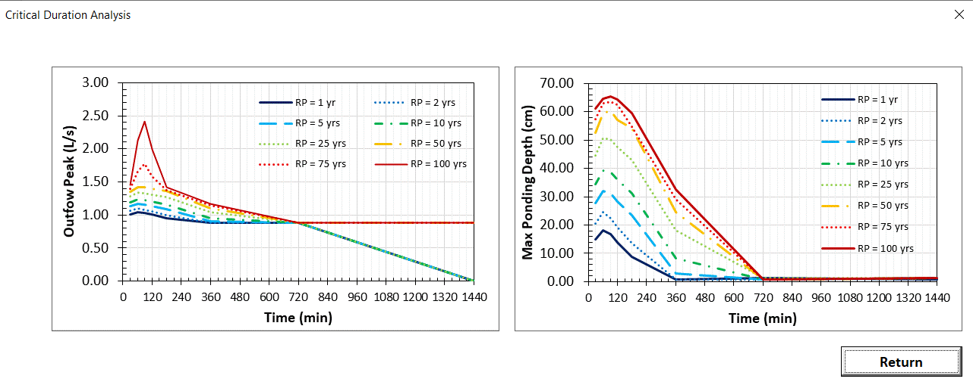

#### 1.4.6 Box-Plot Hydrograph

A statistical box-plot hydrograph is developed assuming 485 modeling results varying the rainfall temporal distribution, infiltration properties and initial storage.

Figure 20 - Box-plot parameters, where min and max are the assessed saturation conditions and rate the variation in the estimated values

Figure 21 - Box-plot parameters

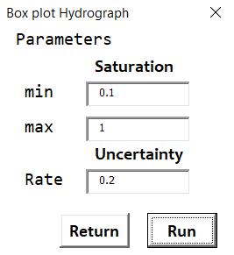

Figure 22 - Box-plot hydrograph

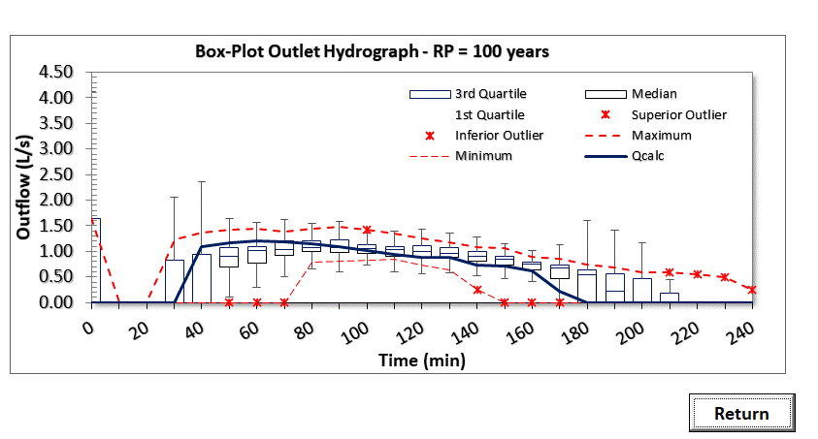

#### 1.4.7 Optimization Module

A single objective optimization problem is designed assuming a cost function given by the volume, area, ponding depth and a penalizing function in terms of a required minimum peak flow mitigation. Weights are given to represent the desire of the designer in the optimization.

Given a decision vector and a cost function

The optimization problem is defined as:

*subject to*

Figure 23 - Optimization Module Parameters

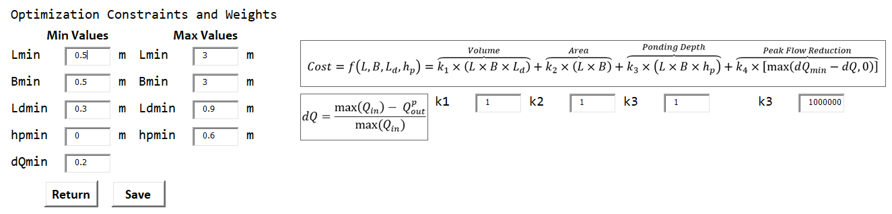

After the configuration of the optimization problem, a genetic algorithm optimization problem with 100 population, 40 generations, mutation rate of 0.075 and computational time limited for 240 seconds is defined. The near optimal results are displayed in the interface, as showed in this figure below

Figure 24 - Near-optimal results including decision variables and cost function evaluation

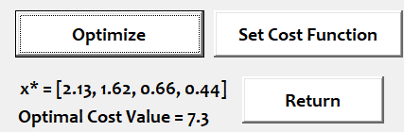

#### 1.4.8 Pre-Design Methods

The pre-design methods of the Water Quality Volume and Pre-development Flow Conditions are calculated assuming the following parameters.

Figure 25 - Pre-design parameters

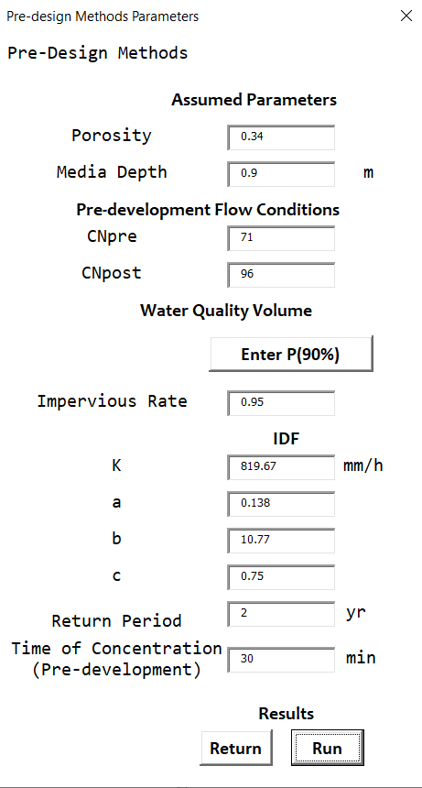

The following equations represent the main calculations for the water quality volume and pre-development flow conditions volume.

* Water Quality Volume
* Pre-development Flow Conditions

* Envelope Curve

where Rv is the impervious connected rate, P(90%) is the daily rainfall with 10% of excedeence of probability, Ppost and Ppre are accumulated precipitations calculated based on the 2-yr, 24-h storm and P(90%), Pefpost and Pefpre are effective precipitation of post and pre development, η is the average porosity of the bioretention and AWQV and APFC are the bioretention surface areas for the water quality volume and pre-development flow conditions methods.

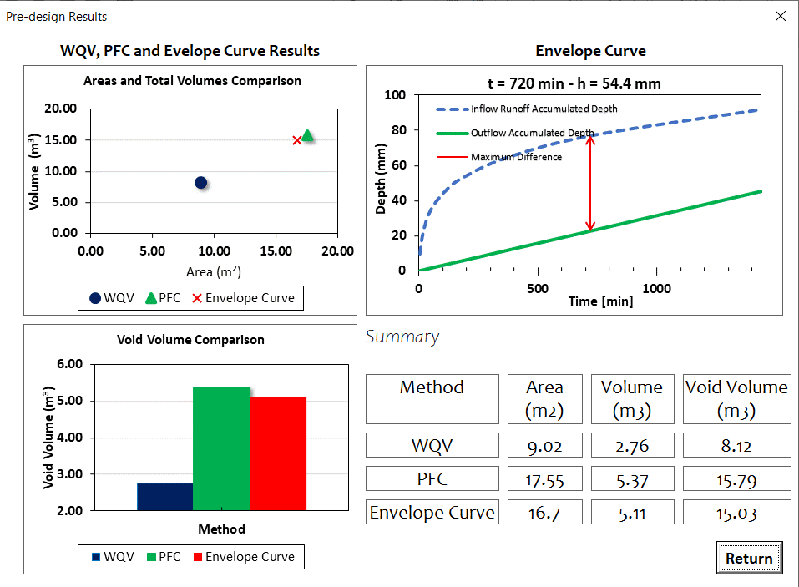

Figure 26 - Comparison between pre-design methods in the TC-Hydro Model

# 2. IDF Curve of São Carlos

The IDF curve assumed to estimate the rainfall dynamics in São Carlos – São Paulo is given by:

# 3. Evaluation Functions

For each pertubation in the assessed variables in the one-at-time sensitivity analysis, a variance is calculated in terms of the baseline scenario results.

* Outflow Peak Variance
* Outflow Time to Peak Variance
* Residence Time Variance

where b index refers to the baseline scenario.