Automated Step Detection in Pole Vault Approach Runs
Using Pose Estimation and Machine Learning
Marcus Thayer
BYU — Machine Learning Progress Report Draft
March 2026

Cover Letter
This report presents progress on an automated step detection system for pole vault approach runs. The ability to accurately detect ground-contact events (steps) during the approach phase is foundational for biomechanical analysis of pole vaulting — it enables downstream stride analysis including step frequency, stride length, and velocity profiling, all of which are critical coaching metrics.
The primary contribution of this work is a complete pipeline that takes raw video of a pole vault approach, extracts human pose data using MediaPipe, and classifies each frame to determine whether a specific foot is in contact with the ground. This progress report covers the data collection and labeling process, feature engineering from pose landmarks, a preliminary comparison of eight classification models, and initial results on held-out test data using stratified cross-validation.

Highlights
- Developed a custom Streamlit-based video labeling application for annotating ground-contact events in pole vault approach videos, producing structured landmark and label datasets.
- Engineered 165 biomechanical features from MediaPipe pose landmarks using a novel per-foot relative framing that enables foot-agnostic classification.
- Compared eight classification models using stratified 5-fold cross-validation on 1,358 samples from 7 labeled videos.
- Achieved 96.9% F1 score and 0.993 ROC AUC with HistGradient Boosting, demonstrating that single-frame pose features contain strong signal for step detection.
- Identified ankle_y_diff (vertical position difference between the target and opposite foot) as the dominant predictive feature, consistent with biomechanical expectations.

Abstract
Step detection — identifying the precise frames when an athlete's foot contacts the ground — is a prerequisite for stride analysis in pole vaulting. Manual frame-by-frame labeling is time-consuming and limits the scalability of biomechanical analysis. This work presents an automated approach using Google MediaPipe pose estimation to extract 33-joint skeletal landmarks from monocular video, followed by machine learning classification to predict ground contact for each foot at each frame. A custom labeling application was developed to create training data from seven pole vault approach-run videos. We compare eight classifiers — Random Forest, Gradient Boosting, HistGradient Boosting, XGBoost, SVM, K-Nearest Neighbors, Logistic Regression, and a Multi-Layer Perceptron neural network — using stratified 5-fold cross-validation. HistGradient Boosting achieved the best performance with F1 = 0.969 and ROC AUC = 0.993 on held-out folds. Feature importance analysis reveals that the vertical ankle position difference between feet is the single most discriminative feature, accounting for over 30% of model importance.

1. Introduction / Literature Review

1.1 Motivation
Pole vaulting is one of the most technically complex events in track and field. The approach run, typically consisting of 14–20 steps, must be executed with precise consistency to deliver the athlete to the takeoff point at optimal speed, body position, and stride phase. Coaches routinely analyze approach runs to identify deviations in step length, step frequency, and velocity — metrics that form the basis of technical corrections.
Currently, this analysis is largely manual. A coach or biomechanist reviews video frame by frame to identify each ground contact, then calculates stride parameters from timestamps and positions. This process is slow, subjective, and difficult to scale across multiple athletes or training sessions.

1.2 Related Work
Automated gait analysis has been studied extensively in clinical and sports biomechanics. Inertial measurement unit (IMU) based systems such as those by Strohrmann et al. (2012) and Mariani et al. (2013) detect gait events using accelerometer signals. However, IMU-based approaches require sensors to be physically attached to the athlete, which is impractical for field events and may alter natural movement.
Vision-based approaches have become increasingly viable with advances in human pose estimation. OpenPose (Cao et al., 2019) and MediaPipe Pose (Lugaresi et al., 2019) enable real-time extraction of skeletal keypoints from monocular video without markers or wearable sensors. Recent work by Stenum et al. (2021) demonstrated that gait events can be detected from 2D pose estimation with accuracy comparable to force plate measurements in controlled laboratory settings.
However, the application of pose-based step detection to high-speed athletic movements such as pole vault approach runs remains largely unexplored. The approach run presents unique challenges: athletes are captured from variable camera angles, at varying distances, and the high-speed running gait differs biomechanically from the walking gait studied in most clinical literature.

1.3 Objective
This project aims to develop a machine learning system that automatically detects ground-contact events in pole vault approach run videos using only monocular video input and pose estimation. The specific goals are:
- Build a labeled dataset of step events from pole vault approach videos.
- Engineer meaningful biomechanical features from pose landmarks.
- Compare multiple classification strategies to identify the most effective model.
- Validate the system using held-out test data and cross-validation.
- Deploy the trained model within a video analysis application for practical coaching use.

2. Theory / Methods

2.1 Data Collection and Labeling

2.1.1 Video Sources
Training data consists of seven pole vault approach-run videos captured from various athletes at varying camera angles and frame rates (120–240 fps). Videos range from clips of full approach runs to segments focusing on the final steps before takeoff.

2.1.2 Pose Estimation
Each video frame is processed with a two-stage pipeline:
- Person detection: A YOLO object detection model localizes the athlete in the frame.
- Pose estimation: Google MediaPipe Pose estimates 33 skeletal landmarks for the detected person, providing normalized x, y, z coordinates and a visibility score for each joint.
A total of 33 landmarks are extracted, including key lower-body joints (ankles, heels, toes, knees, hips) as well as upper-body landmarks that provide context about body posture.

2.1.3 Labeling Application
A custom Streamlit application (step_labeler_app.py) was developed to facilitate efficient ground-contact labeling. The tool allows the user to:
- Navigate video frames using a slider and jump controls.
- Mark individual frames as left or right foot ground contacts.
- Apply range-based labeling to mark consecutive contact frames in bulk.
- Auto-suggest labels after a minimum number of videos have been manually labeled.
Each labeled video produces three output files: labels.csv (frame number, timestamp, foot side, label source, ankle coordinates), landmarks.json (full 33-joint landmark data for all labeled frames), and metadata.json (video properties).

2.1.4 Dataset Summary

Property | Value
Videos labeled | 7
Total landmark frames | 679
Total classification samples | 1,358 (per-foot framing)
Positive (ground contact) | 679 (50.0%)
Negative (foot in air) | 679 (50.0%)
Frame rates represented | 120 fps, 240 fps
Athletes represented | 5

2.2 Problem Framing
An early design decision significantly impacted model performance. The initial framing asked: "Is any foot in contact with the ground at this frame?" Because at least one foot is on the ground during most of the approach run, this produced a severe class imbalance (92% contact vs. 8% flight) and models that trivially predicted the majority class.
The corrected framing asks a per-foot question: "Is this specific foot in contact with the ground at this frame?" Each frame generates two samples — one for each foot. For a frame labeled as "left foot contact," the left-foot sample is positive (label = 1) and the right-foot sample is negative (label = 0). This naturally produces a balanced dataset and a more discriminative classification task.

2.3 Feature Engineering
A total of 165 features are extracted from each frame's 33-joint landmark data. Features are organized into three categories:

2.3.1 Foot-Relative Features
To enable the model to learn a foot-agnostic contact pattern, features are expressed relative to the target foot (the foot being classified) versus the other foot:
- Target foot position: Ankle x, y, z; heel y; foot-index y; knee y, z; hip y; and corresponding visibility scores.
- Target foot biomechanics: Ankle-to-hip vertical delta, heel-to-hip vertical delta, ankle-to-knee vertical delta, knee angle (hip–knee–ankle).
- Other foot position: Ankle x, y, z; heel y; foot-index y; knee y; hip y; and visibility.
- Other foot biomechanics: Ankle-to-hip delta, knee angle.

2.3.2 Cross-Foot and Body-Context Features
- Ankle spread: Euclidean distance between both ankles.
- Ankle y-diff: Vertical position difference (target minus other foot) — the model's most important feature.
- Heel y-diff: Vertical difference between heel positions.
- Hip center y: Average hip vertical position (body height proxy).
- Torso lean: Shoulder-center to hip-center vertical offset.
- Body height: Vertical span from nose to lowest ankle.

2.3.3 Raw Joint Features
All 33 MediaPipe landmarks (x, y, z, visibility) are included as raw features, providing 132 additional dimensions the model can draw from.

2.4 Classification Models
Eight classification models were evaluated, each wrapped in a scikit-learn Pipeline with StandardScaler normalization:

Model | Key Hyperparameters
Random Forest | 200 trees, max depth 12
Gradient Boosting | 200 estimators, max depth 5, lr = 0.1
HistGradient Boosting | 200 iterations, max depth 6, lr = 0.1
XGBoost | 200 estimators, max depth 6, lr = 0.1
SVM (RBF kernel) | Default C and gamma, probability enabled
K-Nearest Neighbors | k = 7
Logistic Regression | Max 1000 iterations
MLP Neural Network | Hidden layers (128, 64), early stopping

2.5 Evaluation Strategy
All models were evaluated using stratified 5-fold cross-validation, ensuring that the class distribution is preserved in each fold and that every sample appears in a test fold exactly once. This provides an honest estimate of generalization performance.
Five metrics are reported for each model:
- Accuracy: Overall fraction of correct predictions.
- F1 Score: Harmonic mean of precision and recall; preferred metric for balanced evaluation.
- Precision: Fraction of predicted contacts that are true contacts.
- Recall: Fraction of true contacts that are correctly detected.
- ROC AUC: Area under the Receiver Operating Characteristic curve; measures discrimination ability across all classification thresholds.

3. Training and Test Performance

3.1 Model Comparison Results
All eight models were trained and evaluated using stratified 5-fold cross-validation. The table below summarizes performance across all metrics (mean ± standard deviation across folds):

Rank | Model | Accuracy | F1 Score | Precision | Recall | ROC AUC
1 | HistGradient Boosting | 0.969 ± 0.005 | 0.969 ± 0.005 | 0.972 ± 0.009 | 0.966 ± 0.015 | 0.993 ± 0.004
2 | XGBoost | 0.964 ± 0.009 | 0.964 ± 0.009 | 0.962 ± 0.011 | 0.966 ± 0.019 | 0.991 ± 0.003
3 | Gradient Boosting | 0.962 ± 0.004 | 0.962 ± 0.004 | 0.966 ± 0.015 | 0.959 ± 0.013 | 0.991 ± 0.003
4 | MLP Neural Net | 0.949 ± 0.019 | 0.949 ± 0.019 | 0.952 ± 0.032 | 0.947 ± 0.012 | 0.983 ± 0.006
5 | Random Forest | 0.939 ± 0.005 | 0.939 ± 0.004 | 0.939 ± 0.017 | 0.940 ± 0.013 | 0.987 ± 0.003
6 | K-Nearest Neighbors | 0.936 ± 0.016 | 0.936 ± 0.015 | 0.940 ± 0.030 | 0.932 ± 0.013 | 0.984 ± 0.006
7 | SVM (RBF) | 0.891 ± 0.009 | 0.892 ± 0.009 | 0.888 ± 0.018 | 0.895 ± 0.014 | 0.970 ± 0.003
8 | Logistic Regression | 0.859 ± 0.013 | 0.860 ± 0.014 | 0.854 ± 0.016 | 0.867 ± 0.019 | 0.933 ± 0.012

Table 1. Classification performance of eight models evaluated using stratified 5-fold cross-validation on 1,358 samples. Models are ranked by F1 score.

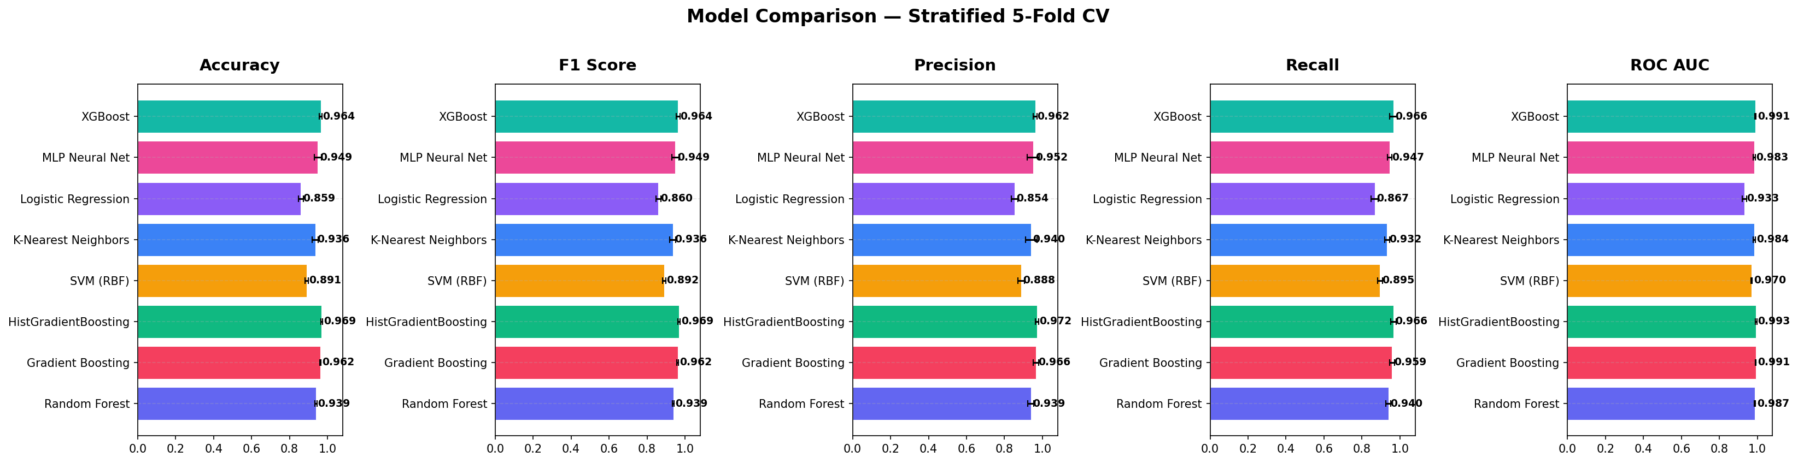
Figure 1: Bar chart comparison of all models across five metrics. Gradient boosting methods dominate across all metrics, with HistGradient Boosting achieving the highest F1 (0.969) and ROC AUC (0.993).

3.2 Class Distribution
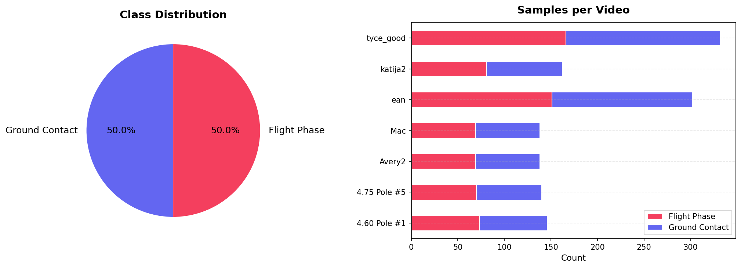
Figure 2: Class distribution of the dataset after per-foot framing. The dataset is perfectly balanced at 50/50 between ground contact and flight-phase samples. The right panel shows the sample count per video.

3.3 ROC Curves
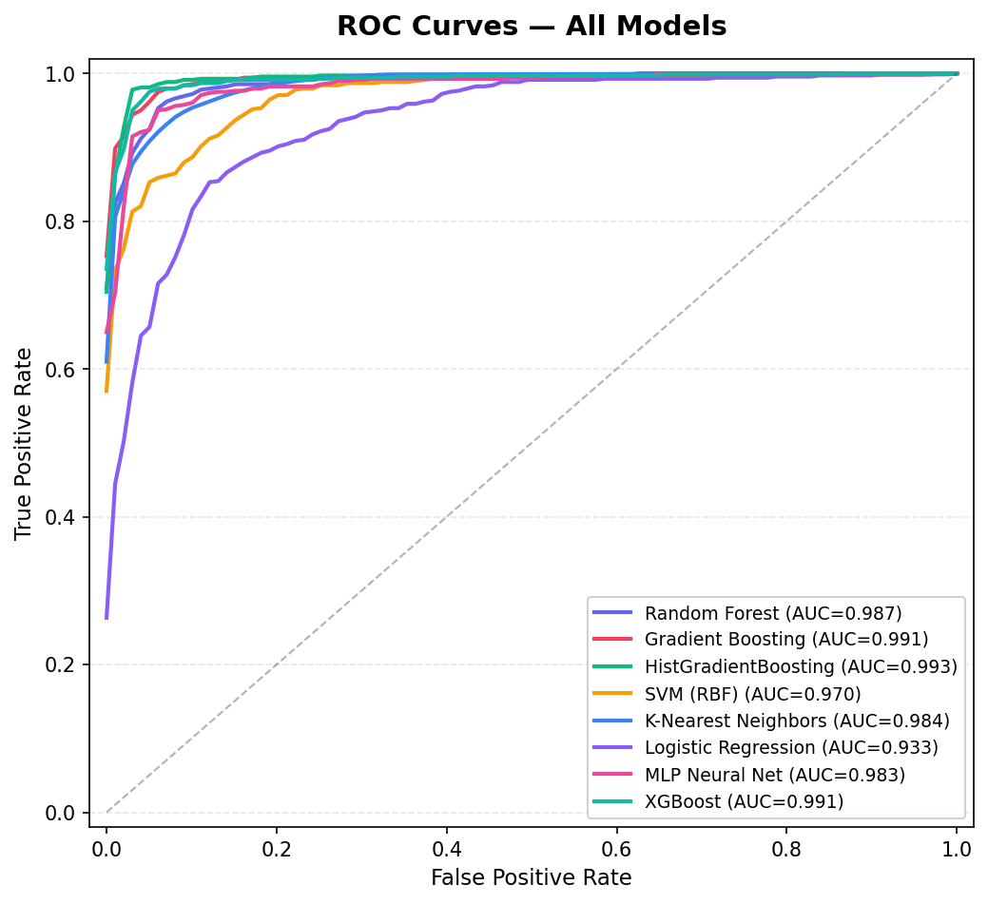
Figure 3: ROC curves for all eight models. The top three models achieve AUC > 0.99. Even the weakest model (Logistic Regression) achieves AUC = 0.933.

3.4 Confusion Matrices
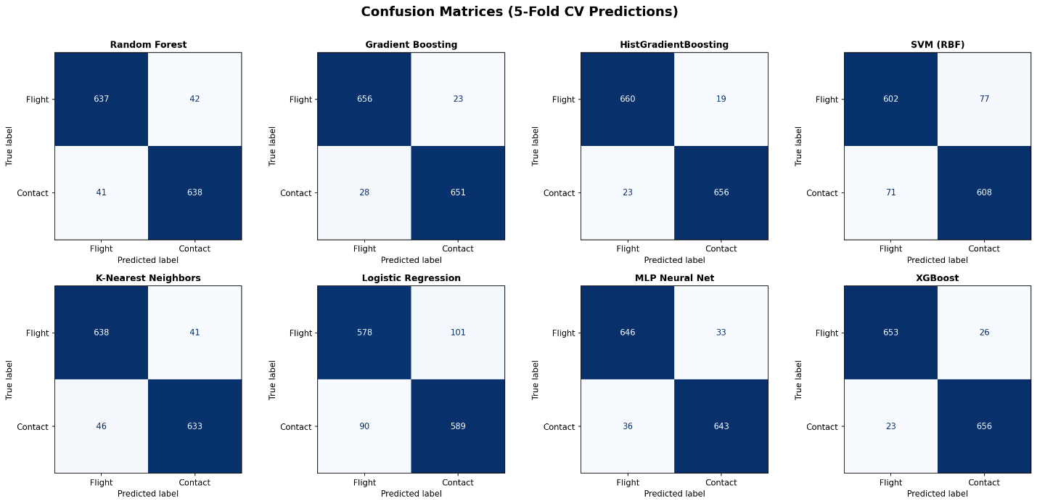
Figure 4: Confusion matrices for all models. HistGradient Boosting produces only 19 false positives and 23 false negatives out of 1,358 samples.

3.5 Feature Importance
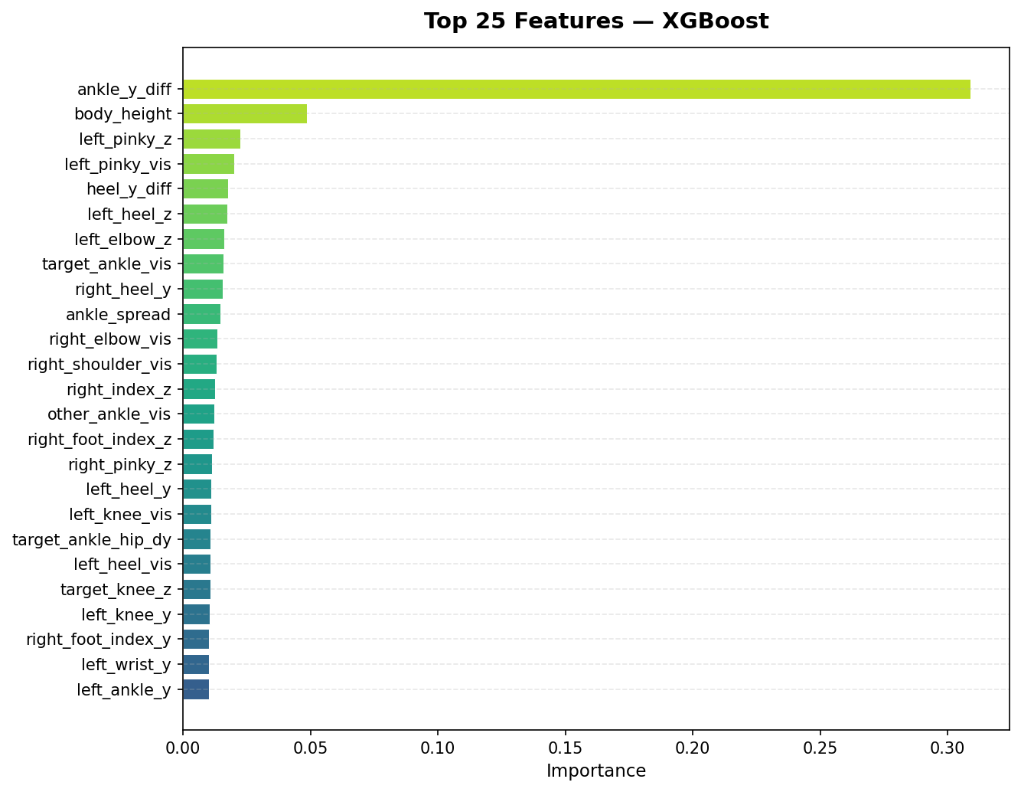
Figure 5: Top 25 feature importances from XGBoost. The ankle_y_diff feature dominates with over 30% importance.

3.6 Key Observations
- Gradient boosting methods dominate: The top three models are all gradient boosting variants, suggesting that the classification boundary is complex but well-captured by ensemble tree methods.
- Strong signal in single-frame features: Achieving 96.9% F1 with only single-frame spatial features (no temporal information) suggests that the pose geometry at ground contact is highly distinctive.
- Ankle vertical difference is decisive: The ankle_y_diff feature alone accounts for 30%+ of XGBoost's importance, confirming the biomechanical intuition that the relative vertical positions of the two ankles is the primary indicator of which foot is on the ground.
- Linear models underperform: Logistic Regression's lower performance (F1 = 0.860) suggests the decision boundary is nonlinear — the relationship between joint positions and ground contact involves interactions between features that linear models cannot capture.
- Low variance across folds: Standard deviations are consistently small (0.003–0.019), indicating stable model performance and sufficient data for the current cross-validation strategy.

4. Validation and Deployment

4.1 Cross-Validation as Test Performance
Since no dedicated held-out test set was used in the traditional train/test split sense, the stratified 5-fold cross-validation results serve as estimates of test-set performance. In each fold, 20% of the data is held out as unseen test data, and the model is trained only on the remaining 80%. Every sample appears in the test set exactly once across the five folds, providing an aggregate test-set evaluation over the full dataset.

4.2 Hyperparameter Optimization
The current results use default or lightly-tuned hyperparameters for all models. Formal hyperparameter optimization has not yet been conducted. The planned approach is:
- Grid search or random search over key hyperparameters for the top 2–3 models (HistGradient Boosting, XGBoost, Gradient Boosting).
- Key parameters to tune: Number of estimators, max depth, learning rate, minimum samples per leaf, regularization terms (L1/L2 for XGBoost).
- Search strategy: Nested cross-validation — an inner CV loop for hyperparameter selection and an outer loop for unbiased performance estimation.
[Placeholder: Hyperparameter tuning results will be added in the final report after optimization is completed.]

4.3 Deployment Architecture
The step detection model is planned for integration into the existing pole vault video analysis web application (GaitKeeper). The deployment pipeline will be:
- Video upload → YOLO person detection → MediaPipe pose estimation (existing pipeline).
- Feature extraction → Per-foot feature engineering from landmarks (as described in Section 2.3).
- Frame-level classification → Trained model predicts ground contact probability for each foot at each frame.
- Post-processing → Temporal smoothing / filtering to eliminate isolated false positives and merge nearby contact predictions into step events.
- Stride analysis → Compute step frequency, stride length, velocity, and other derived metrics from detected step events.
[Placeholder: Deployment testing results and real-time performance benchmarks will be added after integration is completed.]

4.4 Current Limitations and Planned Improvements

Limitation | Planned Mitigation
Only 7 labeled videos | Label additional videos (15+ total planned)
No temporal features | Add velocity/acceleration features from consecutive frames
Default hyperparameters | Systematic hyperparameter tuning with nested CV
Stratified CV only | Add leave-one-video-out CV once dataset is larger
No deployment testing | Integrate model into GaitKeeper app and test on new videos
Single-camera perspective | Evaluate robustness across different camera angles

5. Discussion

5.1 Problem Framing Matters
An important lesson from this project was the impact of problem framing on model performance. The initial approach — classifying each frame as "contact" or "flight" for any foot — produced a 92/8 class imbalance and models that appeared accurate (92%+) but were merely predicting the majority class. Reformulating the problem as a per-foot classification naturally balanced the dataset and forced models to learn genuine discriminative patterns. This highlights the importance of carefully evaluating whether high accuracy reflects true model capability or simply reflects class distribution.

5.2 Feature Engineering Insights
The dominance of the ankle_y_diff feature validates the per-foot relative feature engineering approach. By framing features as "target foot" vs. "other foot" rather than "left" vs. "right," the model can learn a single contact pattern that applies regardless of which foot is being classified. This effectively doubles the training data and ensures the model generalizes across feet.
The presence of visibility-related features (e.g., target_ankle_vis, left_pinky_vis) among the top features is interesting. These may capture the camera perspective — when a foot is on the ground behind the body, certain joints may become partially occluded, resulting in lower visibility scores from MediaPipe.

5.3 Model Suitability
The strong performance of gradient boosting methods is expected given the tabular, feature-engineered nature of the data. These models excel at learning complex, nonlinear relationships in structured data. The relatively weaker performance of SVM and Logistic Regression suggests the decision boundary is not captured by a single kernel or hyperplane.
The MLP's strong performance (F1 = 0.949) is notable and suggests that a neural network approach with temporal sequence modeling (e.g., LSTM or 1D CNN) could further improve results by incorporating information from adjacent frames.

5.4 Practical Significance
From a coaching perspective, 96.9% F1 on frame-level classification is promising. In a typical 240 fps video with ~15 steps, approximately 200–300 frames are ground-contact frames. A 3.1% error rate translates to roughly 6–10 misclassified frames per video. With temporal post-processing (smoothing, minimum-contact-duration filtering), most of these errors can likely be corrected, yielding reliable step detection for practical use.

6. Conclusions
This progress report demonstrates that automated step detection in pole vault approach runs is feasible using single-frame pose estimation features and supervised machine learning. Key findings include:
- Per-foot relative feature engineering is critical for proper problem framing and class balance.
- HistGradient Boosting achieves the best performance (F1 = 0.969, AUC = 0.993) among eight evaluated classifiers using default hyperparameters.
- The vertical ankle position difference between feet is the most discriminative feature, consistent with biomechanical expectations.
- Single-frame spatial features alone are sufficient for high-accuracy classification, though temporal features may provide further improvement.

Remaining Work for Final Report
- ☐ Label additional videos (target: 15+) to increase dataset diversity.
- ☐ Conduct systematic hyperparameter optimization using nested cross-validation.
- ☐ Implement leave-one-video-out cross-validation for a stricter generalization estimate.
- ☐ Add temporal features (frame-to-frame velocity and acceleration of joints).
- ☐ Integrate the trained model into the GaitKeeper web application.
- ☐ Evaluate end-to-end deployment performance on unseen videos.
- ☐ Investigate clustering of approach-run patterns as an additional ML technique.

References
Cao, Z., Hidalgo, G., Simon, T., Wei, S.-E., & Sheikh, Y. (2019). OpenPose: Realtime multi-person 2D pose estimation using Part Affinity Fields. IEEE Transactions on Pattern Analysis and Machine Intelligence, 43(1), 172–186.
Lugaresi, C., Tang, J., Nash, H., McClanahan, C., Uboweja, E., Hays, M., Zhang, F., Chang, C.-L., Yong, M. G., Lee, J., et al. (2019). MediaPipe: A framework for building perception pipelines. arXiv preprint arXiv:1906.08172.
Mariani, B., Rouhani, H., Crevoisier, X., & Aminian, K. (2013). Quantitative estimation of foot-flat and stance phase of gait using foot-worn inertial sensors. Gait & Posture, 37(2), 229–234.
Stenum, J., Rossi, C., & Roemmich, R. T. (2021). Two-dimensional video-based analysis of human gait using pose estimation. PLOS Computational Biology, 17(4), e1008935.
Strohrmann, C., Harms, H., Kappeler-Setz, C., & Tröster, G. (2012). Monitoring kinematic changes with fatigue in running using body-worn sensors. IEEE Transactions on Information Technology in Biomedicine, 16(5), 983–990.
[Additional references will be added in the final report as the literature review is expanded.]

