ExcelMate
- an application that reads from a Trackmate into Excel spread sheets
This application is intended to be used at slalom skateboard races to help getting the race data correct. The application reads data from a Trackmate (timing device) into a text area from where the user can insert the data with one click into an Excel spread sheet.

The application is very easy to setup and use and can be used on PC’s running windows 2000 and later (really only Excel 2000 or later is needed).

Requirements:
- Trackmate of version 6.0 or later (the ones with PC port on the side)
- Computer (at the moment only PC is supported) with preferably a COM port.
- If no COM port is available then you need to get a USB to RS232 converter cable (cost 15€).
- A modem cable (cost 5€).

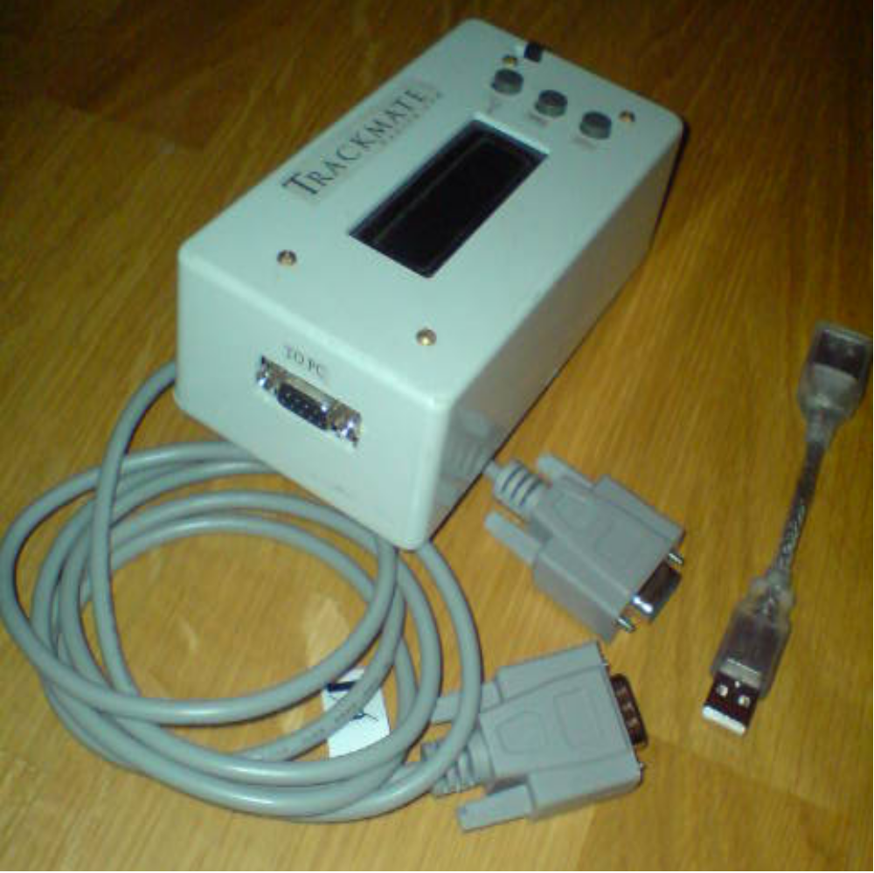
Basic usage
Connect the modem cable to the Trackmate and the computer. If no COM port exists on the PC then insert the USB to RS232 converter into any USB port on the computer and connect the modem cable to the converter. Start the Trackmate and click “Exit” to get it into ready mode.

Start the application from the start menu on the computer (Start->Programs->EttSexEtt->ExcelMate). Below is what you will see.

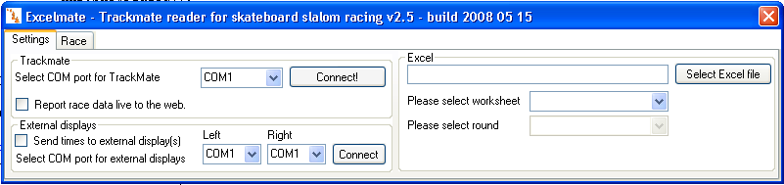

Start by selecting the COM port that you connected the cable to (or the one you have assigned your USB converter to act as during installation of your USB to RS232 converter cable). All available COM ports on the computer should be in the dropdown list and selectable. Click the connect button.

Click “Select Excel file” and browse to the excel file that contains all the racers for this race. The application is shipped with blank templates of the de facto standard Excel spread sheets used in slalom racing, courtesy of Dan Gesmer at Seismic Skate. Please use these templates each time you create a new start list for a race.

Once you have found your excel file and selected it, its available worksheets will be listed in the drop list below the filename. Please select the event you wish to run by choosing worksheet.

When you select the event, the spread sheet will be visible. If the selected worksheet is considered single lane or qualification then the program will automatically switch to the race tab. If the selected worksheet is considered head to head racing, then you need to select the round that you are about to run before the program changes to the race tab.
Race tab
In the race tab you have two dropdowns that contains the names of the riders in this race. You will only see racers that belong in this class or round. So if this is the round of 4 you will only have the riders that belong in the round of 4 in the list. You will also see textboxes with the reaction time and raw time. These boxes will be filled by the trackmate once the racer crosses the start/finish. If you wish to change these values just type in the value you wish. Any text is valid and will be transferred into the Excel sheet once you click save.

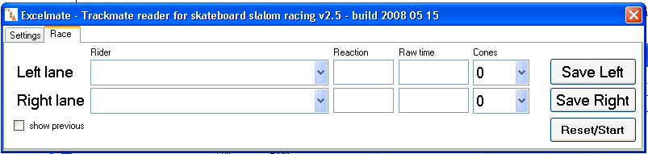

Once you are ready to race select the riders for each lane in the lists, and click Reset/Start and the timer will be reset. You can of course select the riders after you click Reset/Start and the riders are on their way to the finish. The names only need to be selected when you hit “save”.

Once the riders cross the start and finish the Trackmate will send the times to the PC and the times will be showed in the program. Once the cones are counted select the correct number in the list and click “Save”. The times will be saved in the Excel spread sheet and be cleared in the application. In order to send next rider down the hill.

If a rider DQs, just write “DQ” in the text field and click “Save”, and this will be written to the spread sheet. To make life even easier there is a DQ at the end of the cone list, so press “d” when the cursor is in the cones dropdown and you will get a messagebox that asks you if this really was a DQ, and then the program will automatically set DQ in the raw time field.

Everytime you click “Save” the actual Excel sheet will be saved to disk using the same name and path as you opened it as. The filename is showed in the top list of the program so you can see what file you are working with at all times.

Of you wish to edit something manually in the spread sheet while you are using the program, feel free. The program is just an add on and when ever you feel like not using it, just skip it. Perhaps you like to use the reset/start button on the Trackmate instead of reset/start in the Excelmate, well then just use that one instead.

Advanced usage
You can click “show previous” in the race tab and a log that keeps track of the saved times will show. This is not saved anywhere and once the program closes it will be lost. This is there to make sure in case of conflict when someone feel like they got the wrong time saved or so.

When people get their second run in, the application will sense that there are data present for the first round and save this time as second run. If someone gets a third run/rerun the program will sense that there are data present in both runs already and will ask you what run to overwrite.

You can also connect a display program that will show the start reaction, the running time and the final time on a display/PC. In order to use this you need another serial cable that is connected from the PC that runs Excelmate to another PC where the display program is running. To use this just select the COM port that you are connecting to the other PC and select “connect” in the settings tab. One COM port is needed for each display/lane. The display program is available for download at

http://www.ettsexett.com/200/SlalomDisplaySetup.msi

You can also upload each saved run to the web. This is very convenient for race organizers since you don’t need to upload any results later on. Just select “Report race data live to the web” on the settings tab and then enter the race id that you need in order to specify what race you are reporting data for. To get this Id send an email to marcus@ettsexett.com

The live reporting needs internet access. If no wireless LAN is available you can connect using a cell phone. The data sent is minimized and will be less than 200 bytes per saved race, so even a whole day of racing should only cost a minimum of data.

Good to know
- Fill all riders in the Excel sheet before opening the Excelmate in order to minimize confusion.
- Please use first and second name when registering racers
- Never leave an empty row in the spreadsheet, if a racer does not show up please enter DNS or DQ.
- Never copy/paste in the spread sheet or write in your own race order in the eliminations, the sheets should organize the racers automatically if everything is filled in.
- Do not change the names of the excel tabs. The program looks for ‘elims’ and ‘qual’ in order to know what race type this is.

It is a very simple program that hopefully can help all timekeepers out there from losing their minds. Please try it out and give me some feedback so that it can be improved.

Email me at marcus@ettsexett.com

The program is of course free of charge and anyone who feels like it can get the code. It is written in Microsoft.Net C# Framework 2.0 using Visual Studio 2005.

Thank you Daniel Gesmer for providing the spread sheets. Any questions regarding them could or should be sent to him, but I’ll relay the emails so please contact me for any questions.

Enjoy! /Marcus Seyffarth

