Culture Health Report

Green Meadows Complex, Southeast Distribution Facility

**Prepared for**

Lynne Flavors

**Prepared by**

The Transformation Guild

**Date**

2025-08-16

This report contains confidential and proprietary information intended solely for Green Meadows Complex, Southeast Distribution Facility. Do not distribute, reproduce, or share without written permission from The Transformation Guild and Green Meadows Complex, Southeast Distribution Facility.

***Table of Contents***

Executive Summary 3

Engagement Summary 3

Results Summary 3

Collusion: Overview 4

Collusion Results: Company A 4

Feedback, Receiving: Overview 6

Feedback, Receiving Results: Company A 7

Feedback, Giving: Overview 8

Feedback, Giving Results: Company A 9

Accountability: Overview 10

Accountability Results: Company A 11

Sensitivity: Overview 12

Sensitivity Results: Company A 13

Trust: Overview 14

Trust Results: Company A 15

Relationship Focus: Overview 16

Peer to Peer Relationship Focus 17

Conclusion 18

# Executive Summary

## Engagement Summary

In October of 2025, Company A engaged The Transformation Guild to perform an assessment of the strength and vulnerabilities of the Green Meadows Complex, a key distribution facility for the Southeast region.  
  
Interacting closely with Company contact Lynn Flavors, Transformations Guild consultants interviewed key Subject Matter Experts. Using this information, The Guild constructed a custom survey instrument designed to surface key insights into the culture of the Green Meadows Complex.

## Results Summary

Consultants from The Transformation Guild uncovered:  
Long-held resentments between two teams who worked consecutive shifts, which was resulting in problematic collusive behaviors, at times rising to the level of outright sabotage  
“Factions” that had formed in support of one or the other of these teams  
Resentment towards a manager, since departed, who was viewed as spearheading the collusive behavior  
Teams who were fatigued by the conflicts and eager to find a way forward, frequently referring to the work environment “toxic” and “exhausting”  
Individuals who felt that some of the perpetrators of “all the unpleasantness” were still present and not been held accountable for their actions. Trust that the leadership teams will make a positive difference are exceedingly low.

## Suggested Actions Summary

Use the data obtained from the survey to recognize the severity of the issues in the culture of the Green Meadows Complex, and allocate remedial resources accordingly  
Convene a leadership conversation to share responsibility for the culture of the Green Meadows Complex, and determine a path forward together  
Introduce a relationship-smart culture, emphasizing accountability and feedback skills, that will help team members at the individual contributor and supervisor levels make a positive difference in the organization’s culture

# Collusion: Overview

In the C FASTR model, **collusion** refers to any group activity that harms another member of the group. It is not a misunderstanding, a simple disagreement, or an honest mistake—it is the deliberate joining together of two or more people in ways that undermine someone else. Common examples include malicious gossip, clique-forming, “venting” about a colleague or category of people without any intent to resolve the issue, or staying silent while others engage in these destructive acts.

Collusion is always harmful. Just as a red traffic light never means “go,” there is no such thing as “good collusion.” It damages trust, fractures cohesion, and makes it harder for people to build or repair healthy relationships. Left unchecked, it often creates factions that force others into choosing sides between the person being colluded against and those driving the collusion.

Intervening on collusion is challenging because it means confronting behavior that is, by nature, relationally hostile—while the person or group is still actively engaged in it. Addressing it requires courage, clarity, the ability to redirect people toward constructive dialogue and relationship repair, and support from a culture that normalizes and encourages intervening on collusion.

Fighting collusion isn’t just about stopping the instigator’s behavior; it also means dismantling the factions, repairing trust across divides, and restoring the group’s ability to work together without suspicion or taking sides. Although difficult, it is essential work: organizations that address collusion early prevent deep divisions, protect team trust, and keep their culture aligned with healthy, productive relationships.

## Collusion Results: Company A

**Summary:**

Your Collusion scores indicate the potential that harmful group behaviors—such as “People on my team regularly talk negatively about others” and “It’s common for team members to align with each other against someone”—are occurring. Sub-optimal Collusion scores usually have a damaging effect on overall trust levels, as they can contribue to creating factions and making collaboration harder. It's important to ensure that, at all three critical levels (peer-to-peer, with managers, and in cultural support), Collusion is challenged vigorously and never allowed to become normalized.

**Risks identified:**

Left unaddressed, high Collusion will deepen divisions, increase turnover, and erode performance.

**Recommendations for remediation:**

Peer-to-Peer:   
 + Train employees in real-time intervention language (“Let’s bring that concern directly to them”; "How can I help you to improve your relationship with Chris?"; or (during 'the meeting after the meeting') "How can we surface these ideas in so that they can be acted upon?" etc.).   
 + Establish and encourage norms for addressing issues directly be refernecing the cultural principles regarding Collusion.  
  
• With Managers:   
 + Require managers to be diligent about avoiding Collusion amongst themselves  
 + Encourage managers to model skills at intervening on Collusion without becoming "the conversation police."   
 + Support managers by providing both the skills and the infrastructure to help facilitate repair conversations between parties.  
  
• In the Culture:   
 + Make “No harmful group behavior” a visible cultural value, reinforce it in onboarding, rewards, recognition habits.   
 + Integrate examples and skill-building into leadership training.  
 + Promote bridge-building stories in internal communications and add Collusion-awareness checkpoints to team health reviews.

**Collusion results by Business Function:**

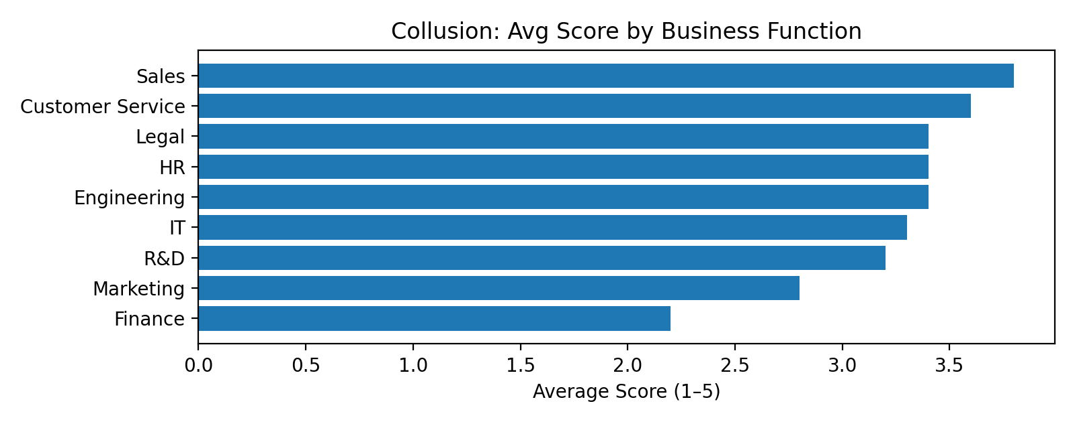

**Collusion results by Job Level:**

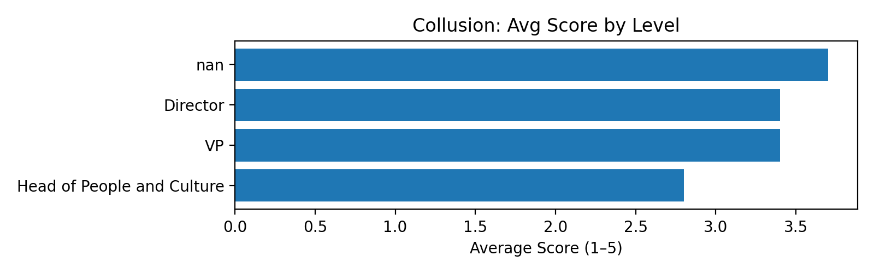

# Feedback, Receiving: Overview

In the C FASTR model, Feedback is not the standard evaluation-against-goals-and-objectives conversation. Instead, it refers to the subtle and overt signals we give and receive every time we communicate with one another in any way. Our posture, our body language, our listening skills, how we react to what’s being said, how we respond - or don’t respond - to an email or text message or conversation – all these things convey a point of view, from us, about the person with whom we are interacting, and our feelings about what’s being communicated. This is an important distinction: in this model, feedback is not the act of communicating; it’s the reactions we deliver to the things being communicated. Communication is the tool by which feedback is delivered, just as it is the tool by which other pieces of information are delivered. Feedback is, therefore, a particular kind of communication.

Feedback can be thought of as consisting of two dynamics: giving it and receiving it. Of the two, it’s slightly more important to be skilled at receiving feedback. This is because people will simply refuse to give feedback to people are bad at receiving feedback. This is the “I don’t like talking to a brick wall” scenario. People must actively convey that they are open to feedback, since giving someone feedback is often an emotionally and / or professionally risky activity. If you blow up, or get defensive, or hold a grudge whenever someone gives you feedback, it’s a safe bet that people will stop giving you feedback, which is a disastrous outcome, since no person, system, or entity can long survive without receiving feedback.

One of the keys to being good at receiving feedback is the ability to do so no matter how bad the giver of that feedback may be. In a relationship-smart culture, tremendous effort is made to make sure that everyone is good at both receiving and giving feedback; but receiving feedback is so essential that one is best served by being able to make feedback lemonade even from feedback lemons.

## Feedback, Receiving Results: Company A

**Summary:**

Low scores in items like “I feel I am good at receiving feedback” show people struggle to accept input without defensiveness. This discourages peers and managers from offering feedback at all.

**Risks identified:**

Without feedback, performance problems and skill gaps go unaddressed.

**Recommendations for remediation:**

Peer-to-Peer: Train teams to listen without interruption and ask clarifying questions.  
With Managers: Model openness to feedback by responding calmly and appreciatively.  
Culture: Normalize feedback as a growth tool by including it in team rituals and recognition.

**Feedback, Receiving results by Business Function:**

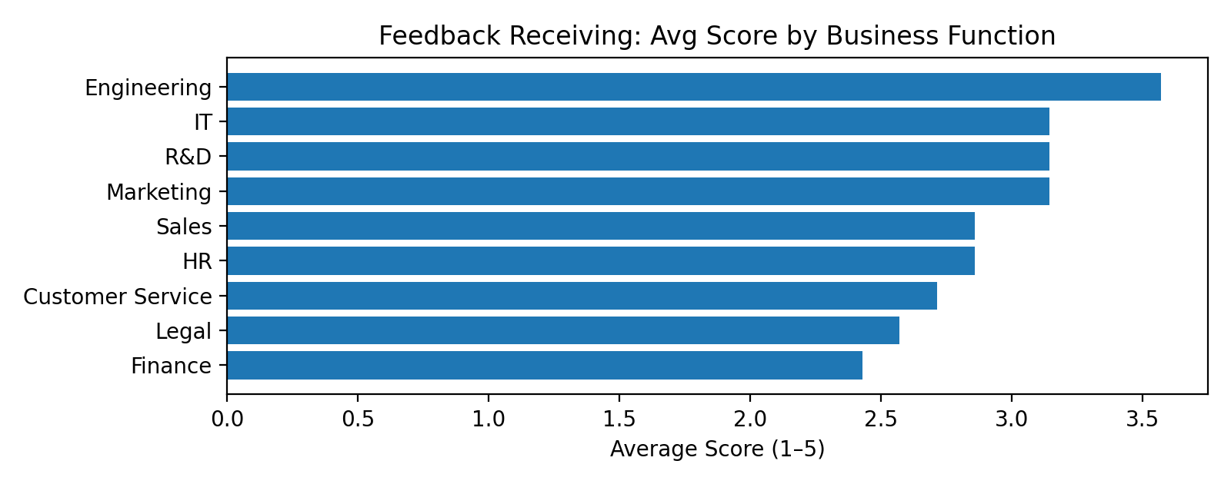

**Feedback, Receiving results by Job Level:**

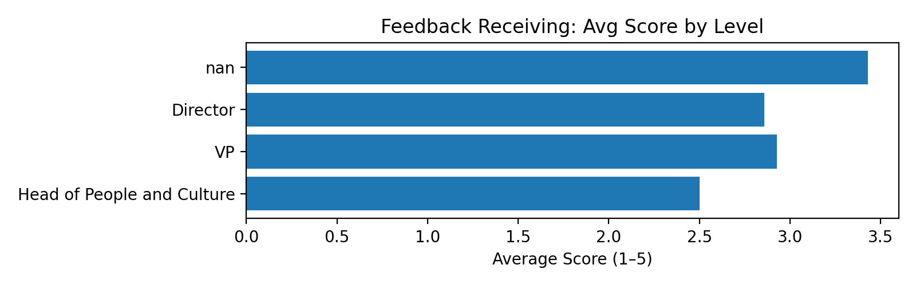

# Feedback, Giving: Overview

As with receiving Feedback, the ability to give feedback effectively and well is borderline miraculous impact on a workplace relationship. When a person receives effective feedback effectively delivered, it enables the person to execute changes that could be important to that person's health, effectiveness, and overall wellbeing. When a person takes the time to think about how to give feedback effectively, and does so, it is a profonde expression of caring. Think of a stranger with whom you have no connection. Are you likely to take time from your life, compose your thoughts, and give that person feedback? Or are you more likely just ignore them? The risks of giving feedback to – especially “tough” feedback - a stranger are high, and it is rare that a person is willing to do so. So when a person gives good feedback effectively, it is rightly received as a tremendous gift.

So healthy relationships are rich in the flow of feedback, and taking the time to learn to give feedback to people you care about is often received as tremendous investment in the relationship, and thus in the person with whom you have that relationship.

A person who is skilled at giving feedback is an absolutely invaluable person with wom to from a relationship. It is why the C FASTR model suggests that organizations allocate substantial resources to helping every single person in the organization become exceptionally skilled at giving (and receiving) feedback.

## Feedback, Giving Results: Company A

**Summary:**

Low scores in “I feel I am good at giving feedback” suggest hesitation or lack of skill in delivering honest, constructive input.

**Risks identified:**

Without candid feedback, poor behaviors or processes persist unchecked.

**Recommendations for remediation:**

Peer-to-Peer: Train in framing feedback constructively and specifically.  
With Managers: Require regular, structured feedback conversations.  
Culture: Position feedback-giving as a responsibility, not an option.

**Feedback, Giving results by Business Function:**

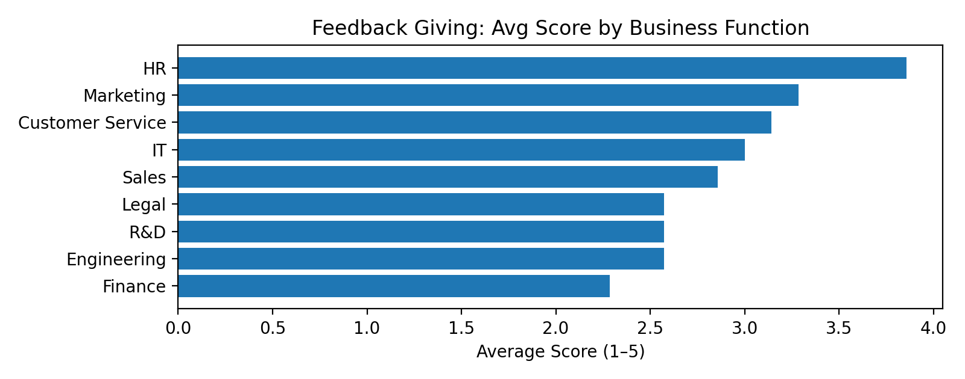

**Feedback, Giving results by Job Level:**

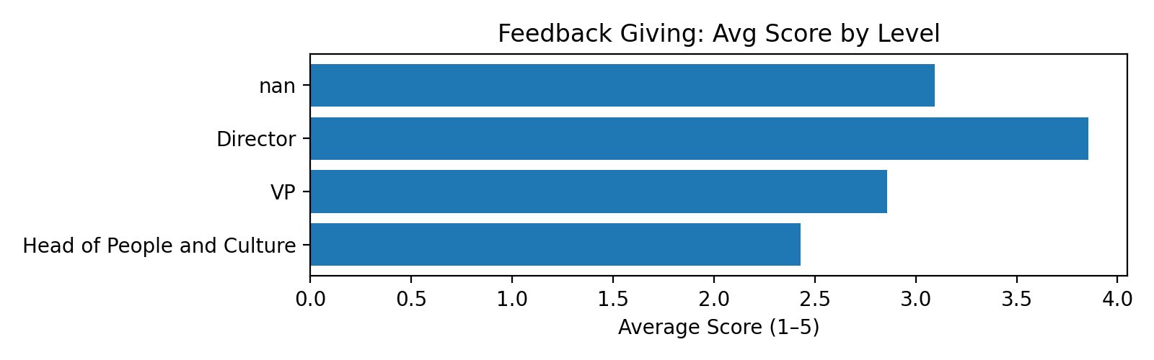

# Accountability: Overview

In the C FASTR model, accountability and responsibility are essentially interchangeable. The intent is to convey that people are willing to be held accountable for the impact of their actions and words, and are fair and honorable about holding others accountable as well. It means that people keep their word. It means that they refuse finger-pointing and scapegoating, instead choosing to embrace honest evaluations.

Imagine how hard it is to be in a relationship with someone who never takes responsibility for their words or actions. Everything is someone else’s fault, or something else’s fault, or is the responsibility of someone else. They never make mistakes, and are fixated with assigning blame rather than creating effective change. Such toxic habits can create an “every man for himself!” environment, as everyone is constantly scrambling to avoid the finger of blame from being pointed at them, rather than working together to find the best lessons to learn and the best way forward together.

A relationship-smart culture seizes every opportunity to reinforce the principle that “we are a learning culture, not a blaming one.” These cultures work assiduously to help everyone become skilled in the practice of holding one another accountable, and being held accountable, in honest and supportive ways.

The benefits of a culture of accountability are numerous [insert research here].

## Accountability Results: Company A

**Summary:**

Low scores in “People on my team follow through on their commitments” reveal unreliable execution.

**Risks identified:**

Missed commitments damage trust and delay results.

**Recommendations for remediation:**

Peer-to-Peer: Use shared tracking tools for commitments.  
With Managers: Enforce clear deadlines and consequences.  
Culture: Make follow-through a non-negotiable cultural value.

**Accountability results by Business Function:**

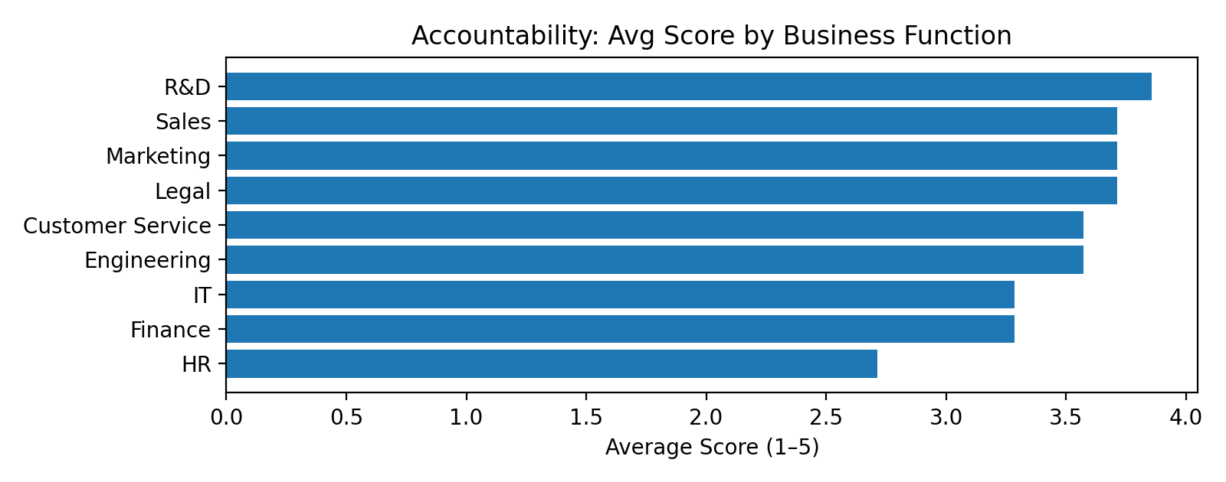

**Accountability results by Job Level:**

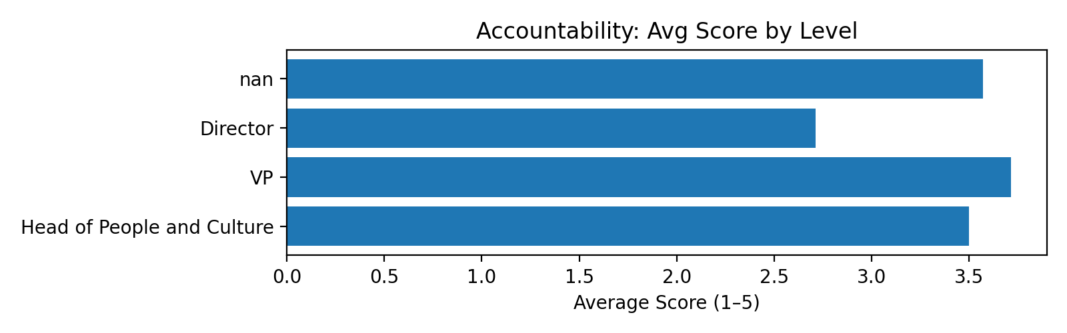

# Sensitivity: Overview

In the C FASTR model, sensitivity has a very specific meaning: the ability to understand the point of view of another human being so well that they’d trust you to speak on their behalf if necessary.

To be good at sensitivity means that you are good at understanding another person – their perspectives their motivations, their desires, their needs. I worked of ryears in IT and the ability to be sensitive to the needs of others is absolutely indispensable when you’re trying to provide a deliverable. There’s a joke it IT where a deliverable is completed and the product owner says “you gave me exactly what I asked for but not what I want.” The whole philosophy of agle software development originates from a simple problem: a poor ability – not anyone’s fault - to truly understand the perspective of the user of the tool being built.

Overly silo’d organizations, likewise, need this skill desperately. Experts are hired and placed into silos because the company needs that expertise; but the ability to work across silos to deliver an integrated solution – one that works effectively, end-to-end - requires the ability to deeply understand other human beings.

Sensitivity is the “you really get me” skill. There are few interpersonal experiences that are more deeply rewarding, nourishing, and connective than for me to be in a difficult situation with you, and you are taking the time and effort to really understand me – without judgement, without rancor, without hidden agendas. Few skills bond a team and a relationship more powerfully.

## Sensitivity Results: Company A

**Summary:**

Low scores in “Our team consistently reinforces the importance of understanding others’ perspectives” show a lack of empathy and perspective-taking.

**Risks identified:**

Misunderstandings and exclusion can become chronic.

**Recommendations for remediation:**

Peer-to-Peer: Practice perspective-taking in meetings.  
With Managers: Model curiosity and ask for multiple viewpoints.  
Culture: Provide cultural competence and empathy training.

**Sensitivity results by Business Function:**

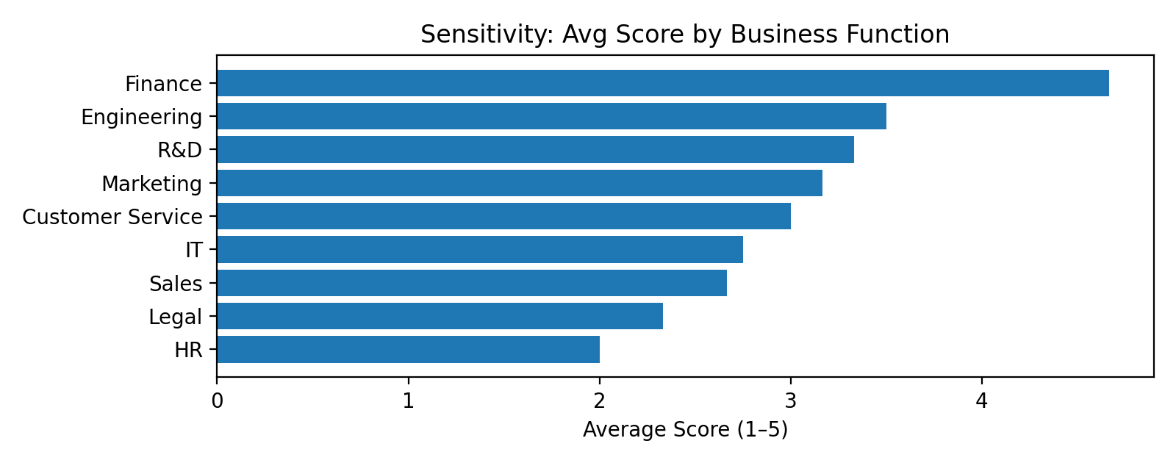

**Sensitivity results by Job Level:**

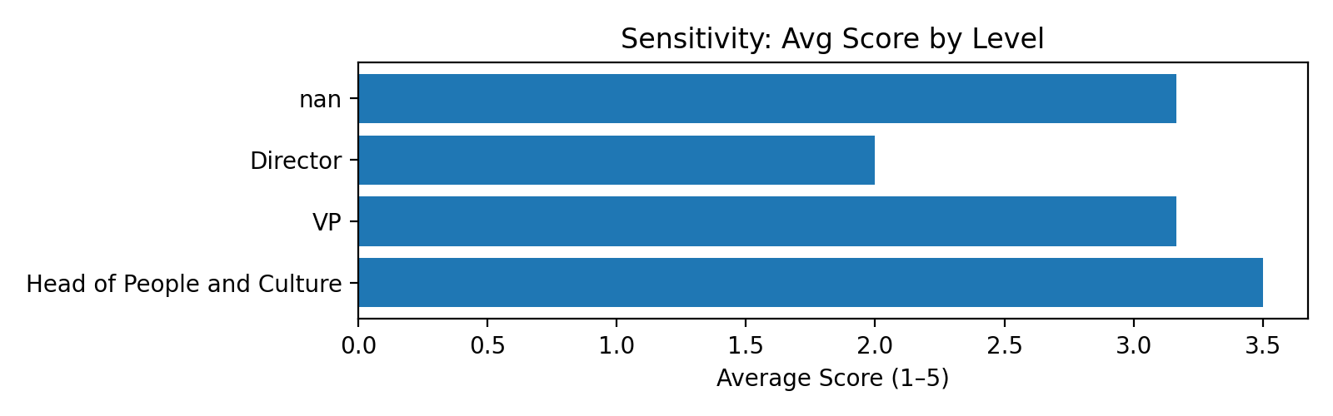

# Trust: Overview

Feedback may be the workhorse of the mode – the skill that’s used most often.

Sensitivity might be the most powerful and difficult skill of the model, since being able to see another’s point of view, especially in today’s world, requires significant dedication and practice.

However, of all the skills required of a healthy relationship, Trust might be the most vital. It is the beating heart of the C FASTR model and, indeed, or any relationship.

In the C FASTR model, **trust** is essentially the belief that others will act in ways that are consistent, fair, and aligned with the shared goals of the group. It is the confidence that team members will keep their commitments, tell the truth even when it’s inconvenient, and avoid exploiting one another’s vulnerabilities. Trust is not blind faith or naïve optimism; it is a relationship asset built over time through repeated demonstrations of reliability, integrity, and goodwill.

Trust is the foundation of every healthy workplace relationship. When it is strong, people can take risks, share information openly, and collaborate without fear of hidden agendas. When it is weak, even small misunderstandings can escalate into conflict, cooperation dries up, and energy that should be directed toward results gets spent on self-protection and second-guessing others’ motives. The presence or absence of trust determines whether a group can recover quickly from setbacks—or whether it fractures under pressure.

Maintaining trust requires more than simply avoiding dishonest acts; it demands active stewardship. This means following through on commitments, addressing issues directly rather than letting them fester, and being transparent about decisions that affect others. It also means repairing trust when it has been damaged, even if the breach was unintentional. In a relationship-smart culture, trust is treated as a shared responsibility: each person is accountable for protecting it, restoring it when necessary, and recognizing that without it, no amount of skill, strategy, or structure can keep a team healthy and effective.

## Trust Results: Company A

**Summary:**

Low Trust scores across items like “I trust my colleagues to look out for my best interests” and “The culture emphasizes repairing trust when it’s damaged” mean people doubt whether others—peers, managers, or the culture—will act fairly, keep commitments, or safeguard relationships.

**Risks identified:**

Low trust slows decision-making, increases conflict, and drives disengagement.

**Recommendations for remediation:**

Peer-to-Peer: Train teams to address misunderstandings directly and build trust through shared wins.  
With Managers: Require visible follow-through on commitments and encourage vulnerability.  
Culture: Embed trust-repair training into leadership programs and make restoring trust an explicit performance expectation.

**Trust results by Business Function:**

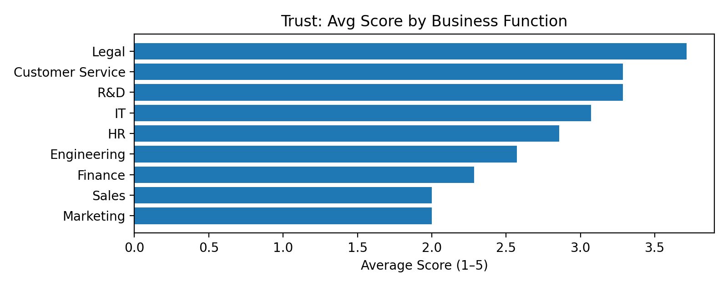

**Trust results by Job Level:**

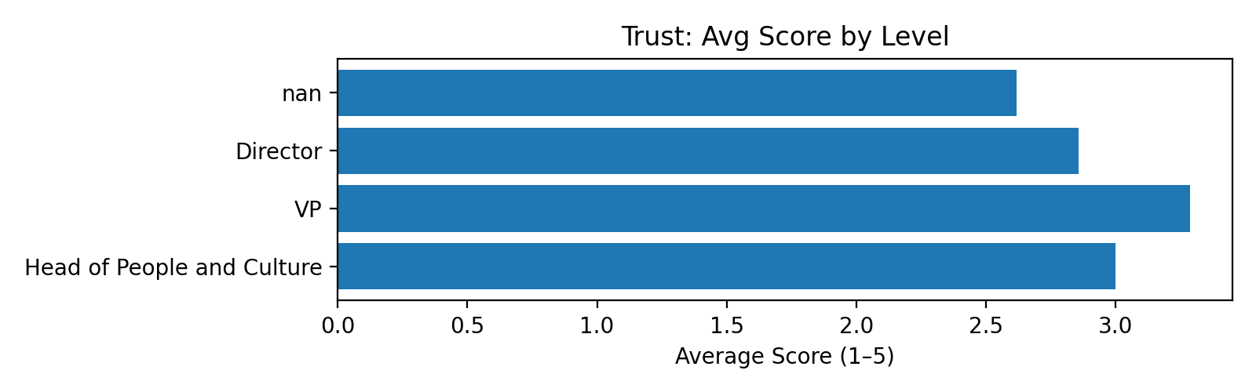

# Relationship Focus: Overview

“This relationship matters to me; you matter to me.”

In the C FASTR model, **Relationship Focus** means approaching every person and every workplace relationship with the mindset, “This relationship matters to me; you matter to me.” It is the commitment to treat each interaction—no matter how small—as part of an ongoing connection that is worth preserving and strengthening. Relationship Focus is not about liking everyone equally or avoiding hard conversations; it is about valuing the relationship enough to handle differences with care and to make choices that protect, rather than erode, the connection.

When people bring a Relationship Focus to their work, they enter conversations looking for ways to make the relationship work, even when the subject is difficult or the stakes are high. They think before they speak or act, asking, “Will this build trust, damage it, or leave it unchanged?” They recognize that healthy relationships don’t just happen—they require thoughtful management, intentional preservation, and consistent investment over time.

A strong Relationship Focus does not mean sacrificing results for harmony. In fact, it often produces better results, because people are more willing to collaborate, share information, and support each other when they know their relationships are valued. In a relationship-smart culture, this mindset becomes the default: every member of the team actively works to maintain, repair, and enhance relationships, knowing that the health of those connections is inseparable from the health of the organization itself.

## Relationship Focus: Company A

**Summary:**

Low scores in “I feel that my teammates genuinely care about me” mean relationships are treated as transactional, not valued assets.

**Risks identified:**

Weak relationships break easily under stress.

**Recommendations for remediation:**

Peer-to-Peer: Introduce regular relationship check-ins.  
With Managers: Make relationship health a standing agenda item.  
Culture: Include relationship-building in performance measures.

**Relationship Focus results by Business Function:**

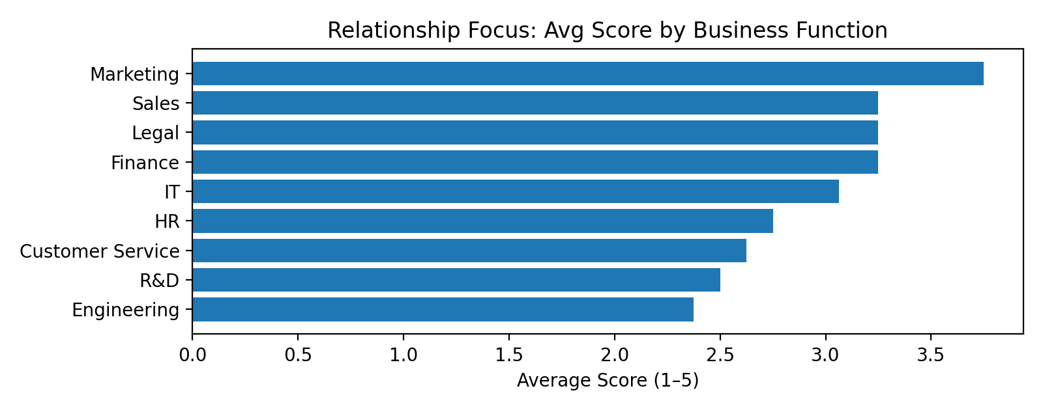

**Relationship Focus results by Job Level:**

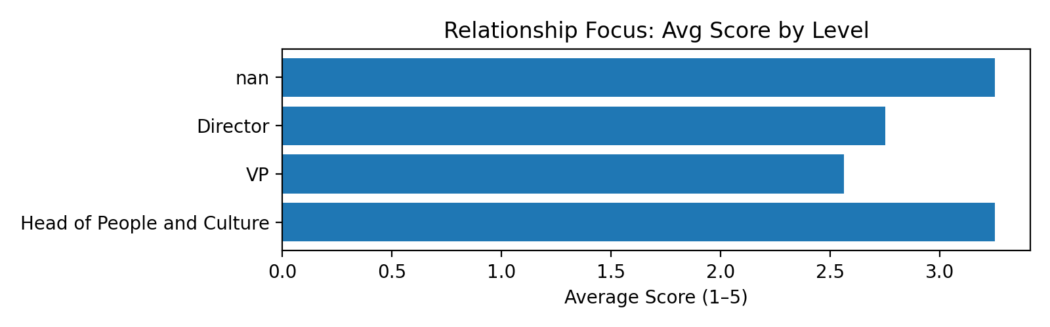

# Conclusion

This report summarizes organizational signals across C FASTR categories based on 470 scored responses.  
Overall, 41% of responses were positive (average score 3.05 out of 5).  
  
Strengths observed: Accountability (54%), Collusion (50%), Relationship Focus (39%).  
  
Priority focus areas: Trust (33%), Sensitivity (37%), Feedback Receiving (37%).  
  
Notable variation by level and function:  
- By level (Title): Sensitivity (gap 1.50), Feedback Giving (gap 1.43).  
- By function: Sensitivity (gap 2.67), Trust (gap 1.71).

## 30/60/90: From diagnosis to momentum

30 days — Quick wins and clarity  
 • Leaders share context and constraints in plain language; schedule listening sessions with Q&A.  
• Set team norms on respectful debate and meeting hygiene; introduce ‘one-mic’ and ‘assume positive intent’.  
• Establish a simple feedback ritual (e.g., ‘start/stop/continue’) at the team level; model receivership skills in staff meetings.  
  
 60 days — Build durable habits  
 • Publish decision rationales post-launch; add ‘what we learned/changed’ sections to reviews.  
• Offer manager toolkits for navigating hard conversations; audit meeting load & inclusion signals.  
• Train managers on coaching micro-skills; implement a monthly ‘feedback Friday’ cadence.  
  
 90 days — Scale and measure  
 • Commit to a predictable comms cadence; assess trust drivers quarterly and adjust rituals.  
• Reinforce norms via recognition; ensure retro actions close the loop on psychological safety issues.  
• Embed feedback into 1:1 templates and quarterly reviews; recognize teams demonstrating high-quality feedback loops.

Next 30 days

• • Leaders share context and constraints in plain language; schedule listening sessions with Q&A.  
• Set team norms on respectful debate and meeting hygiene; introduce ‘one-mic’ and ‘assume positive intent’.  
• Establish a simple feedback ritual (e.g., ‘start/stop/continue’) at the team level; model receivership skills in staff meetings.

Days 31–60

• • Publish decision rationales post-launch; add ‘what we learned/changed’ sections to reviews.  
• Offer manager toolkits for navigating hard conversations; audit meeting load & inclusion signals.  
• Train managers on coaching micro-skills; implement a monthly ‘feedback Friday’ cadence.

Days 61–90

• • Commit to a predictable comms cadence; assess trust drivers quarterly and adjust rituals.  
• Reinforce norms via recognition; ensure retro actions close the loop on psychological safety issues.  
• Embed feedback into 1:1 templates and quarterly reviews; recognize teams demonstrating high-quality feedback loops.

What to measure (quarterly)

• Trust & Relationship Focus (% positive): trend by function and job level  
- Collusion indicators: decrease in destructive teasing and being forced to choose a side; increase in direct-conversation resolutions.  
- Improvement of accountability skills at the leadership level

Closing thoughts

• We’re seeing clear strengths to amplify and a focused set of habits to tighten. With visible ownership, simple rituals, and steady measurement, momentum typically shows up inside the first quarter. Maintain a 30-day inspect-and-adapt loop and a quarterly read-out on the metrics above to keep progress durable.