Culture Health Report

oijoij

Prepared for

uih;ih

Prepared by

The Transformation Guild

Date

2025-08-19

uihi;

Table of Contents

Executive Summary 2

Engagement Summary 2

Results Summary 2

Suggested Actions Summary 2

Collusion: Overview 3

Collusion Results 3

Feedback, Receiving: Overview 4

Feedback, Receiving Results 5

Feedback, Giving: Overview 6

Feedback, Giving Results 6

Accountability: Overview 7

Accountability Results 8

Sensitivity: Overview 8

Sensitivity Results 9

Trust: Overview 10

Trust Results 11

Relationship Focus: Overview 11

Relationship Focus: 12

Conclusion 13

30/60/90: From diagnosis to momentum 13

# Executive Summary

## Engagement Summary

uihih

## Results Summary

iui;h

## Suggested Actions Summary

oihhi

# Collusion: Overview

In the C FASTR model, collusion refers to any group activity that harms another member of the group. It is not a misunderstanding, a simple disagreement, or an honest mistake—it is the deliberate joining together of two or more people in ways that undermine someone else. Common examples include malicious gossip, clique-forming, “venting” about a colleague or category of people without any intent to resolve the issue, or staying silent while others engage in these destructive acts.

Collusion is always harmful. Just as a red traffic light never means “go,” there is no such thing as “good collusion.” It damages trust, fractures cohesion, and makes it harder for people to build or repair healthy relationships. Left unchecked, it often creates factions that force others into choosing sides between the person being colluded against and those driving the collusion.

Intervening on collusion is challenging because it means confronting behavior that is, by nature, relationally hostile—while the person or group is still actively engaged in it. Addressing it requires courage, clarity, the ability to redirect people toward constructive dialogue and relationship repair, and support from a culture that normalizes and encourages intervening on collusion.

Fighting collusion isn’t just about stopping the instigator’s behavior; it also means dismantling the factions, repairing trust across divides, and restoring the group’s ability to work together without suspicion or taking sides. Although difficult, it is essential work: organizations that address collusion early prevent deep divisions, protect team trust, and keep their culture aligned with healthy, productive relationships.

## Collusion Results

Summary:

95.0% of responses indicated positive experience in the Collusion domain.

Risks identified:

Risks identified in Collusion.

Recommendations for remediation:

Recommend workshops or sessions for collusion.

Collusion results by Business Function:

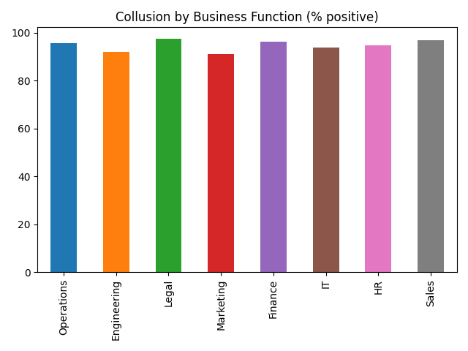

Collusion results by Job Level:

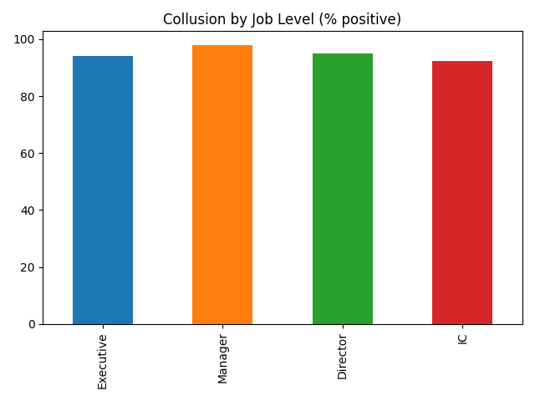

# Feedback, Receiving: Overview

In the C FASTR model, Feedback is not the standard evaluation-against-goals-and-objectives conversation. Instead, it refers to the subtle and overt signals we give and receive every time we communicate with one another in any way. Our posture, our body language, our listening skills, how we react to what’s being said, how we respond - or don’t respond - to an email or text message or conversation – all these things convey a point of view, from us, about the person with whom we are interacting, and our feelings about what’s being communicated. This is an important distinction: in this model, feedback is not the act of communicating; it’s the reactions we deliver to the things being communicated. Communication is the tool by which feedback is delivered, just as it is the tool by which other pieces of information are delivered. Feedback is, therefore, a particular kind of communication.

Feedback can be thought of as consisting of two dynamics: giving it and receiving it. Of the two, it’s slightly more important to be skilled at receiving feedback. This is because people will simply refuse to give feedback to people are bad at receiving feedback. This is the “I don’t like talking to a brick wall” scenario. People must actively convey that they are open to feedback, since giving someone feedback is often an emotionally and / or professionally risky activity. If you blow up, or get defensive, or hold a grudge whenever someone gives you feedback, it’s a safe bet that people will stop giving you feedback, which is a disastrous outcome, since no person, system, or entity can long survive without receiving feedback.

One of the keys to being good at receiving feedback is the ability to do so no matter how bad the giver of that feedback may be. In a relationship-smart culture, tremendous effort is made to make sure that everyone is good at both receiving and giving feedback; but receiving feedback is so essential that one is best served by being able to make feedback lemonade even from feedback lemons.

## Feedback, Receiving Results

Summary:

95.9% of responses indicated positive experience in the Feedback Receiving domain.

Risks identified:

Risks identified in Feedback Receiving.

Recommendations for remediation:

Recommend workshops or sessions for feedback receiving.

Feedback, Receiving results by Business Function:

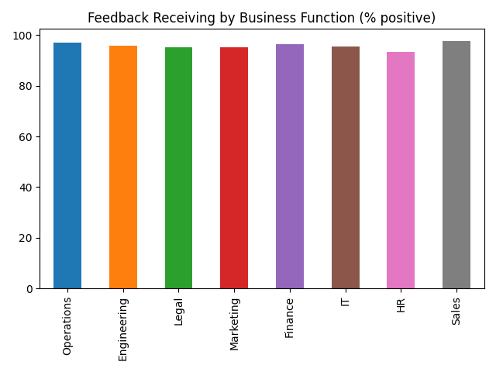

Feedback, Receiving results by Job Level:

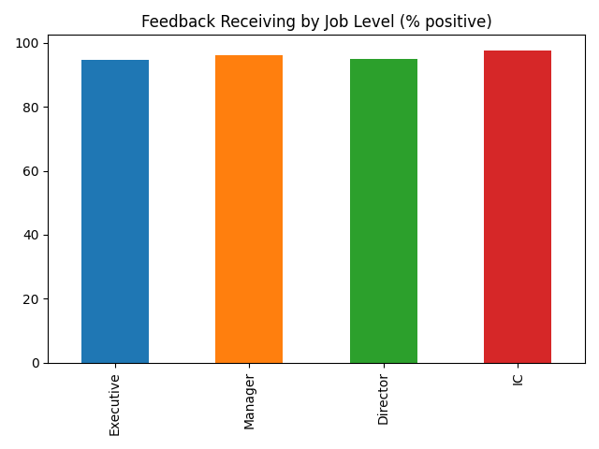

# Feedback, Giving: Overview

As with receiving Feedback, the ability to give feedback effectively and well is borderline miraculous impact on a workplace relationship. When a person receives effective feedback effectively delivered, it enables the person to execute changes that could be important to that person's health, effectiveness, and overall wellbeing. When a person takes the time to think about how to give feedback effectively, and does so, it is a profonde expression of caring. Think of a stranger with whom you have no connection. Are you likely to take time from your life, compose your thoughts, and give that person feedback? Or are you more likely just ignore them? The risks of giving feedback to – especially “tough” feedback - a stranger are high, and it is rare that a person is willing to do so. So when a person gives good feedback effectively, it is rightly received as a tremendous gift.

So healthy relationships are rich in the flow of feedback, and taking the time to learn to give feedback to people you care about is often received as tremendous investment in the relationship, and thus in the person with whom you have that relationship.

A person who is skilled at giving feedback is an absolutely invaluable person with wom to from a relationship. It is why the C FASTR model suggests that organizations allocate substantial resources to helping every single person in the organization become exceptionally skilled at giving (and receiving) feedback.

## Feedback, Giving Results

Summary:

95.0% of responses indicated positive experience in the Feedback Giving domain.

Risks identified:

Risks identified in Feedback Giving.

Recommendations for remediation:

Recommend workshops or sessions for feedback giving.

Feedback, Giving results by Business Function:

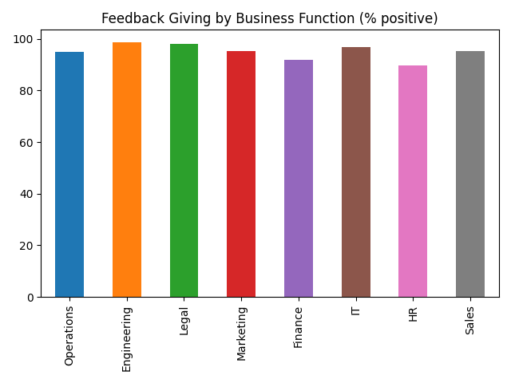

Feedback, Giving results by Job Level:

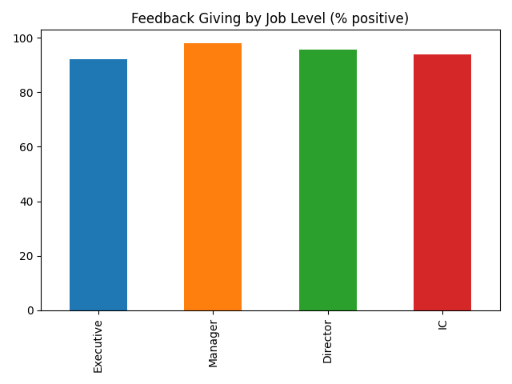

# Accountability: Overview

In the C FASTR model, accountability and responsibility are essentially interchangeable. The intent is to convey that people are willing to be held accountable for the impact of their actions and words, and are fair and honorable about holding others accountable as well. It means that people keep their word. It means that they refuse finger-pointing and scapegoating, instead choosing to embrace honest evaluations.

Imagine how hard it is to be in a relationship with someone who never takes responsibility for their words or actions. Everything is someone else’s fault, or something else’s fault, or is the responsibility of someone else. They never make mistakes, and are fixated with assigning blame rather than creating effective change. Such toxic habits can create an “every man for himself!” environment, as everyone is constantly scrambling to avoid the finger of blame from being pointed at them, rather than working together to find the best lessons to learn and the best way forward together.

A relationship-smart culture seizes every opportunity to reinforce the principle that “we are a learning culture, not a blaming one.” These cultures work assiduously to help everyone become skilled in the practice of holding one another accountable, and being held accountable, in honest and supportive ways.

The benefits of a culture of accountability are numerous [insert research here].

## Accountability Results

Summary:

95.4% of responses indicated positive experience in the Accountability domain.

Risks identified:

Risks identified in Accountability.

Recommendations for remediation:

Recommend workshops or sessions for accountability.

Accountability results by Business Function:

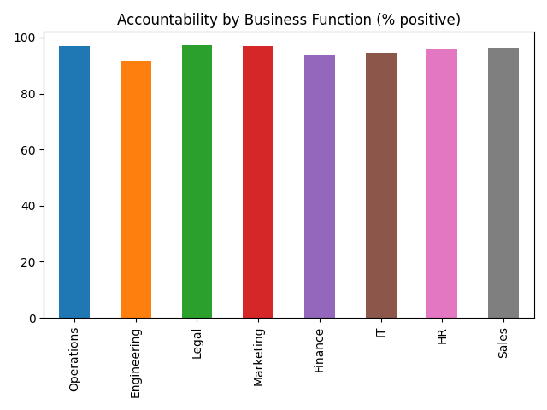

Accountability results by Job Level:

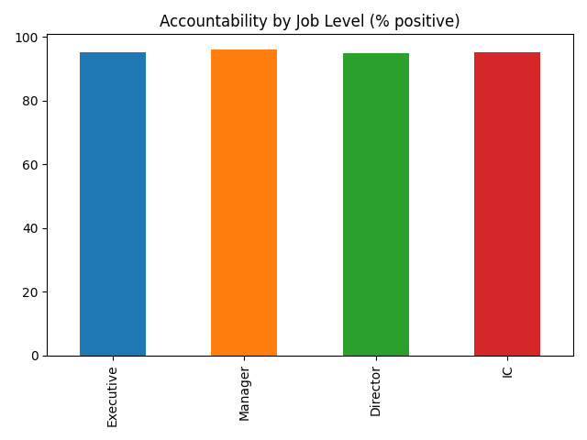

# Sensitivity: Overview

In the C FASTR model, sensitivity has a very specific meaning: the ability to understand the point of view of another human being so well that they’d trust you to speak on their behalf if necessary.

To be good at sensitivity means that you are good at understanding another person – their perspectives their motivations, their desires, their needs. I worked of ryears in IT and the ability to be sensitive to the needs of others is absolutely indispensable when you’re trying to provide a deliverable. There’s a joke it IT where a deliverable is completed and the product owner says “you gave me exactly what I asked for but not what I want.” The whole philosophy of agle software development originates from a simple problem: a poor ability – not anyone’s fault - to truly understand the perspective of the user of the tool being built.

Overly silo’d organizations, likewise, need this skill desperately. Experts are hired and placed into silos because the company needs that expertise; but the ability to work across silos to deliver an integrated solution – one that works effectively, end-to-end - requires the ability to deeply understand other human beings.

Sensitivity is the “you really get me” skill. There are few interpersonal experiences that are more deeply rewarding, nourishing, and connective than for me to be in a difficult situation with you, and you are taking the time and effort to really understand me – without judgement, without rancor, without hidden agendas. Few skills bond a team and a relationship more powerfully.

## Sensitivity Results

Summary:

95.3% of responses indicated positive experience in the Sensitivity domain.

Risks identified:

Risks identified in Sensitivity.

Recommendations for remediation:

Recommend workshops or sessions for sensitivity.

Sensitivity results by Business Function:

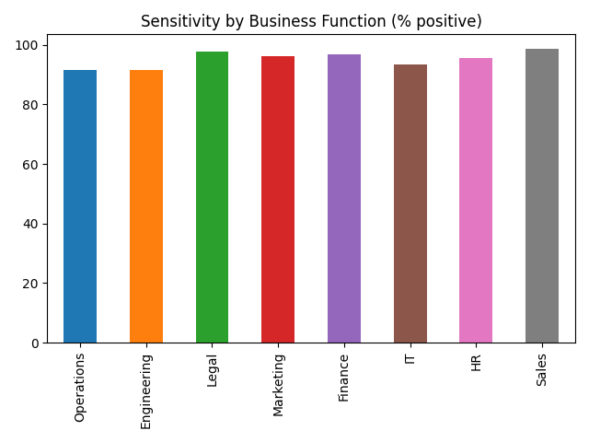

Sensitivity results by Job Level:

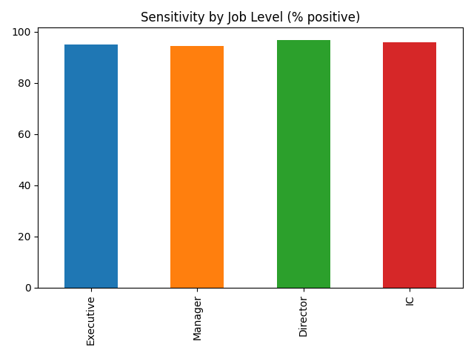

# Trust: Overview

Feedback may be the workhorse of the mode – the skill that’s used most often.

Sensitivity might be the most powerful and difficult skill of the model, since being able to see another’s point of view, especially in today’s world, requires significant dedication and practice.

However, of all the skills required of a healthy relationship, Trust might be the most vital. It is the beating heart of the C FASTR model and, indeed, or any relationship.

In the C FASTR model, trust is essentially the belief that others will act in ways that are consistent, fair, and aligned with the shared goals of the group. It is the confidence that team members will keep their commitments, tell the truth even when it’s inconvenient, and avoid exploiting one another’s vulnerabilities. Trust is not blind faith or naïve optimism; it is a relationship asset built over time through repeated demonstrations of reliability, integrity, and goodwill.

Trust is the foundation of every healthy workplace relationship. When it is strong, people can take risks, share information openly, and collaborate without fear of hidden agendas. When it is weak, even small misunderstandings can escalate into conflict, cooperation dries up, and energy that should be directed toward results gets spent on self-protection and second-guessing others’ motives. The presence or absence of trust determines whether a group can recover quickly from setbacks—or whether it fractures under pressure.

Maintaining trust requires more than simply avoiding dishonest acts; it demands active stewardship. This means following through on commitments, addressing issues directly rather than letting them fester, and being transparent about decisions that affect others. It also means repairing trust when it has been damaged, even if the breach was unintentional. In a relationship-smart culture, trust is treated as a shared responsibility: each person is accountable for protecting it, restoring it when necessary, and recognizing that without it, no amount of skill, strategy, or structure can keep a team healthy and effective.

## Trust Results

Summary:

94.4% of responses indicated positive experience in the Trust domain.

Risks identified:

Risks identified in Trust.

Recommendations for remediation:

Recommend workshops or sessions for trust.

Trust results by Business Function:

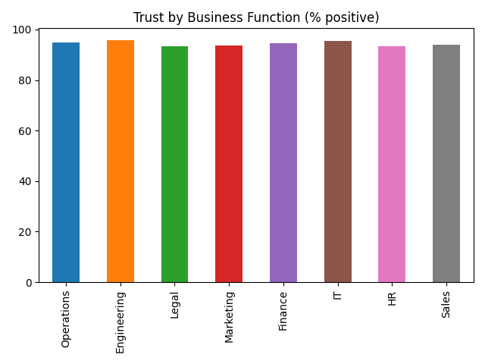

Trust results by Job Level:

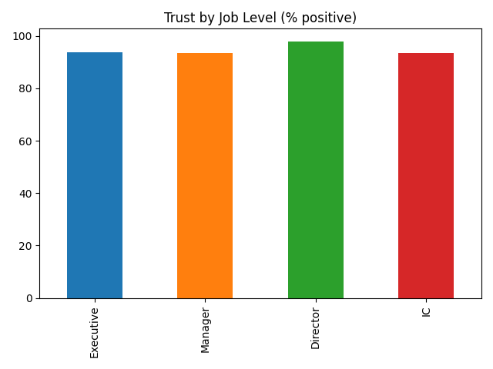

# Relationship Focus: Overview

“This relationship matters to me; you matter to me.”

In the C FASTR model, Relationship Focus means approaching every person and every workplace relationship with the mindset, “This relationship matters to me; you matter to me.” It is the commitment to treat each interaction—no matter how small—as part of an ongoing connection that is worth preserving and strengthening. Relationship Focus is not about liking everyone equally or avoiding hard conversations; it is about valuing the relationship enough to handle differences with care and to make choices that protect, rather than erode, the connection.

When people bring a Relationship Focus to their work, they enter conversations looking for ways to make the relationship work, even when the subject is difficult or the stakes are high. They think before they speak or act, asking, “Will this build trust, damage it, or leave it unchanged?” They recognize that healthy relationships don’t just happen—they require thoughtful management, intentional preservation, and consistent investment over time.

A strong Relationship Focus does not mean sacrificing results for harmony. In fact, it often produces better results, because people are more willing to collaborate, share information, and support each other when they know their relationships are valued. In a relationship-smart culture, this mindset becomes the default: every member of the team actively works to maintain, repair, and enhance relationships, knowing that the health of those connections is inseparable from the health of the organization itself.

## Relationship Focus:

Summary:

95.1% of responses indicated positive experience in the Relationship Focus domain.

Risks identified:

Risks identified in Relationship Focus.

Recommendations for remediation:

Recommend workshops or sessions for relationship focus.

Relationship Focus results by Business Function:

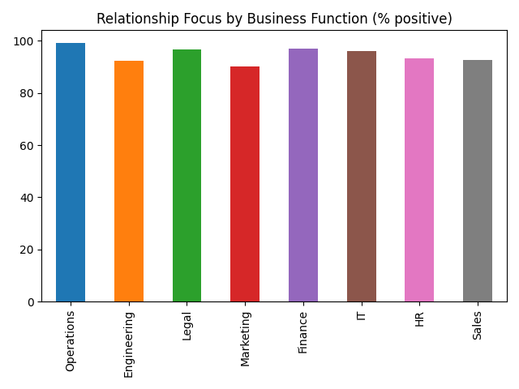

Relationship Focus results by Job Level:

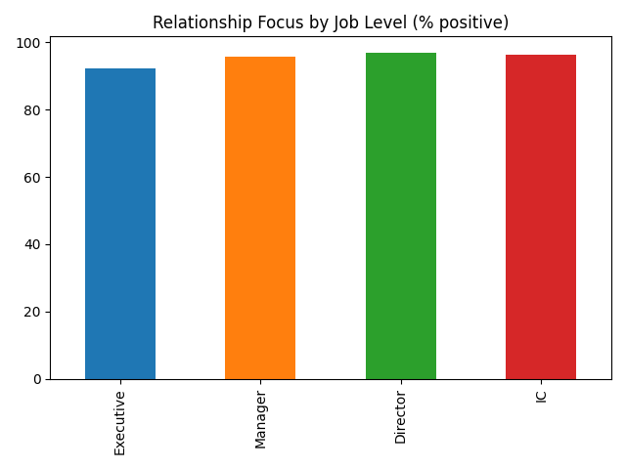

# Conclusion

Culture is improving.

## 30/60/90: From diagnosis to momentum

30/60/90 plan attached.

Focus on feedback.

Accountability training.

Trust-building exercises.

What to measure (quarterly)

Quarterly survey.

Closing thoughts

Thank you for partnering with us.

Debug check: collusion_pct = 95.0%