BigMart Sales Prediction
Machine Learning for Developers (CAI2C08) — Program Code Submission

Student Name:
[Insert your name as it appears in TP-LMS]
Student ID:
[Insert your student ID]
Submission Date:
[Insert submission date]

Declaration of Originality
I declare that this project, including the Jupyter notebook, Streamlit application, and this accompanying document, represents my own work. Where external sources, libraries, or tools were used, they have been acknowledged below.

Use of Generative AI tools
Generative AI (Claude, by Anthropic) was used during this project as a coding assistant to help scaffold the project structure, write and debug Python/scikit-learn/Streamlit code, and draft explanatory text in the notebook. All analytical decisions (feature engineering choices, model selection, hyperparameter search space, evaluation metric justification) were reviewed and verified against the actual data and model outputs before being included. I understand the concepts, code, and results in this submission and can explain and defend them during the demo and Q&A.
[Edit this section to accurately reflect your own use of Gen AI tools, per the assignment's Gen AI guidelines. Being specific and honest here does not affect your marks.]

Signature:
[Sign / type your name]
Date:
[Insert date]

Source of Dataset
Dataset name: BigMart Sales Dataset
Source: Kaggle — https://www.kaggle.com/datasets/yasserh/bigmartsalesdataset
Size: 8,523 rows, 12 columns (11 features + target)
Target variable: Item_Outlet_Sales (continuous) — a regression problem predicting the revenue a specific product generates at a specific outlet.
The dataset is real historical retail transaction data (not synthetically generated), contains no unstructured text/image columns, and is not a time-series-only dataset.

Project Links
GitHub repository link:
[Insert your GitHub repository link here after pushing this project]

Streamlit web app link:
[Insert your Streamlit Community Cloud link here if deployed. If running locally only, write: "Deployed locally — run via 'streamlit run app.py' after installing requirements.txt" and note this to your tutor.]

Web Application Screenshots

1. Before any option is selected (default state)
[Insert screenshot here: open the app fresh (streamlit run app.py) and capture the full page before changing any input from its default value. The default prediction will already be visible — that is expected, since every input starts at a sensible default rather than blank.]

2. After an option is selected (shows a prediction)
[Insert screenshot here: change one input, e.g. Outlet Type to 'Supermarket Type3', and capture the updated predicted sales value.]

3. After another option is selected (prediction changes again)
[Insert screenshot here: change a second, different input, e.g. Item MRP, and capture the predicted sales value changing again from screenshot 2.]

Version Control / Development Log
The project was developed under Git version control with incremental commits at each major development stage (data loading & EDA, cleaning, feature engineering, pipeline and baseline models, model comparison, feature importance, hyperparameter tuning, final model export, Streamlit app, documentation).
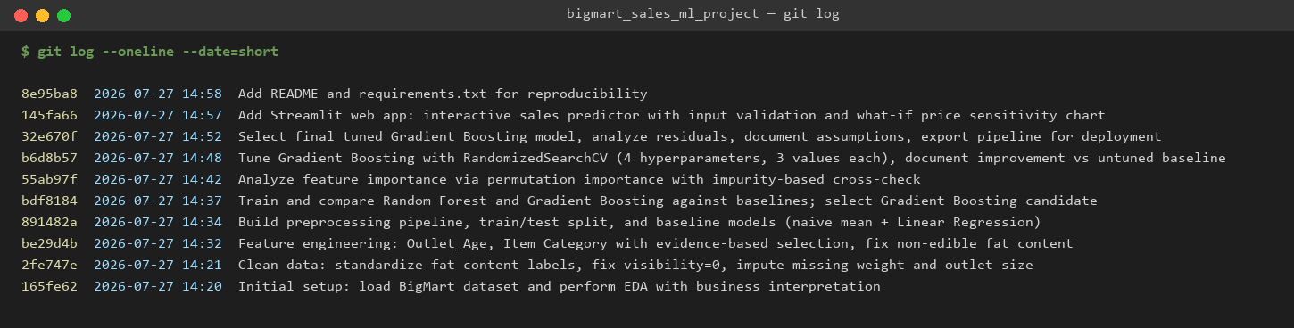

Full commit history is also available in the GitHub repository linked above.

