Tutorial To Extract Cyber Channels data (“From Cyber Monitor”).
Channel Extraction Example: For corrected_imu channel

1 – Go to the folder apollo/cyber/python/examples and create a copy of the file listener.py inside this folder. Now rename this file to “sensor.py”, in this example to corrected_imu.py

2- Open the file corrected_imu.py and modify the the line of code where it is “test_node.create_reader”, change the following channel: from channel/talker to apollo/sensor/gnss/CorrectedImu. This channel name can be easily found launching the command $cyber_monitor or $cyber_channel list in terminal

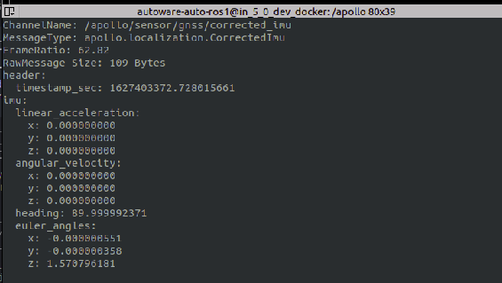

3- Still workig on the line “create_reader..” of this code, change the MessageType name from ChatterBenchmark, to the MessageType displayed by the desired channel, which wishes to extract the data. In this case it is “CorrectedImu

4- Identify the library where the name of the message above is imported. This library can be found in the BUILD file contained into the path modules/localization/proto, then must to look for the line of code written py_proto_library and the desired sensor, in this case it is called imu_py_pb2

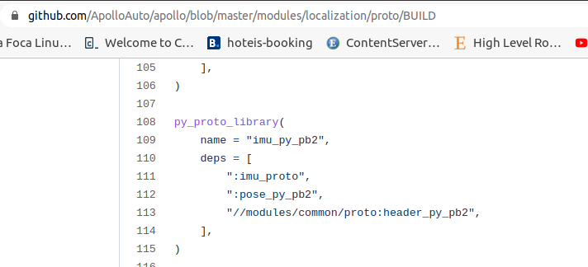

5- After identify the libary that contains the specified message type, it must import this libary in the code which will extract this message Type. In this case must be included in the module corrected_imu.py, the line below:

from modules.localization.proto.imu_pb2 import CorrectedImu

It is important to notice here, that the word py was removed between the words imu_pb2. This is due some build binary feature or other Apollo team compilation nomenclature…And the word “py” must be removed for all sensors: sensor_py_pb2

6 – To debug and visualize if the code is working, and the data is being catched by the callback function, just use a print statement:
print(data.imu.euler_angles.x) the attributes “imu.euler_angles.x” can be taken acessing the cyber_monitor channel to visualize the messages attributes the sensor provides.

7- Now it is required to modify the BUILD file located in the same folder where the corrected_imu.py was put. In this case I put inside a created folder cyber/python/cyber_py3/channels_data_extraction. It is mandatory to include the block of code below, which will build the message type locating its library:

py_binary(
name = "corrected_imu",
srcs = ["corrected_imu.py"],
deps = [
"//modules/localization/proto:imu_py_pb2",
"//cyber/python/cyber_py3:cyber",
],
)

8- Afterwards the user can just store the data in a List (Append) , DataFrame or like open and write a csv file. This code conversion for csv is available on channels_extraction.py file and extracts data for Odometry and Imu attributes.

9- The corrected_imu.py file will have at the end this sketch:

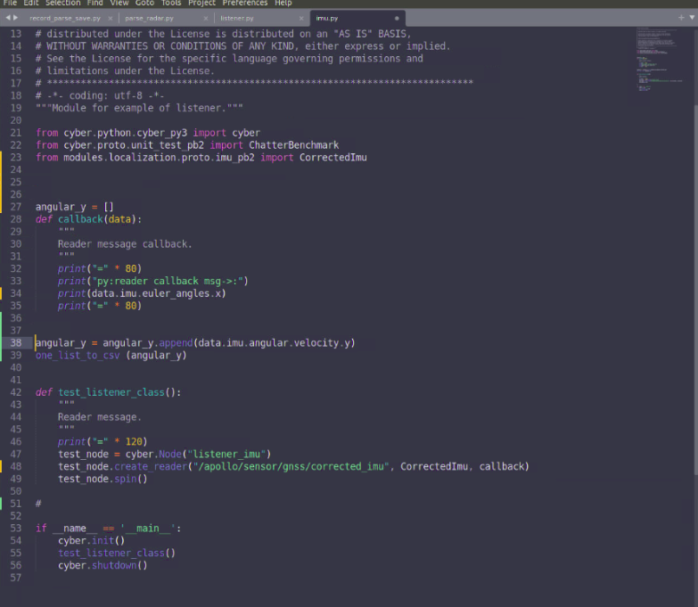

10- Finally the last step is Build these modules. In case for just build the corrected_imu.py
the command is below:

$bazel build cyber/python/cyber_py3/examples:imu

However this usually builds this module and deconstruct the general build (Dreamview and othe modules). So it is required afterwards build again these modules with:

$./apollo.sh build_opt_gpu

Or then build all the cyber module separately:
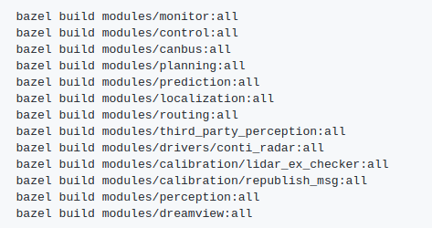
dfd

In this case

$ bazel build cyber/python:all

11- Finally the LAST STEP, run the module!!!

$ ./bazel-bin/cyber/python/cyber_py3/channels_data_extraction:corrected_imu

Corrected_imu is the name you choose in the BUILD file.

And you should see the images printed on the screen!
