Sister Act — Film Reflection
Theology 10B | Ms. Soni | Spring 2026

Name: ___________________________ Period: _________ Date: _________
Why we're watching this:
We just finished Unit 2 on the Four Marks of the Church. Next we’re going into Unit 3 on Ministry. Sister Act lives right at that intersection. As you watch, pay attention to how the Church changes, who does the changing, and what that has to do with both holiness and ministry.
Part 1 — The Four Marks (Unit 2 Bridge)
For each question below, use specific examples from the film. Don’t just name the mark — show it.

1. Which of the Four Marks (One, Holy, Catholic, Apostolic) did you see most clearly in the film? Describe a specific scene that shows it.

2. The Church in the film starts out empty, closed off, and disconnected from its community. Which mark is missing most at the beginning — and what changes by the end?

3. Vatican II said the Church should "open its windows to the world." Give one example from the film where you see that idea come to life.

Part 2 — Ministry (Unit 3 Preview)
Ministry = service in and through the Church. It can be ordained OR lay. Everyone has a vocation.

4. Deloris (Whoopi Goldberg) never planned to minister to anyone — she was hiding. How does she end up becoming a minister anyway? What does that tell us about vocation?

5. Name two characters in the film who are ministering, even if they wouldn’t use that word. What is each person’s specific gift, and how do they use it to serve others?
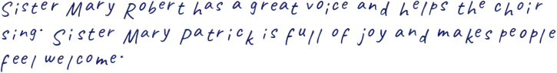

6. Ministry often requires using your actual gifts — not someone else’s. How does the choir in the film illustrate this? What happens when people minister out of who they actually are?

Part 3 — You
These questions are about you. There’s no wrong answer — but be honest.

7. Is there a moment in the film where you saw something that looked like holiness to you — not perfect, but real? Describe it.

8. Deloris doesn’t fit the mold of what a "holy person" is supposed to look like. What does her story say about who gets to minister in the Church?

9. If you had to identify one gift you have that could be used in service to others — your version of the choir — what would it be? How could it be ministry?

Due: ___________________________ Total: ______ / 20 pts

