Well Data & Production Management
Application features, product value, and decisions for the next build cycle
2026-06-30
Meeting objective Align on what the application already does, where it creates operational value, and which capabilities should be prioritized next.

Project Objective
- Develop the WellScout platform as a user-friendly, web-based dashboard integrating spatial visualization, analytics, and machine learning outputs for well inventory management and decision support.
  - Develop a web-based dashboard that integrates spatial mapping, analytics, and machine learning outputs.
  - The interface will enable visualization of well and infrastructure data, interactive filtering, and decision-support tools for analyzing characteristics and site suitability.
- Design and implement a scalable back-end database architecture capable of managing and analyzing large spatial well datasets.
- Validate system performance, accuracy, and scalability under large data volumes while maintaining a modular architecture that allows future expansion to other infrastructure sectors.
- Enhance and retrain machine learning models to identify suitable well candidates for multiple energy storage applications, including off-grid use cases.

Product at a glance
SP is an independent well-data workspace that turns spreadsheet and database inputs into governed operational views. Its core strength is the connected workflow: ingest → map → review → publish → explore.
4 | 3 | 7+ | 1
core application modules | review stages before publishing | well-domain source tables | isolated Docker stack

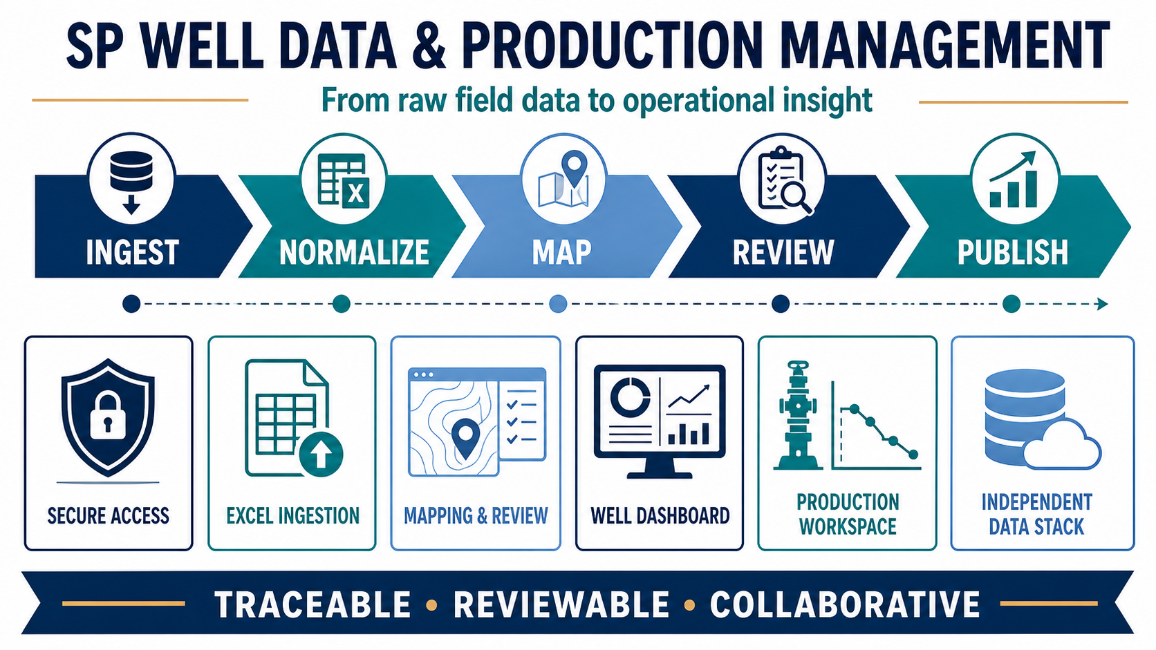

Proposed application features
1. Secure application access — Keeps operational views behind a simple authenticated session.
- Login flow backed by Django authentication endpoints.
- Session-scoped token handling in the React client.
- Protected navigation across import, dashboard, production, and data-browser modules.
2. Raw Excel ingestion — Creates a traceable landing zone for incoming field and partner data.
- Accepts .xlsx and .xlsm workbooks and reads the first worksheet.
- Cleans headings into consistent snake_case names and resolves blanks and duplicates.
- Captures import timestamp, generated raw ID, source filename, batch metadata, and raw-row content.
3. Column mapping and non-destructive review — Lets collaborators validate transformation logic before target tables change.
- Suggests mappings from a reusable CSV template, while keeping each upload editable.
- Groups casing mappings and support multiple values for unique well identification (TBD)
- Group formation tops and support multiple values for unique well identification (TBD)
- Previews mapped headers and transformed sample rows before the Complete Process action.
4. Operational well dashboard — Turns imported records into a filterable field-operations view.
- Define project area – provincial or states or region or areas (TBD)
- Create the project database from the master database for dashboard
- Interactive well map with status/type /depth markers
- Create selected operator highlighting layer in master map
- Filters including:
- Production Formation
- operator filters,
- search,
- well status - like suspended, Abandon, Idle, Active
- well status details
- wellbore type register - vertical, inclined, horizontal
- well id link for production workspace
- well id link for logs workspace
- Uses base UWI reconciliation and latest-record rules for duplicated identifiers.
5. Production workspace — Supports focused review of well production information.
- Dedicated production module separated from data-import controls.
- Dedicated data tables for production
- Search and filter patterns consistent with the operational dashboard.
- API-backed data access designed for additional trends, KPIs, and comparative views.
6. Logs workspace – Supports focused view of the individual well logs (TBD)
- Log data file either img or las file save as a file location info in the database
- Actual file is saved in a separate place/directory

6. Data browser and independent platform stack — Makes the underlying data inspectable without coupling it to another system.
- Django REST API, React/Vite interface, PostgreSQL 16, and PostGIS 3.4.
- Independent Docker Compose project, ports, credentials, database, and persistent volume.
- Admin and database access paths for troubleshooting, governance, and future automation.

End-to-end operating flow
01  INGEST  Upload Excel | 02  NORMALIZE  Clean + trace | 03  MAP  Link columns | 04  REVIEW  Preview output | 05  PUBLISH  Refresh views

What is proposing to develop
- Clear separation between raw ingestion, mapping, review, and operational consumption.
- Traceability is designed into uploads rather than bolted on after data reaches target tables.
- Domain structure already covers wells, status, drilling, casing, location, formations, costs, completions, and inventory foundations.
- The isolated Docker stack makes development and collaboration reproducible.
- Interactive between Backend to Frontend Communication
- PostgreSQL/PostGIS is where persistent dashboard data resides.
- Django REST API is the controlled data-access layer. It filters, combines, paginates, and serializes database records.
- React is the interactive presentation layer. It temporarily holds returned data and current filter selections in browser memory.
- Vite is the frontend build/development tool. It packages and serves React; it does not store application data.
- React calls /api/wells/?cur_operator_name=....
- Django applies that filter to its database query.
- PostgreSQL returns the matching wells.
- Django converts the results to JSON.
- React updates the map, counts, and well register without reloading the page.

React/Vite Interactive Interface ↔ Django REST API ↔ PostgreSQL/PostGIS Data Layer

Collaboration decisions for the meeting
Decision area | Question to settle
Product focus | The primary user for the next milestone is production engineer, or management would be the product focus.
Data Publishing rules | completing an import append by default and keep the version register.
WellStor Module | WellStor processed Datatable – well candidate flag, vol, air mass, energy.
Product features | The most needed query features well type, well status, well completion info -casing, perforation, formation tops.
Production module | Production KPIs includes cumulative productions, last 30 days productions, and production plots.
Data quality | validations should block publication versus appear as warnings, for duplication import.
Collaboration model | Agree on Git branching, review ownership, release cadence, and definition of done.

Recommended next build sequence
- 1 — Lock the target data model and publication rules.
- 2 — Add visible import validation, exception reporting, and rollback/version history.
- 3 — Define and build the first master dashboard as per feature 4.
- 4 – define and build Wellstor Module and spatial map visualization.
- 5 — Add role-based permissions, audit history, and collaborator-ready environments.
- 6 — Establish automated tests and a repeatable release pipeline.

Suggested meeting outcome
Leave with one agreed user persona,
one prioritized workflow,
measurable product outcomes, and
owners for the next two-week build cycle.

