clear;
clc;
f = linspace(-10,10,1e5);
w = 2*pi*f;
a = 1;
T = 1;
tao = 1;
%Fourier transform of signal (a)
Xa = (-2./(j*w)) .* (-2 + exp(-j*w) + exp(-2*j*w));
%Fourier transform of signal (b)
Xb = (2./(tao .* w.^2)).*(tao .* w .* sin(w .* tao) + cos(w .* tao) - 1);
Xa_mag = abs(Xa);
Xa_phase = angle(Xa);
Xb_mag = abs(Xb);
Xb_phase = angle(Xb);
subplot(2,2,1);
plot(f,Xa_mag);
title('Signal (a) magnitude plot');
ylabel('Magnitude');
xlabel('Frequency (Hz)');
axis([-10 10 0 10])
subplot(2,2,2);
plot(f,Xa_phase);
title('Signal (a) phase plot');
ylabel('Phase');
xlabel('Frequency (Hz)');
subplot(2,2,3);
plot(f,Xb_mag);
title('Signal (b) magnitude plot');
ylabel('Magnitude');
xlabel('Frequency (Hz)');
axis([-4 4 0 2])
subplot(2,2,4);
plot(f,Xb_phase);
title('Signal (b) phase plot');
ylabel('Phase');
xlabel('Frequency (Hz)');
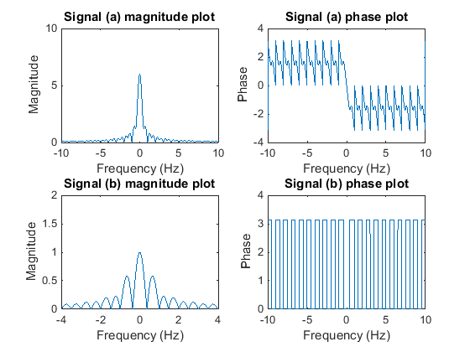
Published with MATLAB® R2014b

