Interactive Dashboard for Ultimate Frisbee strategy analysis
[ ultimate_tactical_board ]

Use Case:

Amateur teams in ultimate Frisbee are

Input: Video sequence of an ultimate game

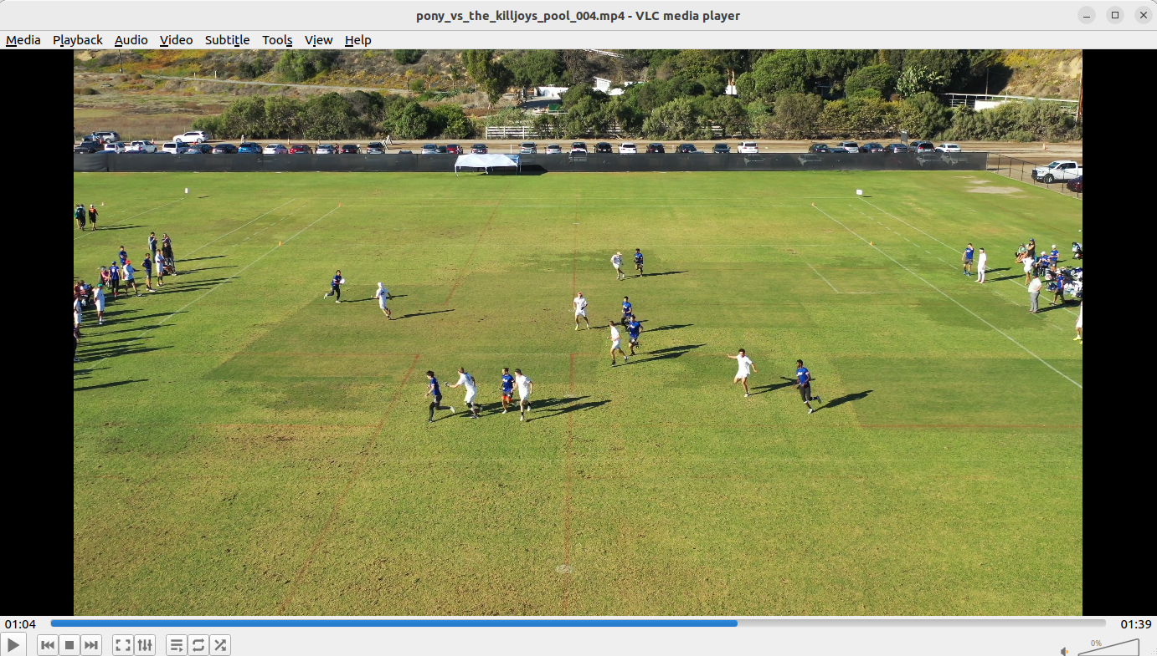

Output: Interactive dashboard
Menu
Video sequence

Similar projects:
- https://medium.com/latinxinai/into-football-analytics-how-to-track-football-players-using-yolov8-2d64ed31199c

Project plan

Milestone – Stage I (must reach):

Create a clean Github repository – [Deadline: 11.02.2024]
- implement a folder structure which fits the given data science project
  - https://drivendata.github.io/cookiecutter-data-science/

Collect and clean Data – [Deadline: 11.02.2024]
- Cut raw videos into smaller videos representing one point of a match
- collect metadata for each cutted video including [video_id, interupted, notes]
- backup on USB stick

ML Modeling:
- Implement ML model for playground detection
  - Model: YOLOv8 – ultralytics
- Implement ML model for player detection
  - Model: YOLOv8 – ultralytics
- Implement ML model for frisbee detection
  - Model: YOLOv8
- Track players over time
  - Model: Deepsort

Streamlit app
- implement video upload and presentation
  - Blueprint: https://github.com/SahilChachra/Video-Analytics-Dashboard
- implement ultimate frisbee court representation
- add drawable canvas
  - Blueprint: https://discuss.streamlit.io/t/drawable-canvas/3671

Milestone – Stage II (bonus):

ML Modeling:
- Implement a ML model for

