I have written a short explanation per assignment detail so that you can understand my way of thinking in this

1. Create a full responsible HTML file as per email design

I started with a standard piece of CSS that I always use with emails. Because I used the <img src> I downloaded the images from the case and uploaded them to a dropbox. Then I looked for a way to use the link in the email. I changed the sharing link from /image.jpg?dl=0 to /image.jpg?raw=1. I also compiled the e-mail in codepen where I could constantly see if it was going to look good. To see what it would look like on different devices I used the "inspect" function. See screenshot. I also used litmus. If possible, I would have chosen the test send option within SFMC. For the texts etc. I always looked at the font-size, font-color and line height that were indicated within "inspect" in the case.

I also had some trouble downloading the "social icons" such as the WhatsApp logo. So I chose to take a screenshot of the image and upload it to dropbox again and then have the image come back with the correct dimensions.

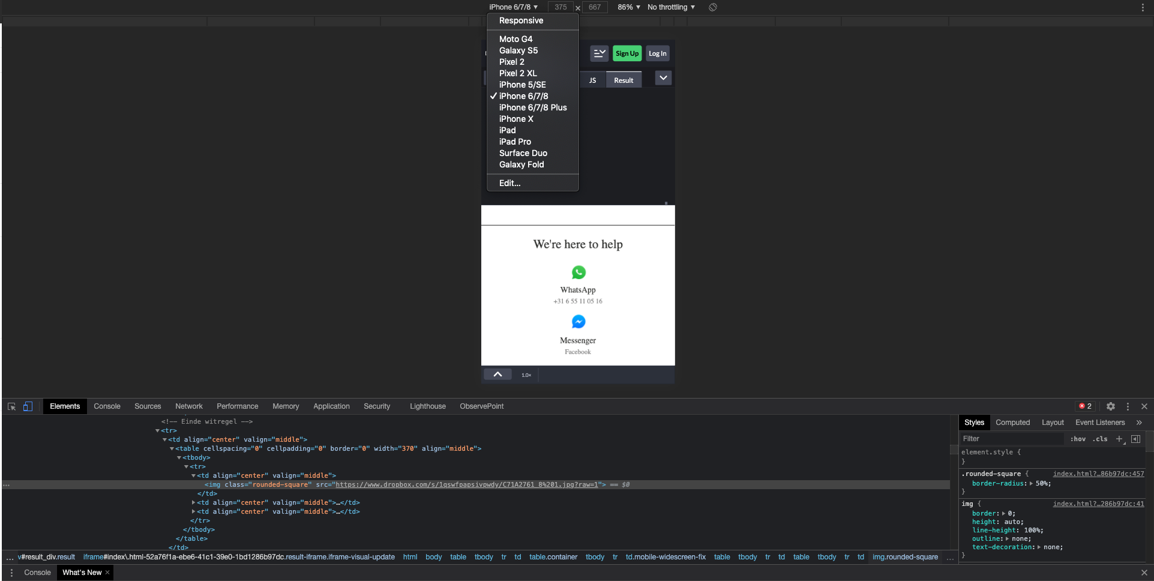

1. Create JSON model to power the data shown in the email

First of all, I have never worked with JSON in email, so it was a nice learning experience. Since XML resembles JSON I first looked at a few variables in the email I would like to use. I first typed this out in an XML and then pasted it into the following converter: https://www.freeformatter.com/json-to-xml-converter.html.

For example, I got a JSON file that I could then parse again by means of amp script. Both the XML as the JSON I put in the attachments.

1. Create AMPScript used to parse JSON created above to fill in the data in email template

After I created the JSON file, I searched for information on stackoverflow to find out how to use the JSON in an email using AMPscript. This was another area that I have no experience with yet. I have developed the file containing the development of 1 variable under the file name: json_ampscript.html. The difficulty for me was extracting the values ​​from the JSON. With an XML I would use the BuildRowsetFromXML ampscript function to get the values ​​from the file. This is something I would also like to learn at JSON and I am convinced that if this is explained briefly or if I look at the excisting coding that you guys have set up will pick it up immediately.

1. Outline which tools you would use to aid email development in areas:
2. translation management;

In this area I need an explanation of what is meant here.

1. Responsiveness;

So I used the "inspect" function in my browser here, see screenshot for assignment 1. Furthermore, I would look in litmus at the different browser and devices to see if the mail scales with the device and email provider.

1. email testing.

I would use the test sends function within SFMC to see how the email is sent and whether it looks good on different devices. Furthermore, I would check every link behind the buttons on the correct landing page.

1. Share the work using private GitHub repository. List of desired usernames will be shared later.