28.2.1 Exercise-2 Microsoft Word

Mardan Mirzaguliyev

library(tidyverse)

── Attaching core tidyverse packages ──────────────────────── tidyverse 2.0.0 ──  
✔ dplyr 1.1.3 ✔ readr 2.1.4  
✔ forcats 1.0.0 ✔ stringr 1.5.0  
✔ ggplot2 3.4.4 ✔ tibble 3.2.1  
✔ lubridate 1.9.3 ✔ tidyr 1.3.0  
✔ purrr 1.0.2   
── Conflicts ────────────────────────────────────────── tidyverse_conflicts() ──  
✖ dplyr::filter() masks stats::filter()  
✖ dplyr::lag() masks stats::lag()  
ℹ Use the conflicted package (<http://conflicted.r-lib.org/>) to force all conflicts to become errors

# Exercise 2

colnames(mpg)

[1] "manufacturer" "model" "displ" "year" "cyl"   
 [6] "trans" "drv" "cty" "hwy" "fl"   
[11] "class"

mpg |>   
 count(manufacturer)

# A tibble: 15 × 2  
 manufacturer n  
 <chr> <int>  
 1 audi 18  
 2 chevrolet 19  
 3 dodge 37  
 4 ford 25  
 5 honda 9  
 6 hyundai 14  
 7 jeep 8  
 8 land rover 4  
 9 lincoln 3  
10 mercury 4  
11 nissan 13  
12 pontiac 5  
13 subaru 14  
14 toyota 34  
15 volkswagen 27

mpg |>   
 ggplot(aes(  
 x = displ,  
 y = hwy,   
 color = class)  
 ) +  
 geom_point()

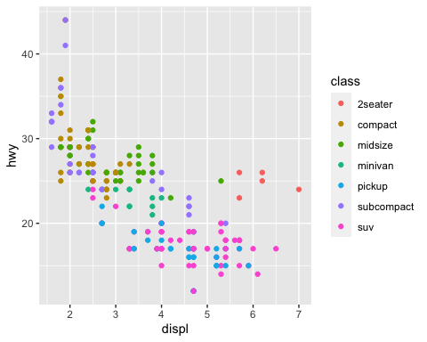

mpg |>   
 ggplot(aes(  
 x = displ,  
 y = hwy,   
 color = class)  
 ) +  
 geom_point() +  
 labs(  
 x = "Engine displacement, in litres",  
 y = "Highway miles per gallon",  
 color = "Class"  
 )

