Xolotl: An Intuitive and Comprehensible Neuronal Simulator
Alec Hoyland,* Srinivas Gorur Shandilya,* Eve Marder

ABSTRACT

xolotl is an open-source neuronal simulator written in C++ with MATLAB wrappers. Complex
models and networks can be designed efficiently using an intuitive language tightly coupled
to the object-based architecture of the underlying C++ code. Models are specified by adding
conductances to compartment objects. The structure is modular, serialized, and searchable,
permitting high-level programmatic control over nearly all features of the models. C++ templates
are provided for developing new conductances, compartments, and integration schemata.
xolotl readily implements parallel-processing on multicore processors and high-performance
computing clusters. It also includes a customizable graphical user interface (puppeteer) for rapid
prototyping and hand-tuning conductances in real-time. In addition, xolotl comes packaged with
a powerful optimization toolbox (procrustes) for optimizing any model parameters accessible
in the xolotl tree. xolotl is freely available at https://github.com/marderlab/xolotl. This tool
provides rapid implementation and fast simulation of neuronal models while permitting full control
over every aspect of the network and integration.

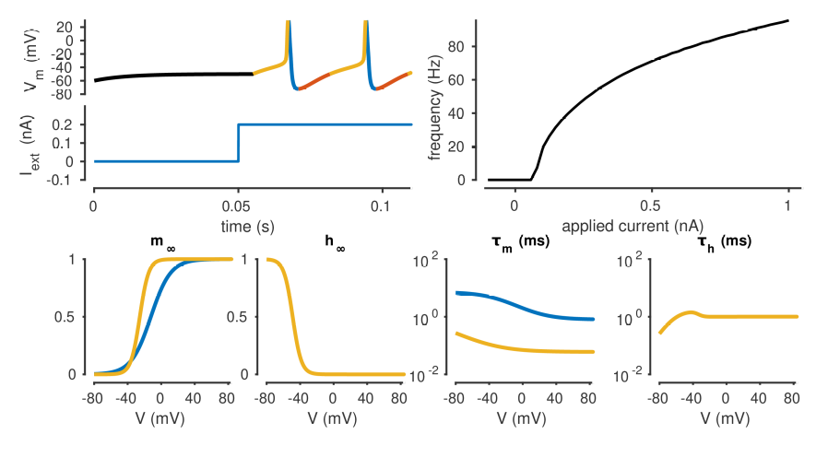

Figure 1. xolotl can quickly set up and simulate conductance-based models. (A) Cartoon of a Hodgkin-
Huxley single-compartment neuron model with fast sodium, delayed rectifier, and leak currents. (B) Code snippet in MATLAB used to implement D, F-I. (C) xolotl schematic displayed in the MATLAB command prompt. (D) Simulated voltage trace with 0.1 nA applied current. Colors indicate the dominant current (gold is fast sodium, blue is delayed rectifier, red is leak). (E) Frequency-input relation displaying firing rate as a function of applied current. (F-G) Steady-state gating functions for activation (m) and inactivation (h) gating variables. Variables not plotted are unity for all voltage. (H-I) Voltage-dependence of time constants for activation (m) and inactivation (h) gating variables. Variables not plotted are unity for all voltage. Colors indicate conductance type (gold is fast sodium, blue is delayed rectifier, red is leak).

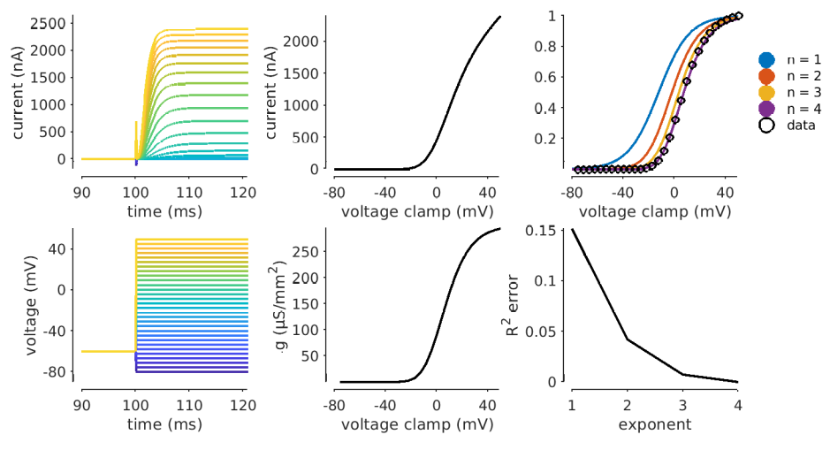

Figure 2. xolotl readily implements voltage clamp. (A) Cartoon of a cell with potassium conductance
with experimentally-fixed voltage. (B) Structure of xolotl object in A. (C) Code snippet depicting
integration under voltage clamp. (D-E) Current response to steps in voltage from a holding potential of
V_{m} = −60 mV. (F) Current-voltage relation of the steady-state current (t = 400 ms) indicating a reversal potential of E = −80 mV and no inactivation. (G) Conductance-voltage relation at steady-state takes the form of a sigmoid. (H) Sigmoids m fit to the model as m^{n} data indicating that n = 4 is the best fit. (I) r² correlation of the sigmoid fits at various powers where n = 4 is an exact fit.

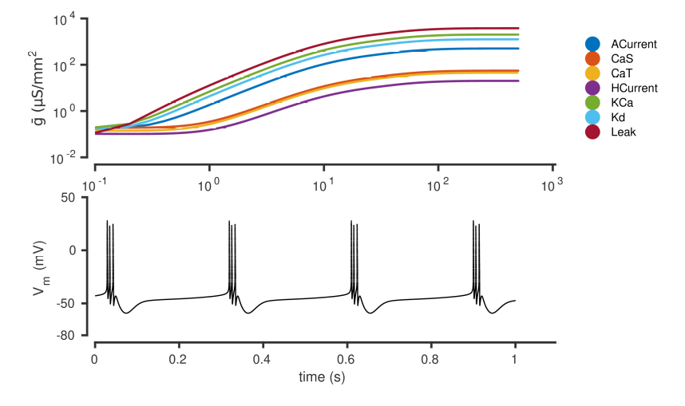

Figure 3. xolotl can implement homeostatic tuning rules as integral control as in O’Leary et al. 2013. (A) Cartoon of a model neuron with integral control. (B) Hierarchical structure of a neuronal network considers controllers as components of compartments which act on conductances. (C) xolotl implements controllers as fields of conductances. (D) Controllers sense calcium concentration to change maximal conductances, moving from quiescence to the desired bursting state. (E) Voltage trace of the controlled neuron shows regular bursting activity.

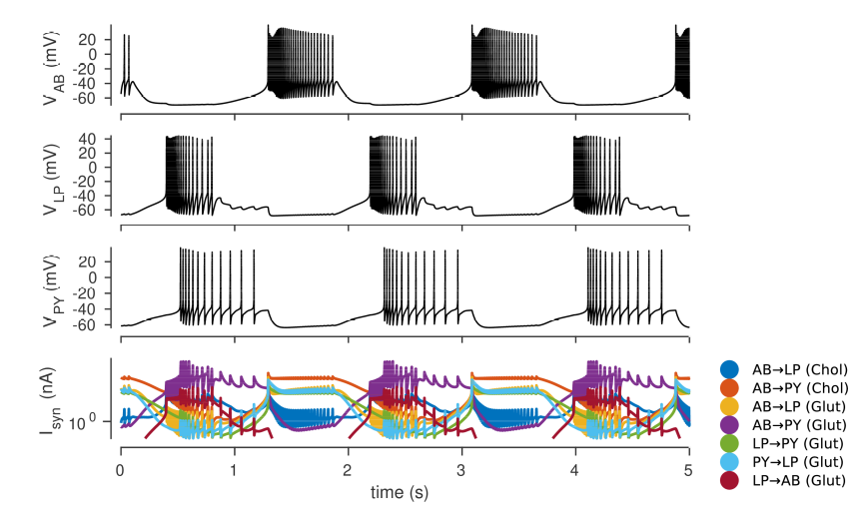

Figure 4. xolotl readily implements conductance-based network models. (A) Diagram of a network
model of the pyloric rhythm in the crustacean stomatogastric ganglion (Prinz et al. 2004). (B)
Hierarchical structure of a neuronal network considers compartments as components of the network
and conductances and synapses as components of compartments. (C) xolotl implements conductances
as fields of compartments and synapses as connections between compartments. (D-F) Simulated voltage trace of a model network for the three compartments. (G) Time series of synaptic currents in the simulated network with model cholinergic (chol) and glutamatergic (glut) synapses are outputs of the integration.

