Part 1, core experiments
Four experiments carry Part 1. Each entry: the scene, the figure, a one-line caption, a plain-language explanation (setup, what is altered, what is measured, what happens, why it matters), and line-level code citations at commit 35e64ae8da89.
Reading guide, assume nothing: every experiment compares four “arms”, meaning the same physics advanced four different ways. There are two contact solvers: MuJoCo, the contact solver of the standard robotics simulator, and ICF, the convex contact solver CENIC is built on. Each runs in two modes. FIXED STEP: the simulation always advances by the same slice of time δt, chosen in advance (10 ms, 1 ms, ...). ERROR CONTROL (EC): the solver takes a trial step, re-takes it as two half-steps, compares the two results to estimate its own error, and shrinks or grows the step so the error stays below a tolerance ε you request: small steps during impacts, big steps when nothing is happening. CENIC is ICF's error-controlled mode. Everywhere: smaller δt or smaller ε means more accurate and more expensive.

Experiment 1, Realized contact stiffness
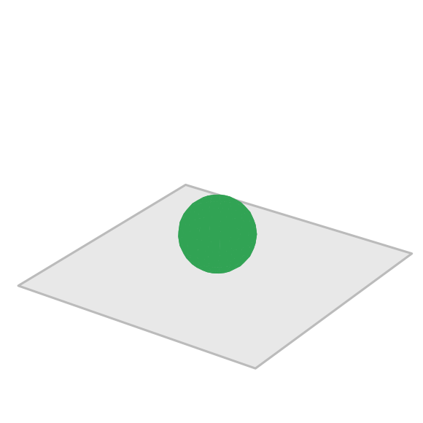
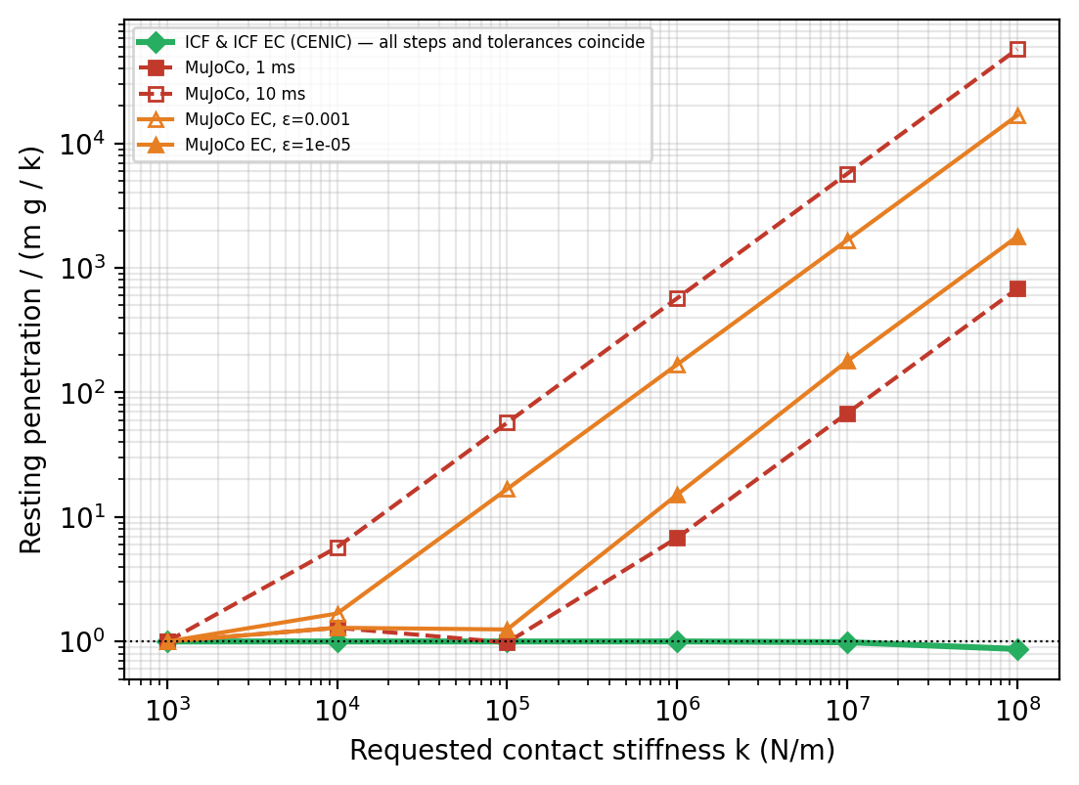
One 65 g sphere rests on the floor; we ask both solvers for the same contact, each in its own language, and measure what each actually delivers as the timestep changes.
The setup is a single 65-gram sphere resting on a flat floor. The two solvers describe contact in fundamentally different ways, and that difference is what this experiment measures. ICF has a literal stiffness parameter: you hand it a number k in newtons per meter, and the floor pushes back with a force equal to k times the overlap depth, Hooke's law, exactly as written. MuJoCo has no such number anywhere in its interface. What you give MuJoCo instead is a time constant τ (through a parameter called solref), which means: when this contact is violated, remove the violation smoothly over about τ seconds. An effective stiffness emerges from that request, but it is not a fixed number. It scales with the mass of the touching bodies, it varies with how deep the contact already is, and, critically, MuJoCo refuses to honor any τ smaller than twice the timestep (a documented safety rule called refsafe). So there is no single k inside MuJoCo to set, ever. That is not a flaw we discovered; it is how the solver is designed, and it is exactly why this experiment exists.
The yardstick comes from statics. A resting sphere must be held up by a contact force equal to its weight, mg. If the contact truly behaves like a spring of stiffness k, force balance fixes the resting overlap at exactly mg/k: about 6.4 micrometers for our sphere at k = 100,000 N/m. To make a comparison possible at all, we translate each requested k into MuJoCo's language by calibration: we choose the τ that makes the sphere sink by exactly mg/k at a 1-millisecond step. At that one anchor point, both solvers agree by construction. The experiment is then: hold the physical request fixed, change the timestep, and watch whether each solver keeps delivering it.
Between runs we change the requested stiffness k, in six steps from 1,000 to 100,000,000 N/m (each k carried into MuJoCo as its calibrated τ), and the numerical setting: fixed steps of 10 ms and 1 ms, and error control at tolerances 0.001 and 0.00001. Everything else, the sphere, the floor, the 3 seconds of settling, is identical in every run.
After the sphere has fully settled we read its actual overlap depth from the geometry and divide by mg/k. A ratio of 1 means the solver delivered the contact that was requested. Because a resting contact always carries exactly the weight, a ratio above 1 means the delivered contact was softer than requested by precisely that factor.
What happens: ICF sits at 1.00 all the way to 10 million N/m in every one of its four settings, the four curves lie exactly on top of each other, which is why the plot shows a single green line. That coincidence is the result: in ICF, the contact you request is the contact you get, and the timestep does not enter. MuJoCo tracks the request only as long as its clamp allows. Stiffer contacts need smaller τ; once the calibrated τ falls below twice the timestep, refsafe silently substitutes a softer contact. At a 10 ms step, the clamp arithmetic predicts a contact about 69 times softer than requested at k = 100,000 N/m; the measurement reads 57 to 60 times. Prediction and measurement agree, MuJoCo's integrator is faithfully executing its own documented rule.
Why it matters: nothing here is a bug in MuJoCo. The finding is that under a fixed step, the physics MuJoCo delivers depends on the step you chose, and error control on positions does not buy the stiffness back, because the clamped contact is perfectly self-consistent at those steps and the softening is invisible to a position-error test. Fairness caveat: the 1-millisecond calibration anchor is a choice; anchored at 10 ms instead, MuJoCo's 10 ms curve would read 1.0 and its 1 ms curve would drift. The anchor-independent statement, and the one the paper makes, is that MuJoCo's delivered compliance moves with the timestep while ICF's does not.
Code:
- k sweep values, https://github.com/mardigiorgio/icra2027/blob/35e64ae8da89/part1/bench/benchmarks/part1_stiffness_sweep.py#L32
- sphere build (rest on plane), https://github.com/mardigiorgio/icra2027/blob/35e64ae8da89/part1/bench/benchmarks/part1_stiffness_sweep.py#L42
- 3 s settle loop, https://github.com/mardigiorgio/icra2027/blob/35e64ae8da89/part1/bench/benchmarks/part1_stiffness_sweep.py#L59
- per-arm, per-k sweep, https://github.com/mardigiorgio/icra2027/blob/35e64ae8da89/part1/bench/benchmarks/part1_stiffness_sweep.py#L76
- MuJoCo solref calibration anchors, https://github.com/mardigiorgio/icra2027/blob/35e64ae8da89/part1/scenes/cenic_scenes.py#L66-L69
- solref applied per scene, https://github.com/mardigiorgio/icra2027/blob/35e64ae8da89/part1/scenes/cenic_scenes.py#L186-L194

Experiment 2, Work-precision on the clutter scenes
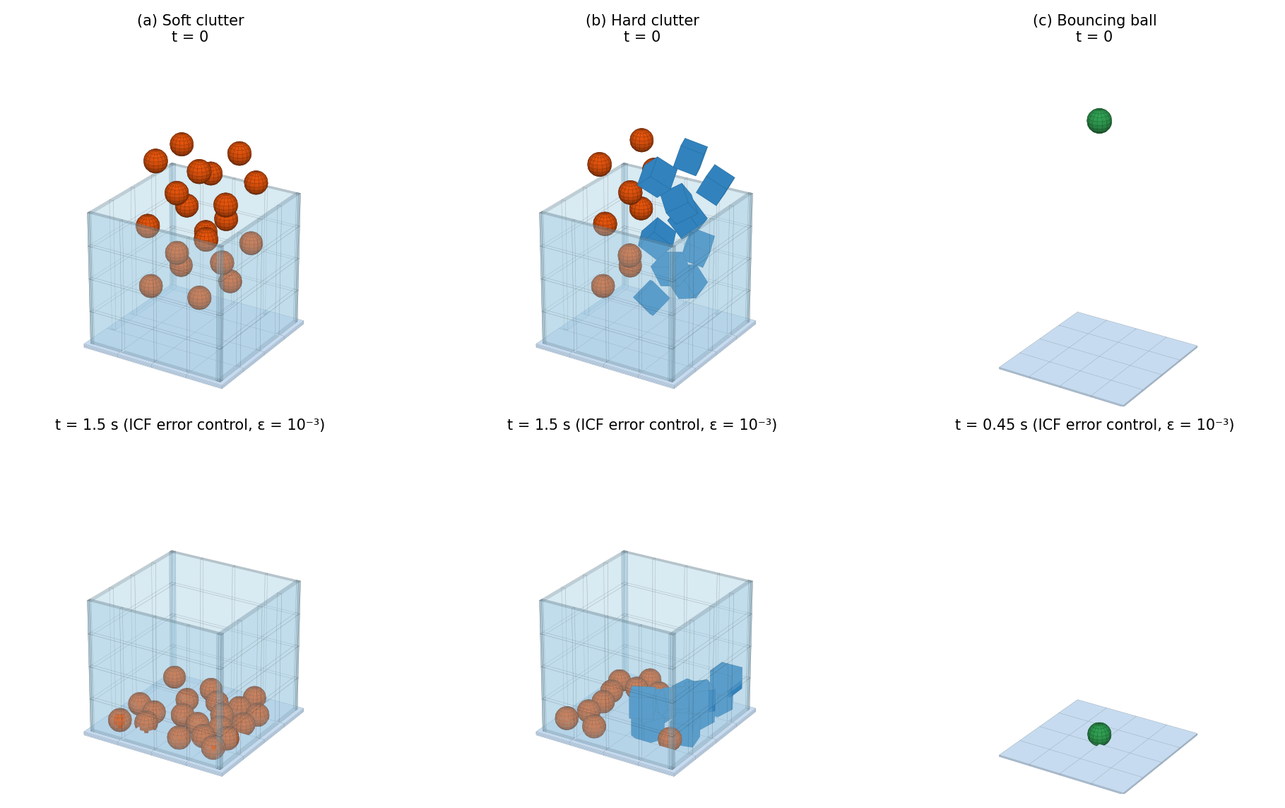
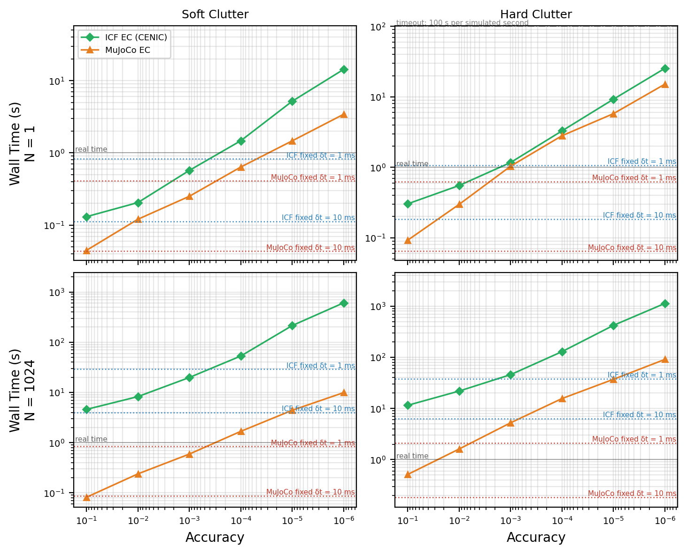
Twenty objects dropped into a bin; we sweep the requested accuracy and measure what each error-controlled solver charges for it.
The setup is the two clutter drops from the CENIC paper: twenty spheres falling into a box-shaped bin with soft contact (k = 1,000 N/m), and a mix of spheres and cubes with hard contact (k = 100,000 N/m). Each run simulates 2 seconds: the fall, the impacts, and the settling into a pile.
Between runs we change two things: the accuracy the error controller is asked for (ε from 0.1 down to 0.000001: smaller means stricter), and how many copies of the scene run in parallel on the GPU (1 or 1024; reinforcement learning uses the large number). The scenes and every physical parameter stay fixed.
We measure wall-clock seconds per simulated second: how long the computer works to produce one second of physics. Lower is cheaper. The dotted horizontal lines show what a plain fixed step costs at 10 ms and 1 ms, for reference.
What happens: MuJoCo's error control is cheaper than CENIC at every accuracy, 1.1 to 3.3 times at a single scene (nearly equal at middle tolerances), and 8 to 22 times at 1024 parallel scenes. The reason is the price of one attempt: each error-controlled attempt requires three full physics solves (the trial step plus the two half-steps that estimate its error) and two collision checks, and one ICF attempt costs 2.7 to 6.9 milliseconds against MuJoCo's 1.6 to 2.1, while both take similar numbers of attempts. At large batches the gap compounds, because at every attempt the entire batch waits for its slowest world.
Why it matters: this is the honest cost picture in the clutter regime, and it favors the MuJoCo backend. CENIC's speed case is not here. It is in Experiment 4, where the stiffness sits in the actuator instead of the contact pile, and the ranking reverses.
Code:
- timeout semantics (per world-second), https://github.com/mardigiorgio/icra2027/blob/35e64ae8da89/part1/bench/benchmarks/part1_workprecision.py#L8-L16
- accuracy ladder + march budget, https://github.com/mardigiorgio/icra2027/blob/35e64ae8da89/part1/bench/benchmarks/part1_workprecision.py#L18-L21
- first attempt k_Init·δt_max, https://github.com/mardigiorgio/icra2027/blob/35e64ae8da89/part1/bench/four_arms.py#L47
- inner tolerance rule (CENIC eq. 34), https://github.com/mardigiorgio/icra2027/blob/35e64ae8da89/part1/bench/four_arms.py#L48
- contact budgets (≥ 2× measured demand), https://github.com/mardigiorgio/icra2027/blob/35e64ae8da89/part1/bench/four_arms.py#L62-L64

Experiment 3, Wall time vs number of parallel worlds

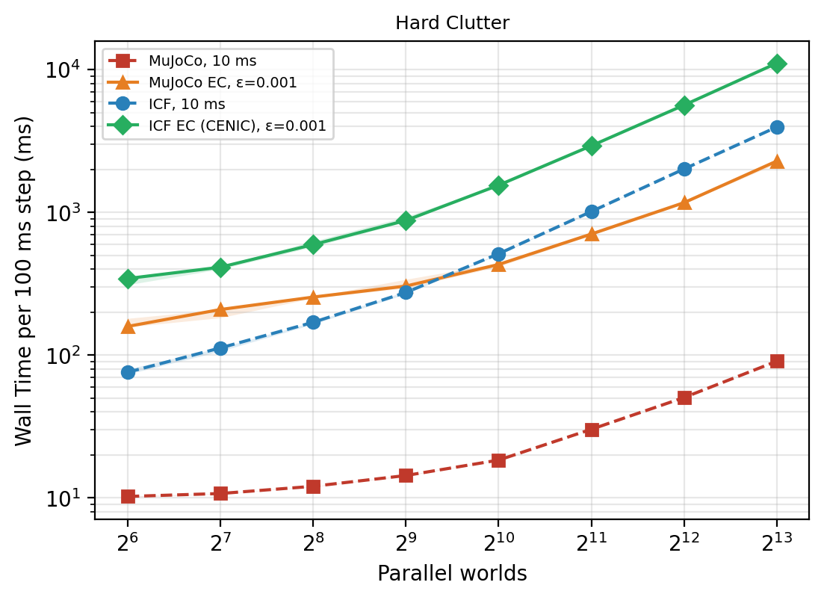
The same hard-clutter scene copied across more and more GPU worlds; we measure what each additional world costs.
The setup is the hard-clutter scene again, but the variable is now scale: the same scene is copied 64, 128, 256, and so on up to 8,192 times, all advancing in parallel on one GPU, which is how reinforcement learning actually consumes a simulator. Each solver runs at one representative setting: fixed step 10 ms, error control at ε = 0.001.
We measure how long it takes to advance every copy through one 100-millisecond slice of simulated time, take the median over a 2-second window, and repeat the whole run three times; the shaded band is the spread between repeats.
What happens: at small counts, adding copies is nearly free, the GPU has idle capacity, so the cost per copy falls. Then each solver saturates the GPU and total cost starts doubling when the copies double. The ICF arms saturate earliest, from about 1,024 copies. At 8,192, the cost per copy per 100 ms slice is: MuJoCo fixed 11 microseconds, MuJoCo error control 279 microseconds, ICF fixed 484 microseconds, CENIC 1.35 milliseconds.
Why it matters: Part 2 trains at 2,048 copies, which lives on this curve, every wall-time claim about training inherits these numbers. We also checked the obvious suspect, the tolerance of ICF's internal equation solver: loosening it moves these numbers by at most about 5 percent at scale. The cost is what it takes to resolve stiff contact with a convex solve, paid at the pace of the batch's slowest world.
Code:
- runner (per-N subprocess), https://github.com/mardigiorgio/icra2027/blob/35e64ae8da89/part1/bench/benchmarks/part1_scaling.py#L36
- warm-up handling, https://github.com/mardigiorgio/icra2027/blob/35e64ae8da89/part1/bench/benchmarks/part1_scaling.py#L44-L47
- median statistic, https://github.com/mardigiorgio/icra2027/blob/35e64ae8da89/part1/bench/benchmarks/part1_scaling.py#L72
- defaults: 2 s timed, 0.2 s warm-up, 3 trials, https://github.com/mardigiorgio/icra2027/blob/35e64ae8da89/part1/bench/benchmarks/part1_scaling.py#L82-L89

Experiment 4, The actuated stiff-contact case (PD gantry push)
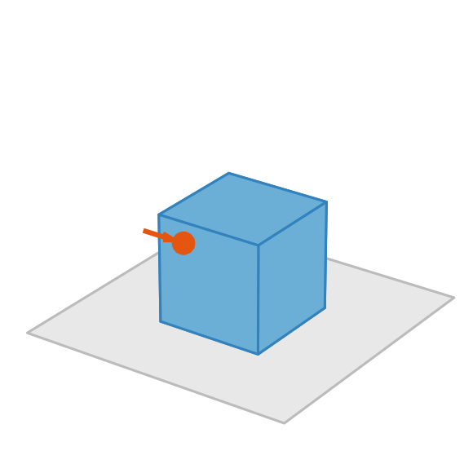
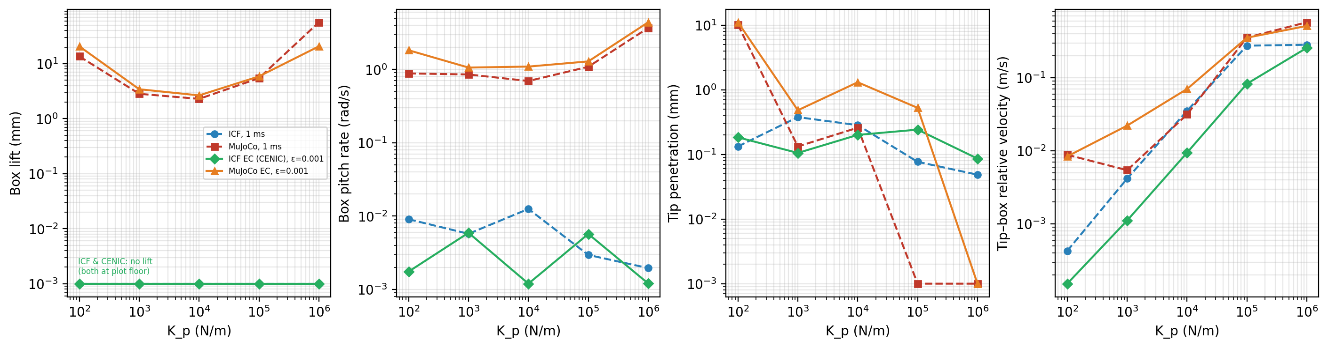
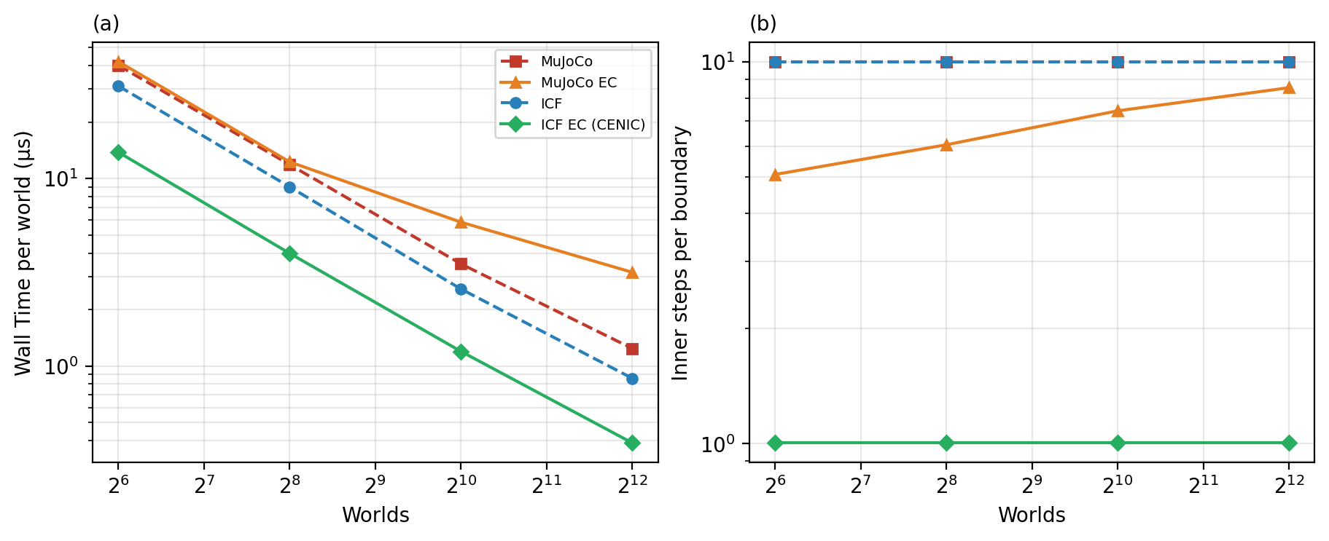
A position-controlled fingertip pushes a box across the table, commanded the way a trained policy commands a robot; we sweep the controller stiffness and watch what each solver does to the physics.
The setup is the smallest scene that has the ingredients of robot learning. A gantry is the simplest possible robot: a carriage that slides left–right and up–down, like the moving head of a 3D printer. Ours carries a small round fingertip (100 grams, 1 centimeter radius). In front of it, a 1-kilogram box, 10 centimeters on a side, rests on the table. The task is to push the box 30 centimeters across the table at 300 mm/s, with hard contact (k = 100,000 N/m) and ordinary friction.
The gantry is driven by a PD controller, the standard control law of nearly every robot. You give it a target position, and it pulls the fingertip toward that target with a force proportional to the remaining distance; that is the P term, and its gain K_p is literally the stiffness of a virtual spring stretched between fingertip and target. A second term (the D) brakes proportionally to velocity so the pull does not oscillate forever. A trained policy commands a real robot exactly this way: the policy outputs a target, the PD pulls the joints toward it. Here the target updates 100 times per second and is HELD in between, just as a policy's action would be. Every update suddenly re-stretches the virtual spring by 3 millimeters, and at K_p = 100,000 N/m, a 3 mm stretch is a kick of several hundred newtons landing on a 100-gram fingertip. That kick, repeated 100 times a second, is what makes this scene stiff even though the contact itself is ordinary.
Between runs we change the controller stiffness K_p (from 100 to 1,000,000 N/m (a soft compliant arm up to a rigid industrial one), the solver setting (four fixed steps, four tolerances), and, for the second figure, the number of parallel copies. The scene geometry, masses, friction, and the target program never change.
We measure five things per run: whether the simulation blows up (velocities beyond 10 m/s, or numbers that stop being finite), how high the box lifts off the table during what should be a flat horizontal push, how fast the box rocks, how deep the fingertip presses into the box face, and the rattling between fingertip and box while cruising, plus wall time.
What happens: MuJoCo integrates the controller's virtual spring explicitly. It applies the spring force from the start of the step for the whole step, so there is a hard stability boundary, roughly when the spring's natural frequency times the timestep exceeds 2. Six of MuJoCo's forty cells blow up outright, and in every surviving cell the box visibly hops millimeters off the table during the push; error control does not remove the hop. ICF folds the same controller into its implicit solve, the spring force is computed at the end of the step, consistently with where things actually end up, so all forty of its cells are stable and the box never leaves its resting depth: 25 micrometers, which is the weight mg spread over the box's four contact corners, mg/(4k), the same force balance as Experiment 1. One more effect matters directly for training: at a 10-millisecond step, the fingertip–box rattling that the held targets excite disappears from the simulation entirely. A policy trained at that step never feels the vibration its own commands create. (In the box-lift panel, both ICF curves sit on the plot floor. One visible line is two configurations, both reading zero lift.)
Why it matters, and the speed reversal: in this regime the stiffness lives in the actuator, not in a pile of objects. Because CENIC handles that stiffness implicitly, it crosses each 10 ms control boundary in a single step, while MuJoCo's explicitly-integrated spring forces its error controller to 5–9 sub-steps and its fixed arm down to 1 ms just to stay stable. The second figure shows the consequence at scale: CENIC is the fastest of all four configurations at every batch size. This is the regime Part 2 trains in, and it is where the paper's speed claim lives.
Code:
- scene geometry and start pose, https://github.com/mardigiorgio/icra2027/blob/35e64ae8da89/part1/scenes/actuated_press.py#L32-L42
- scene build (densities, bodies), https://github.com/mardigiorgio/icra2027/blob/35e64ae8da89/part1/scenes/actuated_press.py#L68-L80
- grid: fixed steps × tolerances, https://github.com/mardigiorgio/icra2027/blob/35e64ae8da89/part1/bench/benchmarks/part1_actuated.py#L73
- metrics (lift, pitch, penetration, chatter), https://github.com/mardigiorgio/icra2027/blob/35e64ae8da89/part1/bench/benchmarks/part1_actuated.py#L108-L159
- sweep driver (gains × arms × knobs), https://github.com/mardigiorgio/icra2027/blob/35e64ae8da89/part1/bench/benchmarks/part1_actuated.py#L191

