Part 1 — figures with captions (group presentation, 2026-08-31)
Every number audited against the committed CSVs 2026-08-30. Arms: MuJoCo fixed, MuJoCo EC (error control), ICF fixed, ICF EC (= CENIC). Source PNG/PDF: icra2027/part1/bench/results/figures/.
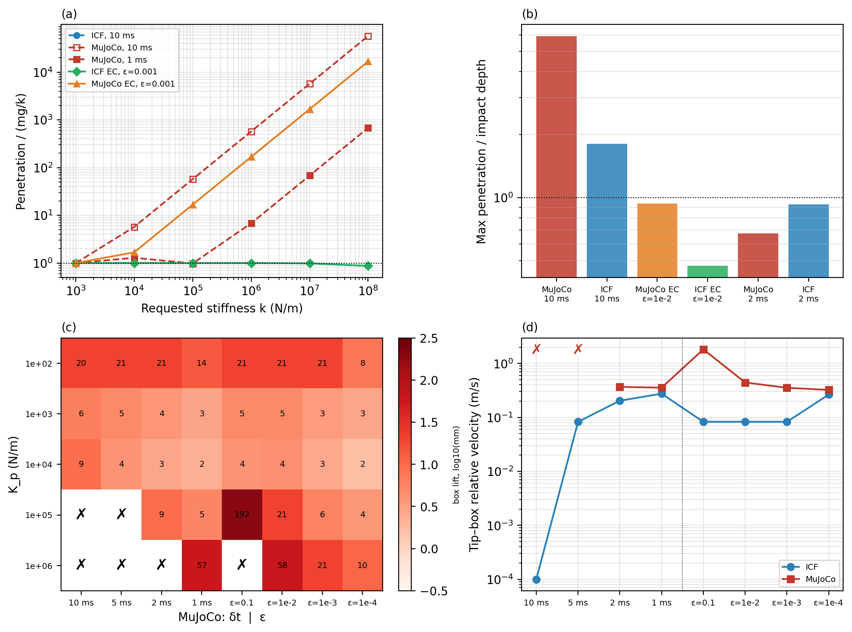
Fig. S1 — At the step a learner uses, fixed stepping makes artifacts and error control removes them: (a) realized stiffness vs requested k; (b) hard-clutter max penetration over the model's impact depth at 10 ms; (c) actuated-push box lift and stability; (d) tip–box chatter vs step.
Why this matters: This is the thesis in one figure: the artifacts are real, measured, and live exactly at RL-practitioner step sizes — MuJoCo 5.9× and ICF 1.8× over the impact depth at 10 ms, the stiffness clamp, the box hop, the hidden chatter. Every Part 2 claim stands on this panel.
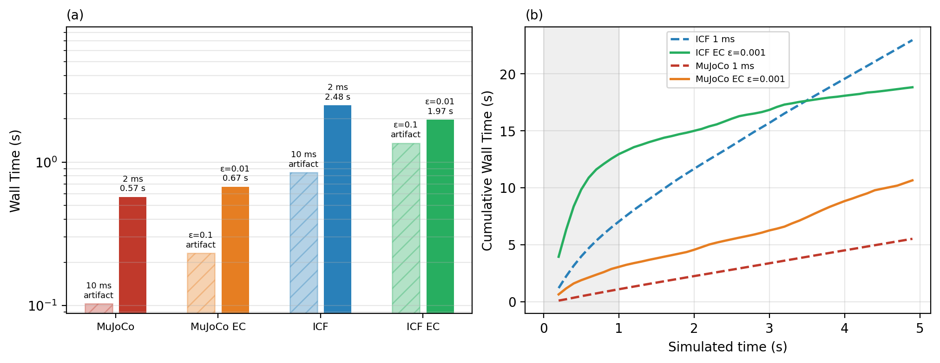
Fig. S2 — Being artifact-free costs fixed stepping every step and error control only the impacts: (a) wall per simulated second at the coarse vs cheapest artifact-free setting per arm; (b) cumulative wall along a 5 s drop, both EC arms at matched ε=10⁻³, both fixed arms at 1 ms.
Why this matters: It shows WHERE adaptivity's saving lives: the settled phase. ICF's error control is its cheaper artifact-free mode (1.97 vs 2.48 s/sim-s), and over a 5 s drop at matched ε=10⁻³ costs 0.82× its fixed 1 ms arm (0.47× at the artifact-free-sufficient 10⁻²) — the economic argument for CENIC at matched accuracy.
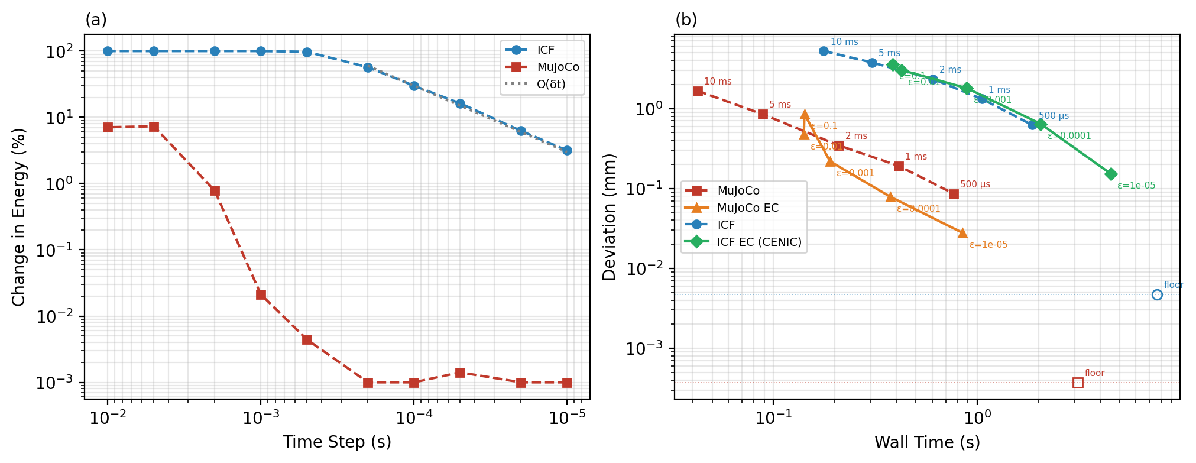
Fig. S3 — Both solvers converge: (a) undamped-ball energy error, first-order for ICF, ±0.03% for MuJoCo at δt ≤ 1 ms; (b) soft-clutter measured error vs cost against a 0.1 ms reference — ICF EC sits on fixed ICF's line, MuJoCo EC undercuts its own line 2–3× at tight ε.
Why this matters: Convergence is the credibility figure: neither solver is broken, so the artifact story of S1 is about step size, not solver bugs. The caption's EC verdict was corrected against the CSVs on 2026-08-30 — present this version.
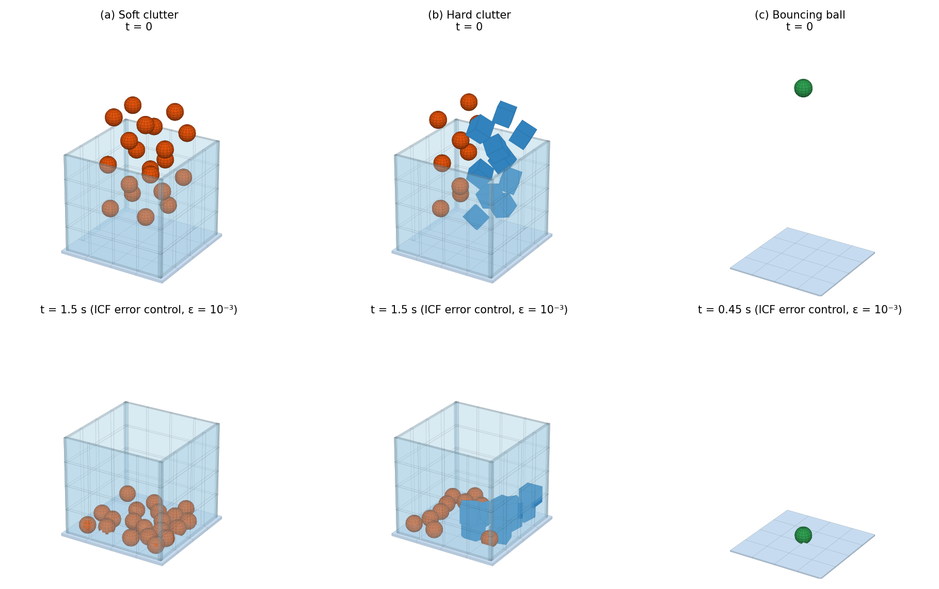
Fig. 1 — The three CENIC test cases rebuilt on Newton: soft clutter (20 spheres, k=10³ N/m), hard clutter (spheres + cubes, k=10⁵ N/m), undamped bouncing ball. Top: initial condition; bottom: settled under error control.
Why this matters: One slide to define every scene the numbers refer to; it also documents that we reproduce the paper's cases on our stack rather than inventing friendlier ones.
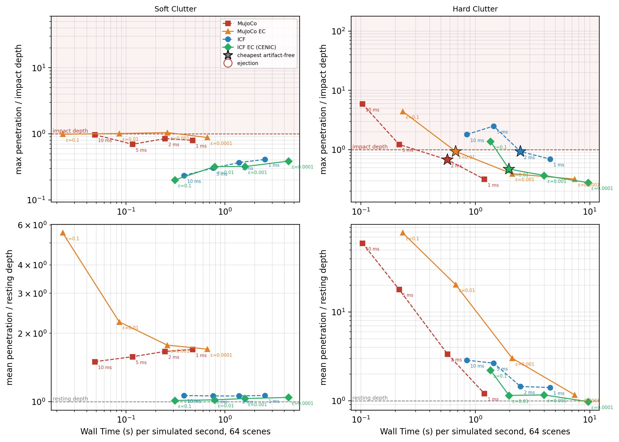
Fig. 2 — Contact artifacts vs cost, 64 scenes: max penetration over the model's impact depth v√(m/k) (top) and mean over the resting depth mg/k (bottom); stars mark each arm's cheapest artifact-free setting.
Why this matters: This defines the paper's artifact criterion and shows the matched-accuracy frontier: artifact-free from 2 ms / ε=10⁻² on hard clutter. It also shows where the criterion is honest about its limits — MuJoCo's soft-clutter max rides the bound (0.70–1.04×), so the binary flag carries no information there.
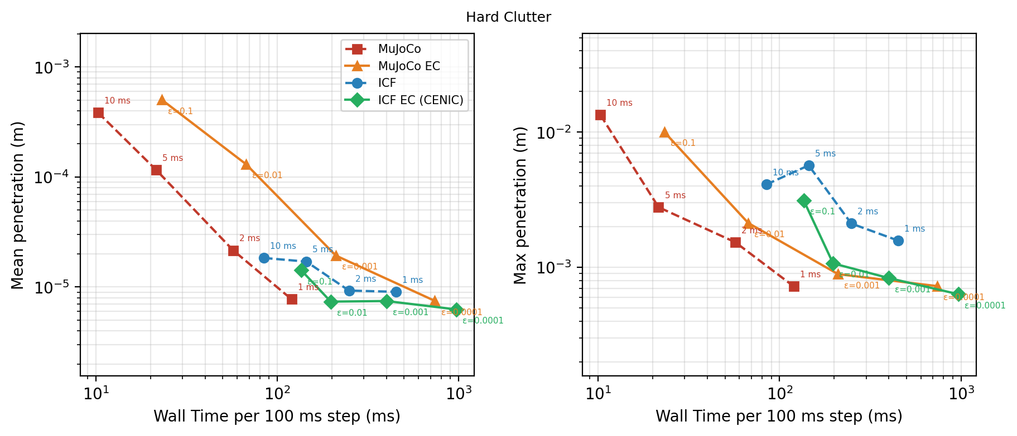
Fig. 3a — Hard clutter: ground penetration vs wall time, every point labeled with its δt or ε.
Why this matters: The direct accuracy-for-cost trade at k=10⁵: ICF penetrates by the model's own compliance at every resolution while MuJoCo penetrates by its clamped impedance — the physical reading of the stiffness clamp at training-relevant cost.
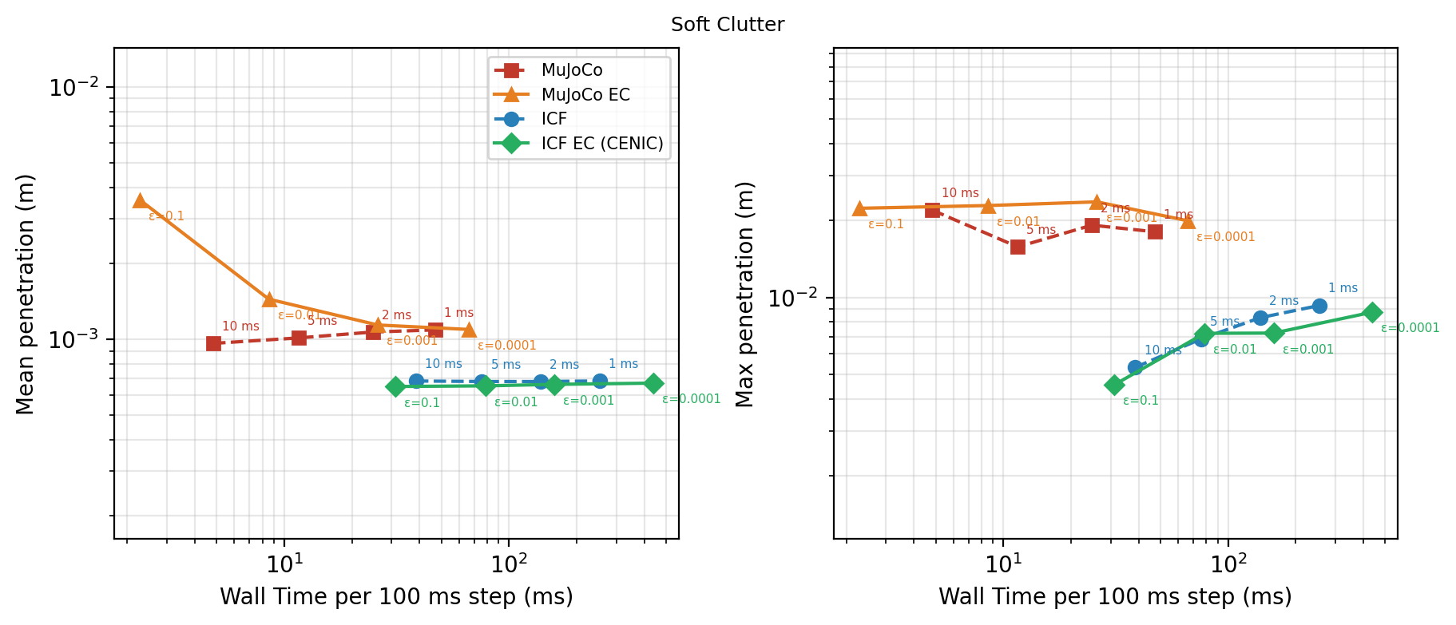
Fig. 3b — Soft clutter: the same axes at k=10³.
Why this matters: The control case: at soft stiffness both solvers behave, which localizes the pathology of Fig. 3a to STIFF contact — exactly the regime the killer experiment targets.
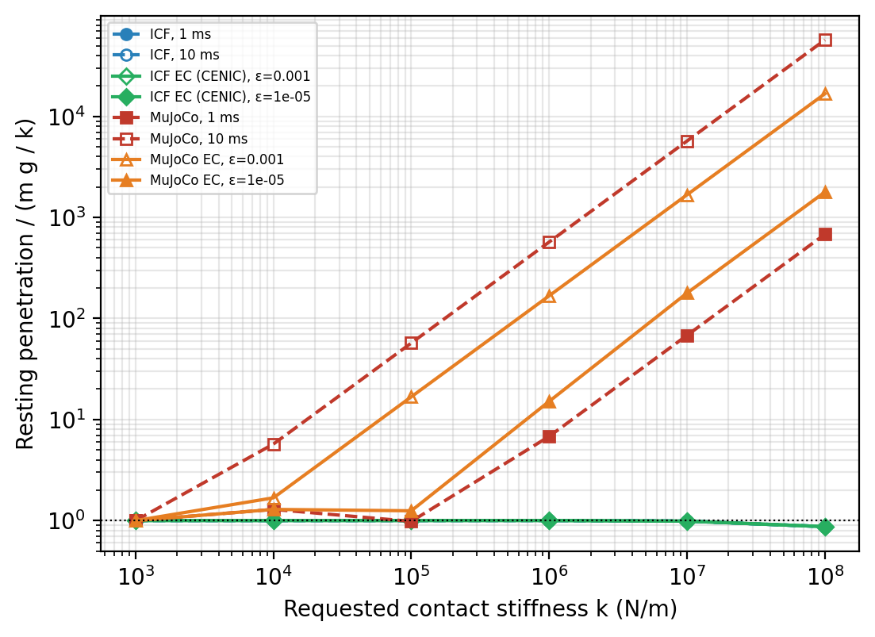
Fig. 4 — Realized stiffness: resting penetration of one 65 g sphere over the model's mg/k as requested k rises 10³→10⁸ N/m.
Why this matters: The cleanest 'fixed step changes your physics' figure: ICF realizes the requested k to 10⁷ at every step and tolerance; MuJoCo floors at the τ ≥ 2δt clamp (57× the model at k=10⁵, 10 ms) and position-only error control does not buy it back.
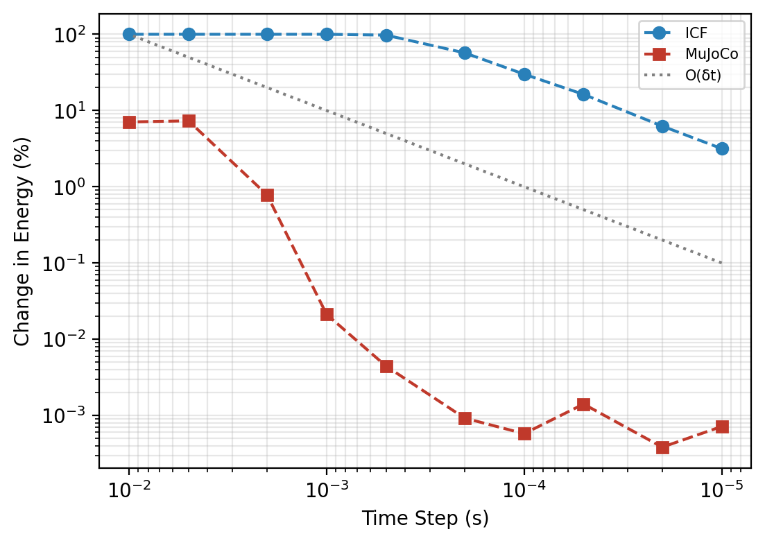
Fig. 5a — Undamped ball energy error after 10 s: fixed step (left) and error control (right).
Why this matters: The integrator test with the model's dissipation at zero: ICF converges first-order; MuJoCo's implicit constraint is near-exact at δt ≤ 1 ms. It also carries our disclosed defect — MuJoCo EC GAINS energy at tight ε (+57% at 10⁻³) from step changes through the undamped constraint.
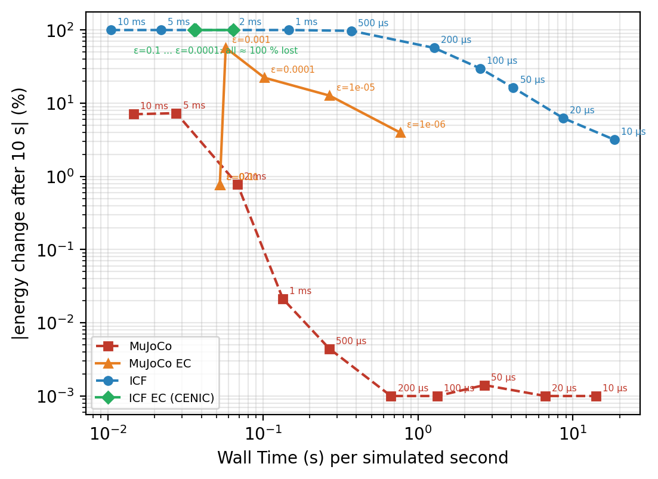
Fig. 5b — Energy error vs cost for the ball, fixed and error-controlled arms on shared axes.
Why this matters: Puts the ball's accuracy on the same cost axis as everything else, and shows the position-only norm's blind spot: ICF error control cannot see the bounce until ε ≤ 10⁻⁵, where the march budget exhausts.
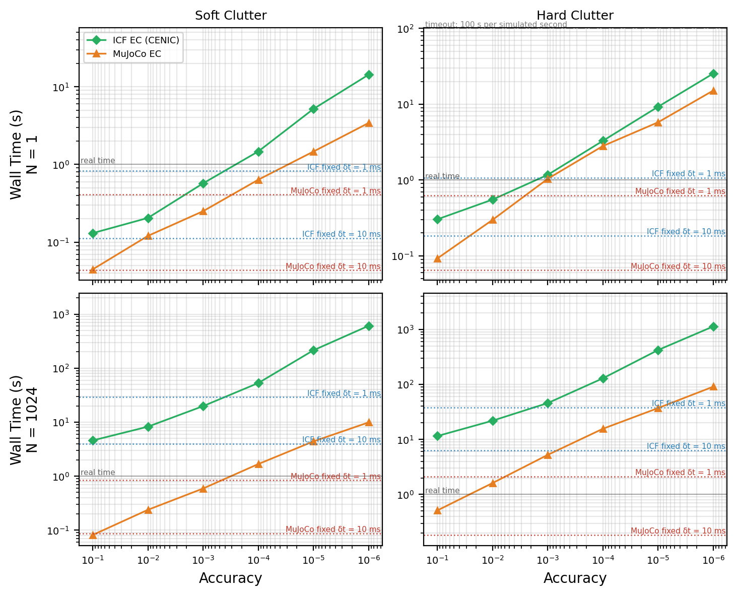
Fig. 6 — Work-precision on both clutters: wall per simulated second vs requested ε (δt_max = 0.1 s); N=1 and N=1024 rows; fixed-step levels dotted.
Why this matters: The core cost figure: MuJoCo EC is cheaper than ICF EC at every ε (1.1–3.3× at N=1, 8–22× at 1024 on hard clutter) because ICF's march iteration costs 2.7–6.9 ms against 1.6–2.1 — and a batch pays for its slowest world.
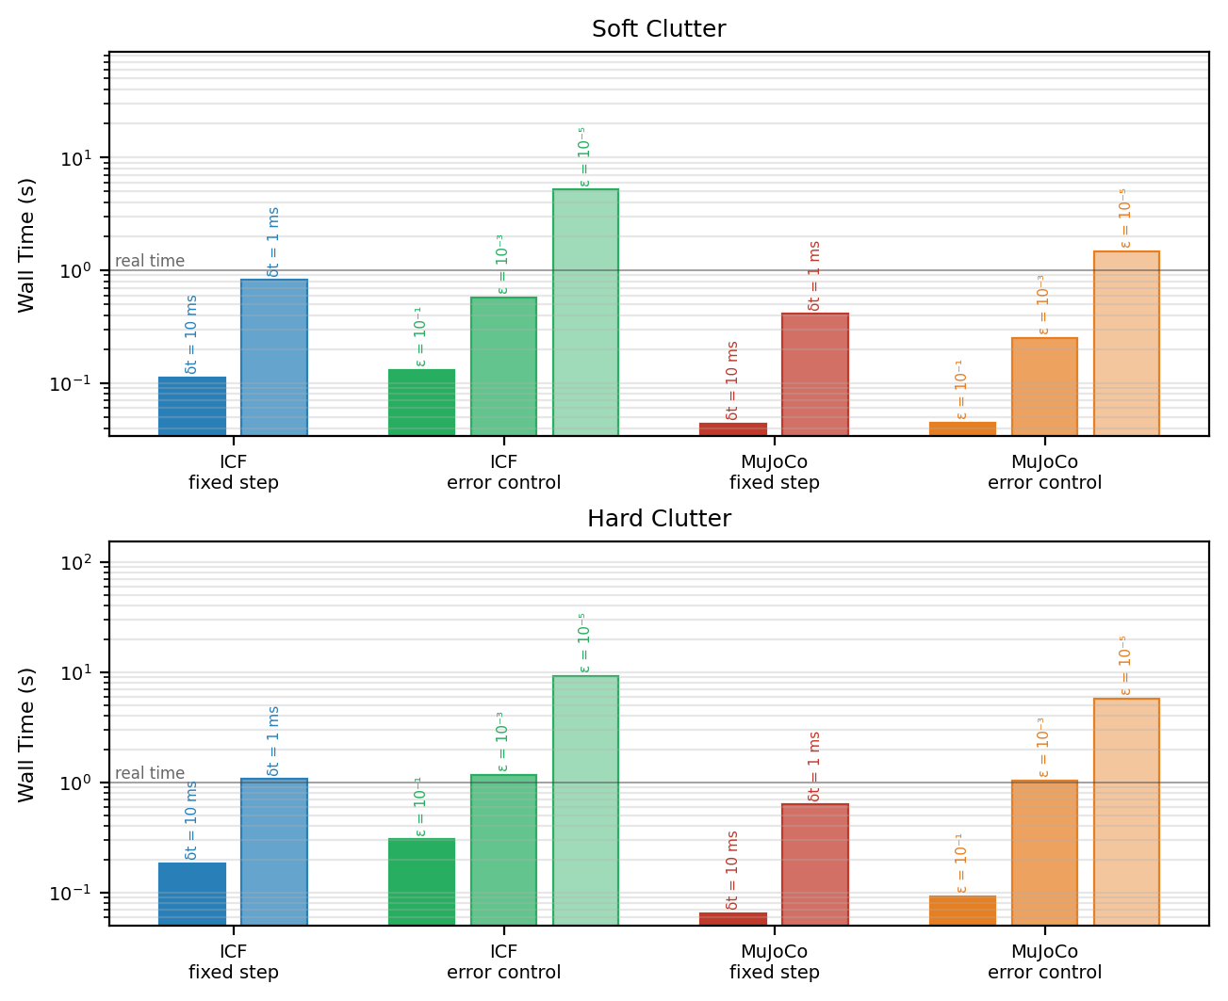
Fig. 7 — Simulator speed comparison for a single scene, fixed and error-controlled settings side by side. Speed only, not quality.
Why this matters: The digestible version of Fig. 6 for a talk — but present it WITH Fig. 2, because speed without the artifact axis is exactly the comparison the paper argues against.
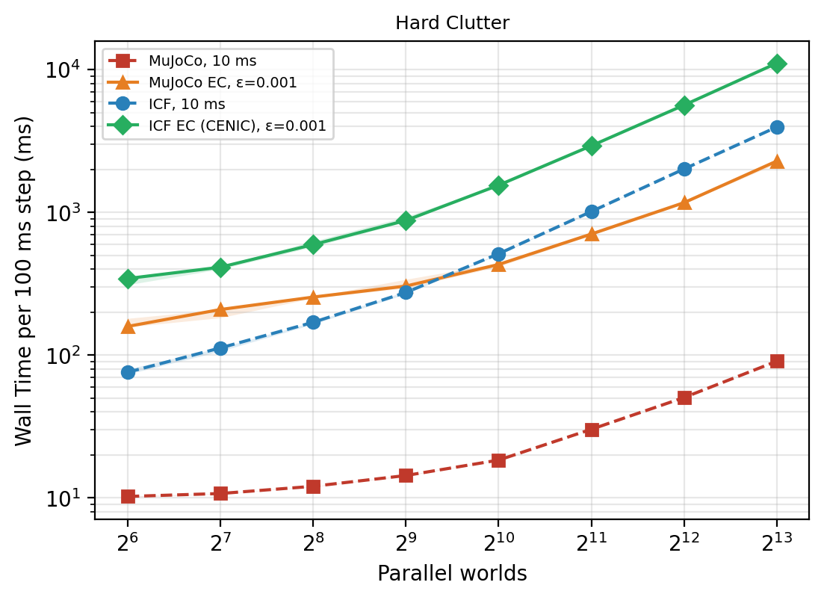
Fig. 8a — Wall per 100 ms boundary vs number of worlds (2⁶–2¹³), hard clutter; median of 3, spread band.
Why this matters: The batch-scaling reality of RL: per world at 8192 it is MuJoCo 11 µs, MuJoCo EC 279 µs, ICF 484 µs, ICF EC 1.35 ms, with ICF saturating the GPU from 2¹⁰ worlds — the cost side every Part 2 wall-time claim must respect.
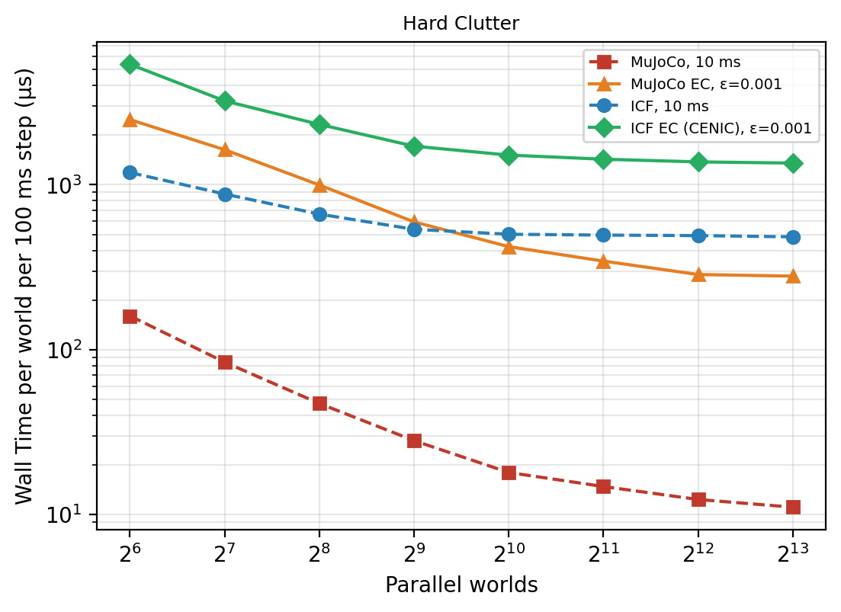
Fig. 8b — The same data as cost per world: batching amortizes until saturation.
Why this matters: Shows where parallelism stops being free per world — the reading that justifies our 2048-env training choice and frames the slowest-world tax on adaptive batches.
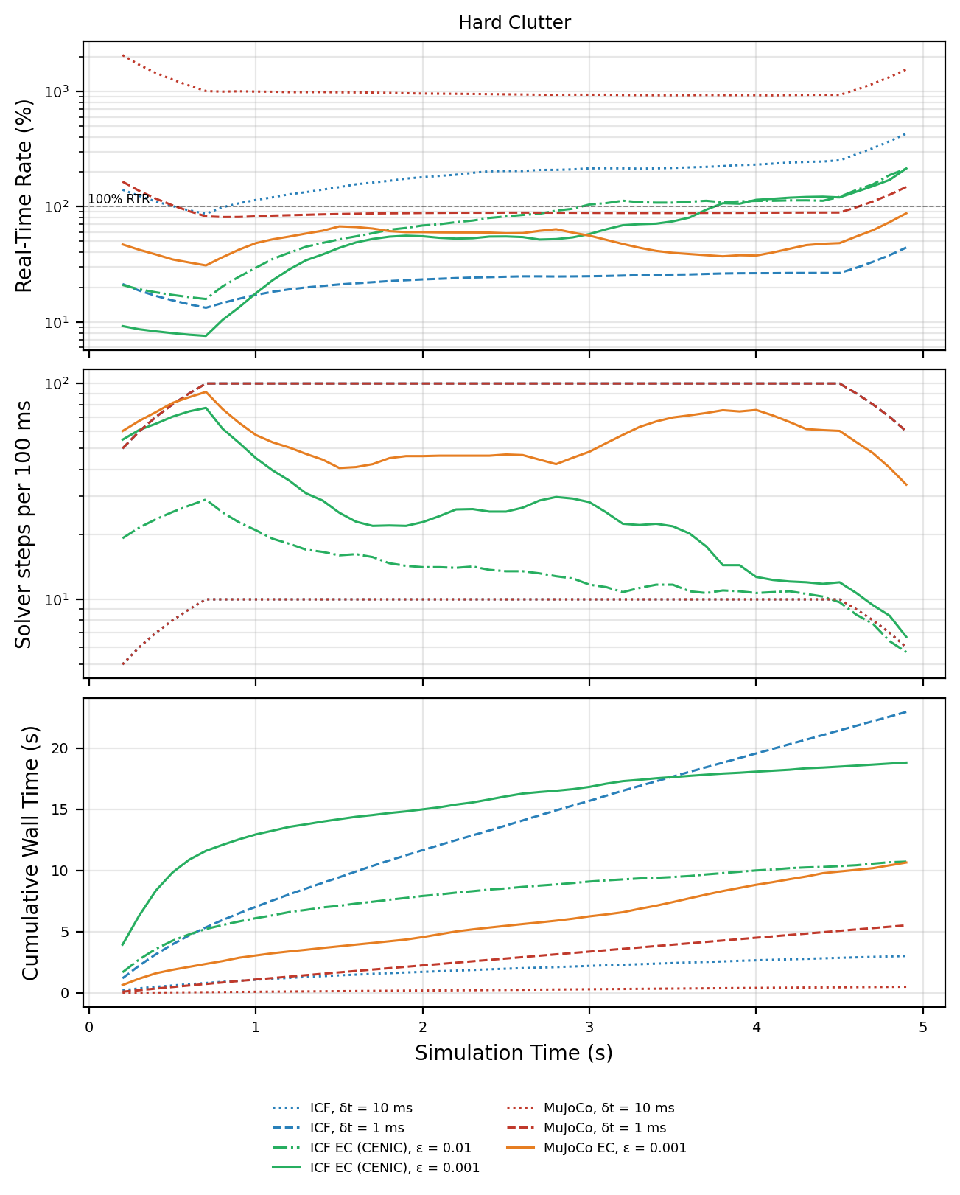
Fig. 9 — Along one 5 s hard-clutter drop: real-time rate, solver steps per 100 ms boundary, cumulative wall (64 scenes).
Why this matters: The 'pays only when something happens' visual: error control at ε=10⁻² crawls at ~10% real time through the impacts, then coasts past 100% settled at ~10 steps per boundary where fixed 1 ms always takes 100.
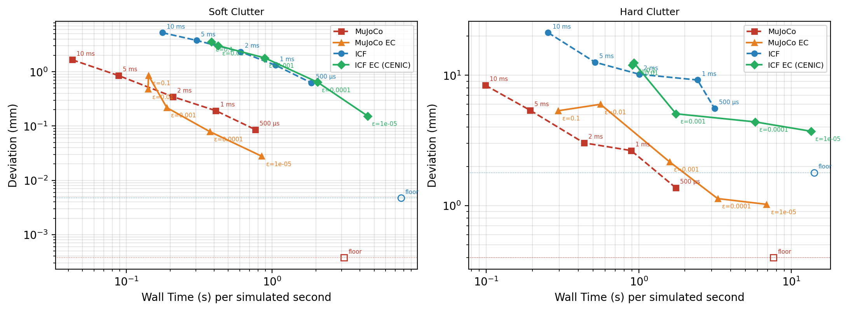
Fig. 10 — Measured error vs cost against each solver's own 0.1 ms reference (8 scenes, 20 restarted windows); hollow markers are the reference against itself — the instrument's noise floor.
Why this matters: Two things at once: the convergence ranking under a like-for-like instrument, and the honest disclosure that GPU runs are not repeatable (floors of 4.7 µm–1.8 mm) — deviations within a few × of the floor rank nothing, which the group should hear from us first.
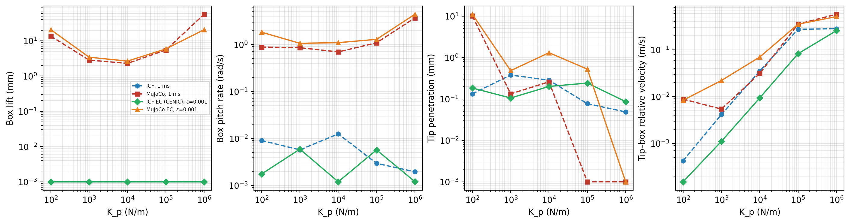
Fig. 11 — The actuated stiff-contact case: a PD gantry pushes a 1 kg box at k=10⁵, K_p swept 10²–10⁶; box lift, pitch rate, tip penetration, tip–box velocity per arm.
Why this matters: The bridge from clutter to robot learning: with the stiffness in the ACTUATOR, MuJoCo's explicit gain diverges in 6 cells and its box hops millimetres in every stable cell, while ICF slides it flat everywhere — the regime Part 2 trains in.
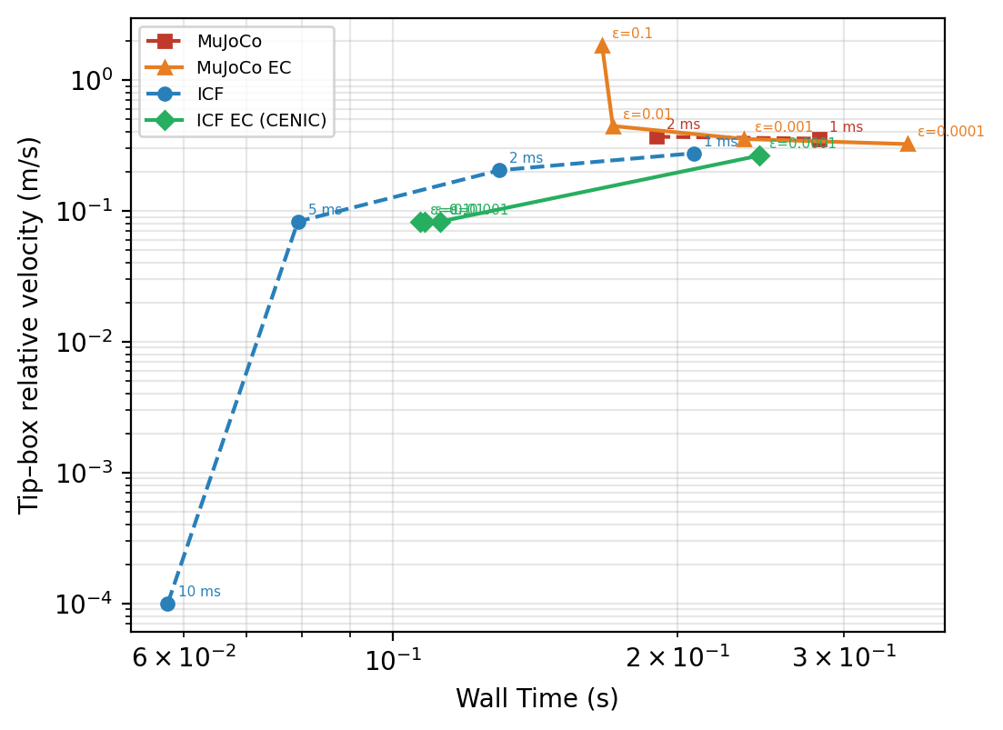
Fig. 12 — Tip–box relative velocity at K_p=10⁵ vs cost: chatter appears as the step is refined; a 10 ms step integrates it away entirely.
Why this matters: The artifact that bites policies: train at 10 ms and the policy never sees the contact its own gains excite. Also an honest limit — ICF's position-normed error control only resolves the chatter at ε=10⁻⁴.
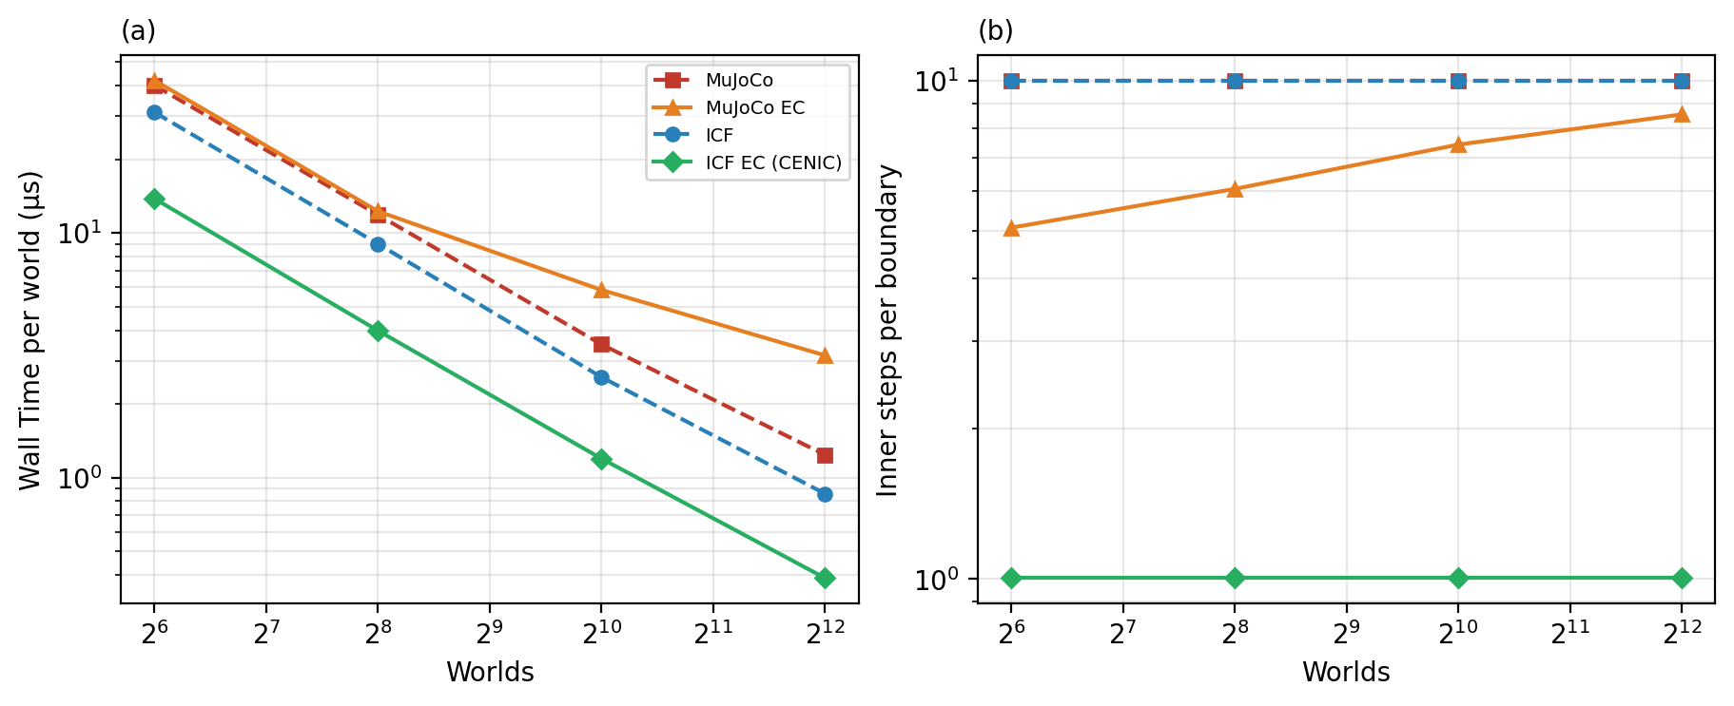
Fig. 13 — Heterogeneous-world throughput (K_p ~ logU[10⁴,10⁵]): wall per 10 ms boundary vs batch size, all four arms.
Why this matters: The one throughput plot where CENIC wins outright at every batch size (0.88–1.59 ms/boundary): its fully implicit joint PD takes ONE step per boundary while MuJoCo's stiffness-explicit PD needs 5–9. This is the Part 1 result that predicts Part 2's interesting reversal on stiff tasks.

