[SIT Pune logo – insert picture here]
CYBER SECURITY
Case Study Report (Unit 4)
AI-Powered Detection and Automated Response to Malicious PowerShell Attacks Using Machine Learning
Group No.: G__
Topic Selected: AI-Powered Detection and Automated Response to Malicious PowerShell Attacks Using Machine Learning
Submitted by:
Kushagra
23070122122
Submitted to: Dr. Pooja Bagane
Department of Computer Science and Engineering
Symbiosis Institute of Technology, Pune
October 2026

Abstract
PowerShell is a scripting tool that comes with every Windows computer. Attackers often use it because it is trusted, powerful and can run code directly in memory without leaving files on disk. This case study examines how PowerShell has been used in real attacks, including the Odinaff attacks on banks, the POSHSPY backdoor of the APT29 group, the Emotet malware campaigns and the REvil ransomware attack through Kaseya VSA. These cases show that traditional signature-based antivirus finds it hard to catch such scripts, because attackers can easily change the text of a script while keeping its behaviour the same. Based on the lessons from these cases, we built and tested a machine-learning system that reads a PowerShell script, decides whether it is malicious, and takes an automatic response according to its risk. Using the public MPSD dataset, from which more than half of the malicious files had to be removed as duplicates, an ensemble model achieved an F1-score of 0.972, detecting 96.2% of malicious scripts while wrongly flagging only 0.7% of benign scripts. In a test on unseen scripts, the automatic response system contained 91.2% of malicious scripts and wrongly blocked only 0.23% of benign ones. The study shows that explainable machine learning combined with a careful, human-supervised response policy can help organisations defend against PowerShell attacks.
Keywords: PowerShell, fileless malware, case study, machine learning, malware detection, automated incident response, ransomware, MITRE ATT&CK.

1 Introduction
PowerShell is a command-line shell and scripting language made by Microsoft. It is installed by default on Windows and is used by system administrators to automate everyday tasks such as managing users, installing software and changing settings. Because it is powerful and already trusted on the system, attackers also like to use it. With a single PowerShell command, an attacker can download harmful code from the internet and run it directly in memory, without saving any file on the disk. This type of attack is called a fileless or living-off-the-land attack, because the attacker uses tools that are already present on the computer [1].
PowerShell attacks remain a serious and current problem. Symantec reported that 95.4% of the PowerShell scripts submitted to its analysis service were malicious [2]. MITRE ATT&CK, a widely used knowledge base of attacker behaviour, lists PowerShell as technique T1059.001 and records its use by many criminal and state-sponsored groups [3]. The 2025 Threat Detection Report by Red Canary found that command and scripting interpreters were the most common attack technique for the sixth year in a row [4]. Removing PowerShell is not possible, because organisations depend on it; in 2022 the NSA and CISA advised organisations to keep PowerShell but to log and monitor it carefully [5].
Logging alone, however, only collects data. Someone still has to decide whether each script is safe or harmful, and do so quickly enough to stop an attack. Attackers make this harder by disguising their scripts with free tools such as Invoke-Obfuscation [6], and security teams already receive more alerts than they can check [7]. Machine learning can help by scoring every script automatically and supporting a fast and consistent response, in line with current incident-response guidance [8].
Problem statement. Given the text of a PowerShell script captured on a Windows computer, the system should (1) decide whether the script is malicious, with very few false alarms, and (2) automatically take a suitable action, such as raising an alert or blocking the script, while leaving the most serious actions to a human analyst.
Objectives. The objectives of this case study are:
1. to study how PowerShell has been used in real attacks and what defenders can learn from them;
2. to review existing research on detecting malicious PowerShell;
3. to build and compare machine-learning models that detect malicious scripts;
4. to design an automated response that acts according to the risk of each script; and
5. to evaluate the system and relate its results back to the real-world cases.

2 Case Study: PowerShell in Real-World Attacks
This section looks at why attackers choose PowerShell, how a typical attack unfolds, and what four well-documented incidents teach defenders.
Why attackers choose PowerShell. PowerShell offers attackers several advantages at once. It is already installed and trusted, so running it does not look unusual. It can call almost any Windows function and .NET library, which allows it to download files, read passwords, change security settings and talk to remote servers. It can run code that exists only in memory, which leaves little evidence on disk for antivirus to scan. Finally, scripts can be encoded or disguised in many ways, so the same attack can look completely different each time [2], [6]. In earlier years, detailed PowerShell logging was also turned off by default in most organisations, so attackers could often act without leaving a record [2].
A typical attack chain. Figure 1 shows how PowerShell commonly appears in an attack. The attacker first gains entry, often through a phishing email with a malicious document. When the victim opens the document, a hidden macro starts PowerShell, which downloads the next stage of the attack (ATT&CK T1105) and runs it in memory (T1059.001, T1620). The attacker then sets up a way to come back later (persistence), steals passwords (T1003), turns off security tools (T1562) and spreads to other computers. The final goal may be data theft, financial fraud or ransomware. PowerShell can be involved at almost every stage, which means that monitoring it gives defenders many chances to stop the attack.
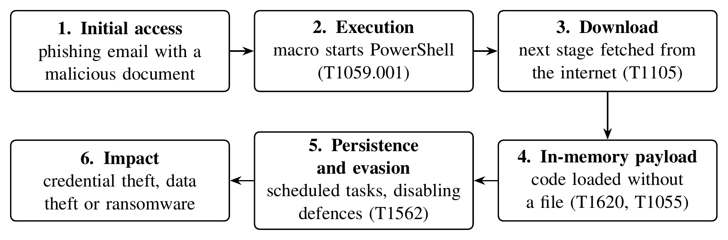
Figure 1: Typical stages of an attack that uses PowerShell, with MITRE ATT&CK technique IDs
Timeline of events. Figure 2 places the cases discussed below alongside important defensive milestones. Attackers adopted PowerShell early, and defenders have gradually responded with better logging, research tools and official guidance, yet scripting interpreters are still the most observed attack technique today [4].
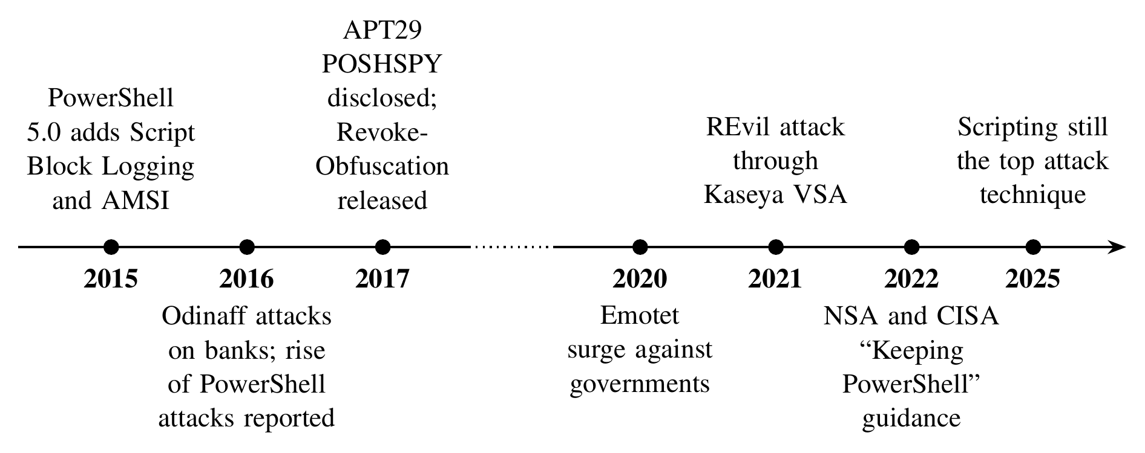
Figure 2: Timeline of major PowerShell-related attacks and defensive milestones [2], [4], [5], [9]–[13]
Case 1: Odinaff attacks on financial organisations (2016). In 2016, Symantec reported a series of targeted attacks on banks, securities and trading firms and payroll companies around the world, carried out with a trojan called Odinaff [9]. The trojan was delivered through malicious Word macros, password-protected archives and existing botnets. Once inside a network, the attackers used lightweight hacking tools such as Mimikatz together with legitimate utilities such as PowerShell to move between computers and find important systems; some victims were users of the SWIFT interbank messaging system. This case shows how criminals combine PowerShell with password-stealing tools to explore a network quietly, because activity by a legitimate administration tool does not raise suspicion on its own.
Case 2: APT29 and the POSHSPY backdoor (2015–2017). Mandiant described POSHSPY, a backdoor used by the state-sponsored group APT29 as a secret fallback in case its main tools were discovered [10]. POSHSPY was built entirely from PowerShell and Windows Management Instrumentation (WMI). Its encrypted PowerShell code was stored inside a custom WMI property instead of a file, and a WMI event subscription restarted it automatically. It could download and run more PowerShell code and programs, and it contacted its servers rarely and through legitimate local websites. Mandiant noted that, because only legitimate system processes were used, the malicious activity could be identified only through enhanced logging or memory analysis. This case shows the importance of PowerShell logging: without it, a fileless backdoor can stay hidden for long periods.
Case 3: Emotet malware campaigns (2014 onwards). Emotet started as a banking trojan and became one of the most widespread malware families in the world, often delivering other malware such as ransomware. In October 2020, CISA warned of a large increase in Emotet phishing emails targeting state and local governments, noting that Emotet spreads through networks by guessing passwords and copying itself to shared drives [12]. Many Emotet campaigns used Word documents whose macros launched an obfuscated PowerShell command to download the malware. Patsakis et al. studied such PowerShell droppers from real Emotet campaigns and found them heavily disguised, so that even advanced language models could not always recover the hidden download addresses [14]. This case shows that obfuscation is used at large scale and that defences based on fixed strings are easily bypassed.
Case 4: REvil ransomware through Kaseya VSA (2021). On 2 July 2021, an affiliate of the REvil ransomware group exploited Kaseya VSA, a remote management tool used by managed service providers, and pushed a malicious update to their customers, affecting hundreds of businesses in a single day [13]. Because the management agent ran with high privileges, the attackers used a PowerShell command to switch off Microsoft Defender's real-time protection and script scanning before deploying the ransomware [15]. This case shows how quickly modern attacks can spread: a single malicious update reached hundreds of businesses on the same day, leaving little time for manual investigation. It also shows that a script trying to disable security tools is itself a strong warning sign.
Table 1: Summary of the real-world cases
Case | Target | Use of PowerShell | Lesson for defenders
Odinaff (2016) [9] | Banks and financial firms | Moving through the network with Mimikatz and PowerShell | Legitimate tools hide malicious activity
APT29 POSHSPY (2015–2017) [10] | Undisclosed high-value organisations | Fileless backdoor stored in WMI | Enhanced logging is essential
Emotet (2014 onwards) [12], [14] | Businesses and governments | Obfuscated download command started by a macro | Signatures fail against obfuscation
REvil / Kaseya (2021) [13], [15] | Managed service providers and their clients | Disabling Microsoft Defender before ransomware | Response must be automatic and fast

Comparing the cases. Although the four incidents had different goals, they share a common pattern. The attackers were of very different types: a financially motivated criminal group (Odinaff), a state-sponsored espionage group (APT29), a large criminal malware operation (Emotet) and a ransomware affiliate (REvil). Their priorities also differed. APT29 valued stealth and long-term access, so POSHSPY was designed to run rarely and to blend in with normal traffic. REvil valued speed and scale, so its PowerShell activity was short and direct, focused on disabling defences just before the ransomware ran. Emotet relied on volume, sending very large numbers of emails with disguised scripts, while Odinaff relied on careful exploration of a small number of selected networks. In every case, however, PowerShell was chosen because it was already present, trusted and capable, and in every case the malicious activity left traces in the scripts that ran. Mapped onto Figure 1, Emotet appears mainly at the execution and download stages, APT29 at the in-memory payload and persistence stages, Odinaff at the credential-theft and network-exploration stages, and REvil at the defence-evasion stage just before impact. A defensive system that examines every script, instead of looking for one particular tool or stage, therefore has a chance to interrupt very different kinds of attack.
Defensive controls suggested by the cases. Looking back at the four cases, several existing controls could have reduced their impact. Table 2 links common defensive controls, most of which are recommended in the joint NSA and CISA guidance [5], to the cases they would have helped with. The table also shows a gap: logging and scanning produce evidence, but none of these controls by itself decides quickly whether a particular script is malicious and what to do about it. This gap is the focus of the system developed in this study.
Table 2: Defensive controls and the cases they address
Control | What it does | Cases helped
Script Block Logging [16] | Records the code that actually runs, even after decoding | POSHSPY, Emotet, all others
AMSI scanning [17] | Lets antivirus check a script just before it runs | Emotet, POSHSPY
Constrained Language Mode with application control [5] | Limits what untrusted scripts are allowed to do | Odinaff, POSHSPY
Least privilege for management tools | Limits the damage if a remote management tool is abused | REvil / Kaseya
Protecting security settings | Stops scripts from switching off antivirus protection | REvil / Kaseya
ML-based detection with automated response (this study) | Scores every logged script and acts within seconds | All four cases

Lessons from the cases. Table 1 summarises the four cases. Together they lead to five requirements for a defensive system, which guide the rest of this study:
1. Use the logs Windows already produces. Script Block Logging and AMSI record the actual code that runs, including code that was hidden or downloaded at run time [16], [17].
2. Look at behaviour, not exact text. Because scripts are easily disguised, detection should use patterns that survive small changes.
3. Keep false alarms very low. Administrators use PowerShell every day, so a detector that blocks legitimate work will not be trusted.
4. Respond automatically and quickly. Ransomware can spread very quickly, so routine actions must happen without waiting for a person.
5. Explain every decision. Alerts should say what the script was trying to do, for example in ATT&CK terms [18], so analysts can act on them.

3 Literature Review
Microsoft has added security features to PowerShell that make detection possible. Script Block Logging records the text of every script that runs as Windows Event ID 4104 [16], and the Antimalware Scan Interface (AMSI) allows antivirus software to scan a script just before it runs [17]. The MITRE ATT&CK framework provides a common language to describe attacker behaviour [18].
Because attackers disguise their scripts, much research has focused on obfuscation. Bohannon showed that a single command can be rewritten in many forms [6], and Bohannon and Holmes built Revoke-Obfuscation, which detects disguised scripts using statistical features [11]. Several tools try to remove the disguise before analysis, including PowerDrive [19], the method of Li et al. [20] and its extension by Xiong et al. [21], PowerDP [22] and PowerPeeler [23].
Machine learning has been applied to detect malicious PowerShell directly. Hendler et al. trained deep neural networks on more than 66,000 PowerShell commands and found that combining two different models gave the best results [24]. In later work they used AMSI data and reached a detection rate of nearly 90% with less than 0.1% false alarms [25], and Microsoft described using such models in its Defender products [26]. Rusak et al. used the syntax tree of scripts [27], Song et al. compared token-based and tree-based features and reported about 98% detection [28], and Mimura and Tajiri used word embeddings [29]. Fang et al. combined several types of features with a random forest, reported 98.93% accuracy and released the MPSD dataset used in this study [30]. Saxe and Berlin showed that character-level models work well for short security texts such as web addresses [31], and general reviews of machine learning for malware are given by Ucci et al. [32] and Gibert et al. [33]. The newest work uses large language models to both detect and explain malicious PowerShell [34].
Researchers have also warned that machine-learning results in security can look better than they really are. Sommer and Paxson explained why intrusion detection is harder than ordinary classification [35]. Arp et al. listed common mistakes, such as allowing very similar samples to appear in both training and test data [36], and Pendlebury et al. showed that careless data splitting can make malware detectors appear much more accurate than they are [37]. On the response side, security orchestration, automation and response (SOAR) tools connect detection to automatic actions [38], and provenance-based methods help analysts handle large numbers of alerts [7], [39].
Table 3 summarises important studies. Most previous work focuses only on detection and reports very high accuracy, but few studies check their datasets for duplicate samples, and very few connect detection to an automatic response. This case study addresses both gaps.
Table 3: Summary of related work
Study | Method | Result
Hendler et al. [24] | Deep neural networks on PowerShell commands | High detection, very few false alarms
Hendler et al. [25] | AMSI data with pre-trained embeddings | About 90% detection
Bohannon & Holmes [11] | Statistical features to detect obfuscation | Robust obfuscation detection
Song et al. [28] | Token and syntax-tree features | About 98% detection
Fang et al. [30] | Hybrid features with random forest | 98.93% accuracy
Wang et al. [34] | Large language models | Detection with explanations

4 Methodology
The proposed system follows the five requirements identified in the case study. It works in six steps, shown in Figure 3: scripts are collected from Windows logs, the data is cleaned, features are extracted, a machine-learning model gives each script a risk score between 0 and 1, a response policy chooses an action, and every decision is recorded.
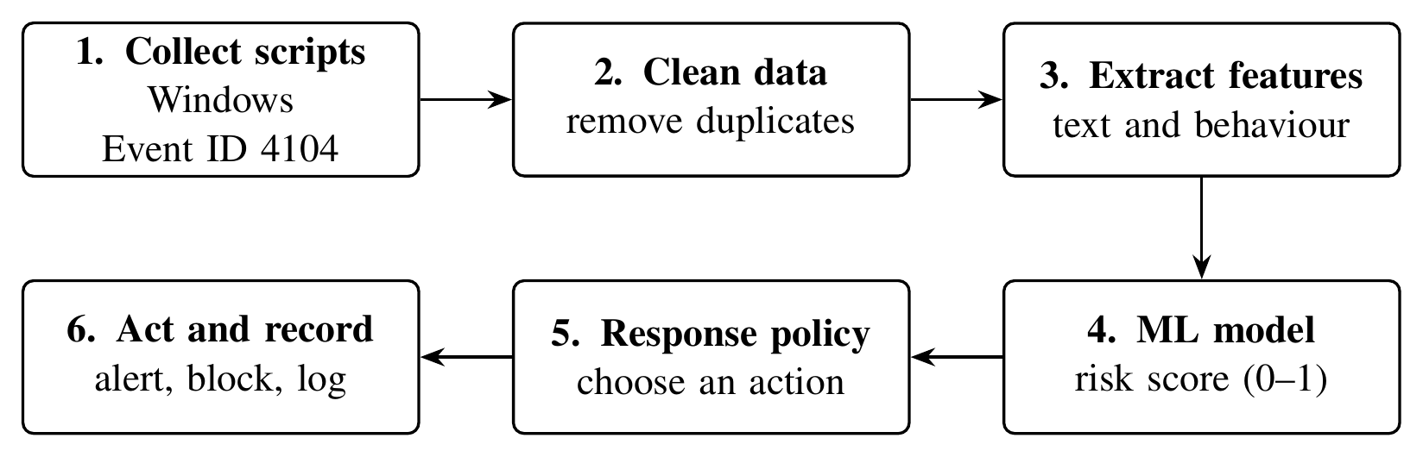
Figure 3: Workflow of the proposed system
Dataset. We used the public MPSD dataset released by Fang et al. [30]. It contains 4,202 malicious scripts, 4,316 benign scripts and 4,202 “mixed” scripts in which malicious code is hidden inside a normal script. The malicious scripts include downloaders, shellcode loaders, reverse shells and password-stealing tools, similar to those seen in the cases above. The benign scripts are normal administration scripts. All malicious scripts were handled only as text and were never run.
Data cleaning. Before training, the data was checked for problems, as recommended by Arp et al. [36]. Only 1,875 of the 4,202 malicious files were unique, which means 55.2% were exact copies; duplicates were removed. Twelve files appeared in both the malicious and benign folders and were removed because their true label is unknown. A special byte-order mark appeared at the start of about 35% of benign files but never in malicious files; since a model could learn this meaningless pattern, it was removed from all files. Finally, many malicious scripts differ only in variable names or numbers, so such near-copies were grouped into “families” (816 families for 1,875 malicious scripts), and a family was never split between training and testing. After cleaning, 1,875 malicious and 4,302 benign scripts remained.
Feature extraction. Each script is converted to lower case and the backtick character is removed, because PowerShell ignores both and attackers use them to disguise commands. Two kinds of features are then extracted. The first are text features: the script is split into short sequences of 3 to 5 characters, and each sequence is weighted with TF-IDF [40], so that a sequence that is frequent in one script but rare in others receives a high weight:
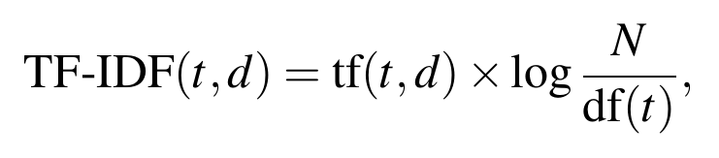 (1)
where tf(t,d) is how often sequence t appears in script d, N is the number of scripts and df(t) is the number of scripts containing t. The second are 33 behaviour and statistical features, such as script length, number of lines, randomness of characters and counts of suspicious keywords. The keywords are grouped by attacker behaviour and linked to ATT&CK, for example downloading tools (T1105), running code (T1059.001), code injection (T1055) and disabling defences (T1562), which are the same behaviours seen in the case study.
Machine-learning models. Four models and one ensemble were trained with the scikit-learn library [41]: logistic regression (LR) on the text features, LR on the behaviour features as a simple baseline, a random forest (RF) of 300 decision trees [42], and a gradient boosting model (HGB) similar to LightGBM [43]. The ensemble averages the scores of the text-based LR and the behaviour-based RF; because the two look at different evidence, combining them makes the result more stable. Deep learning was not used because the dataset is small and simpler models are faster and easier to explain.
Evaluation. The models were tested with five-fold cross-validation [44]: the data is split into five parts, and each part is used once for testing while the other four are used for training. Families of near-copies were always kept in the same part, so a model is never tested on a script it has almost seen before. With TP, FP, TN and FN denoting true positives, false positives, true negatives and false negatives, the main measures were:
(2)
Accuracy and the area under the ROC curve (AUC) were also reported.
Automated response. The risk score is used to choose one of four actions (Table 4). Less harmful actions are taken automatically, while the most serious action, disconnecting a computer from the network, needs a human analyst's approval. Every decision is saved in a log together with the ATT&CK techniques found, and suspicious web addresses are written in a safe form (for example, hxxp instead of http).
Table 4: Response levels used by the system
Level | Risk score | Action
Allow | below 0.30 | Record the result only
Alert | 0.30 to 0.70 | Send an alert to the security team with details
Contain | 0.70 or above | Stop the script, quarantine the file and block its web addresses
Isolate | 0.95 or above, with dangerous behaviour | Disconnect the computer from the network after analyst approval

5 Implementation Details
The system was written in Python 3.13 using scikit-learn for machine learning, pandas and NumPy for data handling and Matplotlib for graphs, and it was run on an ordinary computer with a 4-core processor and 15 GB of memory, without a GPU. The code has four parts: a data module that cleans the dataset, a feature module that calculates the text and behaviour features, a model module that trains and tests the models, and a response module. The response module reads Windows Event ID 4104 records, obtains a risk score from the model, chooses the response level, adds the matching ATT&CK technique and writes the decision to a log. For safety, it runs in a test (dry-run) mode in which actions are recorded but not actually carried out. In a real organisation, Script Block Logging would be enabled through Group Policy [16], the logs would be sent to a central server for scoring, and the response module would be connected to the organisation's security tools. Seven unit tests check the main functions, and all of them pass.

6 Results and Discussion
Model performance. Table 5 shows the results of all models, and Figure 4 compares their F1-scores. All models performed well, which shows that malicious and benign PowerShell scripts are clearly different. The text-based LR model had the highest F1-score (0.974), and the ensemble was almost the same (0.972) but produced fewer false alarms (30 compared with 37). Since false alarms can stop legitimate administrative work, which was the third requirement from the case study, the ensemble was chosen for the response system. The behaviour-only LR model was the weakest, which shows that tree-based models capture patterns that a simple linear model misses.
Table 5: Performance of the models (five-fold cross-validation)
Model | Accuracy | Precision | Recall | F1 | AUC
LR (behaviour) | 0.974 | 0.953 | 0.960 | 0.957 | 0.988
RF (behaviour) | 0.980 | 0.982 | 0.952 | 0.967 | 0.995
HGB (behaviour) | 0.979 | 0.984 | 0.948 | 0.966 | 0.996
LR (text, TF-IDF) | 0.985 | 0.980 | 0.969 | 0.974 | 0.999
Ensemble (LR + RF) | 0.984 | 0.984 | 0.962 | 0.972 | 0.998

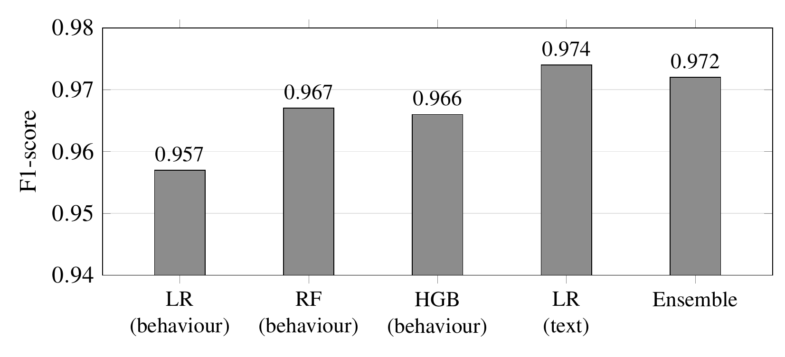
Figure 4: F1-score of each model
Figure 5 shows the confusion matrix of the ensemble. Out of 4,302 benign scripts, 4,272 (99.3%) were correctly classified, and out of 1,875 malicious scripts, 1,803 (96.2%) were correctly detected.
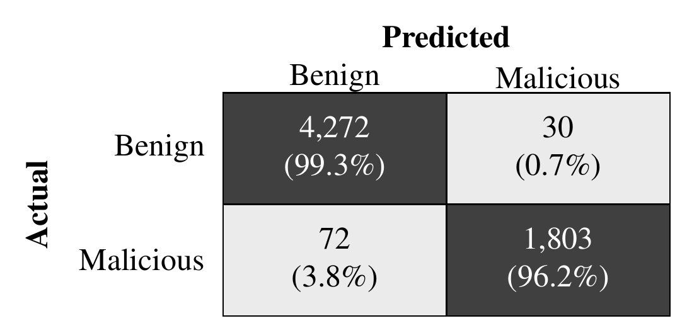
Figure 5: Confusion matrix of the ensemble model
Effect of removing duplicates. When the ensemble was tested on the original data with duplicates and a simple random split, its F1-score rose to 0.988 and the share of missed malicious scripts fell from 3.8% to 1.7%. This higher result is misleading, because the model was partly tested on copies of scripts it had already seen. Without cleaning, the number of attacks missed in real use would have been underestimated by more than half, which agrees with the warnings of Arp et al. [36] and Pendlebury et al. [37].
Malicious code hidden inside normal scripts. The models were also tested on the “mixed” scripts, where malicious code is hidden inside a long normal script, a trick similar to the disguised droppers in the Emotet case. This was the main weakness found: the ensemble detected only 46.7% of these scripts, because the large amount of normal code hides the small malicious part. When examples of mixed scripts were added to the training data, detection rose to 96.4%, while false alarms on normal scripts increased only slightly (from 0.70% to 1.05%). Training with such examples is therefore recommended.
Automated response results. To test the complete system, the ensemble was trained on four parts of the data, and the fifth part (1,233 scripts it had never seen) was sent through the response system as Windows log events. Table 6 shows the outcome. Most malicious scripts were stopped automatically, very few benign scripts were blocked, and a typical script was processed in about 91 milliseconds, which is fast enough to act before an attack like the REvil case can spread. The most common attacker behaviours found were running code with PowerShell (T1059.001), loading code into memory (T1620), code injection (T1055) and downloading tools (T1105), the same stages shown in Figure 1.
Table 6: Results of the automated response test
Measure | Result
Scripts tested (malicious / benign) | 373 / 860
Malicious scripts stopped automatically | 91.2%
Malicious scripts at least alerted | 97.1%
Benign scripts wrongly blocked | 0.23% (2 scripts)
Benign scripts sent as alerts | 0.81%
Typical time per script (median) | 90.7 ms

Relating the results to the cases. Table 7 explains how the system is designed to react to the PowerShell activity seen in the four cases. These are expected behaviours based on the features and response rules, not results of tests on the original incident data, which is not publicly available.
Table 7: Expected reaction of the system to the PowerShell activity in each case
Case | Signals the system looks for | Expected response
Odinaff | PowerShell used with credential-theft tools such as Mimikatz (T1003) | High risk; Contain, or Isolate with analyst approval
APT29 POSHSPY | Downloading and running further code, reflection and encryption (T1105, T1620) | Logged through Event ID 4104 and scored; Alert or Contain
Emotet | Encoded download command started from a document (T1027, T1105) | Contain; download address blocked
REvil / Kaseya | Command switching off Microsoft Defender (T1562) | Defence-evasion signal raised; Alert or Contain before ransomware runs

Illustrative walkthrough: an Emotet-style infection. To show how the parts of the system work together, consider an employee who opens an infected invoice document, as in the Emotet campaigns. The following sequence describes the intended behaviour of the system; it is an illustration based on its design, not a recorded incident.
1. The document's macro starts PowerShell with an encoded command. Windows decodes the command before running it and records the readable script as Event ID 4104.
2. The system receives the event within seconds and extracts its features. The encoding indicator (T1027) and the download indicator (T1105) are both present, and the text features match patterns of known downloaders, so the model gives a high risk score.
3. Because the score is above 0.70, the script is contained: the PowerShell process is stopped, the file is quarantined and the download address is blocked, so the next stage of the malware is never fetched.
4. The security team receives an alert listing the score, the ATT&CK techniques and the blocked address. If signs of code injection or credential theft were also present with a very high score, isolation of the computer would be proposed and would wait for an analyst's approval.
This walkthrough shows how the lessons from the case study (use existing logs, look at behaviour, respond quickly and explain every decision) are reflected in the design of the system.
Limitations. The study has some limitations. Only one public dataset was used, so the results should be checked again on real company data. The system looks only at the script text and not at other information such as which program started the script, which would help in cases like Odinaff where legitimate tools are misused. Most mistakes were made on scripts that can be used for both good and bad purposes, such as system tools that also use low-level Windows functions. Finally, the response actions were tested in a safe simulation, not on a real network.

7 Conclusion
This case study examined how PowerShell is used in real attacks and how machine learning can help defend against them. The Odinaff, APT29, Emotet and REvil cases show that attackers use PowerShell at every stage of an attack, disguise their scripts to avoid signatures, and can cause serious damage very quickly. From these lessons, a system was built that scores PowerShell scripts from Windows logs and responds automatically. After removing duplicates and wrong labels from the MPSD dataset, an ensemble of a text-based logistic regression model and a behaviour-based random forest reached an F1-score of 0.972, detecting 96.2% of malicious scripts with only 0.7% false alarms. In a test on unseen scripts, the response system stopped 91.2% of malicious scripts, wrongly blocked only 0.23% of benign scripts and needed about 91 milliseconds per script. Two further lessons emerged: datasets must be checked for duplicates, otherwise results look better than they are, and malicious code hidden inside normal scripts needs special training examples. In future, the system can be tested on real company logs, connected to AMSI to block scripts before they run, given information about running processes, and combined with large language models that explain alerts to analysts [34]. Overall, explainable machine learning together with a careful, human-supervised response policy offers a practical defence against PowerShell attacks, in line with expert advice to keep PowerShell but monitor it closely [5].

References
[1] C. Wueest and H. Anand, “Living off the land and fileless attack techniques,” Symantec Internet Security Threat Report (ISTR) Special Report, Symantec Corp., Jul. 2017.
[2] C. Wueest, “The increased use of PowerShell in attacks,” Symantec Security Response White Paper, Symantec Corp., Oct. 2016.
[3] The MITRE Corporation, “Command and Scripting Interpreter: PowerShell (T1059.001),” MITRE ATT&CK. [Online]. Available: https://attack.mitre.org/techniques/T1059/001/
[4] Red Canary, “2025 Threat Detection Report,” Red Canary Inc., Denver, CO, USA, 2025. [Online]. Available: https://redcanary.com/threat-detection-report/
[5] National Security Agency, Cybersecurity and Infrastructure Security Agency, New Zealand National Cyber Security Centre and UK National Cyber Security Centre, “Keeping PowerShell: Security measures to use and embrace,” Joint Cybersecurity Information Sheet, Jun. 2022.
[6] D. Bohannon, “Invoke-Obfuscation: PowerShell command and script obfuscator,” presented at DerbyCon 6.0, Louisville, KY, USA, 2016. [Online]. Available: https://github.com/danielbohannon/Invoke-Obfuscation
[7] W. U. Hassan, S. Guo, D. Li, Z. Chen, K. Jee, Z. Li and A. Bates, “NoDoze: Combatting threat alert fatigue with automated provenance triage,” in Proc. Network and Distributed System Security Symp. (NDSS), San Diego, CA, USA, 2019.
[8] A. Nelson, S. Rekhi, M. Souppaya and K. Scarfone, “Incident response recommendations and considerations for cybersecurity risk management: A CSF 2.0 community profile,” NIST Special Publication 800-61 Rev. 3, National Institute of Standards and Technology, Gaithersburg, MD, USA, Apr. 2025.
[9] Symantec Security Response, “Odinaff: New Trojan used in high level financial attacks,” Symantec Threat Intelligence Blog, Oct. 11, 2016. [Online]. Available: https://www.security.com/threat-intelligence/odinaff-trojan-financial-attacks
[10] M. Dunwoody, “Dissecting one of APT29's fileless WMI and PowerShell backdoors (POSHSPY),” Mandiant (FireEye) Threat Research Blog, Apr. 3, 2017. [Online]. Available: https://cloud.google.com/blog/topics/threat-intelligence/dissecting-one-ofap/
[11] D. Bohannon and L. Holmes, “Revoke-Obfuscation: PowerShell obfuscation detection using science,” White Paper, Black Hat USA, Las Vegas, NV, USA, Jul. 2017.
[12] Cybersecurity and Infrastructure Security Agency and Multi-State Information Sharing and Analysis Center, “Emotet malware,” Cybersecurity Alert AA20-280A, Oct. 6, 2020. [Online]. Available: https://www.cisa.gov/news-events/cybersecurity-advisories/aa20-280a
[13] Sophos, “Independence Day: REvil uses supply chain exploit to attack hundreds of businesses,” Sophos News, Jul. 2021. [Online]. Available: https://www.sophos.com/en-us/blog/independence-day-revil-uses-supply-chain-exploit-to-attack-hundreds-of-businesses
[14] C. Patsakis, F. Casino and N. Lykousas, “Assessing LLMs in malicious code deobfuscation of real-world malware campaigns,” Expert Systems with Applications, vol. 256, Art. no. 124912, 2024.
[15] Splunk Threat Research Team, “Kaseya, Sera. What REvil shall encrypt, shall encrypt,” Splunk Blog, Jul. 2021. [Online]. Available: https://www.splunk.com/en_us/blog/security/kaseya-sera-what-revil-shall-encrypt-shall-encrypt.html
[16] Microsoft, “about_Logging_Windows,” PowerShell Documentation, Microsoft Learn. [Online]. Available: https://learn.microsoft.com/en-us/powershell/module/microsoft.powershell.core/about/about_logging_windows
[17] Microsoft, “Antimalware Scan Interface (AMSI),” Win32 Apps Documentation, Microsoft Learn. [Online]. Available: https://learn.microsoft.com/en-us/windows/win32/amsi/antimalware-scan-interface-portal
[18] B. E. Strom, A. Applebaum, D. P. Miller, K. C. Nickels, A. G. Pennington and C. B. Thomas, “MITRE ATT&CK: Design and philosophy,” The MITRE Corporation, McLean, VA, USA, Tech. Rep. MTR180360, 2018.
[19] D. Ugarte, D. Maiorca, F. Cara and G. Giacinto, “PowerDrive: Accurate de-obfuscation and analysis of PowerShell malware,” in Detection of Intrusions and Malware, and Vulnerability Assessment (DIMVA 2019), Lecture Notes in Computer Science, vol. 11543. Cham, Switzerland: Springer, 2019, pp. 240–259.
[20] Z. Li, Q. A. Chen, C. Xiong, Y. Chen, T. Zhu and H. Yang, “Effective and light-weight deobfuscation and semantic-aware attack detection for PowerShell scripts,” in Proc. ACM SIGSAC Conf. Computer and Communications Security (CCS), London, UK, 2019, pp. 1831–1847.
[21] C. Xiong, Z. Li, Y. Chen, T. Zhu, J. Wang, H. Yang and W. Ruan, “Generic, efficient, and effective deobfuscation and semantic-aware attack detection for PowerShell scripts,” Frontiers of Information Technology & Electronic Engineering, vol. 23, no. 3, pp. 361–381, 2022.
[22] M.-H. Tsai, C.-C. Lin, Z.-G. He, W.-C. Yang and C.-L. Lei, “PowerDP: De-obfuscating and profiling malicious PowerShell commands with multi-label classifiers,” IEEE Access, vol. 11, 2023.
[23] R. Li, C. Zhang, H. Chai, L. Ying, H. Duan and J. Tao, “PowerPeeler: A precise and general dynamic deobfuscation method for PowerShell scripts,” in Proc. ACM SIGSAC Conf. Computer and Communications Security (CCS '24), Salt Lake City, UT, USA, 2024.
[24] D. Hendler, S. Kels and A. Rubin, “Detecting malicious PowerShell commands using deep neural networks,” in Proc. ACM Asia Conf. Computer and Communications Security (ASIACCS), Incheon, Republic of Korea, 2018, pp. 187–197.
[25] D. Hendler, S. Kels and A. Rubin, “AMSI-based detection of malicious PowerShell code using contextual embeddings,” in Proc. 15th ACM Asia Conf. Computer and Communications Security (ASIA CCS '20), Taipei, Taiwan, 2020, pp. 679–693.
[26] Microsoft Defender Research Team, “Deep learning rises: New methods for detecting malicious PowerShell,” Microsoft Security Blog, Sep. 3, 2019. [Online]. Available: https://www.microsoft.com/en-us/security/blog/2019/09/03/deep-learning-rises-new-methods-for-detecting-malicious-powershell/
[27] G. Rusak, A. Al-Dujaili and U.-M. O'Reilly, “AST-based deep learning for detecting malicious PowerShell,” in Proc. ACM SIGSAC Conf. Computer and Communications Security (CCS), Toronto, ON, Canada, 2018, pp. 2276–2278.
[28] J. Song, J. Kim, S. Choi, J. Kim and I. Kim, “Evaluations of AI-based malicious PowerShell detection with feature optimizations,” ETRI Journal, vol. 43, no. 3, pp. 549–560, 2021.
[29] M. Mimura and Y. Tajiri, “Static detection of malicious PowerShell based on word embeddings,” Internet of Things, vol. 15, Art. no. 100404, 2021.
[30] Y. Fang, X. Zhou and C. Huang, “Effective method for detecting malicious PowerShell scripts based on hybrid features,” Neurocomputing, vol. 448, pp. 30–39, 2021.
[31] J. Saxe and K. Berlin, “eXpose: A character-level convolutional neural network with embeddings for detecting malicious URLs, file paths and registry keys,” arXiv preprint arXiv:1702.08568, 2017.
[32] D. Ucci, L. Aniello and R. Baldoni, “Survey of machine learning techniques for malware analysis,” Computers & Security, vol. 81, pp. 123–147, 2019.
[33] D. Gibert, C. Mateu and J. Planes, “The rise of machine learning for detection and classification of malware: Research developments, trends and challenges,” Journal of Network and Computer Applications, vol. 153, Art. no. 102526, 2020.
[34] M. Wang, E. Topolovec, B. Arana, N. V. P. S. G. C. Kuladeep, Z. Xi, G. Yan, X. Shu, S. D. Stoller and P. Yang, “Detection and explanation of PowerShell malware with large language models,” Manuscript, Binghamton University, IBM T. J. Watson Research Center and Stony Brook University, 2026.
[35] R. Sommer and V. Paxson, “Outside the closed world: On using machine learning for network intrusion detection,” in Proc. IEEE Symp. Security and Privacy, Oakland, CA, USA, 2010, pp. 305–316.
[36] D. Arp, E. Quiring, F. Pendlebury, A. Warnecke, F. Pierazzi, C. Wressnegger, L. Cavallaro and K. Rieck, “Dos and don'ts of machine learning in computer security,” in Proc. 31st USENIX Security Symp., Boston, MA, USA, 2022, pp. 3971–3988.
[37] F. Pendlebury, F. Pierazzi, R. Jordaney, J. Kinder and L. Cavallaro, “TESSERACT: Eliminating experimental bias in malware classification across space and time,” in Proc. 28th USENIX Security Symp., Santa Clara, CA, USA, 2019, pp. 729–746.
[38] C. Islam, M. A. Babar and S. Nepal, “A multi-vocal review of security orchestration,” ACM Computing Surveys, vol. 52, no. 2, Art. no. 37, 2019.
[39] W. U. Hassan, A. Bates and D. Marino, “Tactical provenance analysis for endpoint detection and response systems,” in Proc. IEEE Symp. Security and Privacy (S&P), San Francisco, CA, USA, 2020, pp. 1172–1189.
[40] G. Salton and C. Buckley, “Term-weighting approaches in automatic text retrieval,” Information Processing & Management, vol. 24, no. 5, pp. 513–523, 1988.
[41] F. Pedregosa et al., “Scikit-learn: Machine learning in Python,” Journal of Machine Learning Research, vol. 12, pp. 2825–2830, 2011.
[42] L. Breiman, “Random forests,” Machine Learning, vol. 45, no. 1, pp. 5–32, 2001.
[43] G. Ke, Q. Meng, T. Finley, T. Wang, W. Chen, W. Ma, Q. Ye and T.-Y. Liu, “LightGBM: A highly efficient gradient boosting decision tree,” in Advances in Neural Information Processing Systems 30 (NeurIPS), 2017, pp. 3146–3154.
[44] R. Kohavi, “A study of cross-validation and bootstrap for accuracy estimation and model selection,” in Proc. 14th Int. Joint Conf. Artificial Intelligence (IJCAI), Montreal, QC, Canada, 1995, pp. 1137–1143.

