- Splunk General
Kurs: tutorialpoint
Installation und Import Daten siehe Kurs
- Splunk - Basic Search
Splunk has a robust search functionality which enables you to search the entire data set that is ingested. This feature is accessed through the app named as Search & Reporting which can be seen in the left side bar after logging in to the web interface.
- New Search, Wildcards, Combinations, AND/OR, Add to Search

On clicking on the search & Reporting app, we are presented with a search box, where we can start our search on the log data that we uploaded in the previous chapter.
We type the host name in the format as shown below and click on the search icon present in the right most corner. This gives us the result highlighting the search term.
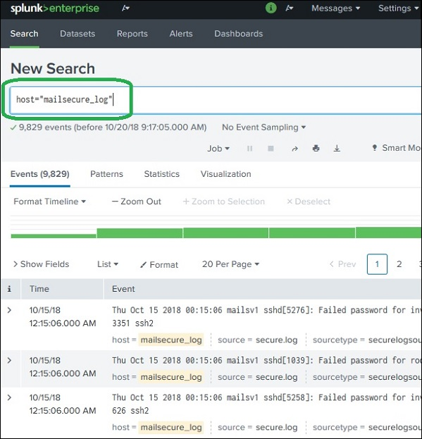
- Combining Search Terms
We can combine the terms used for searching by writing them one after another but putting the user search strings under double quotes.
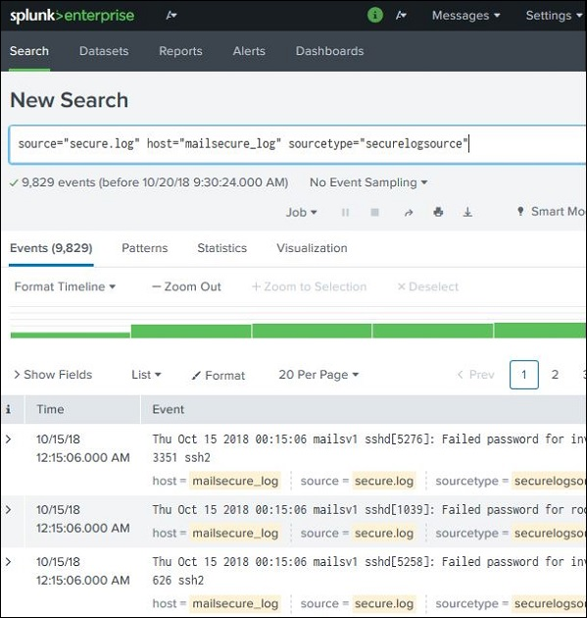
- Using Wild Card
We can use wild cards in our search option combined with the AND/OR operators. In the below search, we get the result where the log file has the terms containing fail, failed, failure, etc., along with the term password in the same line.
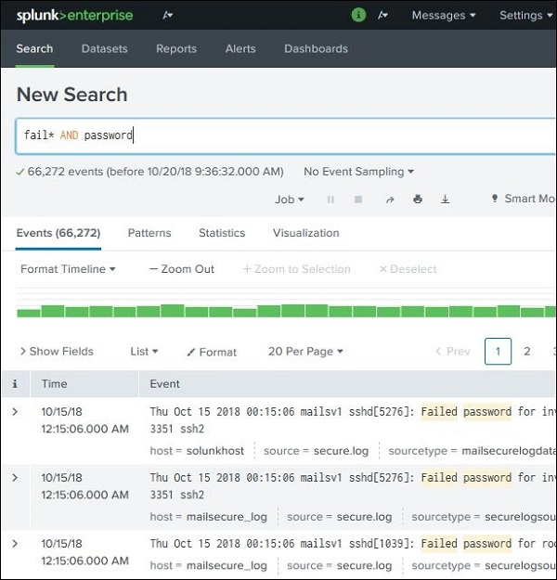
- Refining Search Results
We can further refine the search result by selecting a string and adding it to the search. In the below example, we click over the string 3351 and select the option Add to Search.
After 3351 is added to the search term, we get the below result which shows only those lines from the log containing 3351 in them. Also mark how the time line of the search result has changed as we have refined the search.
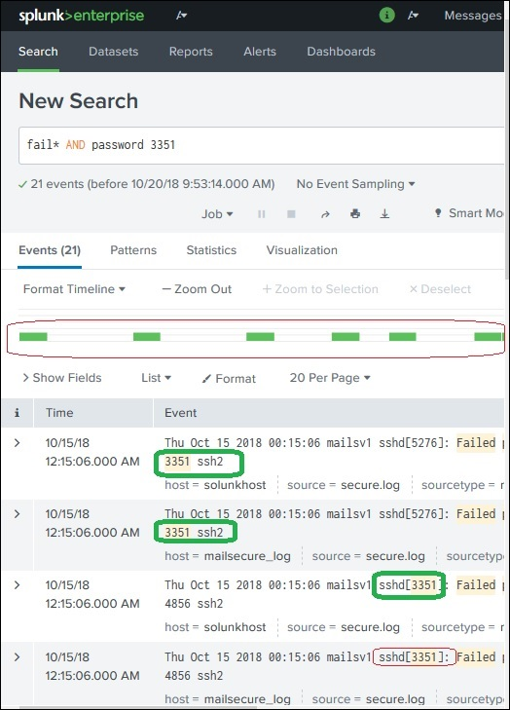
- Splunk - Field Searching

All Regex supported: regex | Splunk Enterprise (last updated 2025-07-03T23:06:01.239Z)
- Add Fields, Field Type
When Splunk reads the uploaded machine data, it interprets the data and divides it into many fields which represent a single logical fact about the entire data record.
For example, a single record of information may contain server name, timestamp of the event, type of the event being logged whether login attempt or a http response, etc. Even in case of unstructured data, Splunk tries to divide the fields into key value pairs or separate them based on the data types they have, numeric and string, etc.
Continuing with the data uploaded in the previous chapter, we can see the fields from the secure.log file by clicking on the show fields link which will open up the following screen. We can notice the fields Splunk has generated from this log file.
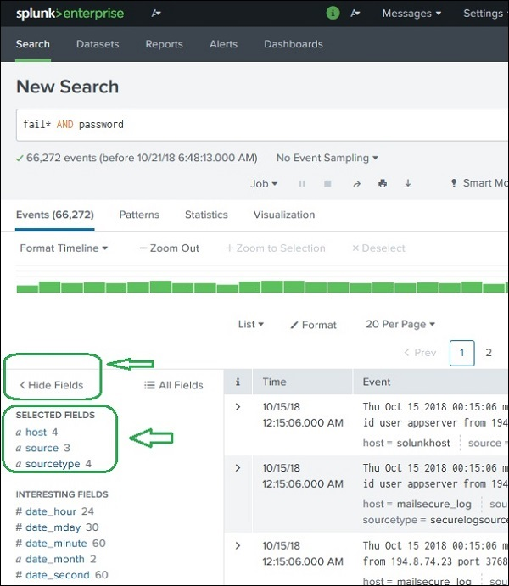
- Choosing the Fields
We can choose what fields to be displayed by selecting or unselecting the fields from the list of all fields. Clicking on all fields opens a window showing the list of all the fields. Some of these fields have check marks against them showing they are already selected. We can use the check boxes to choose our fields for display.
Besides the name of the field, it displays the number of distinct values the fields have, its data type and what percentage of events this field is present in.
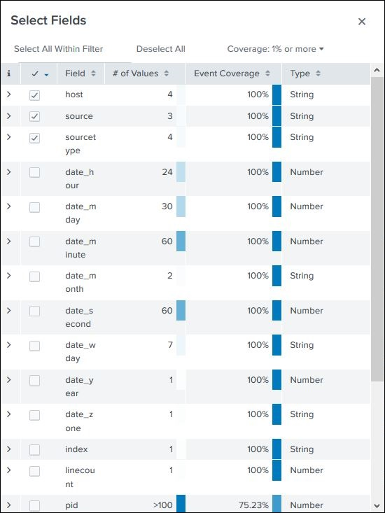
- Field Summary
Very detailed stats for every selected field become available by clicking on the name of the field. It shows all the distinct values for the field, their count and their percentages. >> Window not found
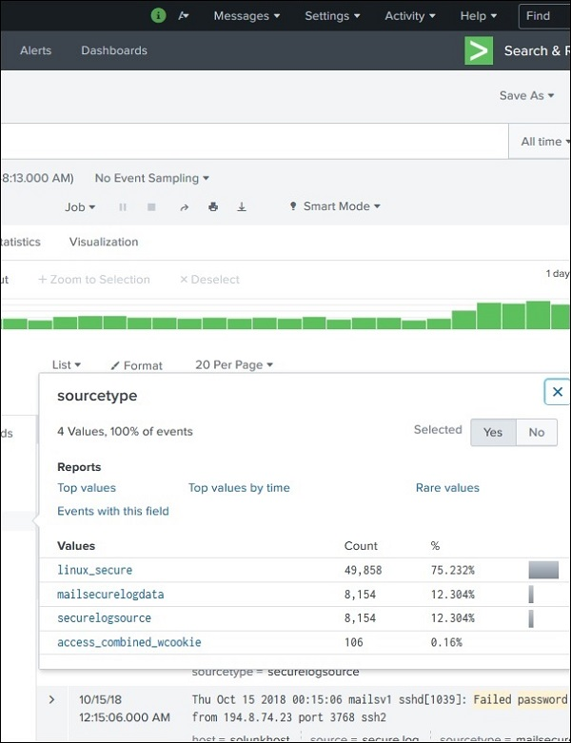
- Using Fields in Search
- Time
The field names can also be inserted into the search box along with the specific values for the search. In the below example, we aim to find all the records for the date, 15th Oct for the host named mailsecure_log. We get the result for this specific date.
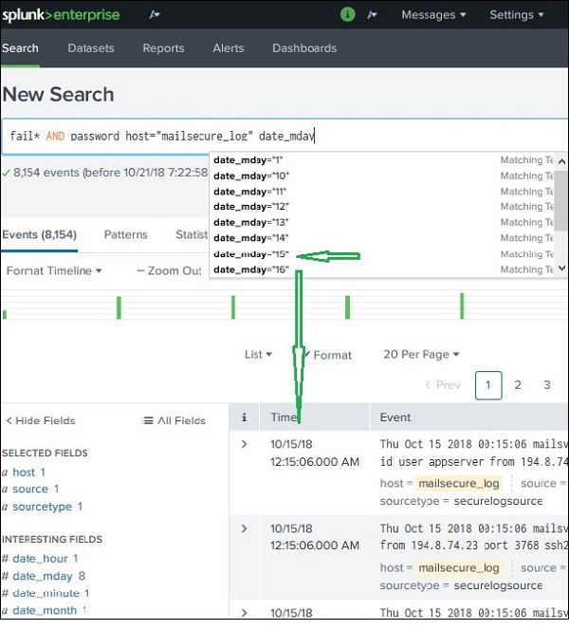
- Splunk - Time Range Search
The Splunk web interface displays timeline which indicates the distribution of events over a range of time. There are preset time intervals from which you can select a specific time range, or you can customize the time range as per your need.
The below screen shows various preset timeline options. Choosing any of these options will fetch the data for only that specific time period which you can also analyse further, using the custom timeline options available.
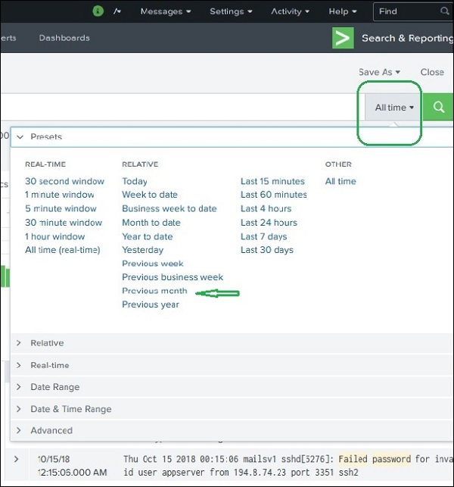
For example, choosing the previous month option gives us the result only for the previous month as you can see the in spread of the timeline graph below.
By clicking and dragging across the bars in the timeline, we can select a subset of the result that already exists. This does not cause the re-execution of the query. It only filters out the records from the existing result set.
Below image shows the selection of a subset from the result set −
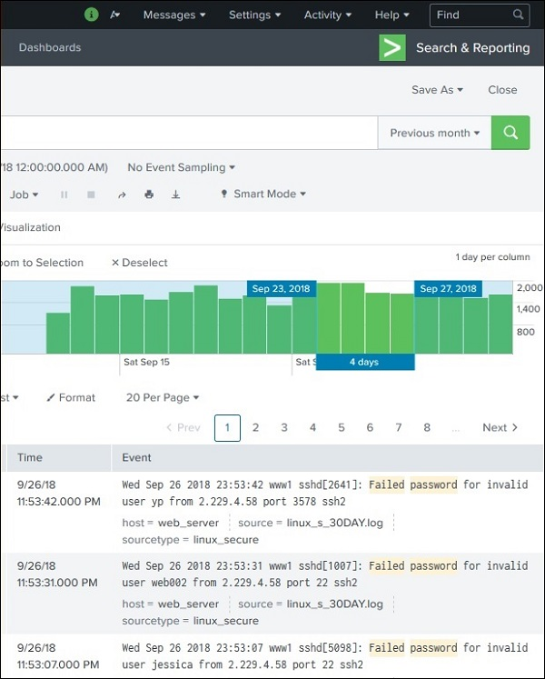
- Earliest and Latest
The two commands, earliest and latest can be used in the search bar to indicate the time range in between which you filter out the results. It is similar to selecting the time subset, but it is through commands rather than the option of clicking at a specific time line bar. So, it provides a finer control over that data range you can pick for your analysis.
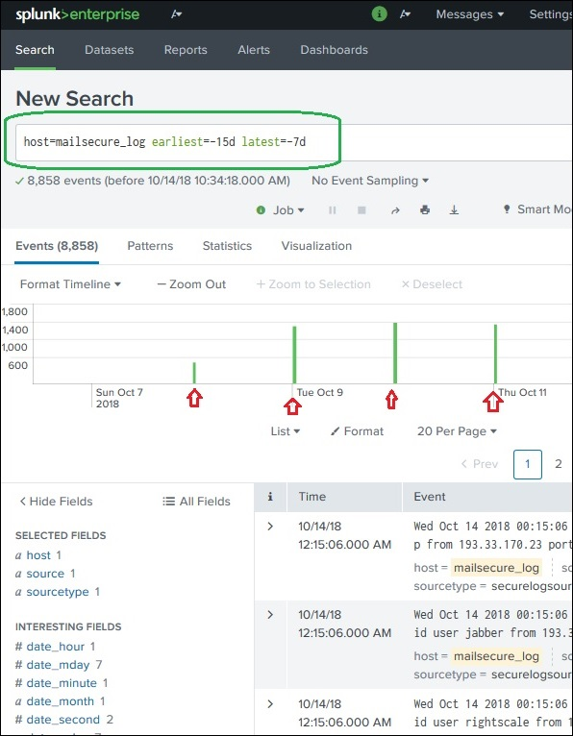
In the above image, we give a time range between last 7 days to last 15 days. So, the data in between these two days is displayed.
We can also find nearby events of a specific time by mentioning how close we want the events to be filtered out. We have the option of choosing the scale of the interval, like seconds, minutes, days and week etc.
- Sharing Exporting
When you run a search query, the result is stored as a job in the Splunk server. While this job was created by one specific user, it can be shared across with other users so that they can start using this result set without the necessity of building the query for it again. The results can also be exported and saved as files which can be shared with users who do not use Splunk.
Once a query has run successfully, we can see a small upward arrow in the middle right of the web page. Clicking on this icon gives a URL where the query and the result can be accessed. There is a need to grant permission to the users who will be using this link. Permission is granted through the Splunk administration interface.
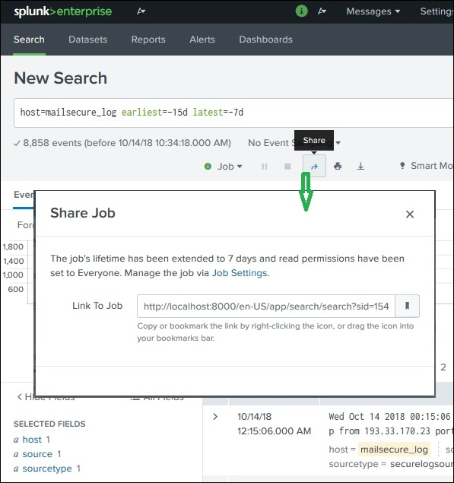
- Finding the Saved Results
The jobs that are saved to be used by all users with appropriate permissions can be located by looking for the jobs link under the activity menu in the top right bar of the Splunk interface. In the below image, we click on the highlighted link named jobs to find the saved jobs.
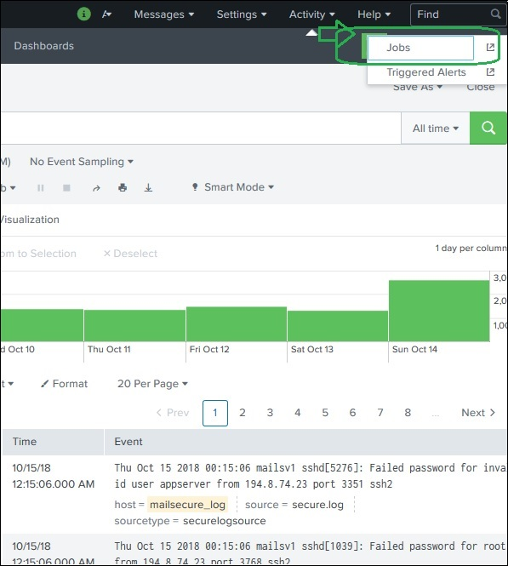
After the above link is clicked, we get the list of all the saved jobs as shown below. He, we have to note that there is an expiry date post where the saved job will automatically get removed from Splunk. You can adjust this date by selecting the job and clicking on Edit selected and then choosing Extend Expiration.
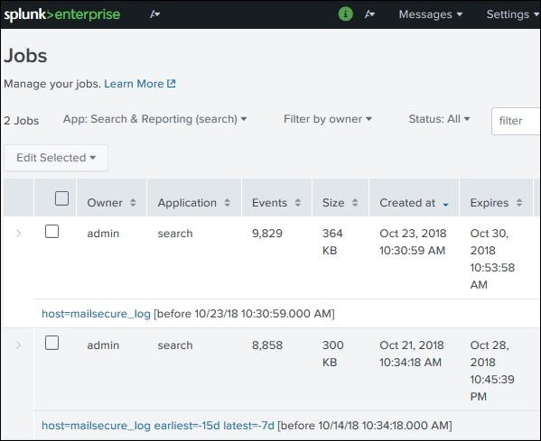
- Exporting the Search Result
We can also export the results of a search into a file. The three different formats available for export are: CSV, XML and JSON. Clicking on the Export button after choosing the formats downloads the file from the local browser into the local system. This is explained in the below image −
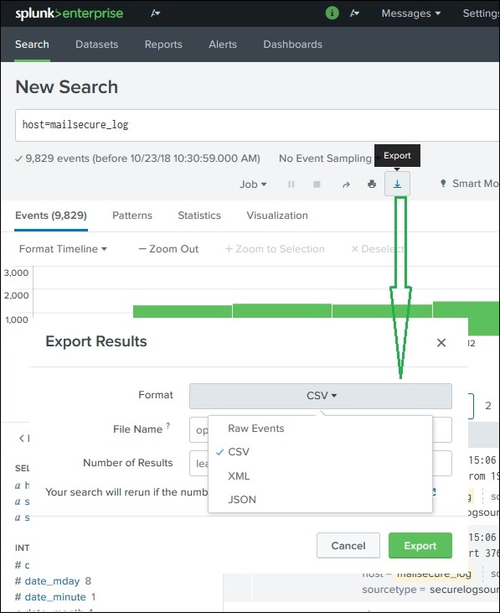
- Search Splunk Language SPL, Show only Top 3 Results
The Splunk Search Processing Language (SPL) is a language containing many commands, functions, arguments, etc., which are written to get the desired results from the datasets. For example, when you get a result set for a search term, you may further want to filter some more specific terms from the result set. For this, you need some additional commands to be added to the existing command. This is achieved by learning the usage of SPL.
The SPL has the following components.
- Search Terms − These are the keywords or phrases you are looking for.
- Commands − The action you want to take on the result set like format the result or count them.
- Functions − What are the computations you are going to apply on the results. Like Sum, Average etc.
- Clauses − How to group or rename the fields in the result set.
These are the terms you mention in the search bar to get specific records from the dataset which meet the search criteria. In the below example, we are searching for records which contain two highlighted terms.
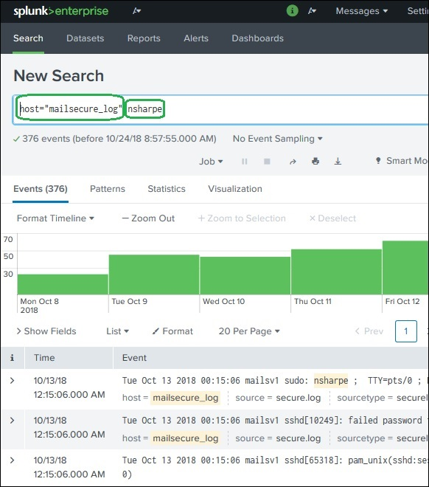
- Commands
You can use many in-built commands that SPL provides to simplify the process of analysing the data in the result set. In the below example we use the head command to filter out only the top 3 results from a search operation.
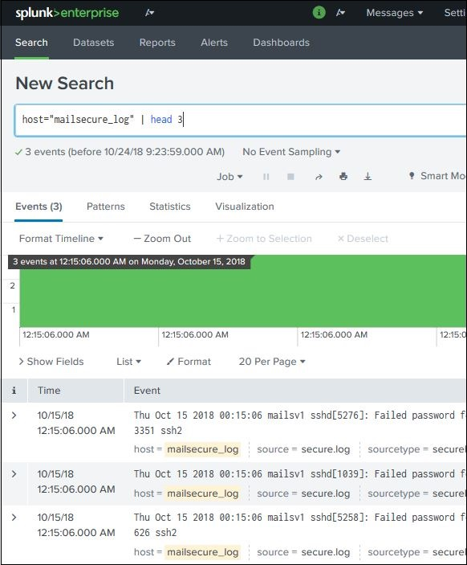
- Search Functions, Grouped by
Along with commands, Splunk also provides many in-built functions which can take input from a field being analysed and give the output after applying the calculations on that field. In the below example, we use the Stats avg() function which calculates the average value of the numeric field being taken as input.
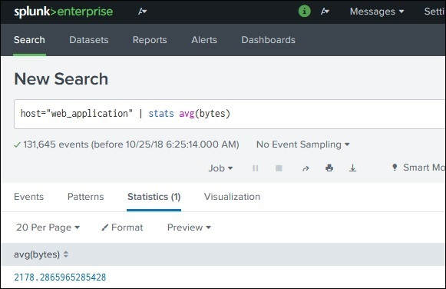
Not easy to find overview Page of functions (seems not to have too many) best Aggregate functions | Splunk Enterprise, Splunk Cloud Platform (last updated 2026-06-26T17:12:46.404Z)

When we want to get results grouped by some specific field or we want to rename a field in the output, we use the group by clause and the as clause respectively. In the below example, we get the average size of bytes of each file present in the web_application log. As you can see, the result shows the name of each file as well as the average bytes for each file.
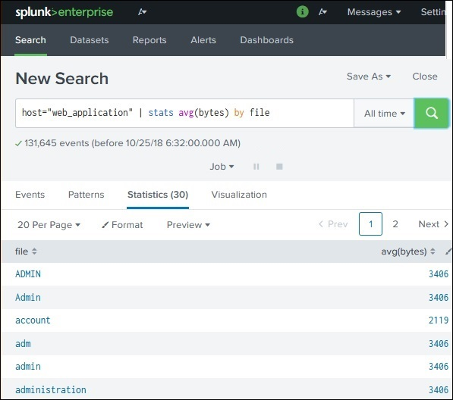

- Splunk – Eigenes Dashboard erstellen
          - Formuliere Splunk Queries, die eine Statisik erstellen
          - Gehe auf den Tab Visualization. Wähle den Chart Typle und alle übrige Einstellungen 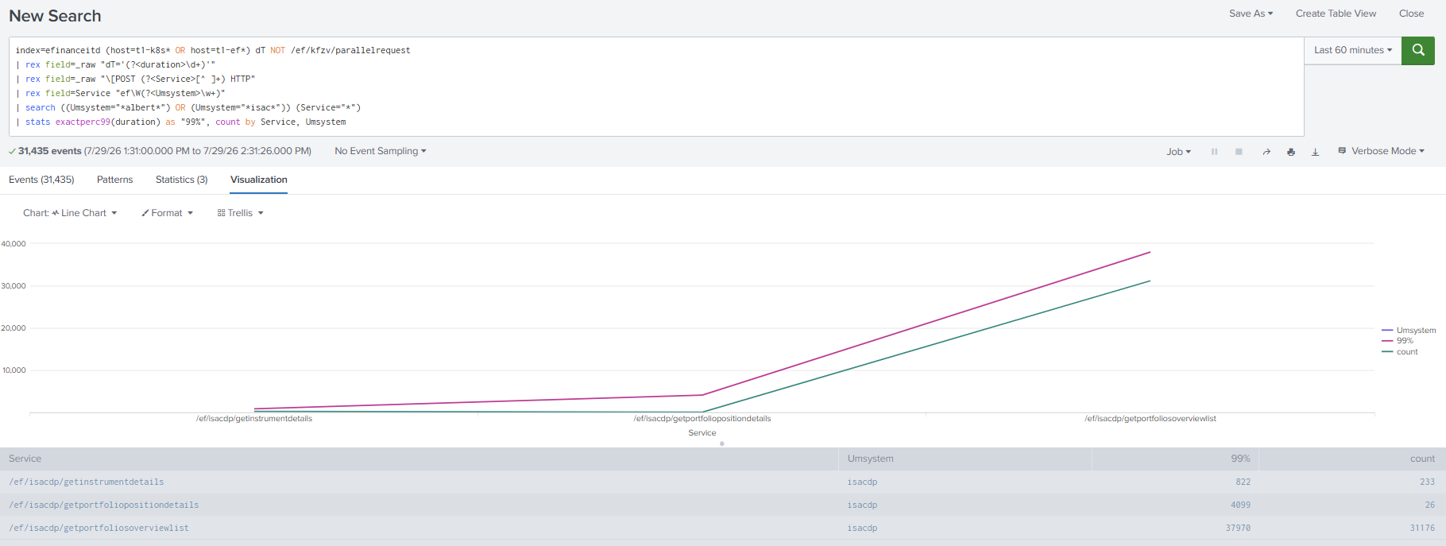
          - Wähle Save As | New Dashboard oder Existing Dashboard
          - Öffne das Dashboard und klicke auf Edit >> Damit lassen sich die Positionierung, der Titel und andere Angaben des Dashboards festlegen

- Splunk – Hauptmenu
App : Übersicht über die Systeme (Hinweis für Index)
[Benutzer] : Erste aufgerufene Seite und Aussehen (Light, Dark) kann eingestellt werden
Activity > Jobs : Ausgeführte splunk queries mit allen Angaben (Status, Runtime, Events, Size usw.)
Suche: Suche nach Reports, Dashboads, Alerts, Datasetes und DataModels

Alle verfügbaren Dashboards sind aufrufbar. Im Menu App kann der Bereich (Bsp. Splunk App Load & Performance) geändert werden.

Allgemein:
- work in progress > Was ist noch nicht fertig?
- Eine Übersichtsseite (roter Faden) würde den Einstieg erleichtern
- kein Runbook vorhanden, es gibt Runbooks für die Data Preparation aber beispielsweise keine Übersicht, wann was gemacht wird

https://confluence.pnet.ch/spaces/NT/pages/725651602/Online+Banking+Performance+Testkonzept+work+in+progress#OnlineBankingPerformanceTestkonzept(workinprogress)-Teststrategie(Gesamt):
- Performancetestansatz und Application Übersicht > Ausgangslage steht mehr oder weniger dasselbe
- Quelle für alle Application Übersicht Graphiken wäre sinnvoll (falls vorhanden)
- Lastmodell SSP: Link funktioniert nicht (gleiche Seite) > Verlinkung auf Performancetest Lastmodell?

https://confluence.pnet.ch/spaces/NT/pages/1550614376/AppID+Registration+Test+Execution
- Test parameters > sollte hier nicht der Load für die verschiedenen Lasten (AVG, PEAK, SLA ..) stehen?
- SQL commands > Mir als aussenstehenden ist nicht klar, welcher Step Plan davor/danach ausgeführt wird.
- Blue-Key und Pink-Key sagt mir nichts >> Erklärung: FIDO Technical Documentation, ev. Verlinken

https://confluence.pnet.ch/spaces/NT/pages/1231104732/Bewertungskriterien+Online+Banking+Work+in+Progress
Die Seite ist meiner Meinung nach sehr allgemein gehalten (wenig Onlinebanking spezifisch)

https://confluence.pnet.ch/spaces/NT/pages/1529277590/CFO+-+FIDO+Technical+Documentation
Möchten wir diese technische Beschreibung im Testkonzept haben?

https://confluence.pnet.ch/spaces/NT/pages/1382908115/MAPPS+Calls
Clickpath bei der Ansteuerung von Mobile Apps über APIs? Kurze Erklärung wäre hilfreich.

https://confluence.pnet.ch/spaces/NT/pages/1529277265/Online+Banking+Monitoring
Der Titel der Seite scheint mir nicht schlüssig zu sein, hier werden häufig auftretende Fehler aufgelistet

https://confluence.pnet.ch/spaces/NT/pages/1559986227/OTS+Cashblocks+Performance+Testkonzept+work+in+progress
Der erste Teil dieser Seite ist mutmasslich eine Kopie der Übersichtsseite. Im zweiten Teil (besonders beim Performance Monitoring) würde ich eine (kurze) Erklärung hilfreich finden.

