LEDSONE · MANAGEMENT AIOS
Management AIOS Calendar
Member User Guide
Create and manage your own Tasks and Leave

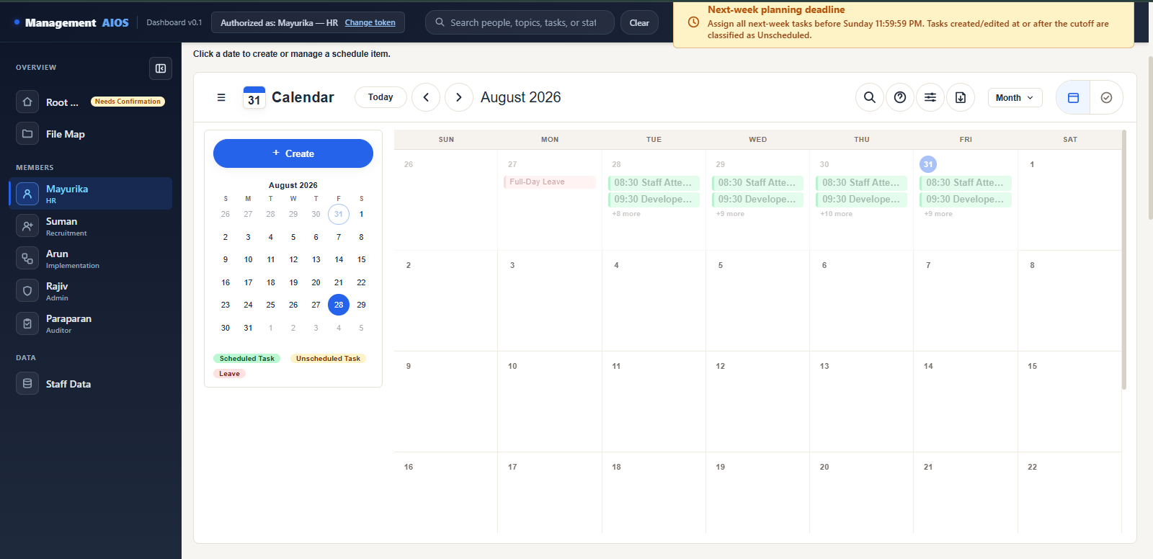
Figure 01: Calendar overview — Month view of a member schedule, showing the toolbar, date grid, and color legend.
Alt text: “Screenshot of the Management AIOS Calendar in Month view, showing the toolbar with Today/Previous/Next navigation, the Create button, and a grid of dates with colored Task and Leave entries.”

Version | 1.0
Production URL | https://management-aios.vercel.app
Prepared | 31 July 2026
Status | User Handout
Built by | Mareenraj (Management AIOS build)
Review routing | Per CLAUDE.md §18 — this is a cross-domain Calendar UX guide with no single business-rule owner; route to whichever Management Team member (Mayurika, Suman, Arun, or Rajiv) next uses the Calendar live, consistent with this repository's existing Calendar-help review precedent.

What You Can Do
The Management AIOS Calendar is shared: every member's schedule is visible to everyone on the Management Team, but each member only controls their own entries.
- Every member can view all members' Calendar schedules.
- You can create, update, complete, uncomplete, or delete only your own Tasks.
- You can create, update, or delete only your own Leave.
- Your member token confirms which Calendar you are allowed to manage.
- Your token is normally entered only once on your own company browser profile.

Allowed and not allowed
Allowed | Not allowed
View every member's Calendar | Create Tasks for another member
Manage your own Tasks | Edit another member's Task
Manage your own Leave | Delete another member's Task or Leave
Change your saved token | Mark another member's Task Completed or Uncompleted
 | Share your token

Why this matters
The Calendar's viewing rules and its management rules are different on purpose. Anyone can look up a colleague's schedule to plan around it, but only the token-holder for that member can change it. This keeps every Calendar accurate and accountable to one person.

Authorize Your Browser
Before you can create, edit, or delete anything, your browser needs to be authorized once with your own member token. Viewing does not require authorization — anyone can look at any Calendar without a token.

Steps
- Select your own member name from the Calendar navigation.
- Choose Create, or any other management action (Edit, Delete, Mark Completed, etc.).
- The “Authorize this browser” window appears.
- Enter the raw member token given to you privately.
- Select Authorize.
- After verification, the top bar shows: “Authorized as: <your name>”.
- The browser remembers the authorization — you will not normally be asked again on this same browser.
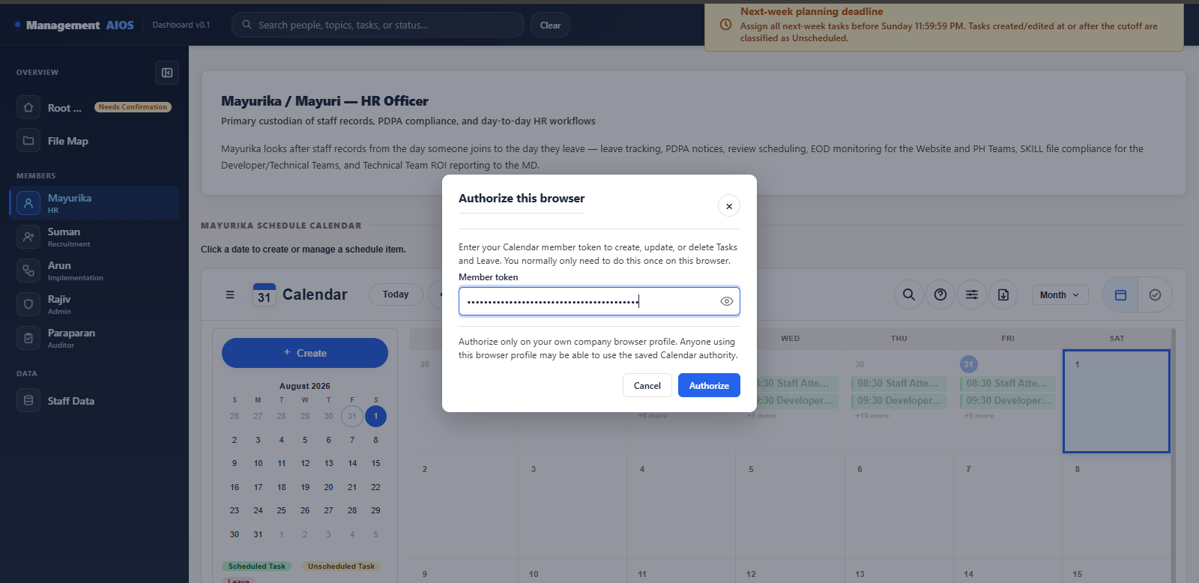
Figure 02: The “Authorize this browser” dialog, with the member token field masked.
Alt text: “The Authorize this browser dialog box, showing the title 'Authorize this browser', an explanatory sentence, a Member token field with dots masking the entry and a show/hide eye icon beside it, a shared-browser warning line, and Cancel and Authorize buttons. No real token is visible.”
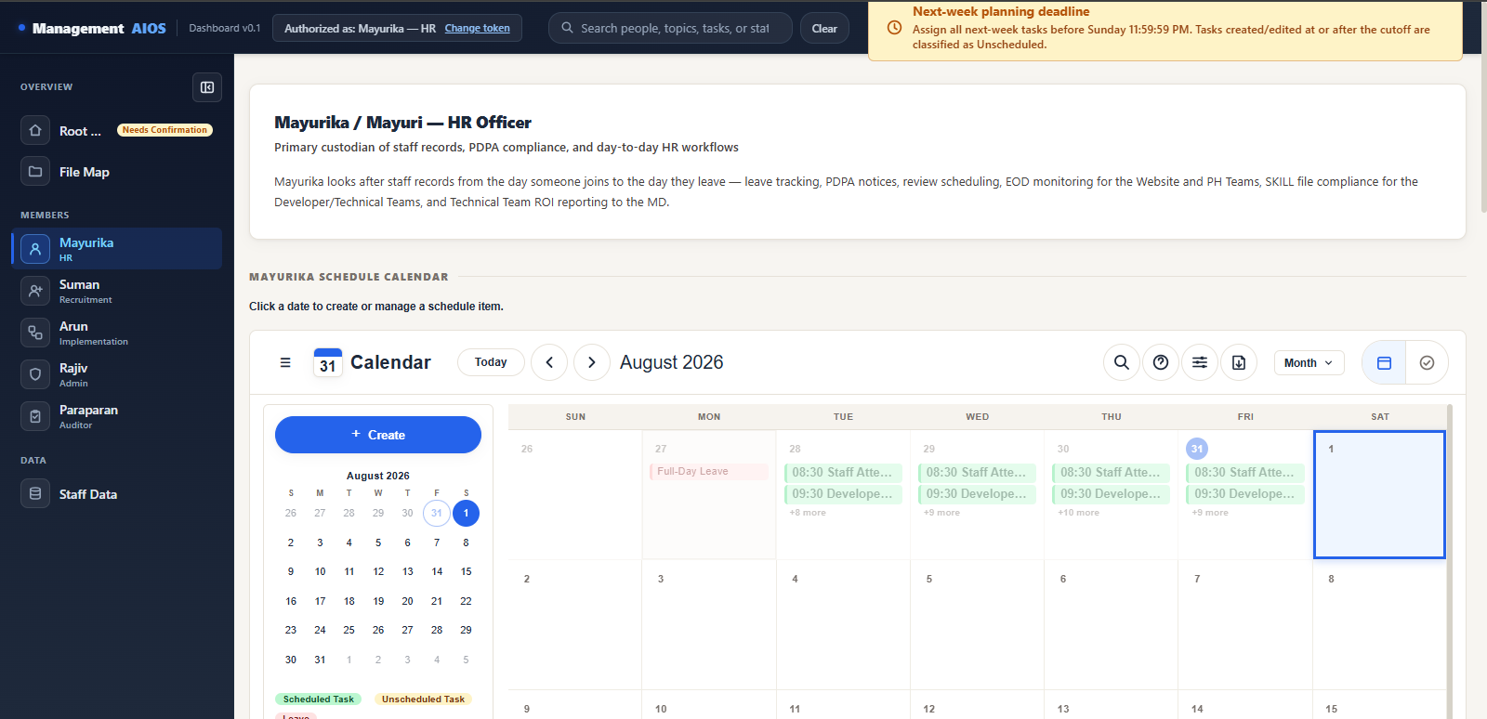
Figure 03: The top-bar indicator that appears after a successful authorization.
Alt text: “The Calendar top bar showing 'Authorized as: Mayurika — HR' next to a 'Change token' button.”

Security notice
Keep your token private
Authorize only on your own company browser profile.
Do not share your token.
Do not send token screenshots.
Do not enter the long backend security code your administrator may mention — enter only the member token given to you.
The token field is masked by default. An eye icon lets you check what you just typed before submitting — it only shows the characters currently in the box, never a token saved from before.

Create Tasks

Steps
- Select your own member Calendar.
- Select the date you want.
- Select Create.
- Choose the Task tab.
- Enter a title, priority, an optional start and end time, and an optional note.
- Select + Add another time to add more time frames for the same Task, if needed.
- Select Add schedule to save.
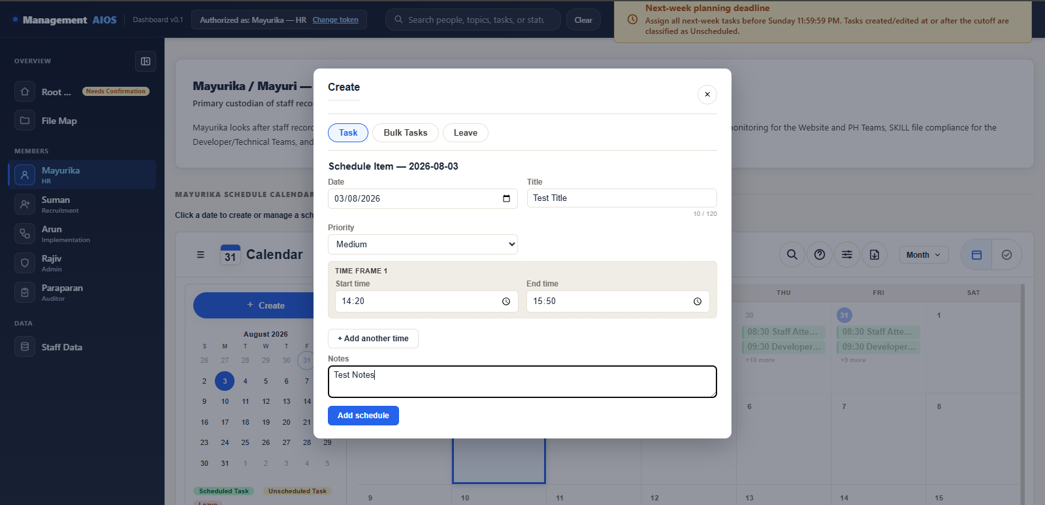
Figure 04: The Task creation form, shown before saving.
Alt text: “The Create Task form filled with a generic example: Date, a Title field showing 'Test Title', a Priority dropdown, a Start time and End time pair, an '+ Add another time' link, a Notes field showing 'Test Notes', and an Add schedule button.”

Good to know
- Scheduled or Unscheduled is assigned automatically based on whether a time is entered. You do not choose that category manually.
- Adding multiple time frames creates one Task occurrence for each time period you enter.
- You can add up to 30 Task occurrences in one submission.
- An exact duplicate (same title, date, and time) is blocked, and an overlapping time for the same title is blocked.
- If your Task falls during the lunch break (12:45 PM–1:30 PM) or overlaps a different Task, a confirmation window (“Check this task time”) will ask if you still want to continue.
Do not save test data
Please do not save a new Task purely to see how the form looks. Fill in the form and review it on screen, or use an existing example that is already safe to view, before saving anything for real.

Bulk Tasks and Leave

Bulk Tasks
Use Bulk Tasks when you need to add several Tasks at once instead of one at a time.
- Select Create.
- Choose the Bulk Tasks tab.
- Add a row for each Task you need.
- Check every row's date, title, priority, and time.
- Select Save to create all the rows together.
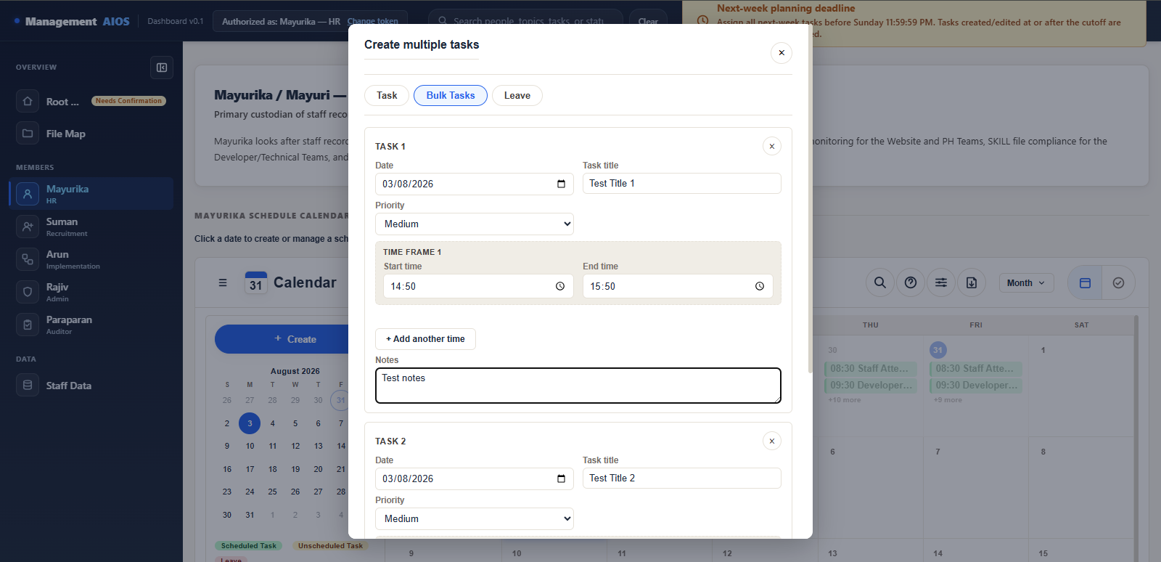
Figure 05: The Bulk Tasks form, shown with generic example rows.
Alt text: “The Create multiple tasks (Bulk Tasks) form, showing generic example rows (Test Title 1, Test Title 2) each with Date, Title, Priority, and time fields, and a Save button.”

Leave
Use Leave to record time away from work on your own Calendar.
- Select Create.
- Choose the Leave tab.
- Select the correct Leave type: Short Leave, Half-Day Leave — First Half (08:30–13:00), Half-Day Leave — Second Half (13:30–18:00), Full-Day Leave, or Multi-Day Leave.
- Enter the dates and any details required for that type.
- Select Save.
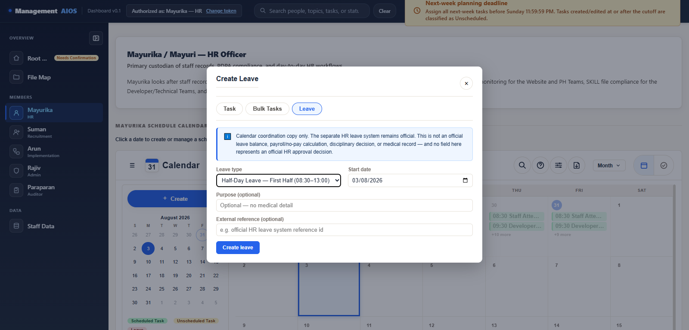
Figure 06: The Leave form, shown with a Leave type selected.
Alt text: “The Create Leave form showing the Leave type field set to Half-Day Leave — First Half, a Start date field, an optional Purpose field, an optional External reference field, and a Create leave button.”
Task and Leave can block each other
Full-Day or Multi-Day Leave can prevent a Task from being added on the dates it covers. Short Leave or Half-Day Leave can block a Task whose time overlaps the Leave period, and an existing Task can likewise block a new Leave entry that overlaps it. If this happens, the screen will explain which one is in conflict.

View, Edit, Delete, and Outcomes

Viewing and changing an item
- Select an existing Task or Leave item on the Calendar.
- Review its details.
- Use Edit to change an allowed field, or Delete to remove it — available only when the item belongs to your own authorized member.
- A Task that already has a recorded outcome cannot have its date changed, and cannot be deleted.
- When a Task has more than one time frame, each time is its own separate item, viewed, edited, or deleted independently.
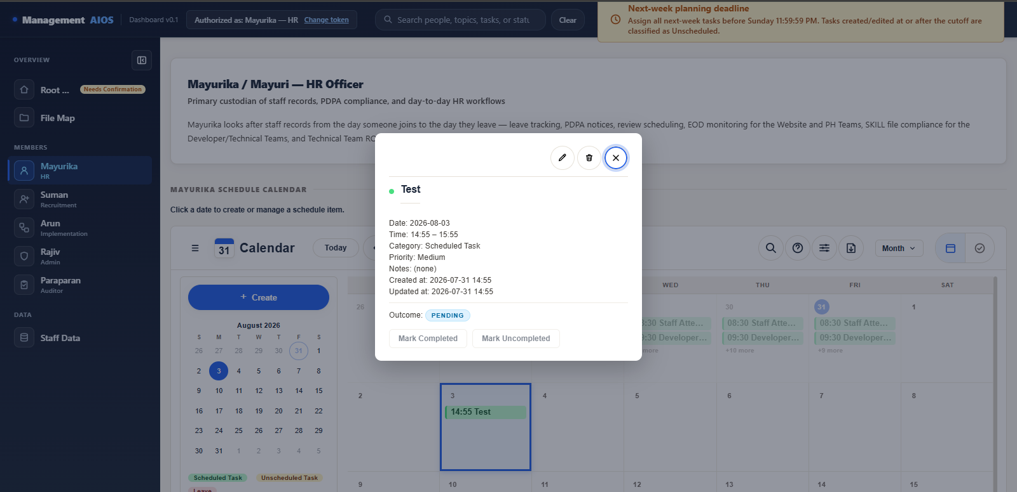
Figure 07: A Task's details view, showing Edit, Delete, and outcome controls.
Alt text: “The Task details panel showing a generic example Task, its date, time, category, priority, and notes, with Edit and Delete icon buttons, the Pending outcome badge, and Mark Completed / Mark Uncompleted buttons beneath. No confidential content is shown.”

Recording a Task outcome
On the Task's own date, you can mark it Completed or Uncompleted. If you mark it Uncompleted, enter a short reason (250 characters or fewer).
- Outcome updates close at 11:59:59 PM on the Task's own date.
- A Task left untouched past that time shows “No response.”
- “No response” is different from “Uncompleted” — it simply means no result was ever selected before the deadline passed.

The four outcome states
State | Meaning
Pending | No result has been selected yet.
Completed | The Task was completed.
Uncompleted | The Task was not completed, and a reason was entered.
No response | The Task's date passed without a result being selected. This is not the same as Uncompleted.

Change Your Token
Use this only when this browser should be authorized as a different, approved member — for example, if you are shown a new token by your coordinator.

Steps
- Select “Change token” in the top bar.
- The “Change Calendar token” dialog opens.
- Enter the new token.
- Select “Change token.”
- The old authorization remains active until the new token is successfully verified.
- Selecting Cancel, or entering an invalid token, does not remove your existing authorization — you stay authorized as before.
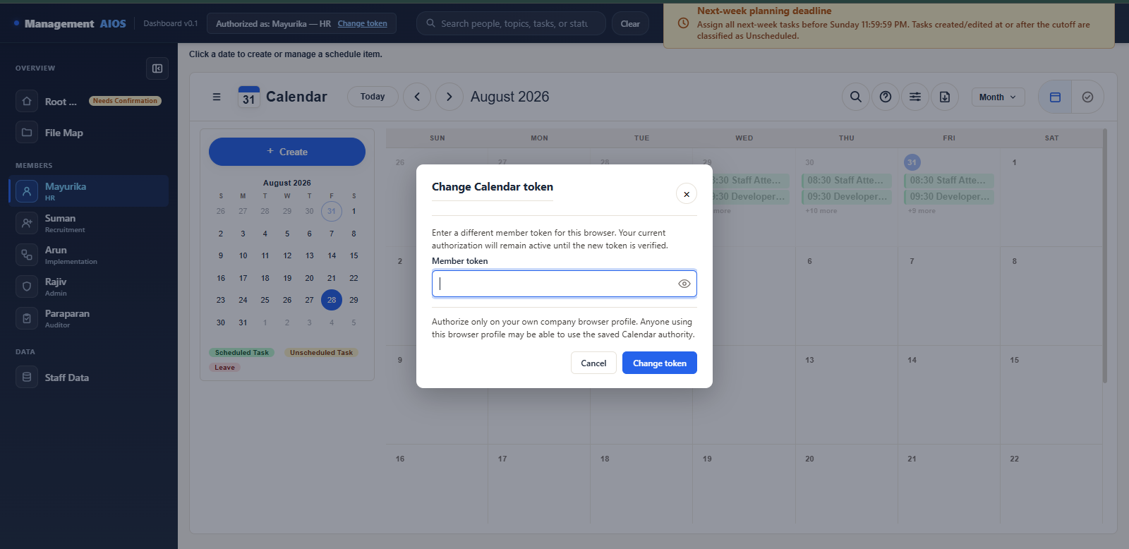
Figure 08: The top-bar “Change token” control and the “Change Calendar token” dialog.
Alt text: “The Calendar top bar showing the 'Authorized as' label next to a 'Change token' button, and beneath it the open Change Calendar token dialog with an empty, masked token field with a show/hide eye icon, an explanatory sentence, and Cancel / Change token buttons.”
- The saved token is never shown or pre-filled in this dialog — the field always starts empty.
- The top-bar “Authorized as” label updates automatically once the new token is verified.
- The show/hide eye icon on this field only reveals what you have just typed into it. It cannot reveal your previously saved token — that value is never placed in the field at all. Select it again to mask it once more.
Never share a real token
This guide never shows a real token or a security code. Always mask your own entry from view when anyone else can see your screen, and never paste a token into chat, email, or a document.

Viewing Another Member's Calendar
You can open and look at any member's Calendar at any time. Viewing is always allowed. Managing someone else's Tasks or Leave is not.
If you try to create, edit, delete, or update an outcome on a Calendar that is not your own, you will see a red warning message similar to this example:
You can't manage Mayurika's Calendar
You are authorized as Suman. You can only create or change Suman's Tasks and Leave.

The exact name shown will always match the member you are currently viewing, and the member you are actually authorized as.
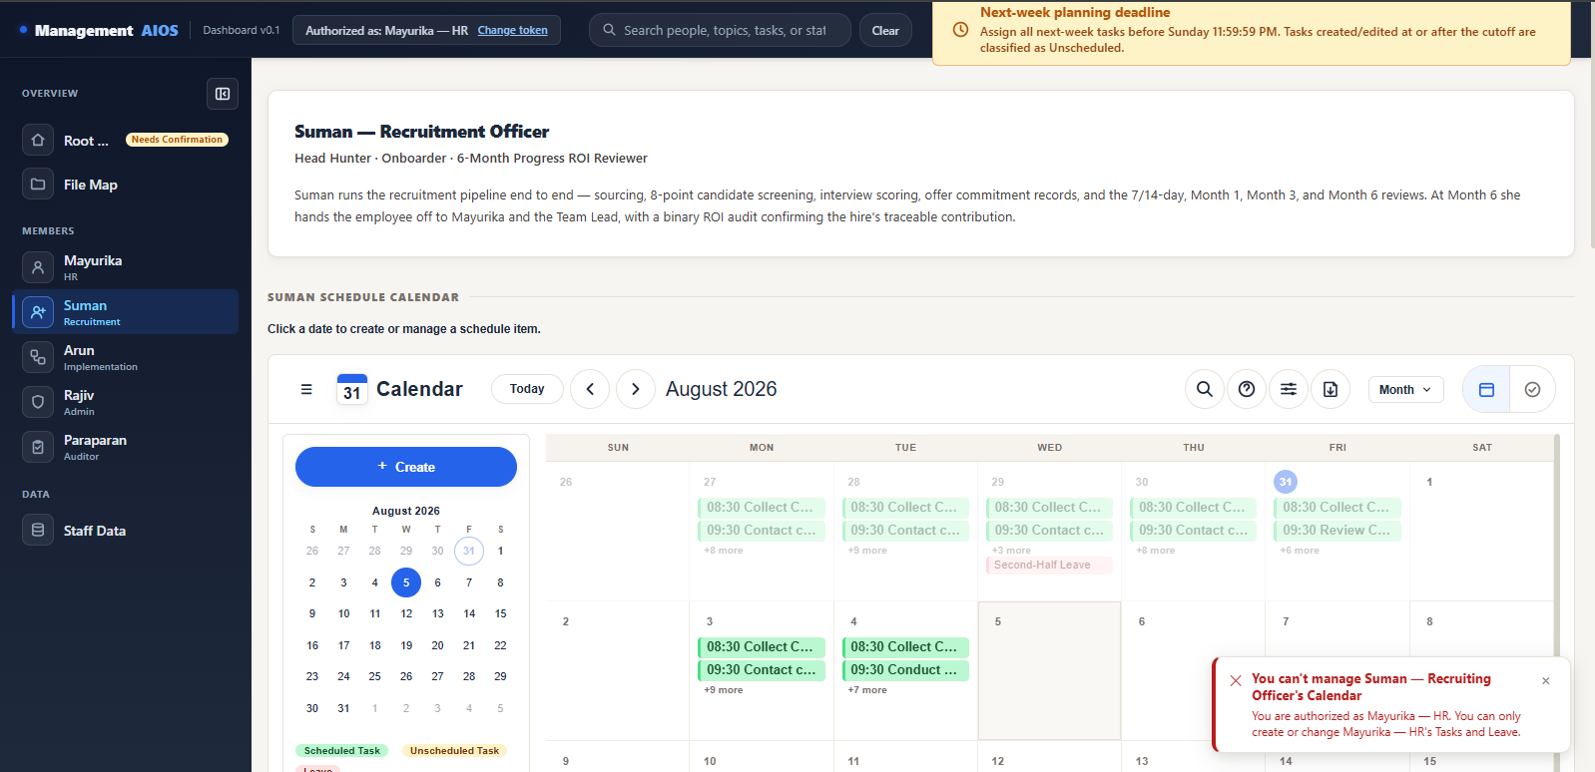
Figure 09: The red cross-member authorization warning.
Alt text: “A red-bordered warning alert with a red icon, a bold red title reading “You can't manage Suman — Recruiting Officer's Calendar”, and a red message reading “You are authorized as Mayurika — HR. You can only create or change Mayurika — HR's Tasks and Leave.” No token, hash, or confidential Calendar content is visible.”
Your authorization is not affected
Seeing this warning does not remove or change your saved token. It only means the action you tried belongs to someone else's Calendar. Return to your own Calendar to continue working, or use Change token only if this browser genuinely needs to switch to another approved member.

Common Problems
Problem | What to do
Token not recognized | - Check that you entered the raw member token, not a long backend security code.  - Check for missing spaces or accidentally copied extra characters.  - Ask your coordinator if the token was recently changed (rotated).
You can't manage another member's Calendar | - Continue viewing if that is all you need.  - Return to your own Calendar to create or change Tasks and Leave.  - Use Change token only when this browser should be authorized as another approved member.
Authorization disappeared | - Browser storage may have been cleared (for example, by clearing browsing data).  - The token may have been rotated by your coordinator.  - Authorize the browser again with your current token.
Saving did not finish | - Check the error message shown on screen.  - Confirm your internet connection.  - Refresh the page and retry only once.  - Contact support if the problem continues.
Wrong member or date selected | - Close the form without saving.  - Select the correct member and date.  - Start again.

Safe Use and Support

Good habits
- Use one browser profile for one member — do not authorize a shared or public browser as yourself.
- Never share your member token with anyone, including other Management Team members.
- Never save your token in email, chat messages, screenshots, or documents.
- Always check the selected member and date before saving anything.
- If you need to report a problem, describe what happened in words — never send a screenshot or message that shows your token.

Support
For Calendar access problems (tokens, authorization, or a rotated token), contact your coordinator through your normal reporting channel. For questions about a specific Task, Leave entry, or Calendar rule, contact the relevant Management Team member for that domain, per this AIOS's reviewer routing rule (CLAUDE.md §18).
Production URL | https://management-aios.vercel.app
Guide version | 1.0
Last updated | 31 July 2026

